პრხ

ადმინისტრატორის სახელმძღვანელო

სარჩევი

2 პარამეტრები 3

2.1 მომხმარებლები 3

2.2 ვიზუალური კომპონენტები 5

3 შეტყობინების შაბლონები(Email) და შეტყობინების შაბლონი(ნომერი) 9

4 შეტყობინებების ისტორია 11

5 შეტყობინების თემები 12

6 დარეკვის შედეგები 12

7 ინდივიდუალური შეტყობინებების გაგზავნა და ისტორია აბონენტის ბარათზე 13

8 კონფიგურაცია 16

8.1 აბონენტები 17

8.1.1 კატეგორიები 18

8.1.2 კონტრაქტის ტიპები 19

8.1.3 საქმიანობა 20

8.1.4 მიწოდების ტიპები 21

8.1.5 სოციალური კატეგორიები 22

8.1.6 მფლობელის ტიპი 23

8.1.7 აბონენტის საბანკო ინფორმაციები 24

8.2 გადავადებები 26

8.2.1 გადავადების ფორმა 27

8.3 ხელშეკრულებები 28

8.3.1 ხელშეკრულების ფაილის ტიპები 28

8.4 მრიცხველები 30

8.4.1 ტიპები 30

8.4.2 ლოცაკია 32

8.4.3 კოეფიციენტები 34

8.5 ტრანზაქციები 35

8.5.1 ტიპები 35

8.5.2 ქვეტიპები 36

8.5.3 ტიპების კომბინაცია 38

8.5.4 დარიცხვის ფორმის პარამეტრები 40

8.6 ანგარიშ-ფაქტურები 42

8.7 წინასასამართლო 43

8.7.1 თანამშრომლების კონფიგურაცია 43

8.8 ბიზნეს ცენტრები 44

8.9 სტატუსები 45

8.10 ნუმერატორები 46

8.11 ჩაჭრის სტატუსები 47

8.12 რესტრუქტურიზაციის შაბლონი 49

8.13 მშობელზე გასატარებელი ოპერაციის ტიპები 50

8.14 მიკორსიმძალვრის ჯგუფები 51

8.15 პარამეტრები 52

8.15.1 მთავარი 52

8.15.2 ნუმერატორები 55

8.15.3 დეპოზიტი 56

8.15.4 მიწოდების ხელშეკრულება 58

8.15.5 ანგარიშ-ფაქტურები 59

8.15.6 ეიჯინგ რეპორტის კონფიგურაცია 60

8.15.7 სუბსიდია 60

8.15.8 RS ინტეგრაცია 60

8.15.9 რესტრუქტურიზაცია 61

8.15.10 თელმიკო 62

8.15.11 ქვითრები 62

8.15.12 დარიცხვები 63

8.16 ქვითრების კონფიგურაცია 64

8.16.1 მიმდინარე დარიხვა 64

8.16.2 გამოყენებული დეპოზიტი 65

8.16.3 კორექტირება 66

8.16.4 მომსახურების ხარისხის კომპენსაცია 67

8.16.5 სუბსიდია 67

8.17 სემეკის რეპორტი - მოხმარებული ელ.ზღვრების 70

8.18 კალენდარი 70

8.19 ჯობების შეტყობინების ელ.მისამართები 71

9 როლები 72

10 ბაზის სტრუქტურა 75

10.1 ცხრილების სია 75

10.2 ცხრილების სტრუქტურა 87

# პარამეტრები

პარამეტრებიდან შესაძლებელია პროგრამის მომხმარებლის დამატება და ვიზუალური კომპონენტების ცვლილება :

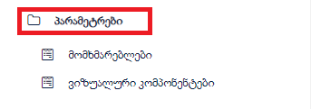

## მომხმარებლები

**ფორმიდან შესაძლებელია პროგრამის მომხმარებლის დამატება და შესამისი როლების** გაწერა:

* **Create-** ახალი თანამშრომლის დამატება პირადი ინფორმაციის დარეგისტრირება.
* **Edit-** რედაქტირება
* **Remove-** წაშლა
* **Role assignments -** დარეგისტირებულ თანამშრომელზე შესაბამისი როლის გაწერა
* **Additional-** დამატებითი ფუნქციები როგორიცა : პაროლის ცვლილება , მომხმარებლის ჩანაცვლება , იუზერის გადატვირთვა.

მომხმარებელზე როლის მინიჭება ხდება პირადი ინფორმაციის დარეგისტრირებისშემდეგ **role assignments-** ის ღილაკის გამოყენებით

1. **Resource permissions-** როლი რომელზეც წვდომა აქვს მომხმარებელს
2. **Row-level constraints-** როლი რომელიც ზღუდავს ცხრილში კონკრეტულ ჩანაწერებს

* **Add-** გაიხსნება როლების ჩამონათვლის ფორმა და ამატებ სასურველ როლს
* **Remove -** დამატებული როლის წაშლა

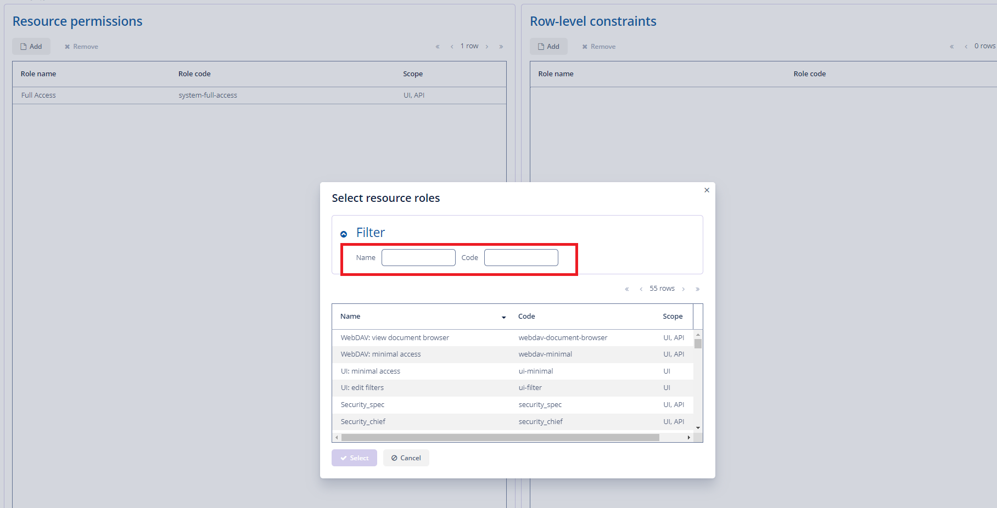

## ვიზუალური კომპონენტები

ვიზუალურ კომპონენტებში შესაძლებელია ფორმების ზომის , ფერის და ინტერფეისის ცვლილება.

# შეტყობინებები

პროგრამიდან შეგვიძლია შექმნა და გაგზავნა სხვადასხვა ტიპის შეტყობინებების, ამისათვის გვაქვს სხვადასხვა ფორმები:

1. **შეტყობინებები**
2. **ხელშეკრულების შეტყობინებები**
3. **შეტყობინების ხელით ფორმირება**
4. **შეტყობინების ხელით ფორმირება ( გაგზავნა )**
5. **შეტყობინების შაბლონები (Email)**
6. **შეტყობინეების შაბლონები (ნომერი)**
7. **ქვითრის sms-ები**
8. **შეტყობინების თემები**
9. **დარეკვის შედეგები**

## ხელშეკრულების შეტყობინებები

ფორმაზე მოცემულია შეტყობინებების სრული სია

* **Refresh**-ფორმის განახლება

## შეტყობინების ხელით ფორმირება

ფორმაზე ფორმირდება ჯგუფური შეტყობინებები

გაიხსნება ფორმა სადაც გვაქვს შემდეგი ღილაკები:

1. **ჩატვირთვა** - აბონენტების შესახებ მიმდინარე მონაცემების განახლება ფორმაზე.
2. **Edit** - აბონენტის ესემესის ცვლილება
3. **Remove** - მოხდება მონიშნული ლაინის წაშლა.
4. **Refresh** - ფორმის განახლება.
5. **შეტყობინების მომზადება** - ახალი შეტყობინების მომზადება და გასაგზავნად
6. **მონიშნულის გაგზავნა-** მონიშნული შეტყობინების გაგზავნა

შეტყობინების მომზადებაზე დაჭერით გაიხსნება ფორმა „შეტყობინების მომზადება “, სადაც გვაქვს შემდეგი ღილაკები

* **სმს ცვლადები -**ცვლადების სია -აბონენტის სახელი, აბონენტის გვარი,აბონენტის ნომერი, გადახდის თარიღი, გათიშვის თარიღი, ბალანსი, ვადაგადაცილების თარიღი ინგლისურად,ვადაგადაცილების თარიღი ქართულად.
* **Email ცვლადები-**ცვლადების სია -აბონენტის სახელი, აბონენტის გვარი,აბონენტის ნომერი, გადახდის თარიღი, გათიშვის თარიღი, ბალანსი, ვადაგადაცილების თარიღი ინგლისურად,ვადაგადაცილების თარიღი ქართულად.
* **SMS- -**ჩეკბოქსი მონიშვნის შემდეგ აბონენტს გაეგზავნება სმს შეტყობინება
* **E-MAIL-**ჩეკბოქსის მონიშვნის შემდეგ აბონენტს გაეგზავნება E-Mail შეტყობინება
* **სმს შაბლონი -**ირჩევთ პროგრამაში არსებულ შაბლონს.
* **სმს ტექსტი-**დაგენერირებული შაბლონი რომელიც იგზავნება აბონენტთან.
* **Email შაბლონი-**ირჩევთ პროგრამაში არსებულ შაბლონს.
* **სათაური-** ჩაწერთ შეტყობინების სათაურს.
* **Email ტექსტი-**დაგენერირებული შაბლონი რომელიც იგზავნება აბონენტთან.
* **Cancel** -ფორმის დახურვა.

„OK “ღილაკზე დაჭერით გაიხსენბა ფორმა **„Customer report notification“,** სადაც ჩავარდება მომზადებული შეტყობინებები

* Refresh- ფორმის გადატვირთვა
* სმს გაგზავნა- მომზადებული სმს გაგზავნა
* Email გაგზავნა- მომზადებული იმეილის გაგზავნა

# შეტყობინების შაბლონები(Email) და შეტყობინების შაბლონი(ნომერი)

შეტყობინებების გასაგზავნათ საჭიროა პროგრამაში გვქონდეს წინასწარ შექმნილი შაბლონები, რომელსაც შემდგომ ვირჩევთ შეტყობინების გაგზავნისას.

Email და ნომერი-ის შაბლონების შექმნის პროცესი იდენტურია და ამისთვის გვაქვს შემდეგი ფორმები:

* შეტყობინების შაბლონი (Email)
* შეტყობინების შაბლონი (ნომერი)

გაიხსნება ფორმა სადაც გვაქვს შემდეგი ღილაკები:

* **Create -**შაბლონის შექმნა .
* **Edit -** შექმნილ შაბლონზე ინფორმაციის ცვლილება.
* **Remove -** შაბლონის წაშლა.
* **Refresh -** შაბლონის განახლება.

შაბლონის შექმნა ღილაკზე დაჭერით გაიხსნება ფორმა სადაც გვაქვს შემდეგი ველები:

* **ცვლადები-** ცვლადების სია- აბონენტის სახელი, აბონენტის გვარი,აბონენტის ნომერი, გადახდის თარიღი, გათიშვის თარიღი, ბალანსი, ვადაგადაცილების თარიღი ინგლისურად,ვადაგადაცილების თარიღი ქართულად
* **სათაური-** შეტყობინების სათაური
* **ტექსტი -**ტექსტი რომელიც უნდა გაიგზავნოს აბონენტთან.
* **ტიპი -** შეტყობინების ტიპი

**გამოყენება-** გაიგზავმოს E-MAIL-ზე თუ ნომერ-ზე

ყველა დაგენერირებული და გაგზავნილი შეტყობინებების ნახვა შეგიძლიათ ფორმაზე **შეტყობინებები.**

**შეტყობინებები>>შეტყობინებები**

გაიხსნება ფორმა, სადაც შეგიძლიათ ნახოთ ყველა ტიპის შექმნილი და გაგზავნილი შეტყობინება (გამაფრთხილებებლი, შეხსენების), ამ ფორმაში არ ხდება ახალი შეტყობინების შექმნა.

შეტყობინებებში შეგიძლიათ ნახოთ და გადაამოწმოთ თითოეული შეტყობინების სტატუსები. (გაგზავნილი, ახალი Error)

* **Edit -** შეტყობინებაში ცვლილების შეტანა
* **Refresh -** გადატვირთვა
* **Remove-** წაშლა
* **გაგზავნა-** შეტყობინების თავიდან გაგზავნა

# შეტყობინებების ისტორია

ყველა დაგენერირებული და გაგზავნილი შეტყობინებების ნახვა შეგიძლიათ ფორმაზე **შეტყობინებები.**

**შეტყობინებები>>შეტყობინებები**

გაიხსნება ფორმა, სადაც შეგიძლიათ ნახოთ ყველა ტიპის შექმნილი და გაგზავნილი შეტყობინება (გამაფრთხილებებლი, შეხსენების), ამ ფორმაში არ ხდება ახალი შეტყობინების შექმნა.

შეტყობინებებში შეგიძლიათ ნახოთ და გადაამოწმოთ თითოეული შეტყობინების სტატუსები. (გაგზავნილი, ახალი Error)

* **Edit -** შეტყობინებაში ცვლილების შეტანა
* **Refresh -** გადატვირთვა
* **Remove-** წაშლა
* **გაგზავნა-** შეტყობინების თავიდან გაგზავნა

# შეტყობინების თემები

* **Create-** ახალი შედეგის შექმნა
* **Edit-** ცლილების განხორციელება
* **Refresh-** გადატვირთვა
* **Remove-**წაშლა

# დარეკვის შედეგები

* **Create-** ახალი შედეგის შექმნა
* **Edit-** ცლილების განხორციელება
* **Refresh-** გადატვირთვა
* **Remove-**წაშლა

# ინდივიდუალური შეტყობინებების გაგზავნა და ისტორია აბონენტის ბარათზე

ინდივიდუალური შეტყობინებების გაგზავნა და ასევე ისტორიის ნახვა შეგიძლიათ თითოეული აბონენტის ბარათზე.

ინდივიდუალური შეტყობინებების გასაგზავნად უნდა შეხვიდეთ აბონენტების სიაზე:

**აბონენტი>> აბონენტები>>აირჩიეთ შესაბამისი აბონენტის ნომერი >>ოპერაციები>>ინდივიდუალური შეტყობინების გაგზავნა**

„ინდივიდუალური შეტყობინების გაგზავნა“-ზედაჭერის შემდგომ გაიხსნება ფორმა :**„ინდივიდუალური შეტყობინება“,** სადაც გვაქვს შემდეგი ღილაკები:

* **ცვლადები-** ცვლადების სია -აბონენტის სახელი, აბონენტის გვარი,აბონენტის ნომერი, გადახდის თარიღი, გათიშვის თარიღი, ბალანსი, ვადაგადაცილების თარიღი ინგლისურად,ვადაგადაცილების თარიღი ქართულად.
* **შაბლონები-** ირჩევთ პროგრამაში არსებულ შაბლონს.
* **SMS-**ჩეკბოქსი მონიშვნის შემდეგ აბონენტს გაეგზავნება სმს შეტყობინება
* **E-MAIL-**ჩეკბოქსის მონიშვნის შემდეგ აბონენტს გაეგზავნება E-Mail შეტყობინება
* **ავტომატურად გაგზავნა-** შეტყობინება გაუგზავნეა ავტომატურად
* **სათაური-** შეტყობინების სათაური
* **ტექსტი-**დაგენერირებული შაბლონი რომელიც იგზავნება აბონენტთან.

თითოეული აბონენტის ბარათზე შეგიძლიათ გადაამოწმოთ გაგზავნილი შეტყობინებების ისტორია. ამისათვის უნდა შეხვიდეთ **აბონენტი>> აბონენტები>>აირჩიეთ შესაბამისი აბონენტის ნომერი >>Edit>>შეტყობინებები**

* **გაგზავნა-** გაგზავნილი შეტყობინების თავიდან გაგზავნა
* **Edit-** შეტყობინებებში ცვლილების შეტანა
* **Refresh-** გადატვირთვა
* **Remove-** წაშლა
* **Excel-** ექსელში გატანა

# კონფიგურაცია

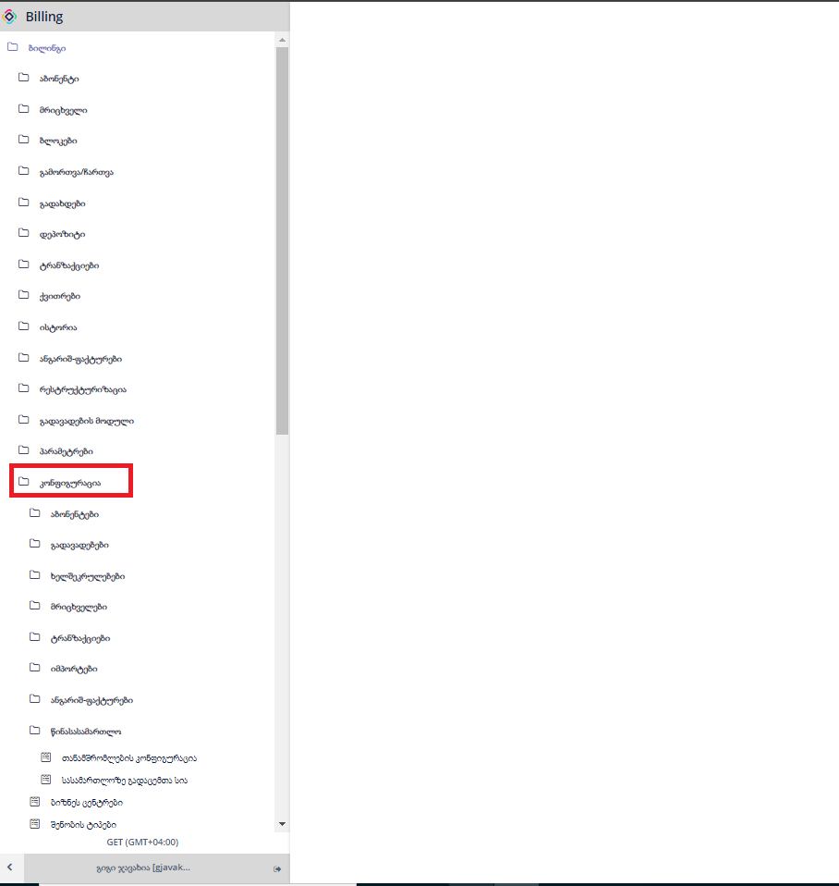

## აბონენტები

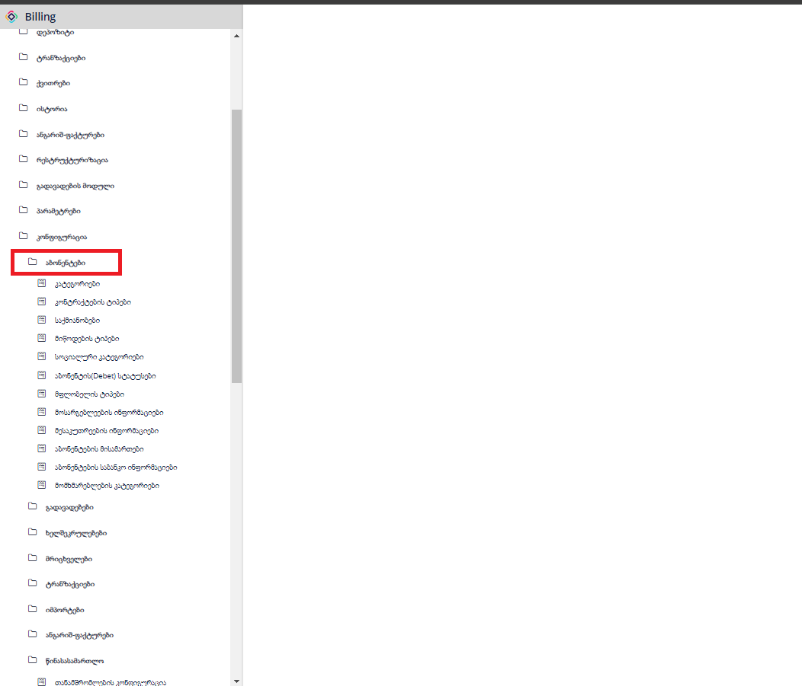

### კატეგორიები

განსაზღვრავს აბონენტის კატეგორიას

* კატეგორიის დასახელება - მოდის თელასიდან
* კოდი -მოდის თელასიდან
* გაუქმებული - მოდის თელასიდან
* იურიდიული - გამოიყენება ისეთ შემთხვევაში თუ კატეგორია იურიდიულია
* VAT types - კატეგორიის შესაბამისად უნიშნავთ დღგს ტიპს
* report category name - უწერთ საბიუჯეტოა, კომერციული თუ სააბონენტო რომელი განსაზღვრავს რეპორტებში აბონენტის ტიპს .
* report is legal name - უთითებთ საყოფაცხოვრებოა თუ არასაყოფაცხოვრებო

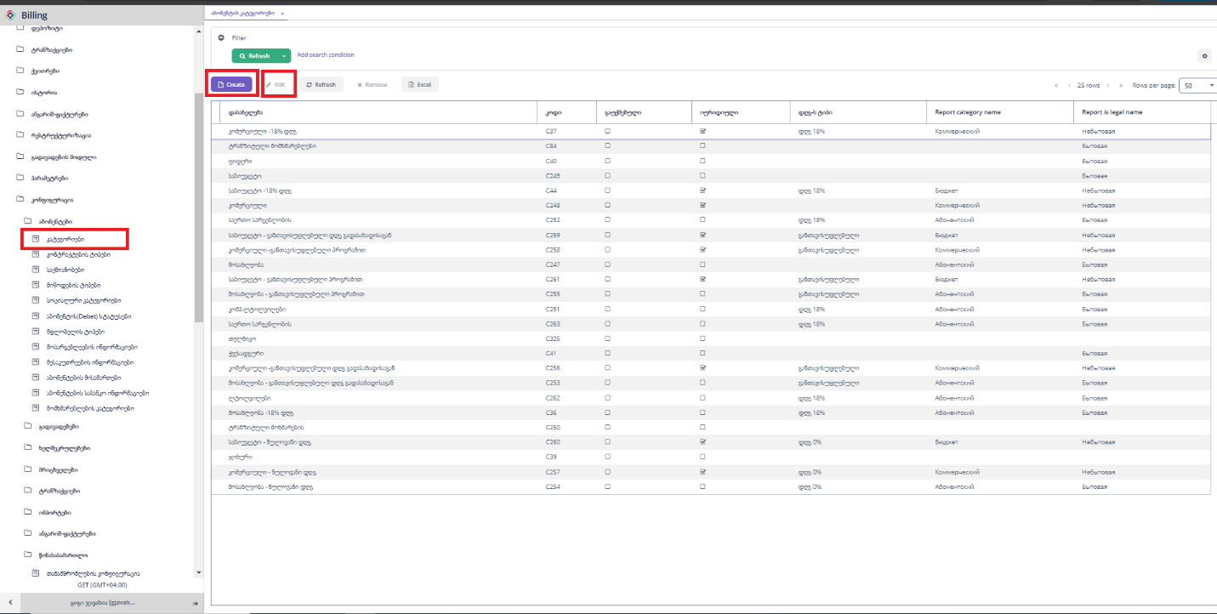

„Create“ ღილაკზე დაჭერით გამოვა კატეგორიის დასამატებელი ფორმა.

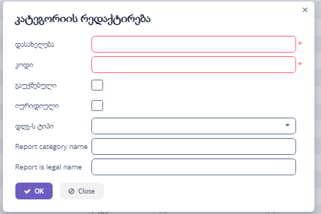

„Edit“ ღილაკზე დაჭერით გამოვა კატეგორიის დასამატებელი ფორმა.



### კონტრაქტის ტიპები

* კონტრაქტის ტიპები- განსაზღვრავს აბონენტის კონტრაქტებს .
* კოდი- ყველა კონტაქტს აქვს უნიკალური და უნდა იყოს თანმიმდევრული.
* დასახალება- ამატებთ კონტრაქტის ტიპის დასახელებას.
* პრიორიტეტი- განსაზღრავს გადახდებში რომელი კონტრაქტის ტიპი ჩახუროს.

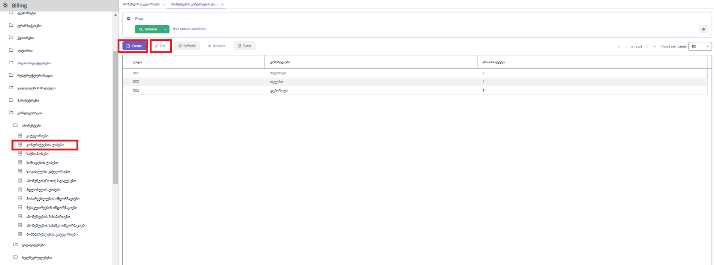

„Create“ ღილაკზე დაჭერით გამოვა კოტრაქტის ტიპის დასამატებელი ფორმა.

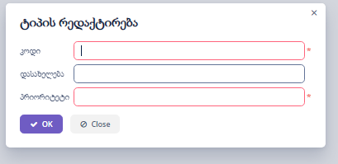

„Edit“ ღილაკზე დაჭერით გამოვა კოტრაქტის ტიპის დასარედაქტირებელი ფორმა.



“Refresh” ღილაკზე დაჭერით ხდება ფორმაზე მონაცემების განახლება.

„Remove“ ღილაკზე დაჭერით ხდება მონიშნული ჩანაწერების წაშლა.

„Excel“ ღილაკზე დაჭერით ხდება მონაცემების ექსეპორტი, შესაძლებელია როგოც ყველა,მონიშნული ან მიმდინარე გვერდზე არსებული ჩანაწერეის ექსელში გატანა.

### საქმიანობა

* დასახელება- მოდის თელასიდან .
* კოდი-მოდის თელასიდან.

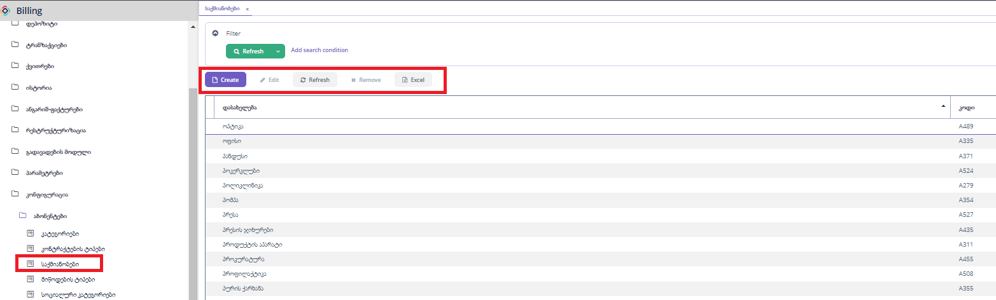

„Create“ ღილაკზე დაჭერით გამოვა საქმიანობის დასამატებელი ფორმა.

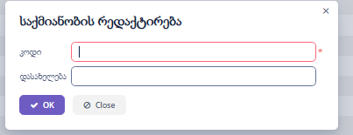

„Edit“ ღილაკზე დაჭერით გამოვა საქმიანობის დასარედაქტირებელი ფორმა.



“Refresh” ღილაკზე დაჭერით ხდება ფორმაზე მონაცემების განახლება.

„Remove“ ღილაკზე დაჭერით ხდება მონიშნული ჩანაწერების წაშლა.

„Excel“ ღილაკზე დაჭერით ხდება მონაცემების ექსეპორტი, შესაძლებელია როგოც ყველა,მონიშნული ან მიმდინარე გვერდზე არსებული ჩანაწერეის ექსელში გატანა.

### მიწოდების ტიპები

* კოდი - ანიჭებს თელასი
* დასახელება-ანიჭებს თელასი
* Report code- გამოიყენება ბუღალტერიის რეპორტისთვის.

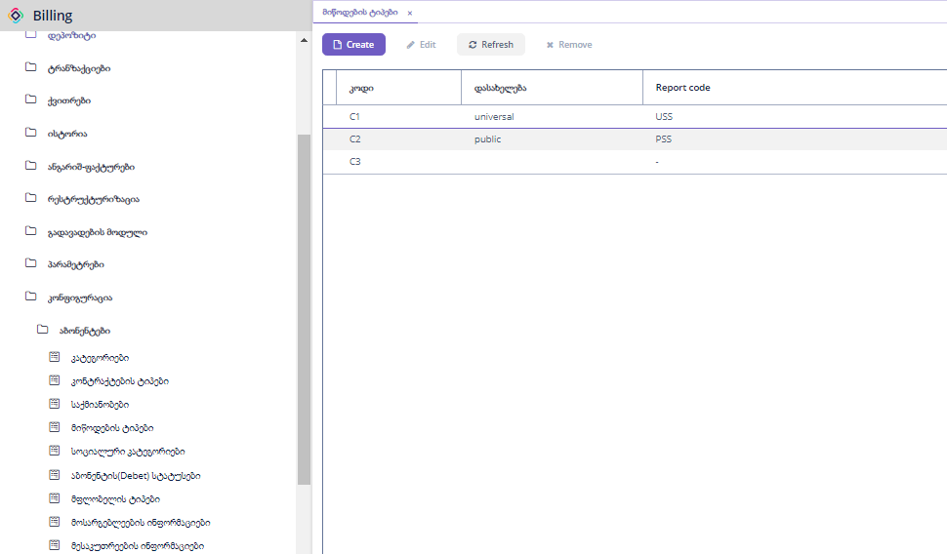

„Create“ ღილაკზე დაჭერით გამოვა მიწოდების ტიპის დასამატებელი ფორმა.

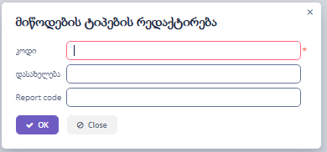

„Edit“ ღილაკზე დაჭერით გამოვა კოტრაქტის ტიპის დასარედაქტირებელი ფორმა.



### სოციალური კატეგორიები

გამოიყენება სუბსიდიების დარიცხვებისთვის , განსაზღვრავს აბონენტის კატეგორიას.

* კოდი- მიანიჭოთ თანმიმდევრობით
* დასახელება- მიანიჭოთ სოციალური კატეგორიის დასახელება
* გადახდის ინტერვალი -არ ვიყენებთ ამ ველს

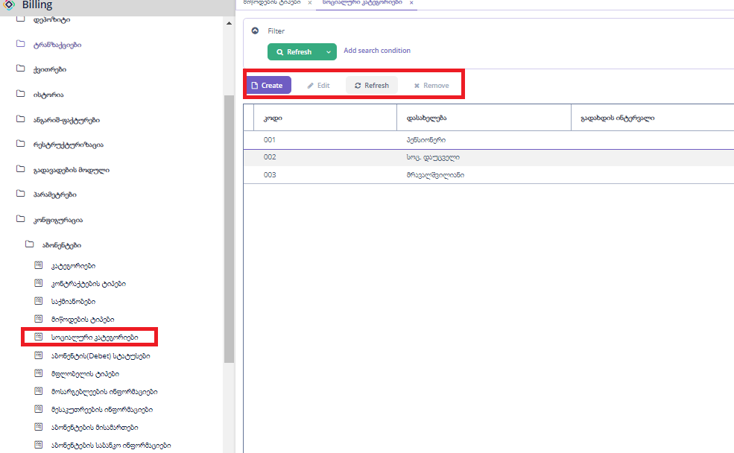

„Create“ ღილაკზე დაჭერით გამოვა სოციალური კატეგორიის დასამატებელი ფორმა.

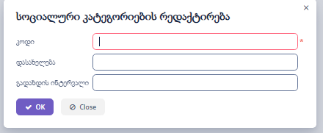

„Edit“ ღილაკზე დაჭერით გამოვა კოტრაქტის ტიპის დასარედაქტირებელი ფორმა.



“Refresh” ღილაკზე დაჭერით ხდება ფორმაზე მონაცემების განახლება.

„Remove“ ღილაკზე დაჭერით ხდება მონიშნული ჩანაწერების წაშლა.

### მფლობელის ტიპი

მაგ. მესაკუთრე ან მეიჯარე თელმიკოს შემთხვევაში.

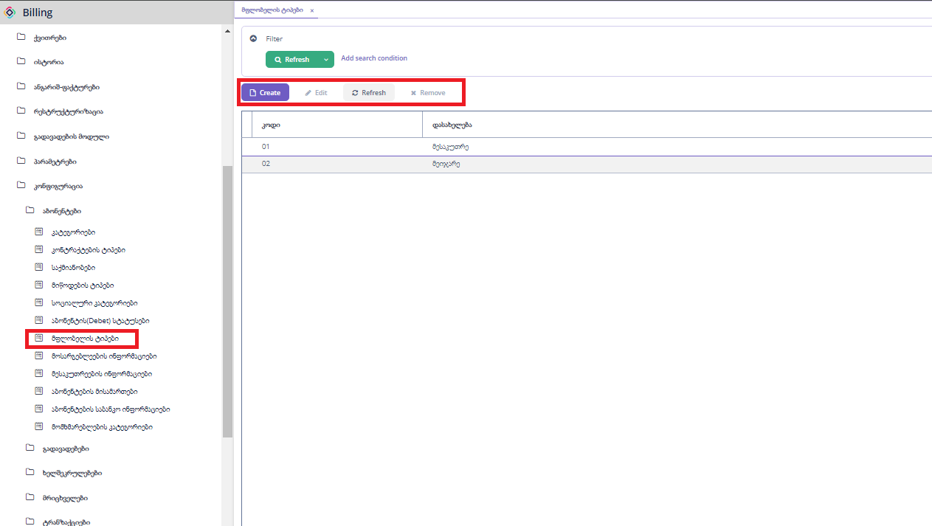

„Create“ ღილაკზე დაჭერით გამოვა მფლობელის ტიპის დასამატებელი ფორმა.

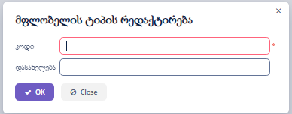

„Edit“ ღილაკზე დაჭერით გამოვა მფლობელის ტიპის დასარედაქტირებელი ფორმა.



“Refresh” ღილაკზე დაჭერით ხდება ფორმაზე მონაცემების განახლება.

„Remove“ ღილაკზე დაჭერით ხდება მონიშნული ჩანაწერების წაშლა.

### აბონენტის საბანკო ინფორმაციები

ეს ინფორმაცია მოდის თელასიდან, ბილინგიდან დამატება და რედაქტირება არ ხდება.

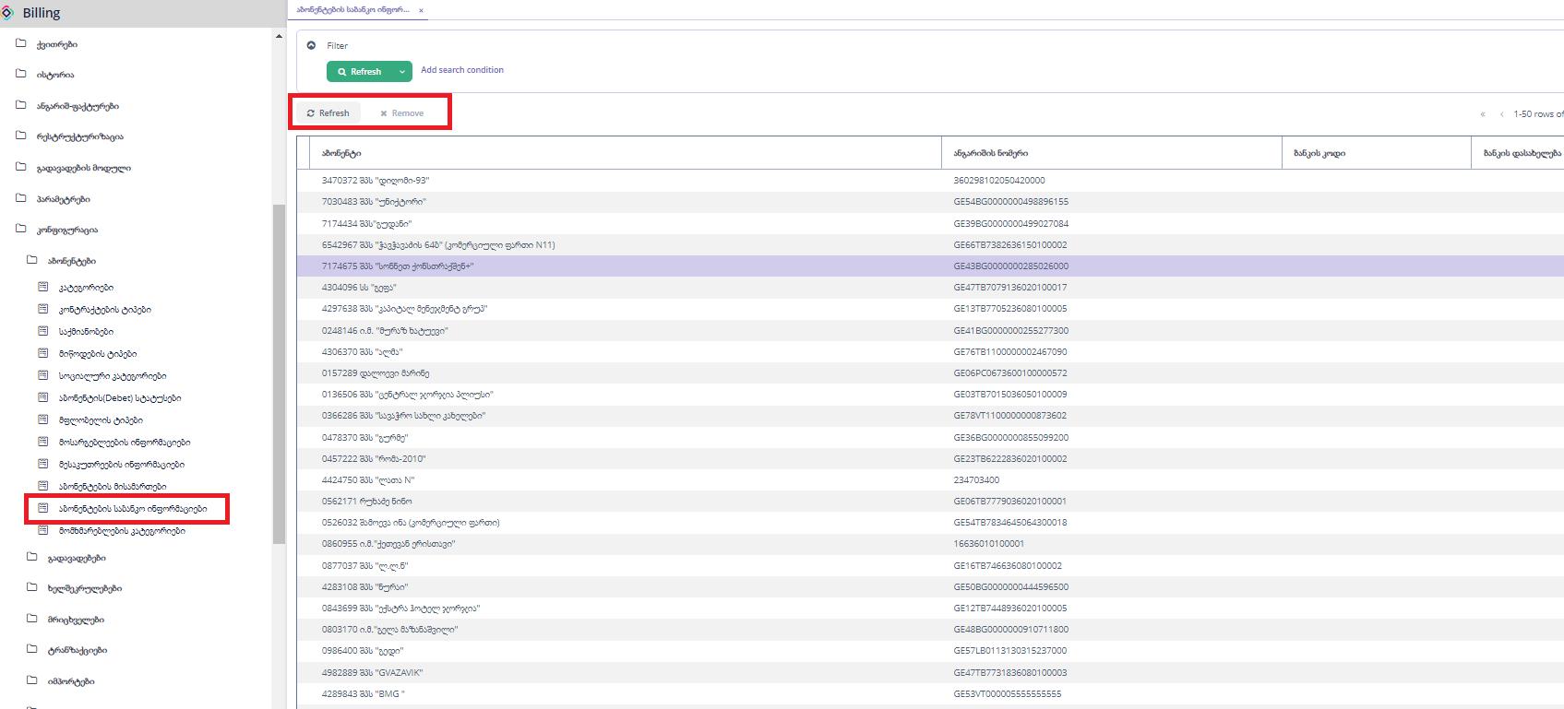

“Refresh” ღილაკზე დაჭერით ხდება ფორმაზე მონაცემების განახლება.

„Remove“ ღილაკზე დაჭერით ხდება მონიშნული ჩანაწერების წაშლა.

## გადავადებები

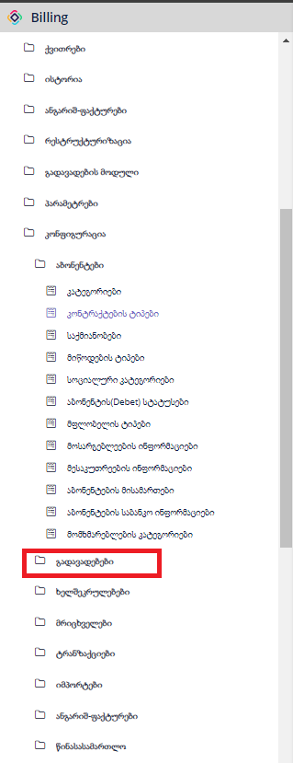

### გადავადების ფორმა

გადავადების მიზეზების კონფიგურაცია.

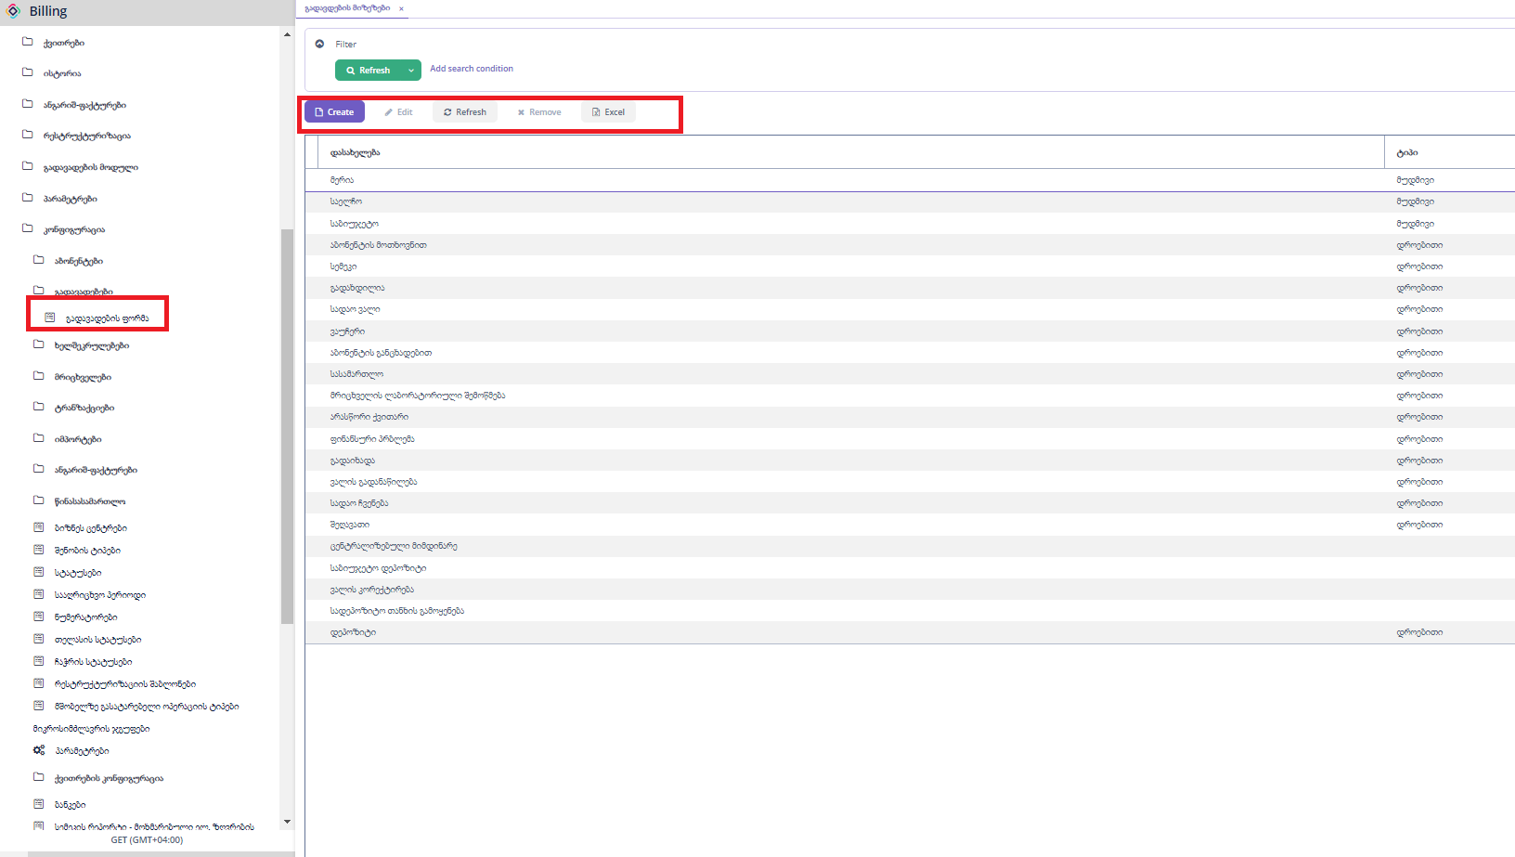

„Create“ ღილაკზე დაჭერით გამოვა გადავადების მიზეზის კონფიგურაციის დასამატებელი ფორმა.

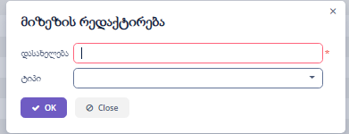

„Edit“ ღილაკზე დაჭერით გამოვა გადავადების მიზეზის კონფიგურაციის დასარედაქტირებელი ფორმა.



“Refresh” ღილაკზე დაჭერით ხდება ფორმაზე მონაცემების განახლება.

„Remove“ ღილაკზე დაჭერით ხდება მონიშნული ჩანაწერების წაშლა.

„Excel“ ღილაკზე დაჭერით ხდება მონაცემების ექსეპორტი, შესაძლებელია როგოც ყველა,მონიშნული ან მიმდინარე გვერდზე არსებული ჩანაწერეის ექსელში გატანა.

## ხელშეკრულებები

### ხელშეკრულების ფაილის ტიპები

ხელშეკრულების ფაილის ტიპები განსაზღავს მიწოდების ხელშეკრულების დარეგისტრირების დროს ფაილის მიბმის დასახელებებს.

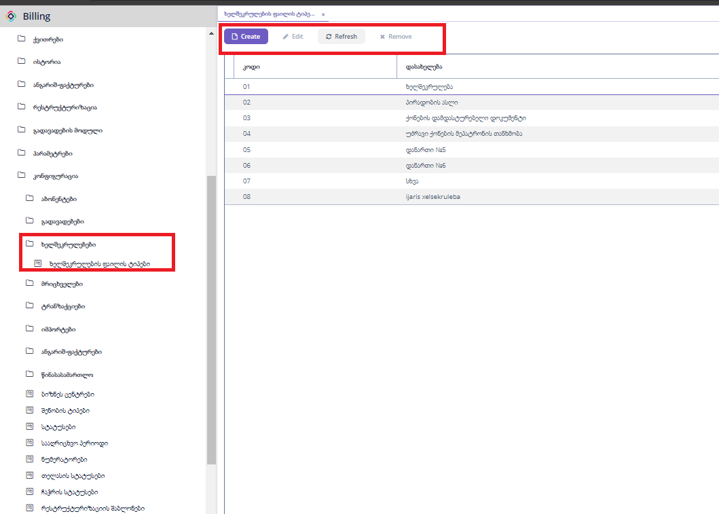

„Create“ ღილაკზე დაჭერით გამოვა ხელშეკრულების ფაილის ტიპის დასამატებელი ფორმა.

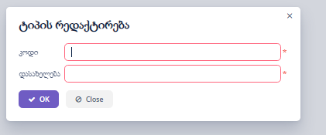

„Edit“ ღილაკზე დაჭერით გამოვა გამოვა ხელშეკრულების ფაილის ტიპის დასარედაქტირებელი ფორმა.



“Refresh” ღილაკზე დაჭერით ხდება ფორმაზე მონაცემების განახლება.

„Remove“ ღილაკზე დაჭერით ხდება მონიშნული ჩანაწერების წაშლა.

## მრიცხველები

მრიცხველის შესახებ სრულ ინფორმაციას გვაწვდის თელასი.

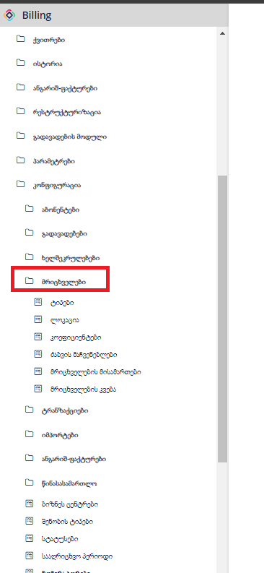

### ტიპები

მრიცხველის ტიპებზე სრულ ინფორმაციას გვაწვდის თელასი

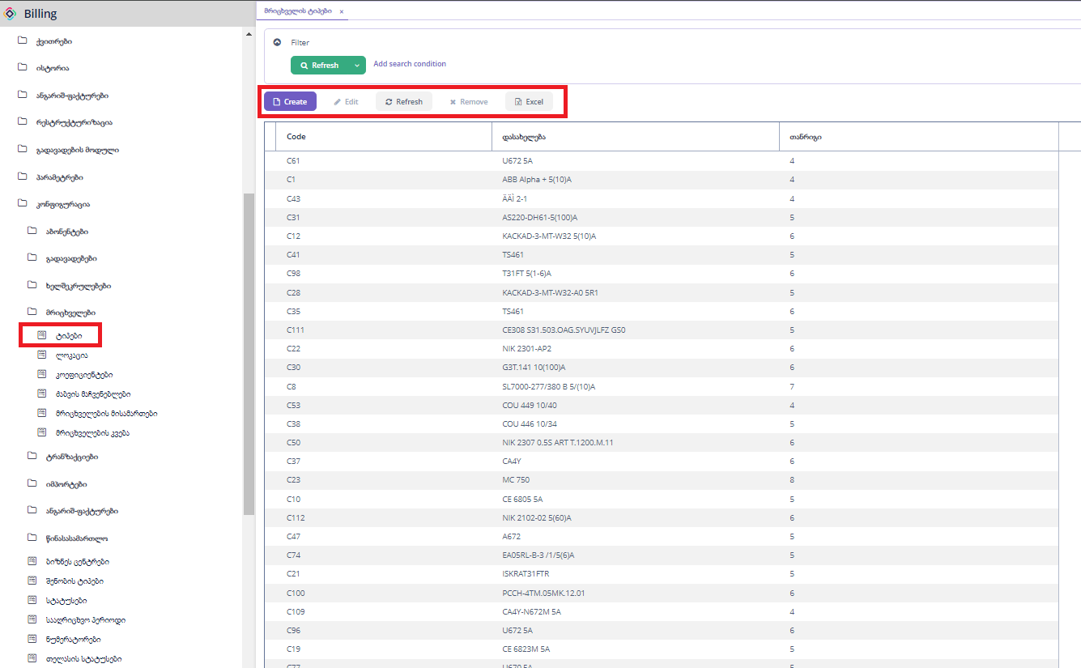

„Create“ ღილაკზე დაჭერით გამოვა მრიცხველის ტიპის დასამატებელი ფორმა.

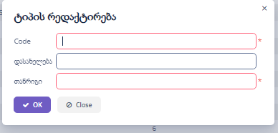

„Edit“ ღილაკზე დაჭერით გამოვა მრიცხველის ტიპის დასარედაქტირებელი ფორმა.



“Refresh” ღილაკზე დაჭერით ხდება ფორმაზე მონაცემების განახლება.

„Remove“ ღილაკზე დაჭერით ხდება მონიშნული ჩანაწერების წაშლა.

„Excel“ ღილაკზე დაჭერით ხდება მონაცემების ექსეპორტი, შესაძლებელია როგოც ყველა,მონიშნული ან მიმდინარე გვერდზე არსებული ჩანაწერეის ექსელში გატანა.

### ლოკაცია

მრიცხველის ლოკაციების სია.

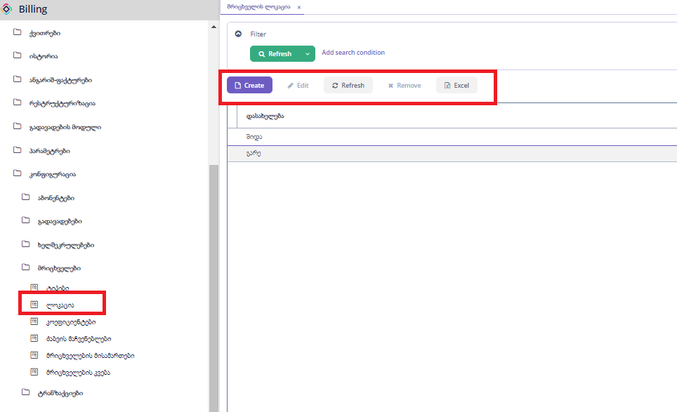

„Create“ ღილაკზე დაჭერით გამოვა მრიცხველის ლოკაციის დასამატებელი ფორმა.

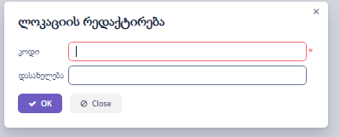

„Edit“ ღილაკზე დაჭერით გამოვა მრიცხველის ლოკაციის დასარედაქტირებელი ფორმა.



“Refresh” ღილაკზე დაჭერით ხდება ფორმაზე მონაცემების განახლება.

„Remove“ ღილაკზე დაჭერით ხდება მონიშნული ჩანაწერების წაშლა.

„Excel“ ღილაკზე დაჭერით ხდება მონაცემების ექსეპორტი, შესაძლებელია როგოც ყველა,მონიშნული ან მიმდინარე გვერდზე არსებული ჩანაწერეის ექსელში გატანა.

### კოეფიციენტები

მრიცხველის კოეფიციენტების სია. სრულ ინფორმაციას გვაწვდის თელასი

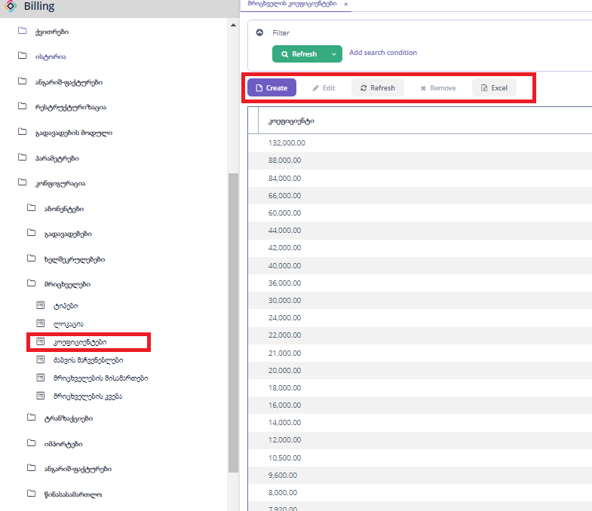

„Create“ ღილაკზე დაჭერით გამოვა მრიცხველის კოეფიციენტის დასამატებელი ფორმა.

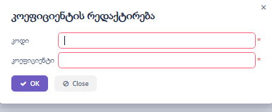

„Edit“ ღილაკზე დაჭერით გამოვა მრიცხველის კოეფიციენტის დასარედაქტირებელი ფორმა.



“Refresh” ღილაკზე დაჭერით ხდება ფორმაზე მონაცემების განახლება.

„Remove“ ღილაკზე დაჭერით ხდება მონიშნული ჩანაწერების წაშლა.

„Excel“ ღილაკზე დაჭერით ხდება მონაცემების ექსეპორტი, შესაძლებელია როგოც ყველა,მონიშნული ან მიმდინარე გვერდზე არსებული ჩანაწერეის ექსელში გატანა.

## ტრანზაქციები

### ტიპები

ყველა შესაძლო ტრანზაქციის ტიპი.

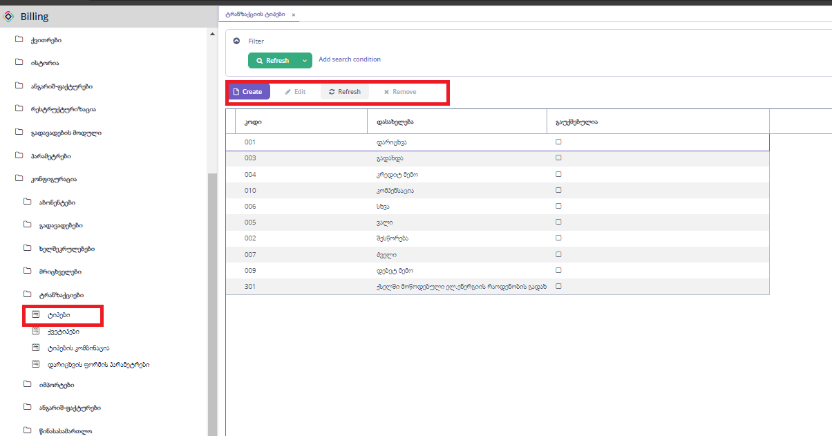

„Create“ ღილაკზე დაჭერით გამოვა ტიპების დასამატებელი ფორმა.

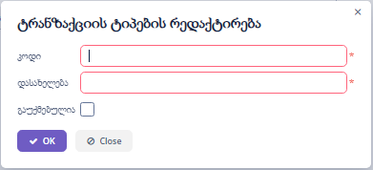

„Edit“ ღილაკზე დაჭერით გამოვა ტიპის დასარედაქტირებელი ფორმა.



“Refresh” ღილაკზე დაჭერით ხდება ფორმაზე მონაცემების განახლება.

„Remove“ ღილაკზე დაჭერით ხდება მონიშნული ჩანაწერების წაშლა.

### ქვეტიპები

ყველა შესაძლო ტრანზაქციის ქვეტიპი

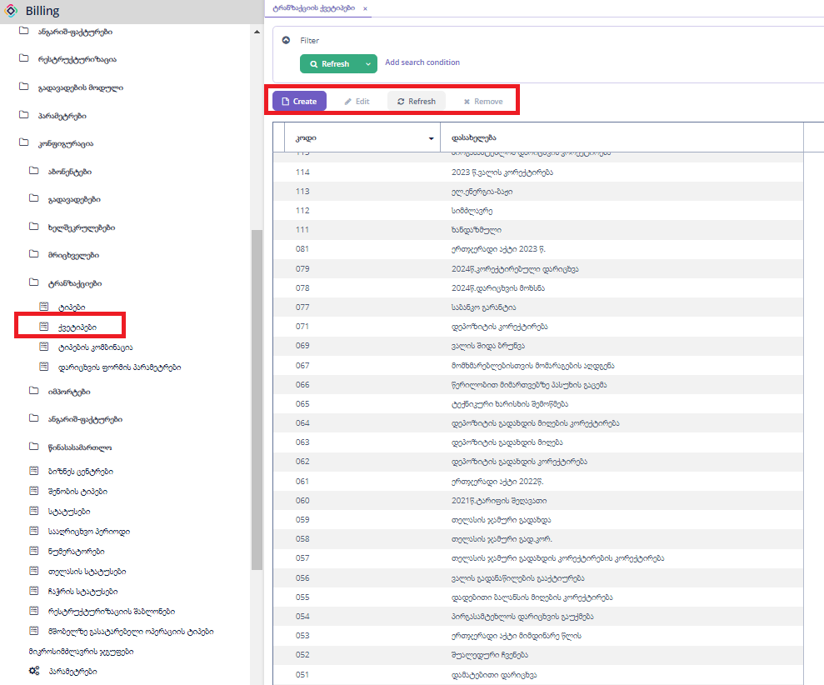

„Create“ ღილაკზე დაჭერით გამოვა ტრანზაქციის ქვე ტიპის დასამატებელი ფორმა.

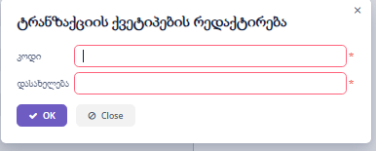

„Edit“ ღილაკზე დაჭერით გამოვა ტრანზაქციის ქვე ტიპის დასარედაქტირებელი ფორმა.



“Refresh” ღილაკზე დაჭერით ხდება ფორმაზე მონაცემების განახლება.

„Remove“ ღილაკზე დაჭერით ხდება მონიშნული ჩანაწერების წაშლა.

### ტიპების კომბინაცია

ტრანზაქციის ტიპის და ქვე ტიპის კომბინაცია

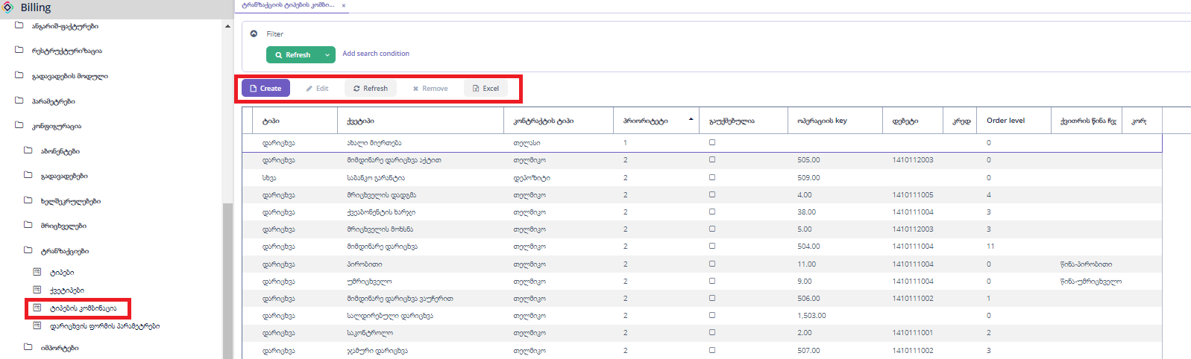

ტიპი: ასარჩევი ველი ტრანზაქციის ტიპებიდან

ქვეტიპი: ასარჩევი ველი ტრანზაქციის ქვე ტიპებიდან

კონტრაქტის ტიპი: რომელი კონტრაქტზე გამოიყენება (თელმიკო,თელასი,დეპოზიტი)

პრიორიტეტი: დაბალიდან მაღლისკენ პრიორიტეტით თავსდება ტრანზაქციები

გაუქმებულია: არ გამოიყენება მონიშნული კომბინაცია

ოპერაციის key: თელასის კოდი

დებეტი: საბუღალტრო ანგარიში, გამოიყენება ბუღალტერიის რეპორტისთვის

კრედიტი: საბუღალტრო ანგარიში, გამოიყენება ბუღალტერიის რეპორტისთვის

Order level: ბრუნვის ისტორიაში დალაგების მიმდევრობა დაბლიდან მაღლისკენ.

ქვითრის წინა ჩვენების ტექსტი: მითითებული კომბინაციაზე ქვითარში რა დასახელება გამოჩნდეს.

კორექტირების ტიპი: მითითებული კომბინაციაზე ქვითარში რომელ ველში დაჯამდეს.

„Create“ ღილაკზე დაჭერით გამოვა კომბინაციის დასამატებელი ფორმა.

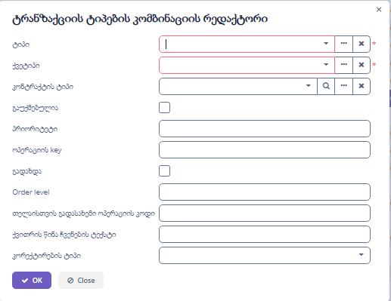

„Edit“ ღილაკზე დაჭერით გამოვა კომბინაციის დასარედაქტირებელი ფორმა.



“Refresh” ღილაკზე დაჭერით ხდება ფორმაზე მონაცემების განახლება.

„Remove“ ღილაკზე დაჭერით ხდება მონიშნული ჩანაწერების წაშლა.

„Excel“ ღილაკზე დაჭერით ხდება მონაცემების ექსეპორტი, შესაძლებელია როგოც ყველა,მონიშნული ან მიმდინარე გვერდზე არსებული ჩანაწერეის ექსელში გატანა.

### დარიცხვის ფორმის პარამეტრები

ეს კონფიგურაცია გამოყენება ახალი ტრანზაქციის შექმნის დროს.

კონკრეტული ტრანზაქციის კომბინაციის არჩევის დროს, გამოვა ამ ფორმაზე მონიშნული ველები

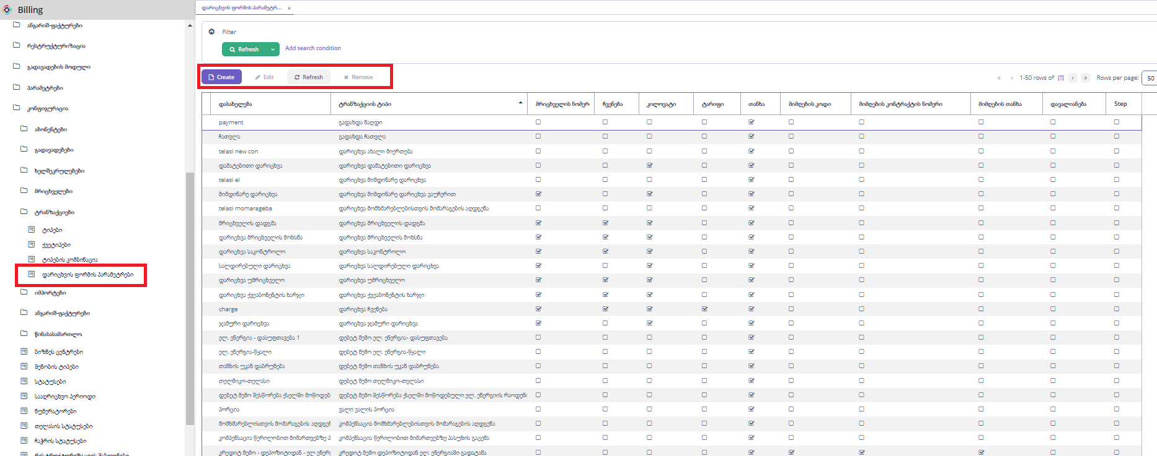

„Create“ ღილაკზე დაჭერით გამოვა დარიცხვის ფორმის პარამეტრების დასამატებელი ფორმა.

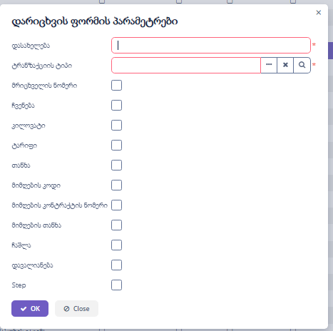

„Edit“ ღილაკზე დაჭერით გამოვა დარიცხვის ფორმის პარამეტრების დასარედაქტირებელი ფორმა.



“Refresh” ღილაკზე დაჭერით ხდება ფორმაზე მონაცემების განახლება.

„Remove“ ღილაკზე დაჭერით ხდება მონიშნული ჩანაწერების წაშლა.

## ანგარიშ-ფაქტურები

ანგარიშ-ფაქტურების სტატუსები, ეს სტატუსები არის rs, ამიტომ აქ ცვლილებების შეტანა არ დაგჭირდებათ

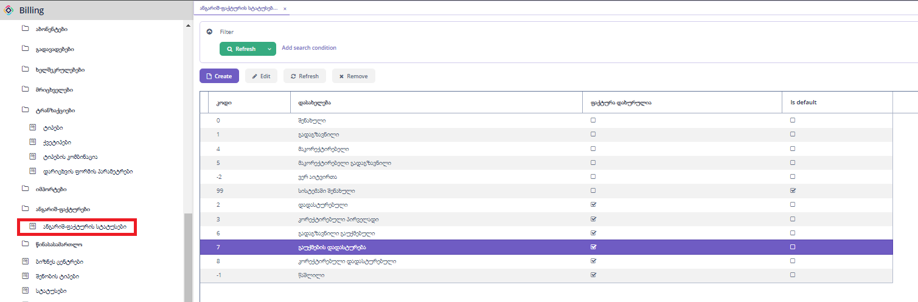

## წინასასამართლო

### თანამშრომლების კონფიგურაცია

წინასასამართლოს დავალების კონფიგურაცია, ბიზნეს ცენტრბის და კატეგორიის მიხედვით.

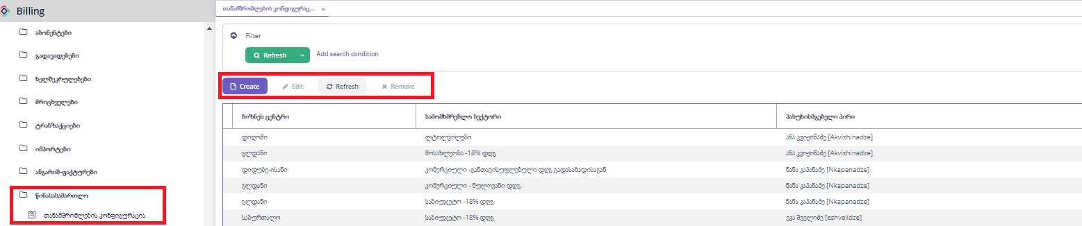

„Create“ ღილაკზე დაჭერით გამოვა თანამშრომლის კონფიგურაციის დასამატებელი ფორმა.

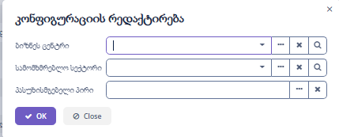

„Edit“ ღილაკზე დაჭერით გამოვა თნამშრომლის კონფიგურაციის დასარედაქტირებელი ფორმა.



“Refresh” ღილაკზე დაჭერით ხდება ფორმაზე მონაცემების განახლება.

„Remove“ ღილაკზე დაჭერით ხდება მონიშნული ჩანაწერების წაშლა.

## ბიზნეს ცენტრები

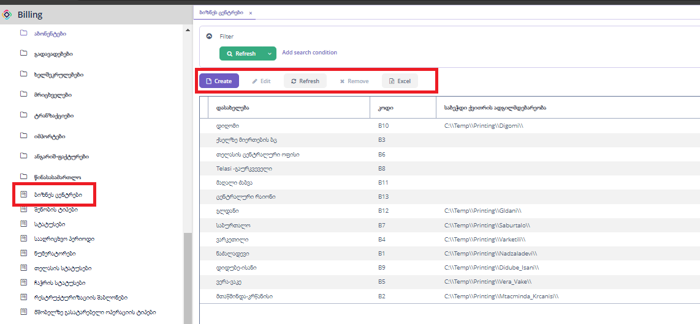

„Create“ ღილაკზე დაჭერით გამოვა ბიზნეს ცენტრის დასამატებელი ფორმა.

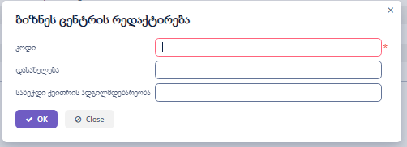

„Edit“ ღილაკზე დაჭერით გამოვა ბიზნეს ცენტრის დასარედაქტირებელი ფორმა.



“Refresh” ღილაკზე დაჭერით ხდება ფორმაზე მონაცემების განახლება.

„Remove“ ღილაკზე დაჭერით ხდება მონიშნული ჩანაწერების წაშლა.

„Excel“ ღილაკზე დაჭერით ხდება მონაცემების ექსეპორტი, შესაძლებელია როგოც ყველა,მონიშნული ან მიმდინარე გვერდზე არსებული ჩანაწერეის ექსელში გატანა.

## სტატუსები

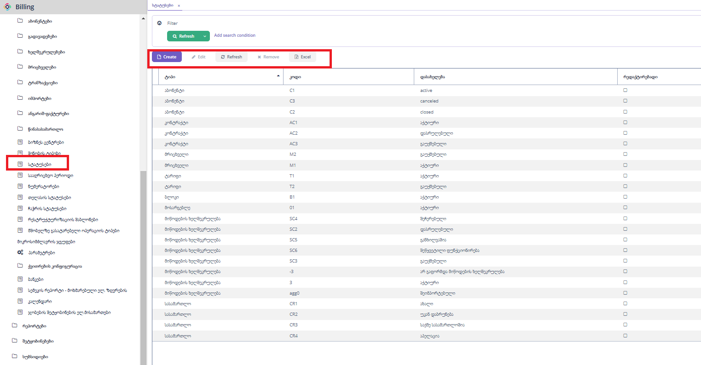

ტიპი: რომელი ობიექტის სტატუსია(აბონენტი,მრიცხველი და ა.შ.)

კოდი: უნიკალური ველი

დასახელება: სტატუსის დასახელება

„Create“ ღილაკზე დაჭერით გამოვა სტატუსის დასამატებელი ფორმა.

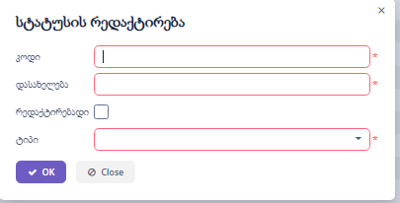

„Edit“ ღილაკზე დაჭერით გამოვა სტატუსის დასარედაქტირებელი ფორმა.



“Refresh” ღილაკზე დაჭერით ხდება ფორმაზე მონაცემების განახლება.

„Remove“ ღილაკზე დაჭერით ხდება მონიშნული ჩანაწერების წაშლა.

„Excel“ ღილაკზე დაჭერით ხდება მონაცემების ექსეპორტი, შესაძლებელია როგოც ყველა,მონიშნული ან მიმდინარე გვერდზე არსებული ჩანაწერეის ექსელში გატანა.

## ნუმერატორები

ნუმერატორი არის ცხრილის კონკრეტული ველის შაბლონი. მაგ.(აბონენტის კოდი - cust-[number(7)] )

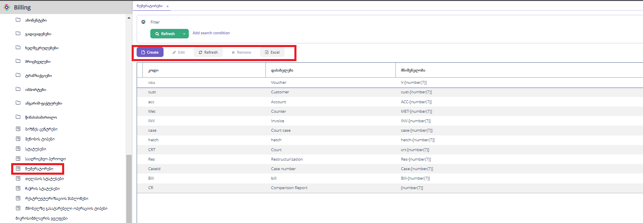

„Create“ ღილაკზე დაჭერით გამოვა ნუმერატორის დასამატებელი ფორმა.

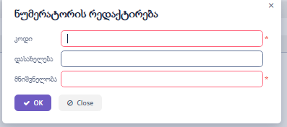

„Edit“ ღილაკზე დაჭერით გამოვა ნუმერატორის დასარედაქტირებელი ფორმა.



“Refresh” ღილაკზე დაჭერით ხდება ფორმაზე მონაცემების განახლება.

„Remove“ ღილაკზე დაჭერით ხდება მონიშნული ჩანაწერების წაშლა.

„Excel“ ღილაკზე დაჭერით ხდება მონაცემების ექსეპორტი, შესაძლებელია როგოც ყველა,მონიშნული ან მიმდინარე გვერდზე არსებული ჩანაწერეის ექსელში გატანა.

## ჩაჭრის სტატუსები

ჩაჭრის მიზეზები

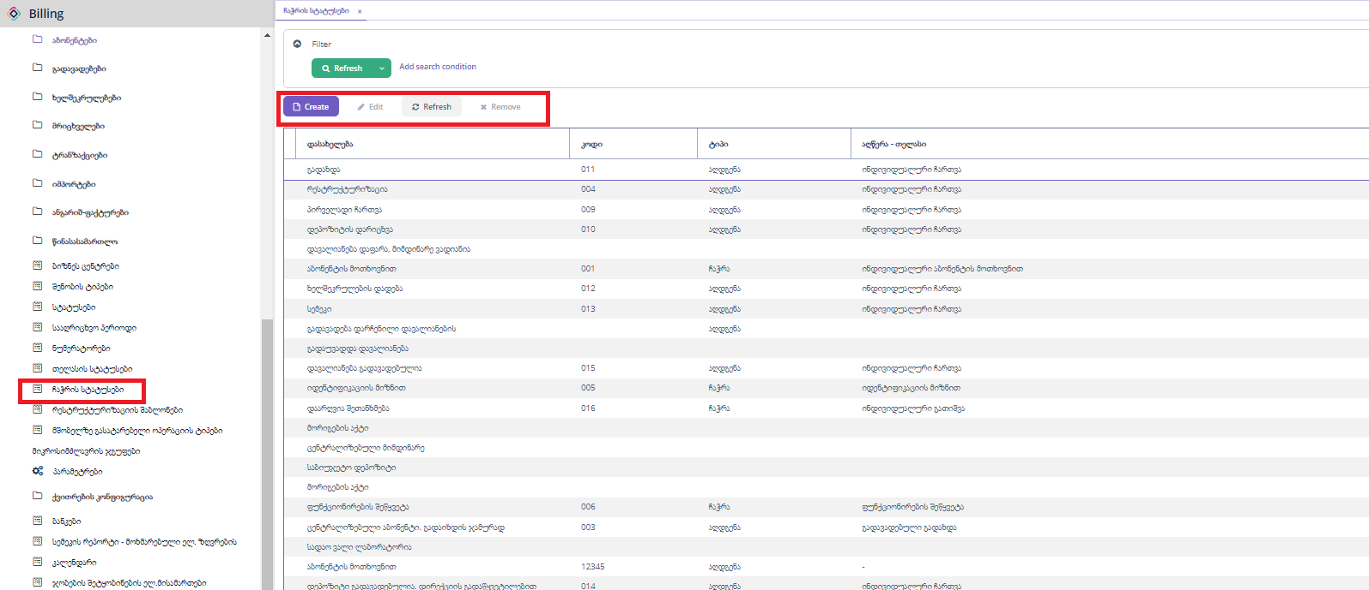

„Create“ ღილაკზე დაჭერით გამოვა ჩაჭრის სტატუსის დასამატებელი ფორმა.

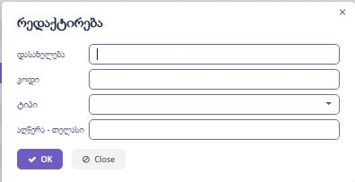

„Edit“ ღილაკზე დაჭერით გამოვა ჩაჭრის სტატუსის დასარედაქტირებელი ფორმა.



“Refresh” ღილაკზე დაჭერით ხდება ფორმაზე მონაცემების განახლება.

„Remove“ ღილაკზე დაჭერით ხდება მონიშნული ჩანაწერების წაშლა.

## რესტრუქტურიზაციის შაბლონი

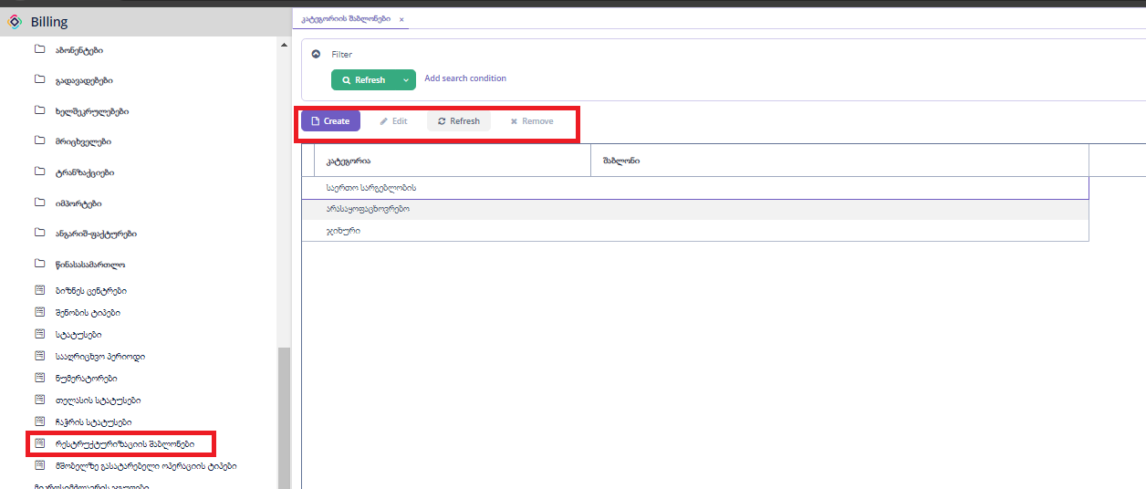

„Create“ ღილაკზე დაჭერით გამოვა რესტრუქტურიზაციის დასამატებელი ფორმა.

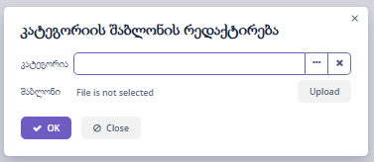

„Edit“ ღილაკზე დაჭერით გამოვა რესტრუქტურიზაციის დასარედაქტირებელი ფორმა.



“Refresh” ღილაკზე დაჭერით ხდება ფორმაზე მონაცემების განახლება.

„Remove“ ღილაკზე დაჭერით ხდება მონიშნული ჩანაწერების წაშლა.

## მშობელზე გასატარებელი ოპერაციის ტიპები

არაციკლური და ციკლიური დარიცხვის დროს, ქვე აბონენტის დარიცხვისას, მშობელზე გასატარებელი ოპერაციის ტიპები.

ტრანზქციის ტიპი: ტრანზაქციის კომბინაციის ტიპი

ვაუჩერი: კომენტარიში რა გაყვეს

Is opposite: საპირისპირო ნიშნით უნდა დაერიცხოს

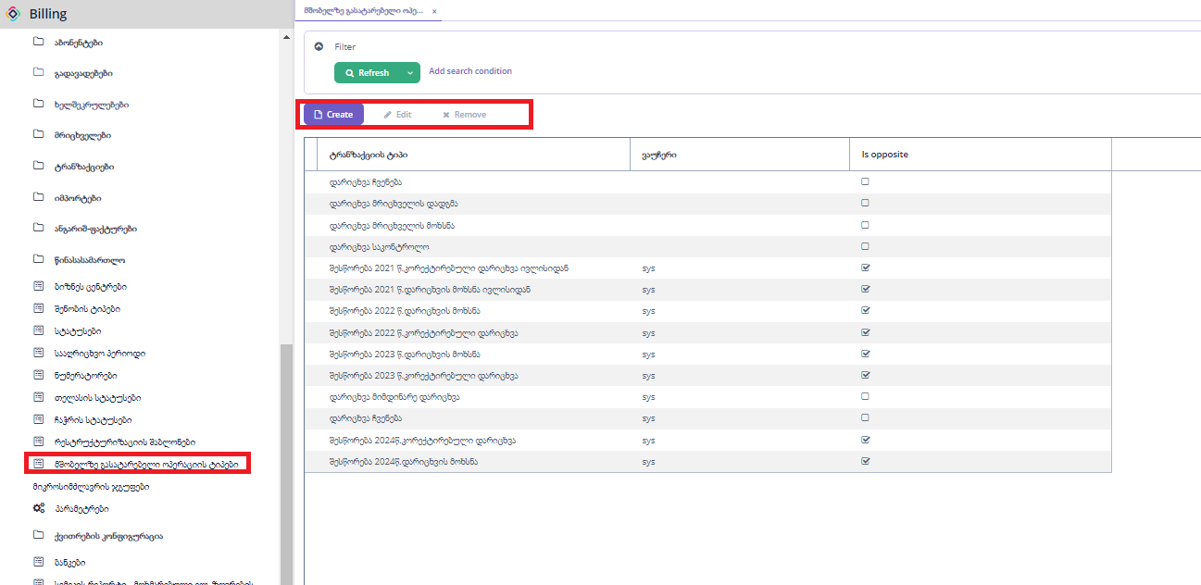

„Create“ ღილაკზე დაჭერით გამოვა ახალი ჩანაწერის დასამატებელი ფორმა.

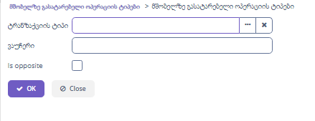

„Edit“ ღილაკზე დაჭერით გამოვა დასარედაქტირებელი ფორმა.



„Remove“ ღილაკზე დაჭერით ხდება მონიშნული ჩანაწერების წაშლა.

## მიკორსიმძალვრის ჯგუფები

ზოგიერთ აბონენტს აქვს ჩაშალა, აქ გაწერილი კონგიგურაციით უნდა ჩაიშალოს დარიცხვა.

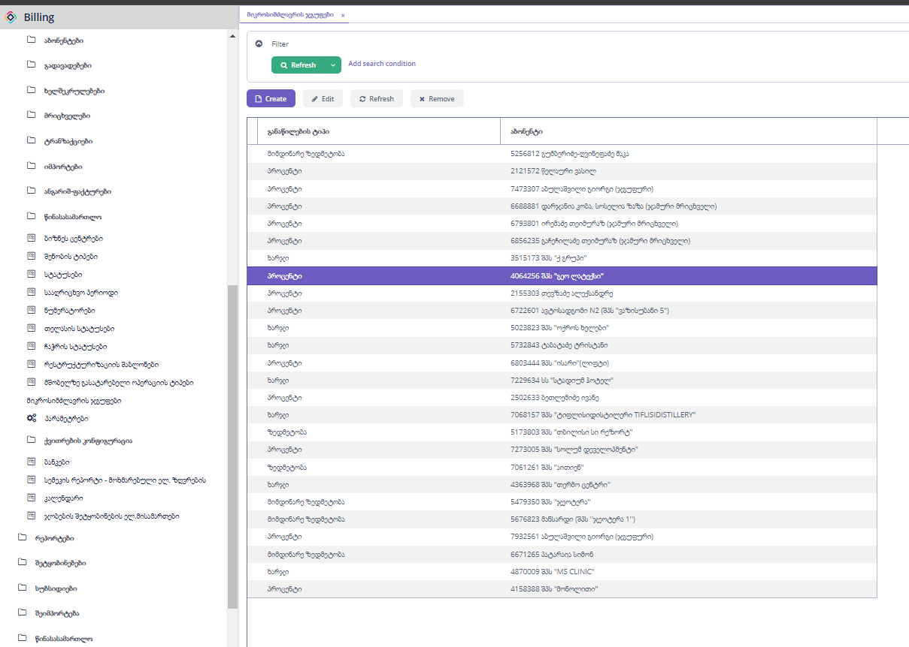

განაწილების ტიპი: (პროცენტი,ხარჯი,ზედმეტობა,მიმდინარე ზედმეტობა).

„Create“ ღილაკზე დაჭერით გამოვა ახალი ჩანაწერის დასამატებელი ფორმა.

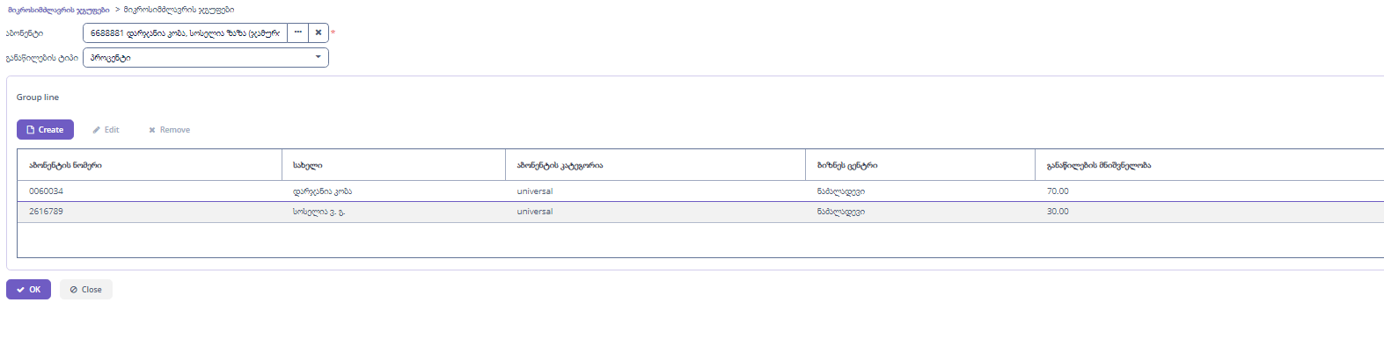

„Edit“ ღილაკზე დაჭერით გამოვა დასარედაქტირებელი ფორმა.



“Refresh” ღილაკზე დაჭერით ხდება ფორმაზე მონაცემების განახლება.

„Remove“ ღილაკზე დაჭერით ხდება მონიშნული ჩანაწერების წაშლა.

## პარამეტრები

### მთავარი

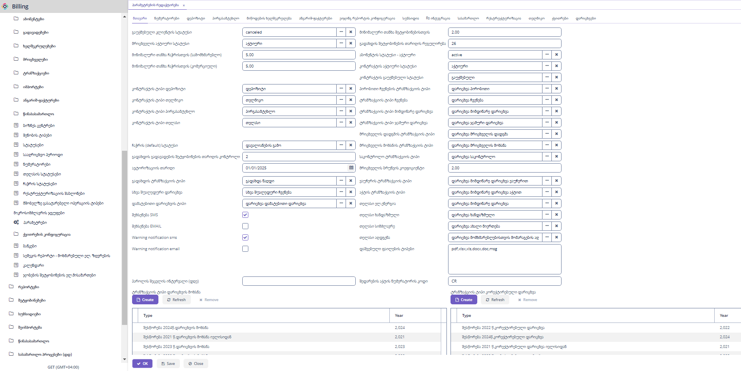

**გაუქმებული აბონენტის სტატუსი:** აბონენტის სტატუსი „გაუქმებული“ გამოიყენება კოდში.

**მრიცხველის აქტიური სტატუსი:** მრიცხველის სტატუსი „აქტიური“ გამოიყენება კოდში.

**მინიმალური თანხა ჩაჭრისთვის (სამომხმარებლო):**  მოსახლეობის კატეგორიის აბონენტები, რომელთაც დავალინება აქვთ 5 ლარზე ნაკლები ან ტოლო, არ მოხვდება ჩაჭრაში.

**მინიმალური თანხა ჩაჭრისთვის (კომერციული):**  კომერციული კატეგორიის აბონენტები, რომელთაც დავალინება აქვთ 5 ლარზე ნაკლები ან ტოლო, არ მოხვდება ჩაჭრაში.

**კონტრაქტის ტიპი დეპოზიტი:** აბონენტის კონტრაქტის ტიპი „დეპოზიტი“ გამოიყენება კოდში.

**კონტრაქტის ტიპი თელმიკო:** აბონენტის კონტრაქტის ტიპი „თელმიკო“ გამოიყენება კოდში.

**კონტრაქტის ტიპი პირგასამტეხლო:** აბონენტის კონტრაქტის ტიპი „პირგასამტეხლო“ გამოიყენება კოდში.

**კონტრაქტის ტიპი თელასი:** აბონენტის კონტრაქტის ტიპი „თელასი“ გამოიყენება კოდში.

**ჩაჭრის (default) სტატუსი:** ავტომატური ჩაჭრის დროს ამ ველში არსებული მნიშვნელობა გადაეცემა თელასს.

**გადახდის გადავადების შეტყობინების თარიღის კონტროლი:** ამ ველში გაწერილია დღეების რაოდენობა. რამდენი მნიშვნელობაც წერია, იმდენი დღით ადრე გაეგზავნება შეტყობინება.

**ავტორიზაციის თარიღი:** მიწოდების ხელშეკრულების ვადის ავტომატური გადაწევის დროს, ახალი თარიღი არ უნდა იყოს ამ ველში მითითებულ თარიღზე მეტი.

**გადახდის ტრანზაქციის ტიპი:** გადახდის შესაბამისი ტრანზაქციის კომბინაციის ტიპი, გამოიყენება კოდში.

**სხვა შუალედური დარიცხვა:** სხვა შულედური ჩვენება ტრანზაქციის კომბინაციის ტიპი, გამოიყენება კოდში.

**დამატებითი დარიცხვის ტიპი:** დამატები დარიხვა ტრანზაქციის კომბინაციის ტიპი, გამოიყენება კოდში.

**შეხსენება SMS:** შეხსენება გაიგზავნოს სმს ით.

**შეხსენება Email:** შეხსენება გაიგზვანოს ელ.ფოსტით.

**Warning notification sms:** გამაფრთხილებელი შეტყობინება გაიგზვანოს სმს ით.

**Warning notificaition email:** გამაფრთხილებელი შეტყობინება გაიგზვანოს ელ.ფოსტით ით.

**პაროლის შეცვლის ინტერვალი:** ამ ველის მნიშვნელობა განსაზღვრავს რამდენ დღეში მოთხოვოს მომხმარებელს პაროლის ცვლილება. Default - ად არის 45 დღე.

**მინუმალური თანხა შეტყობინებისთვის:** გამაფრთხილებელი შეტყობინება უნდა გაიგზვანოს, თუ დავალიანება აღემატება ამ ველში მითითებულ მნიშვნელობას.

**გადახდის შეტყობინების თარიღის რეგულრება:** რომელ რიცხვში გაიგზვანოს გადახდის შეტყობინება, ამ ველში იწერება რიცხვი.

**აბონენტის სტატუსი -** **აქტიური:** აბონენტის სტატუსი „აქტიური“ გამოიყენება კოდში.

**კონტრაქტის აქტიური სტატუსი:** კონტრაქტის სტატუსი „აქტიური“ გამოიყენება კოდში.

**კონტრაქტის გაუქმებული სტატუსი:** კონტრაქტის სტატუსი „გაუქმებული“ გამოიყენება კოდში.

**პირობითი ჩვენების ტრანზაქციის ტიპი:** შეფასებითი დარიცხვის შესაბამისი ტრანზაქციის კომბინაციის ტიპი, გამოიყენება კოდში.

**ტრანზაქციის ტიპი ჩვენება:** რეალური დარიცხვის შესაბამისი ტრანზაქციის კომბინაციის ტიპი, გამოიყენება კოდში.

**ტრანზაქციის ტიპი მიმდინარე დარიცხვა:** მიმდინარე დარიცხვის შესაბამისი ტრანზაქციის კომბინაციის ტიპი, გამოიყენება კოდში.

**ტრანზაქციის ტიპი ჯამური დარიცხვა:** ჯამური დარიცხვის შესაბამისი ტრანზაქციის კომბინაციის ტიპი, გამოიყენება კოდში.

**მრიცხველის დადგმის ტრანზაქციის ტიპი:** მრიცხველს დადგმის შესაბამისი ტრანზაქციის კომბინაციის ტიპი, გამოიყენება კოდში.

**მრიცხველის მოხსნის ტრანზაქციის ტიპი:** მრიცხველს მოხსნის შესაბამისი ტრანზაქციის კომბინაციის ტიპი, გამოიყენება კოდში.

**საკონტროლო ტრანზაქციის ტიპი:** საკონტროლო დარიცხვის შესაბამისი ტრანზაქციის კომბინაციის ტიპი, გამოიყენება კოდში.

**მრიცხველის ბრუნვის კოეფიციენტი:** თუ დარიცხვა, ამ ველში მითითებული რაოდენობა რაც არის, იმდენჯერ აღემატება საშუალო მოხმარებას გადავა პრობლემურში და ავტომატურად არ გატარდება.

**ვაუჩერის ტრანზაქციის ტიპი:** მიმდინარე დარიცხვა ვაუჩერით შესაბამისი ტრანზაქციის კომბინაციის ტიპი, გამოიყენება კოდში.

**აქტის ტრანზაქციის ტიპი:** მიმდინარე დარიცხვა აქტით შესაბამისი ტრანზაქციის კომბინაციის ტიპი, გამოიყენება კოდში.

**თელასი ელ-ენერგია:** თელასის მიმდინარე დარიხვის კომბინაციის ტიპი, გამოიყენება კოდში.

**თელასი ხანდაზული:** თელასის ხანდაზმული დარიხვის კომბინაციის ტიპი, გამოიყენება კოდში.

**თელასი სიმძლავრე:** თელასის ახალი მიერთების დარიხვის კომბინაციის ტიპი, გამოიყენება კოდში.

**თელასი აღდგენა:** თელასის მომარაგების აღდგენის კომბინაციის ტიპი, გამოიყენება კოდში.

**დაშვებული ფაილის ტიპიები:** სისტემაში შესაძლებელი, ასატვირთი ფაილის გაფართოებები.

**შედარების აქტის ნუმერატორის კოდი:** შედარების აქტოს კოდის შაბლონი, გამოიყენება კოდში.

**ტრანზაქციის ტიპი დარიცხვის მოხსნა:** ამ ცხრილში გაწერილია მოხსნის ტიპის ტრანზაქციების კომბინაციები წლების მიხედვით, გამოიყენება კოდში.

„Create“ ღილაკზე დაჭერით გამოვა ახალი ჩანაწერის დასამატებელი ფორმა.

“Refresh” ღილაკზე დაჭერით ხდება ფორმაზე მონაცემების განახლება.

„Remove“ ღილაკზე დაჭერით ხდება მონიშნული ჩანაწერების წაშლა.

**ტრანზაქციის ტიპი კორექტირებული დარიხვა:** ამ ცხრილში გაწერილია შესწორების ტიპის ტრანზაქციების კომბინაციები წლების მიხედვით, გამოიყენება კოდში.

„Create“ ღილაკზე დაჭერით გამოვა ახალი ჩანაწერის დასამატებელი ფორმა.

“Refresh” ღილაკზე დაჭერით ხდება ფორმაზე მონაცემების განახლება.

„Remove“ ღილაკზე დაჭერით ხდება მონიშნული ჩანაწერების წაშლა.

### ნუმერატორები

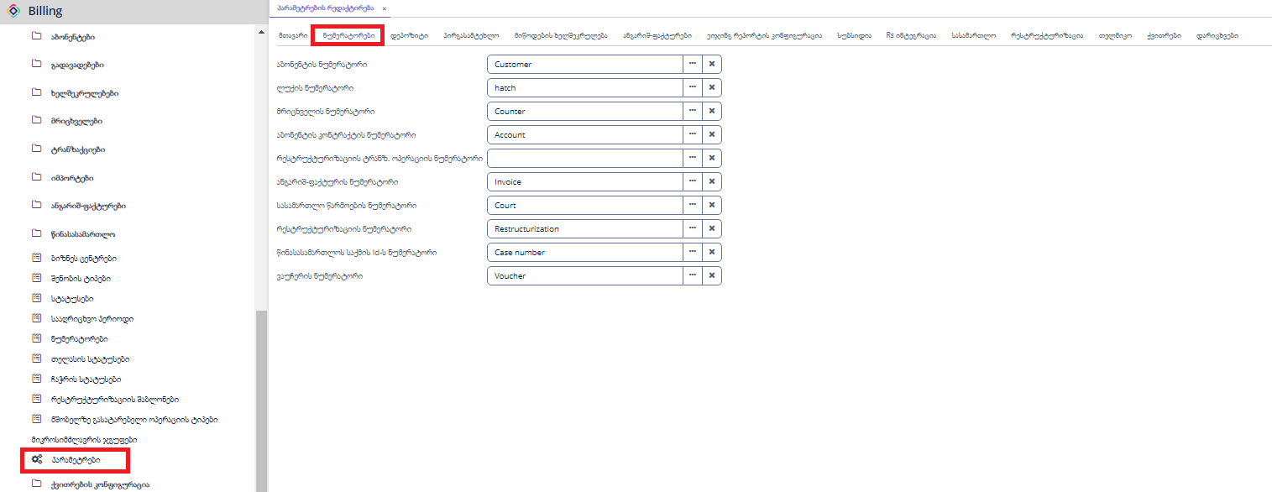

ნუმერატორებში განსაზღვრულია, რომელ ობიექტს რომელი ნუმერატორი შეესაბამება, გამოიყენება კოდში.

### დეპოზიტი

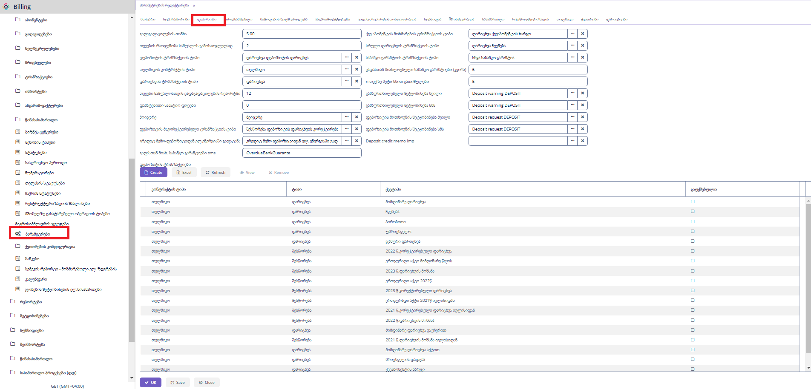

**ვადაგადაცილების თანხა:** მინიმალური თანხის მნიშვნელობა რომელიც ითვლება ვადაგადაცილებულად, გამოიყენება კოდში.

**თვეების რაოდენობა საშუალოს გამოსათვლელად:** მნიშვნელობა განსაზღვრავს რამდენი თვის საშუალო უნდა გამოითვალოს, გამოიყენება კოდში.

**დეპოზიტის ტრანზაქციის ტიპი:** დეპოზიტის დარიცხვის ტრანზაქციის კომბინაციის ტიპი, გამოიყენება კოდში.

**თელმიკოს კონტრაქტის ტიპი:** კონტრაქტის ტიპი თელმიკო, გამოიყენება კოდში.

**დარიცხვის ტრანზაქციის ტიპი:** ტრანზაქციის ტიპი დარიცხვა, გამოიყენება კოდში.

**თვეები საშუალოსთვის ვადაგდაცელების რეპორტში:** მნიშვნელობა გამოიყენება ვადაგადაცილების რეპორტში საშუალოს გამოსათვლელად, გამოიყენება კოდში.

**დამატებითი საპატიო დღეები:** თუ გადაცილებული აქვს 3 დღეს და აქაც წერია 3 ნი, ესეგი ვადაგადაცილებად არ ითვლება, გამოიყენება კოდში.

**მოიჯარე:** მოიჯარე, დროებითი დეპოზიტის გამოთვლის პარამეტრი. გამოიყენება კოდში.

**დეპოზიტის მაკორექტირებელი ტრანზაქციის ტიპი:** დეპოზიტის შესწორების ტრანზაქციის კომბინაციის ტიპი, გამოიყენება კოდში.

**კრედიტ მემო-დეპოზიტიდან ელ_ენერგიაში გადატანა:** დეპოზიტის ელ.ენერგიაში გადატანის ტრანზაქციის კომბინაციის ტიპი, გამოიყენება კოდში.

**გადახთასთან მიახ. საბანკო გარანტიები sms:** საბანკოს გარანტიის შეტყობინების შაბლონის კოდი, გამოიყენება კოდში.

**ქვე აბონენტის მოხმარების ტრანზაქციის ტიპი:** ქვე აბონენტის დარიცხვის ტრანზაქციის კომბინაციის ტიპი, გამოიყენება კოდში.

**სრული დარიცხვის ტრანზაქციის ტიპი:** ჩვენებით დარიცხვის ტრანზაქციის კომბინაციის ტიპი, გამოიყენება კოდში.

**საბანკო გარანტიის ტრანზაქციის ტიპი:** საბანკო გარანტიის ტრანზაქციის კომბინაციის ტიპი, გამოიყენება კოდში.

**ვადასთან მიახლოებული საბანკო გარანტიები (კვირა):** რამდენი კვირით ადრე უნდა გაიგზვანოს საბანკის გარანტიის ვადის გასვლის შეტყობინება.

**n თვეზე მეტი ხნით გათიშულები**: 5 თვეზე მეტი ხნით გათიშულების დეპოზიტის გამოთვლა, შეაძლებელია მნიშვნელობის შეცვლა, მაგ.6 დაითვის 6 თვეზე მეტი ხნით გათიშულებს და ა.შ. გამოიყენება კოდში.

**გამაფრთხილებელი შეტყობინება მეილი:** დეპოზიტის გამაფრთხილებელი შეტყობინების შაბლონი. გამოიყენება კოდში.

**გამაფრთხილებელი შეტყობინება სმს:** დეპოზიტის გამაფრთხილებელი შეტყობინების შაბლონი. გამოიყენება კოდში.

**დეპოზიტის მოთხვნის შეტყობინება მეილი:** დეპოზიტის მოთხოვნის შეტყობინების შაბლონი. გამოიყენება კოდში.

**დეპოზიტის მოთხვნის შეტყობინება მეილი:** დეპოზიტის მოთხოვნის შეტყობინების შაბლონი. გამოიყენება კოდში.

**Deposit credit memo imp:** აღარ გამოიყენება.

**დეპოზიტის ტრანზაქციები:** ცხრილში მოცემულია ის ტრანზაქციის კომბინაცები რაც საჭიროა დეპოზიტის თანხის დასათვლელად. გამოიყენება კოდში.

„Create“ ღილაკზე დაჭერით გამოვა ახალი ჩანაწერის დასამატებელი ფორმა.

“Refresh” ღილაკზე დაჭერით ხდება ფორმაზე მონაცემების განახლება.

„Remove“ ღილაკზე დაჭერით ხდება მონიშნული ჩანაწერების წაშლა.

„Excel“ ღილაკზე დაჭერით ხდება მონაცემების ექსეპორტი, შესაძლებელია როგოც ყველა,მონიშნული ან მიმდინარე გვერდზე არსებული ჩანაწერეის ექსელში გატანა.

„View“ ღილაკზე დაჭერით გამოვა ჩანაწერის დასათვალიერებელი ფორმა.

### მიწოდების ხელშეკრულება

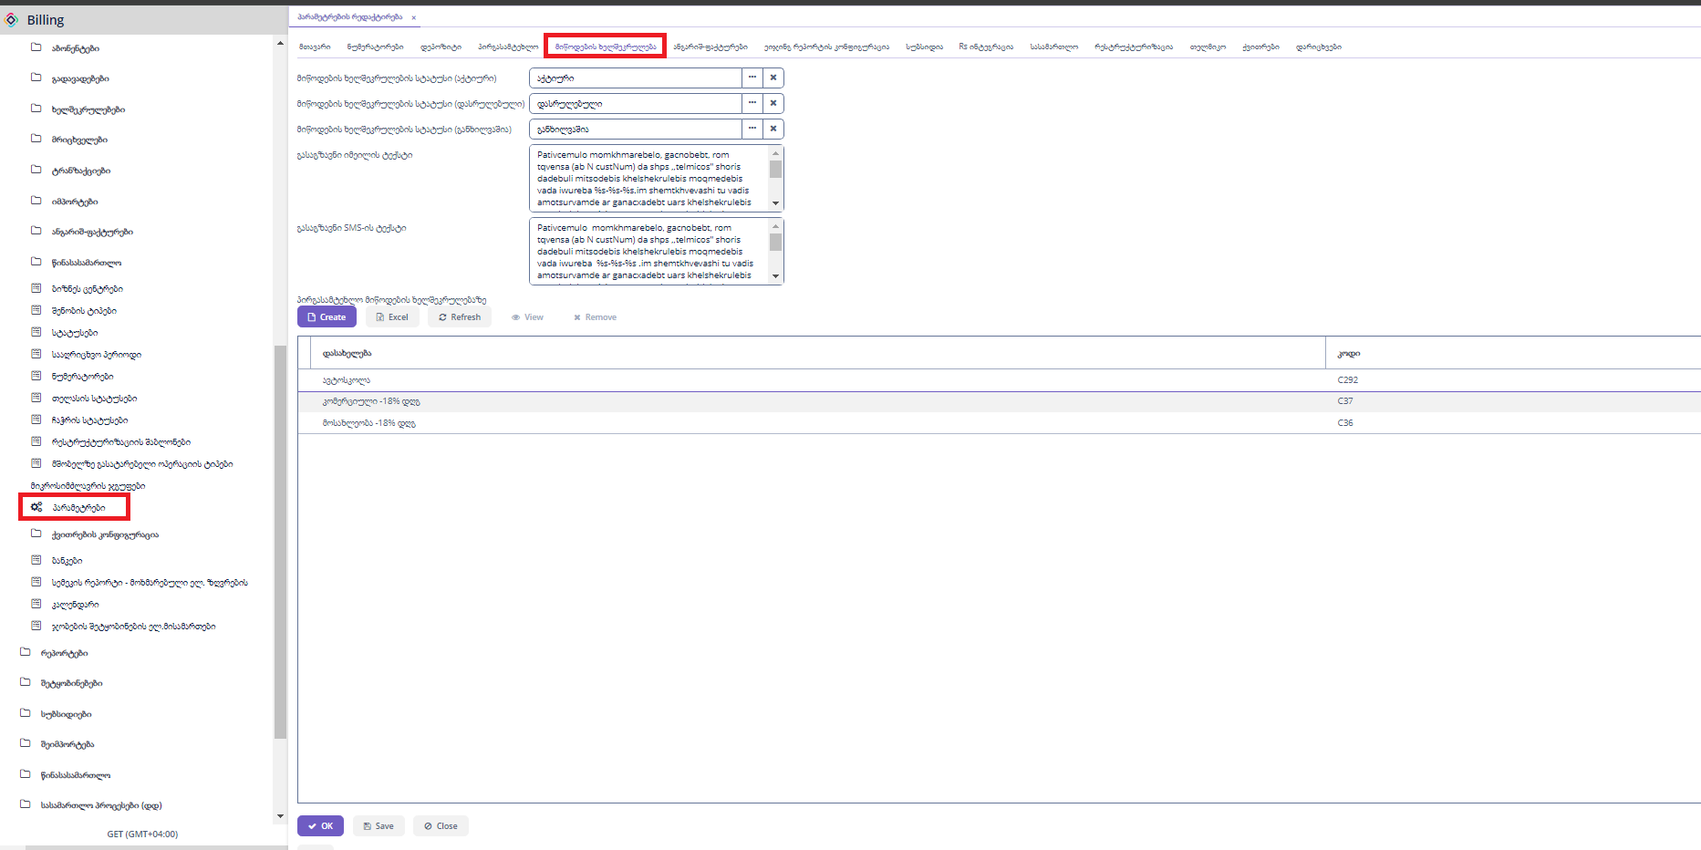

**მიწოდების ხელშეკრულების სტატუსი (აქტიური):** ხელშეკრულების სტატუსი „აქტიური“. გამოიყენება კოდში.

**მიწოდების ხელშეკრულების სტატუსი (დასრულებული):** ხელშეკრულების სტატუსი „დასრულებული“. გამოიყენება კოდში.

**მიწოდების ხელშეკრულების სტატუსი (განხილვაშია):** ხელშეკრულების სტატუსი „განხილვაშია“. გამოიყენება კოდში.

**გასაგზვნი იმეილის ტექსტი:** email შეტყობინების შაბლონი.

**გასაგზვნი SMS -ის ტექსტი:** სმს შეტყობინების შაბლონი.

### ანგარიშ-ფაქტურები

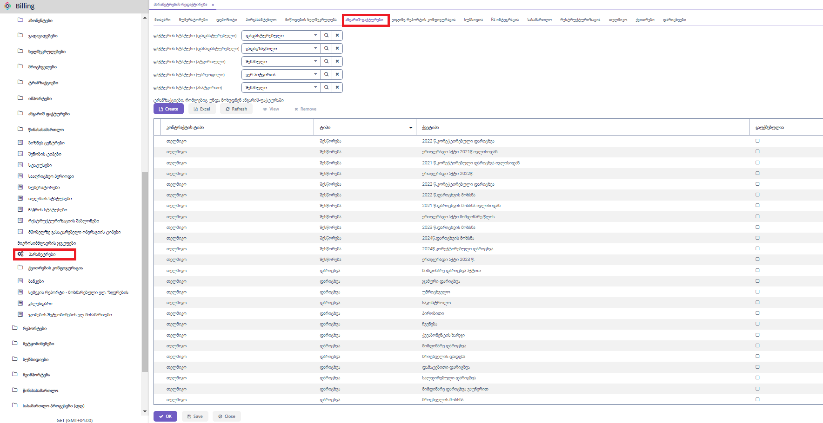

**ფაქტურის სტატუსი (დადასტურებული):** ფაქტურის სტატუსი „დადასტურებული“. გამოიყენება კოდში.

**ფაქტურის სტატუსი (დასადასტურებელი):** ფაქტურის სტატუსი „გადაგზავნილი“. გამოიყენება კოდში.

**ფაქტურის სტატუსი (ატვირთული):** ფაქტურის სტატუსი „შენახული“. გამოიყენება კოდში.

**ფაქტურის სტატუსი (უარყოფილი):** ფაქტურის სტატუსი „ვერ აიტვირთა“. გამოიყენება კოდში.

**ფაქტურის სტატუსი (ასატვირთი):** ფაქტურის სტატუსი „შენახული“. გამოიყენება კოდში.

**ტრანზაქციები, რომლებიც უნდა მოხვდნენ ანგარიშ-ფაქტურაში:** ტრანზაქცის კომბინაციის სია, რომლებიც გამოიყენება ფაქტურის გამოთვლაში. გამოიყენება კოდში.

„Create“ ღილაკზე დაჭერით გამოვა ახალი ჩანაწერის დასამატებელი ფორმა.

“Refresh” ღილაკზე დაჭერით ხდება ფორმაზე მონაცემების განახლება.

„Remove“ ღილაკზე დაჭერით ხდება მონიშნული ჩანაწერების წაშლა.

„Excel“ ღილაკზე დაჭერით ხდება მონაცემების ექსეპორტი, შესაძლებელია როგოც ყველა,მონიშნული ან მიმდინარე გვერდზე არსებული ჩანაწერეის ექსელში გატანა.

„View“ ღილაკზე დაჭერით გამოვა ჩანაწერის დასათვალიერებელი ფორმა.

### ეიჯინგ რეპორტის კონფიგურაცია

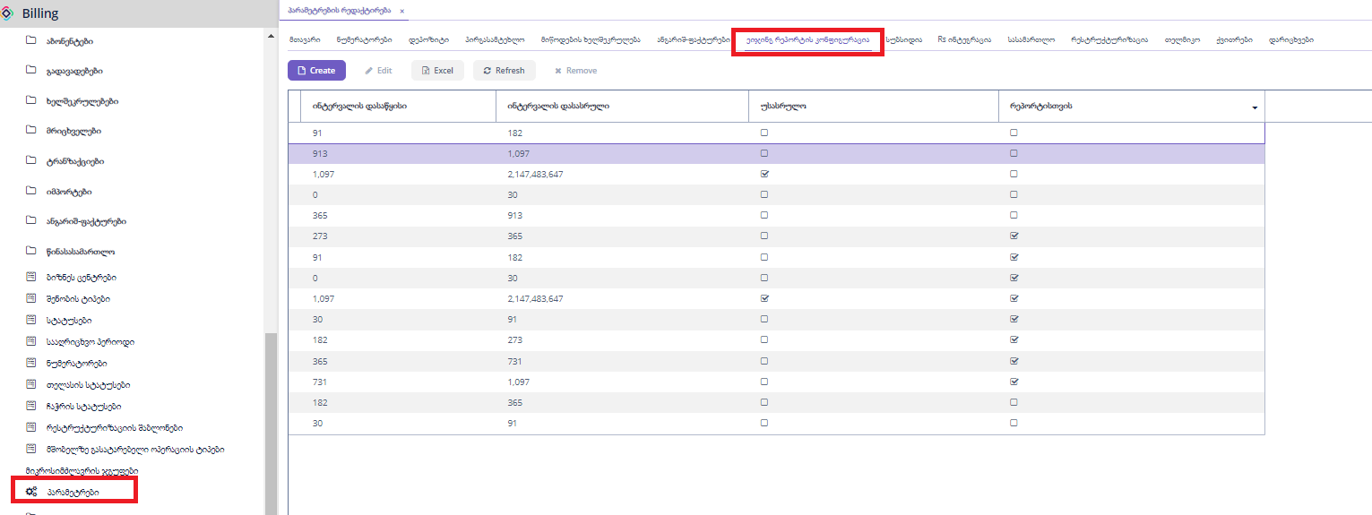

**რეპორტისთვის:** ეს ველი სადაც არის მონიშნული ის ჩანაწერები გამოიყენება ეიჯინგის რეპორტისთვის, ხოლო სადაც არ არის მონიშნული ისინი ეიჯინგის ფუნქციონალისთვის.

### სუბსიდია

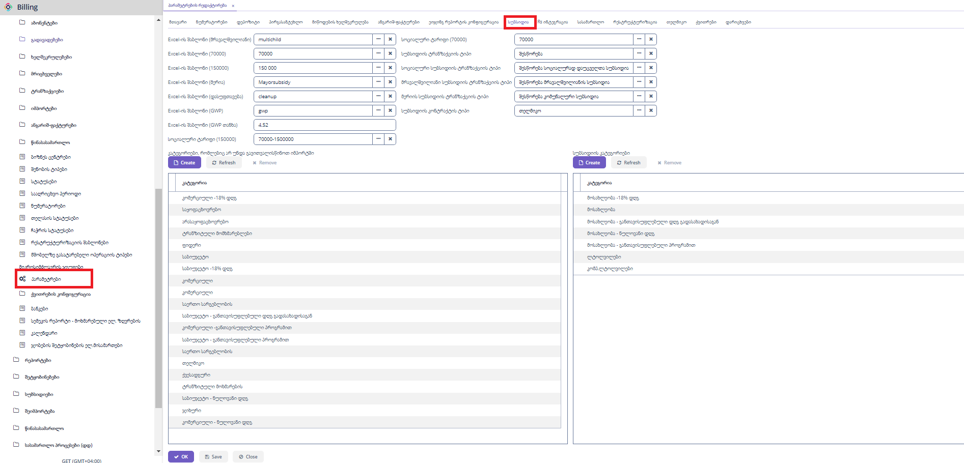

### RS ინტეგრაცია



**თელმიკოს Tin:** თელმიკოს საიდენტიფიკაციო კოდი

**RS -ის ინტეგრაციის სერვისი:** ფაქტურების სერვისის მისამართი

### რესტრუქტურიზაცია

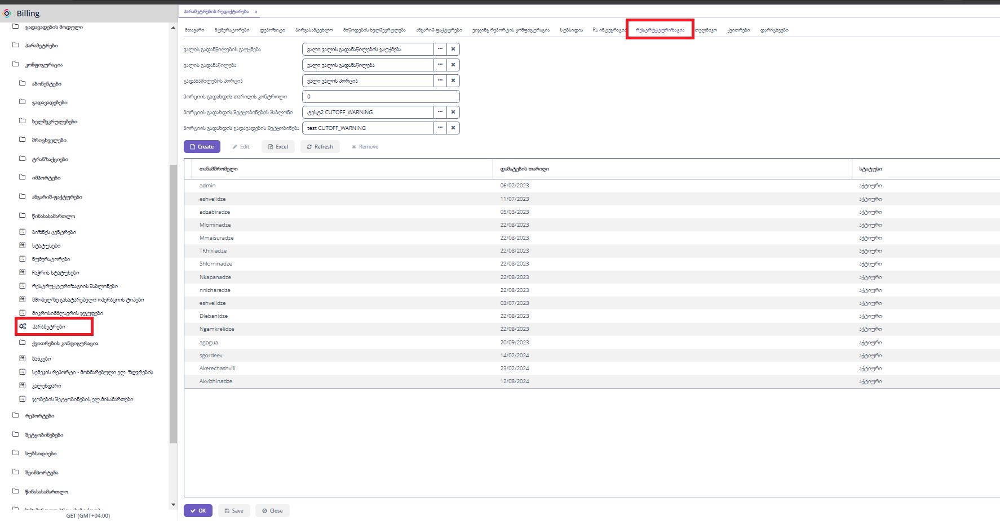

**ვალის გადანაწილების გაუქმება:** გადანაწილების გაუქმების ტრანზაქციის კომბინაციის ტიპი. გამოიყენება კოდში.

**ვალის გადანაწილება:** გადანაწილების ტრანზაქციის კომბინაციის ტიპი.გამოიყენება კოდში.

**გადანაწილების პორცია:** ვალის პორციის ტრანზაქციის კომბინაციის ტიპი. გამოიყენება კოდში.

**პორციის გადახდის თარიღის კონტროლო:** აღარ გამოიყენება

**პორციის გადახდის შეტყობინების შაბლონი:**  აღარ გამოიყენება

**პორციის გადახდის გადავადების შეტყობინება:** აღარ გამოიყენება

**ცხრილური ნაწილი:** რესტრუქტურიზაციის მოქმდები მომხმარებლები.

„Create“ ღილაკზე დაჭერით გამოვა ახალი ჩანაწერის დასამატებელი ფორმა.

„Edit“ ღილაკზე დაჭერით გამოვა დასარედაქტირებელი ფორმა.

“Refresh” ღილაკზე დაჭერით ხდება ფორმაზე მონაცემების განახლება.

„Remove“ ღილაკზე დაჭერით ხდება მონიშნული ჩანაწერების წაშლა.

„Excel“ ღილაკზე დაჭერით ხდება მონაცემების ექსეპორტი, შესაძლებელია როგოც ყველა,მონიშნული ან მიმდინარე გვერდზე არსებული ჩანაწერეის ექსელში გატანა.

### თელმიკო

თელმიკოს ზოგადი ინფორმაცია

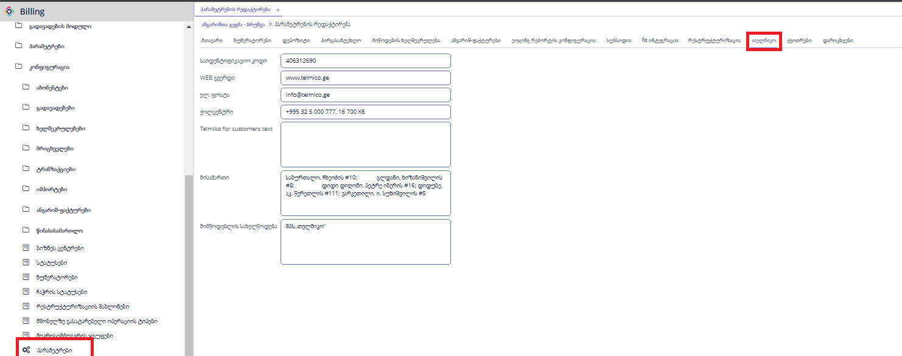

### ქვითრები

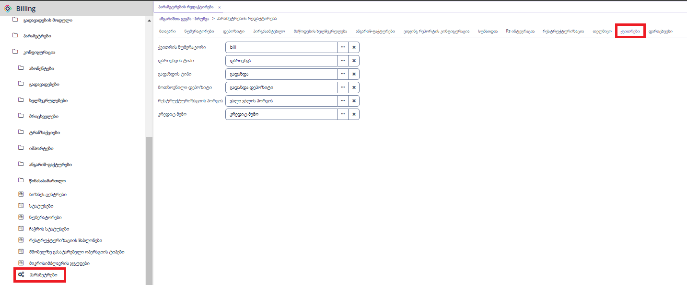

**ქვითრის ნუმერატორი:** ქვითრის კოდის ნუმერატორი.

**დარიცხვის ტიპი:** დარიცხვის ტრანზაქციის ტიპი. გამოიყენება კოდში.

**გადახდის ტიპი:** გადახდის ტრანზაქციის ტიპი. გამოიყენება კოდში.

**მოთხოვნილი დეპოზიტი:** დეპოზიტის დარიცხვის ტრანზაქციის კომბინაციის ტიპი. გამოიყენება კოდში.

**რესტრუქტურიზაციის პორცია:** ვალის ტრანზაქციის კომბინაციის ტიპი. გამოიყენება კოდში.

**კრედიტ მემო:** კრედიტ მემო ტრანზაქციის ტიპი. გამოიყენება კოდში.

### დარიცხვები

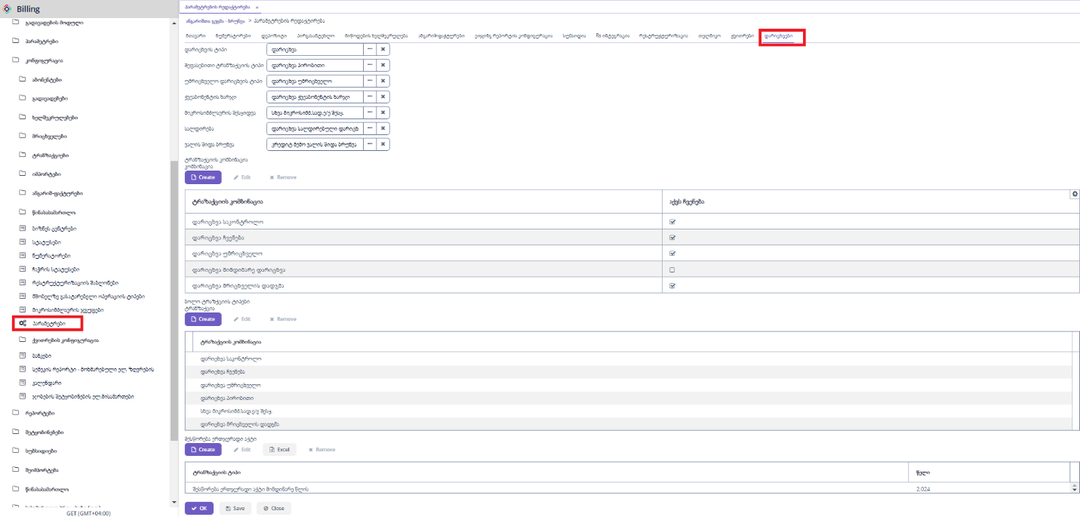

**დარიცხვის ტიპი:** დარიცხვის ტრანზაქციის ტიპი. გამოიყენება კოდში.

**შეფასებითი ტრანზაქციის ტიპი:** შეფასებითი დარიცხვის ტრანზაქციის კომბინაციის ტიპი. გამოიყენება კოდში.

**უმრიცხველო დარიცხვის ტიპი:** უმრიცხველო დარიცხვის ტრანზაქციის კომბინაციის ტიპი. გამოიყენება კოდში.

**ქვეაბონენტის ხარჯი:** ქვეაბონენტის დარიცხვის ტრანზაქციის კომბინაციის ტიპი. გამოიყენება კოდში.

**მიკროსიძლავრის შესყიდვა:** მიკროსიმძლავრის შესყიდვის ტრანზაქციის კომბინაციის ტიპი. გამოიყენება კოდში.

**სალდირება:** სალდირებული დარიცხვის ტრანზაქციის კომბინაციის ტიპი. გამოიყენება კოდში.

**ვალის შიდა ბრუნვა:** კრედიტ მემე ვალის შიდა ბრუნვა ტრანზაქციის კომბინაციის ტიპი. გამოიყენება კოდში.

**ტრანზაქციების კომბინაცია:**

გამოიყენება დარიცხვის დროს კოდში. ლარიანი დარიცხვის ტრანზაქციების კომბინაციები.

„Create“ ღილაკზე დაჭერით გამოვა ახალი დასამატებელი ფორმა.

„Edit“ ღილაკზე დაჭერით გამოვა დასარედაქტირებელი ფორმა.

„Remove“ ღილაკზე დაჭერით ხდება მონიშნული ჩანაწერების წაშლა.

**ბოლო ტრანზაქციის ტიპები:**

გამოიყენება დარიცხვის დროს კოდში. წინა დარიცხვის განსასაზღვრად.

„Create“ ღილაკზე დაჭერით გამოვა ახალი დასამატებელი ფორმა.

„Edit“ ღილაკზე დაჭერით გამოვა დასარედაქტირებელი ფორმა.

„Remove“ ღილაკზე დაჭერით ხდება მონიშნული ჩანაწერების წაშლა.

**შესწორება ერჯერადი აქტი:**

გამოიყენება დარიცხვების დროს კოდში, განსაზღვრავს შესაბამისი წლის ტრანზაქციის კომბინაციას.

„Create“ ღილაკზე დაჭერით გამოვა ახალი დასამატებელი ფორმა.

„Edit“ ღილაკზე დაჭერით გამოვა დასარედაქტირებელი ფორმა.

„Remove“ ღილაკზე დაჭერით ხდება მონიშნული ჩანაწერების წაშლა.

## ქვითრების კონფიგურაცია

### მიმდინარე დარიცხვა

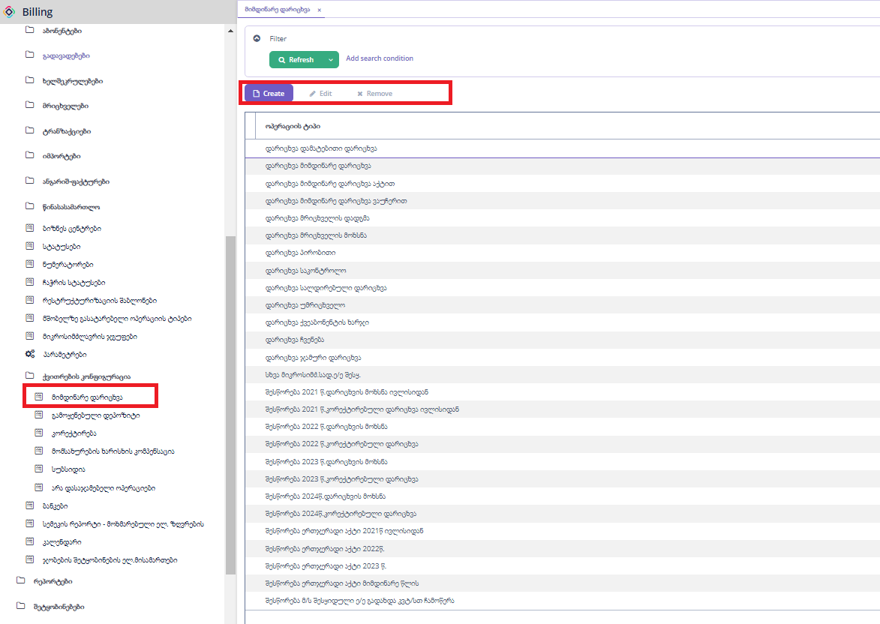

ქვითრში მიმდინარე დარიცხვაში გამოსაყენებლი ტრანზაქციის კომბინაციის ტიპები.

„Create“ ღილაკზე დაჭერით გამოვა ახალი დასამატებელი ფორმა.

„Edit“ ღილაკზე დაჭერით გამოვა დასარედაქტირებელი ფორმა.

„Remove“ ღილაკზე დაჭერით ხდება მონიშნული ჩანაწერების წაშლა.

### გამოყენებული დეპოზიტი

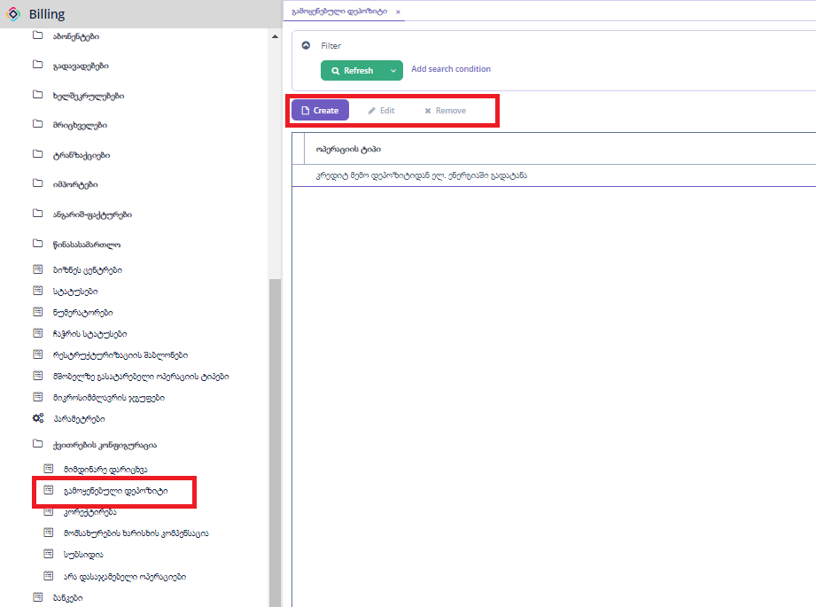

ქვითრში გამოყენებულ დეპოზიტში გამოსაყენებლი ტრანზაქციის კომბინაციის ტიპები.

„Create“ ღილაკზე დაჭერით გამოვა ახალი დასამატებელი ფორმა.

„Edit“ ღილაკზე დაჭერით გამოვა დასარედაქტირებელი ფორმა.

„Remove“ ღილაკზე დაჭერით ხდება მონიშნული ჩანაწერების წაშლა.

### კორექტირება

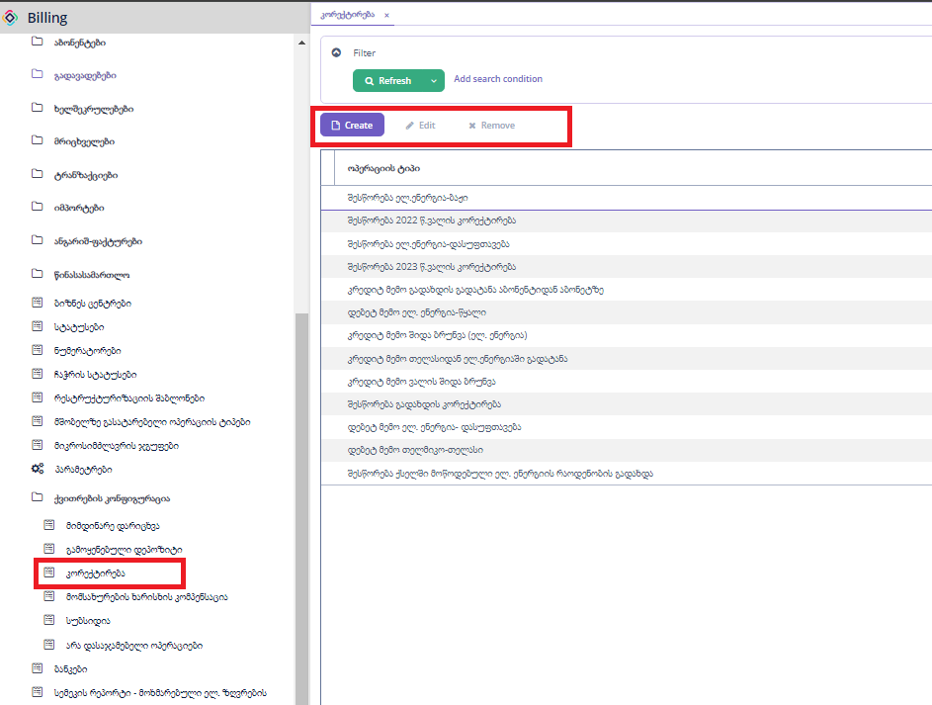

ქვითრში კორექტირებაში გამოსაყენებლი ტრანზაქციის კომბინაციის ტიპები.

„Create“ ღილაკზე დაჭერით გამოვა ახალი დასამატებელი ფორმა.

„Edit“ ღილაკზე დაჭერით გამოვა დასარედაქტირებელი ფორმა.

„Remove“ ღილაკზე დაჭერით ხდება მონიშნული ჩანაწერების წაშლა.

### მომსახურების ხარისხის კომპენსაცია

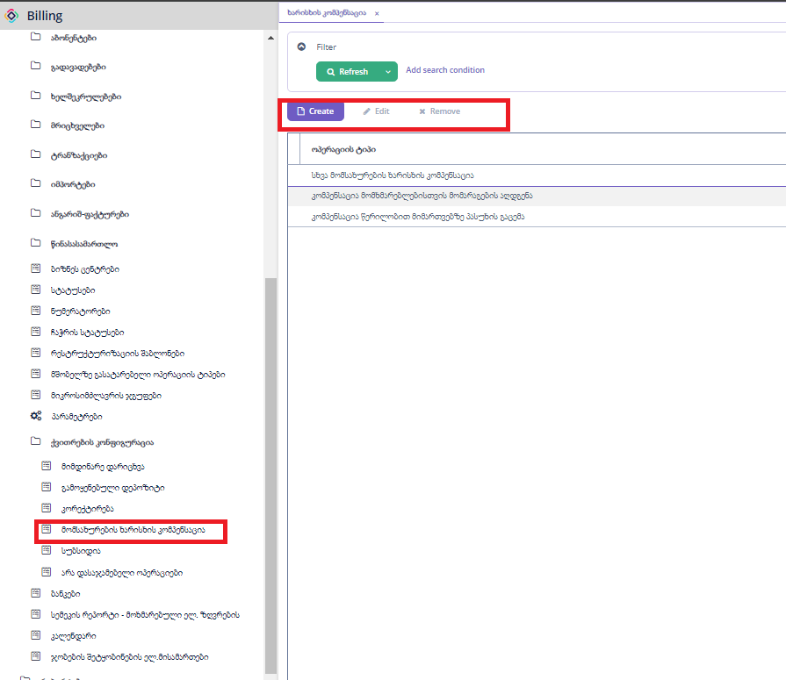

ქვითრში კომპესაციაში გამოსაყენებლი ტრანზაქციის კომბინაციის ტიპები.

„Create“ ღილაკზე დაჭერით გამოვა ახალი დასამატებელი ფორმა.

„Edit“ ღილაკზე დაჭერით გამოვა დასარედაქტირებელი ფორმა.

„Remove“ ღილაკზე დაჭერით ხდება მონიშნული ჩანაწერების წაშლა.

### სუბსიდია

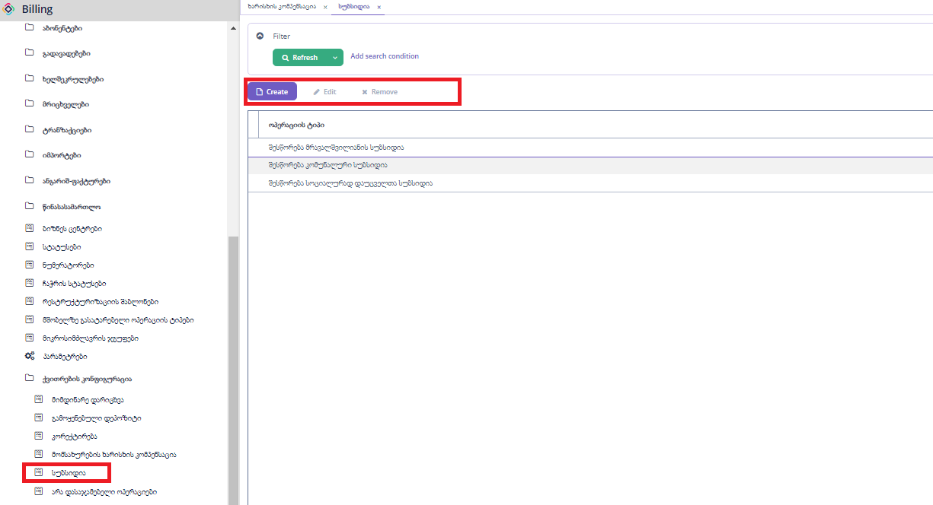

ქვითრში სუბსიდიაში გამოსაყენებლი ტრანზაქციის კომბინაციის ტიპები.

„Create“ ღილაკზე დაჭერით გამოვა ახალი დასამატებელი ფორმა.

„Edit“ ღილაკზე დაჭერით გამოვა დასარედაქტირებელი ფორმა.

„Remove“ ღილაკზე დაჭერით ხდება მონიშნული ჩანაწერების წაშლა.

არა დასაჯამებელი ოპერაციები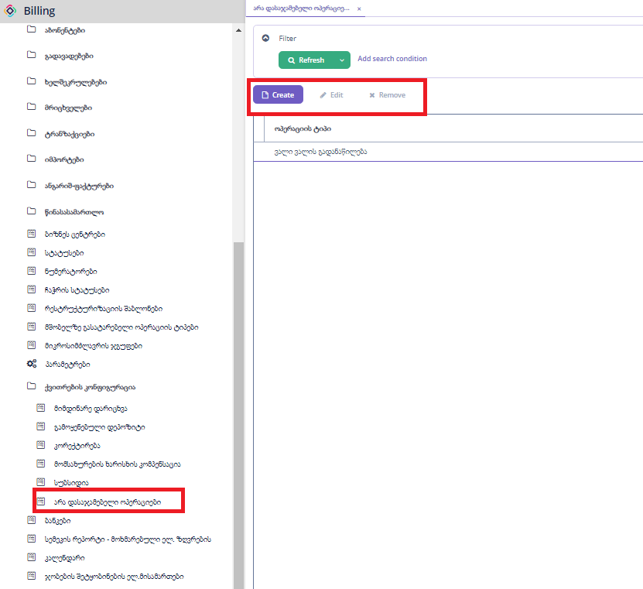

ქვითრში ეს ოპერაციის ტიპიები დავალიანებაში არ იღებენ მონაწილეობას, მხოლოდ ცალკე ველად ჩანს.

„Create“ ღილაკზე დაჭერით გამოვა ახალი დასამატებელი ფორმა.

„Edit“ ღილაკზე დაჭერით გამოვა დასარედაქტირებელი ფორმა.

„Remove“ ღილაკზე დაჭერით ხდება მონიშნული ჩანაწერების წაშლა.

## სემეკის რეპორტი - მოხმარებული ელ.ზღვრების

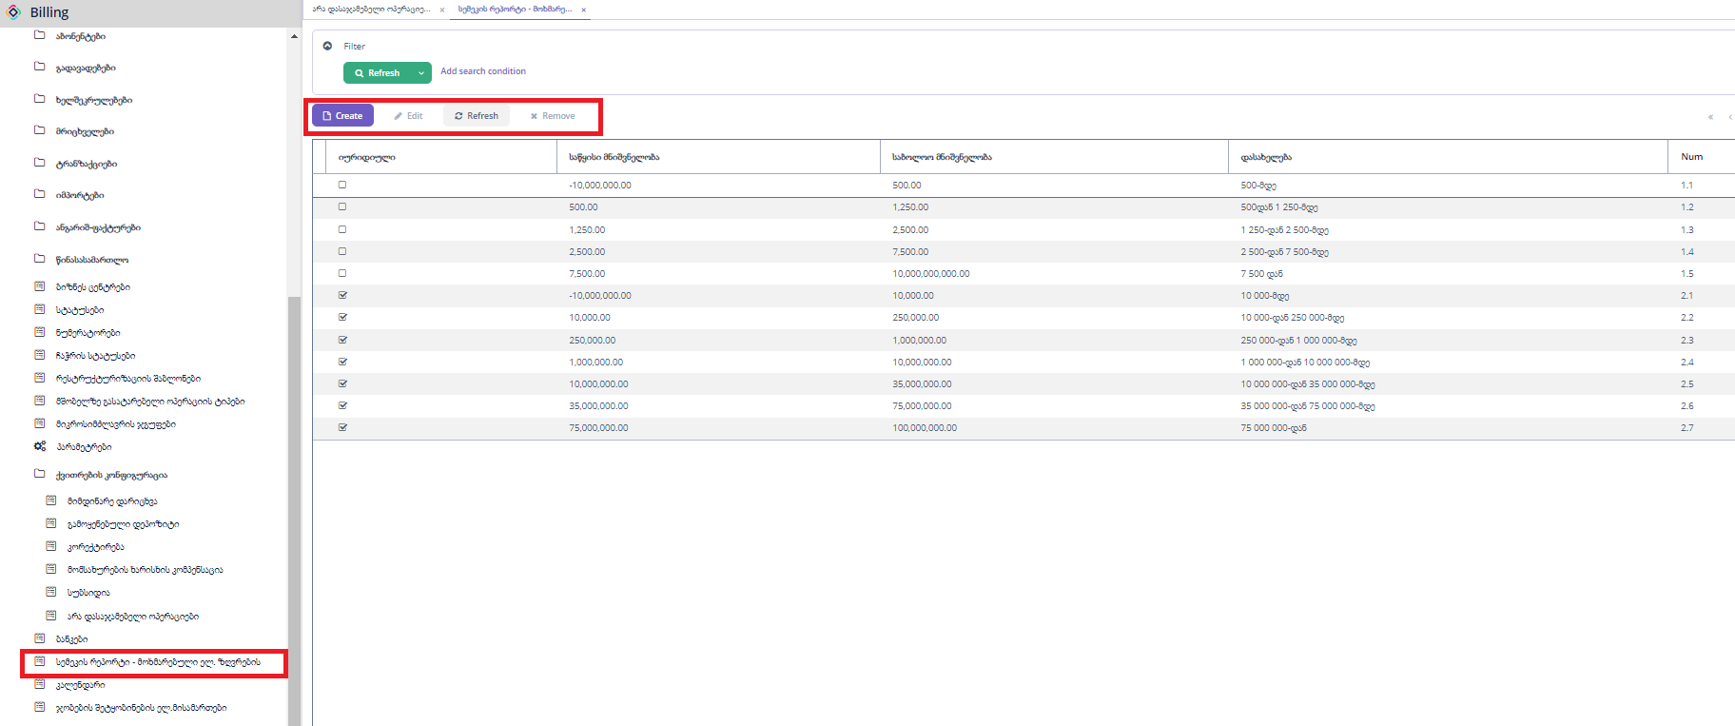

ზღვრების რეპორტის კონფიგურაცია, რა შუალედში რა დასახელება უნდა გამოჩნდეს.

„Create“ ღილაკზე დაჭერით გამოვა ახალი დასამატებელი ფორმა.

„Edit“ ღილაკზე დაჭერით გამოვა დასარედაქტირებელი ფორმა.

„Remove“ ღილაკზე დაჭერით ხდება მონიშნული ჩანაწერების წაშლა.

“Refresh” ღილაკზე დაჭერით ხდება ფორმაზე მონაცემების განახლება.

## კალენდარი

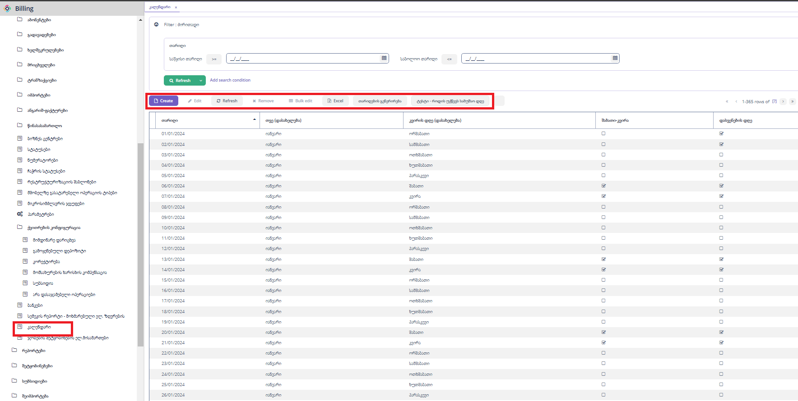

„Create“ ღილაკზე დაჭერით გამოვა ახალი ჩანაწერის დასამატებელი ფორმა.

„Edit“ ღილაკზე დაჭერით გამოვა დასარედაქტირებელი ფორმა.

“Refresh” ღილაკზე დაჭერით ხდება ფორმაზე მონაცემების განახლება.

„Remove“ ღილაკზე დაჭერით ხდება მონიშნული ჩანაწერების წაშლა.

„Excel“ ღილაკზე დაჭერით ხდება მონაცემების ექსეპორტი, შესაძლებელია როგოც ყველა,მონიშნული ან მიმდინარე გვერდზე არსებული ჩანაწერეის ექსელში გატანა.

„Bulk edit” შესაძლებელია ცხრილში მნიშვნელობების შეცვლა.

„თარიღების გენერირება“ გამოდის ფორმა, სადაც უნდა შეიყვანოთ საწყისი და საბოლოო თარიღი, მაგ.(2025.01.01 – 2025.12.31) შექმნის 2025 წლის კალენდარს.

„ტესტი - როდის უწევს სამუშაო დღეს“, შეგვყავს თარიღი და დღეების რაოდენობა და აბრუნებს შემდეგი სამუშაო დღის თარიღს.

## ჯობების შეტყობინების ელ.მისამართები

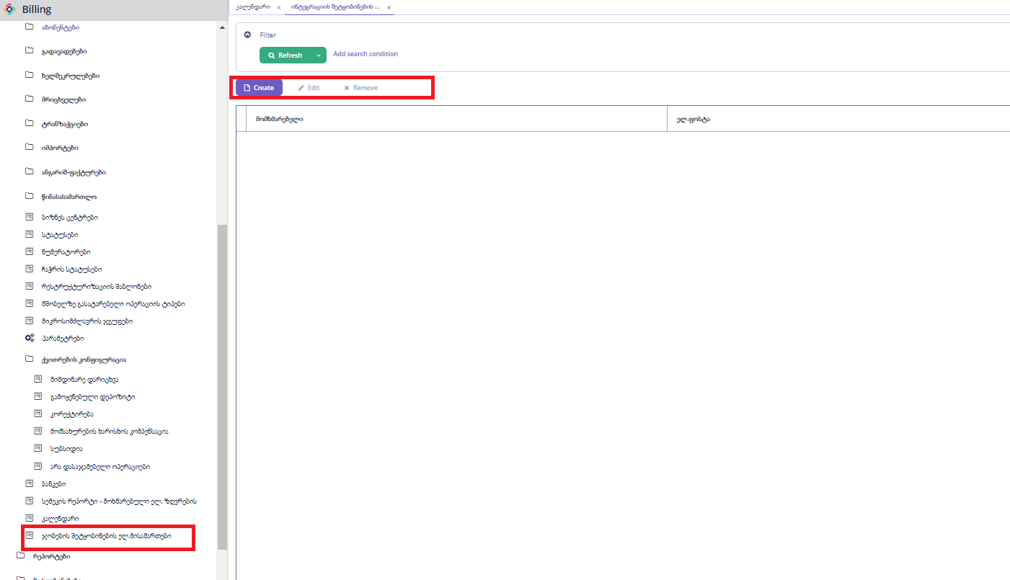

ჯობების მონიტორინგი, ფორმაზე გაწერილ ელ.ფოსტაზე მიდის ჯობის დაწყების, დასრულების და შეცდომის შეტყობინებები.

„Create“ ღილაკზე დაჭერით გამოვა ახალი ჩანაწერის დასამატებელი ფორმა.

„Edit“ ღილაკზე დაჭერით გამოვა დასარედაქტირებელი ფორმა.

„Remove“ ღილაკზე დაჭერით ხდება მონიშნული ჩანაწერების წაშლა.

# როლები

ადმინისტრირების მენიუდან შესაძლებელია ახალი როლების შექმნა/ცვლილება.

## Resourche roles

**ფორმიდან შესაძლებელია პროგრამაში ახალი როლის შექმნა** :

* **Create-** ახალი როლის შექმნა
* **Edit-** რედაქტირება
* **Remove-** წაშლა
* **Refresh-** გადატვირთვა

**Export -** როლის გაექსპორტორება

* **Import-** როლის შემოიმპორტება.

**

* **Name-** როლის დასახელება, რომელსა მიანიჭებთ (სავალდბულო ველი)
* **Code-** როლის კოდი (სავალდებულო როლი )
* **Description- აღწერა**
* **Source - მუდმივი( Database)**
* **Scope ( UI -** როცა შიგნიდან ხდება დაკავშირება **, API -** როცა პროგრამას უკავშირდები მხოლოდ სერვისებით **. )**

**ძირითადი ინფორმაციის დამადატების შემდე “CREATE” ღილაკით ვამატებთ წვდომებს:**

1. **Menu policy**
2. **Screen policy**
3. **Entity policy**
4. **Entity attribute policy**
5. **Specific policy**

## Menu policy - ვამატებთ რომელ მენიუბზე უნდა ქონდეს წვდომა როლს.

გამოიყენება სისტემაში არსებული მენიუს ჩასართვად, შეგვიძლია ავირჩიოთ კონკრეტული მენიუ რომელიც გვინდა რომ შესაბამის როლზე გამოჩნდეს.

* **Resource-** ვირჩევ ისეთ მენიუს რომელზეც უნდა ქონდეს წვდომა როლს
* **Policy group-** Resource არჩევს შემდეგ მოაქვს ავტომატურად ან ხელით უნდა გაეწეროს სასურველი კოდი
* **Screen -** Resource არჩევს შემდეგ მოაქვს ავტომატურად
* **grant access to the screen-** ჩეკბოქსის მონიშვნით წვდომა ექნება სქრინებზეც.

## Screen policy-ვამატებთ რომელი ცხრილის ველზე უნდა ქონდეს წვდომა როლს.

გამოიყენება სისტემაში არსებული ფორმების ჩასართვად, შეგვიძლია ავირჩიოთ კონკრეტული მენიუ რომელიც გვინდა რომ შესაბამის როლზე გამოჩნდეს.

* **Resource-** ვირჩევ ისეთ ცხრილებს რომელზეც უნდა ქონდეს წვდომა როლს
* **Policy group-** Resource არჩევს შემდეგ მოაქვს ავტომატურად
* **Menu item -** არ ვავსებთ
* **Grant access to the menu item -** ჩეკბოსის მონიშვნი შემეგ წვდომა ექნება მენიუს აითემებზე

## Entity policy- ცხრილზე წვდომის პოლიტიკა, სასურველ ცხრილზე რა მოქმედების უფლებას ვაძლევთ

გამოიყენება სისტემაში არსებულ ცხრილებზე წვდომის ჩასართვად, შეგვიძლია ავირჩიოთ კონკრეტული ცხრილი რომელიც გვინდა რომ შესაბამის როლზე გამოჩნდეს, და მივანიჭოთ სქრინზე ნაჩვენები უფლებები.

* **Entity-** ცრილი
* **Policy group-** კოდი
* **All actions-** ყველა მოქმედება
* **Create-** შექმნის უფლება
* **Read-** წაკითხვი უფლება
* **Update-** განახლების უფლება
* **Delete-** წაშლის უფლება

## Entity attribute policy- ცხრილის კონკრეტულ ველზე წვდომის პოლიტიკა.

გამოიყენება სისტემაში არსებული ცხრილის კონკრეტულ ველებზე წვდომების გასაწერად.

* **Entity-** ცრილი
* **View -** მხოლოდ ხედვის უფლება
* **Modify** - რედაქტირების უფლება (რედაქტირება გულისხმობს ხედვის უფლებასაც)

## Specific policy- სპეციფიურ ობიექტებზე წვდომის პოლიტიკა. მაგ: ღილაკზე, ფილტრზე და ა.შ.

გამოიყენება სპეციფიური მოთხოვნებისთვის, შესაძლებელაი გაკეთება მხოლოდ დეველოპმენტით.

# ბაზის სტრუქტურა

## ცხრილების სია

|  |  |
| --- | --- |
| **დასახელება** | **აღწერა** |
| prx_counter | მრიცხველები |
| prx_counter_coefficient | მრიცხველის კოეფიციენტები. |
| prx_counter_adress | მრიცხველის მისამართები |
| prx_customer | აბონენტები |
| prx_customer_address | აბონენტების მისამართები |
| prx_counter_type | მრიცხველის ტიპები |
| prx_customer_contract | აბონენტების ხელშეკრულებები |
| prx_customer_contract_type | ხელშეკრულების ტიპები |
| prx_customer_contact | აბონენტების კონტაქტები |
| prx_customer_category | აბონენტთა კატეგორიები |
| prx_customer_message | სმს. აბონენტეთან გაგზავნილი ან გასაგზავნი შეტყობინებები. |
| prx_bill | ქვითრების ჰედერის ცხრილი. |
| prx_bill_operation | ქვითრების ოპერაციების ცხრილი. |
| prx_bill_operation_type | ქვითრის ოპერაციის ტიპები,გამოიყენება მხოლოდ ქვითრის გენერაციისას. |
| prx_bill_subsidy_operation | ქვითრის სუბსიდიის ოპერაციის ტიპები,გამოიყენება მხოლოდ ქვითრის გენერაციისას. |
| prx_bill_subsidy | ქვითარში სუბსიდიების ჩანართი. |
| prx_block | ბლოკები |
| prx_block_schedule | ბლოკების გრაფიკები |
| prx_c_court_case | სასამართლო საქმეები |
| prx_c_court_case_duty_transactions | სასამართლო ვალდებულებების ტრანზაქციები |
| prx_c_court_case_event_table | სასამართლო საქმეების მოვლენები |
| prx_cassation_court | საკასაციო სასამართლო |
| prx_category | აბონენტის კატეგორიები, I,II კატეგორია. |
| prx_circular_accural | ციკლური დარიცხვები |
| prx_c_court_lawyer | იურისტების ცხრილი |
| prx_c_court_document_prep_cust | მოსამზადებელი სასამართლო საბუთები |
| prx_c_court_document_prep_customer | სასამართლო საბუთების მომზადება |
| prx_customer_multi_child_subsidy | მრავალშვილიანების სუბსიდიები |
| prx_customer_reconnection | აბონენტების აღდგენების ცხრილი. |
| prx_customer_subsidy | აბონენტების სუბსიდიები |
| prx_customer_telasi_balance | აბონენტის ბალანსი თელასში |
| prx_cut_history | ჩაჭრების ისტორია |
| prx_cut_off_sms_notification_auto_email_check | ჩაჭრების შეტყობინებები სმს, email |
| prx_cutoff_status | ჩაჭრების სტატუსები |
| prx_cutt_off_sms_notification_helper | ჩაჭრების გამაფრთხილებელი სმს შეტყობინებები. |
| prx_debet_status | დებეტ სტატუსი |
| prx_debitor_balance_reserve_re | დებიტორების ბალანსის რეზერვების რეპორტის ცხრილი |
| prx_debtor_accrual_account | დებიტორების დარიცხვების ცხრილი- ბუღალტერიის რეპორტი |
| prx_debtor_balance_closing_prep | დებიტორების ბალანსი დასახურად მომზადება |
| prx_debtor_balance_opening_prep | დებიტორების ბალანსი გასახსნელად მომზადება |
| prx_debtor_balance_opening_ | დებიტორების ბალანსი რეპორტი - საწყისი ნაშთი |
| prx_debtor_balance_closing_res | დებიტორების ბალანსი რეპორტი - საბოლოო ნაშთი |
| prx_debtor_balance_report | დებიტორების ბალანსის რეპორტი |
| prx_debtor_payment_account | დებიტორების ფულადი და არაფულადი ოპერაციების ცხრილი- ბუღალტერიის რეპორტი |
| prx_deposit_customers | დეპოზიტის მქონე აბონენტები |
| prx_deposit_disconnected_custo | 5 თვეზე მეტი ხნით გათიშული დეპოზიტის მქონე აბონენტები |
| prx_deposits_for_correction | კორექტირების მქონე დეპოზიტები |
| prx_distribute_transaction | ტრანზაქციების განაწილება. აღარ გამოიყენება |
| prx_payment | გადახდები |
| prx_payment_detail | გადახდების დეტალები, ჩაშლა თელასი თელმიკო. |
| prx_power_information | ძაბვის ინფორმაცია.აღარ გამოიყენება |
| prx_bill_correction_operation | ქვითარში კორექტირების ველში დასაჯამებელი ოპერაციები |
| prx_restructurization_header | რესტრუქტურიზაციის ჰედერი |
| prx_restructurization_line | რესტრუქტურიზაციის ლაინები |
| prx_status | სტატუსები |
| prx_pre_court_work | წინა სასამართლო სამუშაო |
| prx_subsidy_categories | სუბსიდიის კატეგორიები |
| prx_subsidy_tariff | სუბსიდიის ტარიფები |
| prx_subsidy_tariff_line | სუბსიდიის ტარიფის ლაინები |
| prx_summary_info | ჯამური ინფორმაცია აბონენტზე. Summary info |
| prx_tariff | ტარიფები |
| prx_tariff_line | ტარიფის ლაინები |
| prx_telasi_customer_balance | თელასის კლიენტების ბალანსი |
| prx_transaction | ტრანზაქციები |
| prx_transaction_line | ტრანზაქციის ხაზები.აღარ გამოიყენება |
| prx_settle_transaction | შეთავსებული ტრანზაქციები |
| prx_transaction_type | ტრანზაქციის ტიპები |
| prx_open_transaction | ღია ტრანზაქციები |
| prx_rs_invoice | ანგარიშფაქტურები |
| prx_rs_invoice_transaction | ანგარიშფაქტურების ტრანზაქციები |
| prx_rs_invoice_line | ანგარიშფაქტურების ლაინები |
| prx_invoice_status | ანგარიშფაქტურების სტატუსები |
| prx_rs_users | მომხმარებლები |
| prx_rs_users_setup | მომხმარებლების უფლებები |
| prx_parameters | პარამეტრები |
| CircChargePrevCycleMaxDate | ციკლური დარიხვების დამხმარე ცხრილი. გმოიყენება კოდში. |
| RsInvoiceExcepCustomer | ფაქტურებისთვის, გამონაკლისი აბონენტები. |
| RsInvoiceExcepParentCustomer | ფაქტურებისთვის, გამონაკლისი ქსელური აბონენტები. |
| TelasiItemCompare | გადმოსვის მომენტში თელასიდან წამოღებული ტრანზაქციების ცხრილი. |
| act_dmn_databasechangelog | სისტემური. ცვლილებების ლოგი |
| act_dmn_databasechangeloglock | სისტემური. გამოიყენება დეპლოიმენთის დროს. |
| act_dmn_decision | აღარ გამოიყენება. |
| act_dmn_deployment | აღარ გამოიყენება. |
| act_dmn_deployment_resource | აღარ გამოიყენება. |
| act_dmn_hi_decision_execution | აღარ გამოიყენება. |
| act_evt_log | აღარ გამოიყენება. |
| act_ge_bytearray | აღარ გამოიყენება. |
| act_ge_property | აღარ გამოიყენება. |
| act_hi_actinst | აღარ გამოიყენება. |
| act_hi_attachment | აღარ გამოიყენება. |
| act_hi_comment | აღარ გამოიყენება. |
| act_hi_detail | აღარ გამოიყენება. |
| act_hi_entitylink | აღარ გამოიყენება. |
| act_hi_identitylink | აღარ გამოიყენება. |
| act_hi_procinst | აღარ გამოიყენება. |
| act_hi_taskinst | აღარ გამოიყენება. |
| act_hi_tsk_log | აღარ გამოიყენება. |
| act_hi_varinst | აღარ გამოიყენება. |
| act_id_bytearray | აღარ გამოიყენება. |
| act_id_group | აღარ გამოიყენება. |
| act_id_info | აღარ გამოიყენება. |
| act_id_membership | აღარ გამოიყენება. |
| act_id_priv | აღარ გამოიყენება. |
| act_id_priv_mapping | აღარ გამოიყენება. |
| act_id_property | აღარ გამოიყენება. |
| act_id_token | აღარ გამოიყენება. |
| act_id_user | აღარ გამოიყენება. |
| act_procdef_info | აღარ გამოიყენება. |
| act_re_deployment | აღარ გამოიყენება. |
| act_re_model | აღარ გამოიყენება. |
| act_re_procdef | აღარ გამოიყენება. |
| act_ru_actinst | აღარ გამოიყენება. |
| act_ru_deadletter_job | აღარ გამოიყენება. |
| act_ru_entitylink | აღარ გამოიყენება. |
| act_ru_event_subscr | აღარ გამოიყენება. |
| act_ru_execution | აღარ გამოიყენება. |
| act_ru_external_job | აღარ გამოიყენება. |
| act_ru_history_job | აღარ გამოიყენება. |
| act_ru_identitylink | აღარ გამოიყენება. |
| act_ru_job | აღარ გამოიყენება. |
| act_ru_suspended_job | აღარ გამოიყენება. |
| act_ru_task | აღარ გამოიყენება. |
| act_ru_timer_job | აღარ გამოიყენება. |
| act_ru_variable | აღარ გამოიყენება. |
| audit_entity_log | სისტემური ლოგი. |
| audit_entity_snapshot | სისტემური. გამოიყენება დეპლოიმენთის დროს. |
| audit_logged_attr | სისტემური ლოგის ატრიბუტები, ენთითი და ველების სია. |
| audit_logged_entity | სისტემური ლოგის ცხრილები. |
| bill_head_new_el_history | თელასიდან წამოღებული ქვითრის ჰედერი. |
| bill_items_new_el_history | თელასიდან წამოღებული ქვითრის ლაინები. |
| bpm_content_storage | აღარ გამოიყენება. |
| bpm_user_group | აღარ გამოიყენება. |
| bpm_user_group_role | აღარ გამოიყენება. |
| bpm_user_group_user | აღარ გამოიყენება. |
| databasechangelog | სისტემური. ბაზაში ასახული ცვლილებები. |
| databasechangeloglock | სისტემური. გამოიყენება დეპლოიმენთის დროს. |
| dshbrd_dashboard_group | აღარ გამოიყენება. |
| dshbrd_persistent_dashboard | აღარ გამოიყენება. |
| dshbrd_template_group | აღარ გამოიყენება. |
| dshbrd_widget_template | აღარ გამოიყენება. |
| dynat_attr_value | აღარ გამოიყენება. |
| dynat_category | აღარ გამოიყენება. |
| dynat_category_attr | აღარ გამოიყენება. |
| email_sending_attachment | ელ.ფოსტით გაგზავნილი ფაილები |
| email_sending_message | ელ.ფოსტით გაგზავნილი შეტყობინებები |
| emltmp_block_group | სისტემური. ელ.ფოსტის გასაგზვნად. არსად არ ვიყენებთ. |
| emltmp_email_template | სისტემური. ელ.ფოსტის გასაგზვნად. არსად არ ვიყენებთ. |
| emltmp_parameter_value | სისტემური. ელ.ფოსტის გასაგზვნად. არსად არ ვიყენებთ. |
| emltmp_template_attachment | სისტემური. ელ.ფოსტის გასაგზვნად. არსად არ ვიყენებთ. |
| emltmp_template_block | სისტემური. ელ.ფოსტის გასაგზვნად. არსად არ ვიყენებთ. |
| emltmp_template_group | სისტემური. ელ.ფოსტის გასაგზვნად. არსად არ ვიყენებთ. |
| emltmp_template_report | სისტემური. ელ.ფოსტის გასაგზვნად. არსად არ ვიყენებთ. |
| flw_channel_definition | აღარ გამოიყენება. |
| flw_ev_databasechangelog | აღარ გამოიყენება. |
| flw_ev_databasechangeloglock | აღარ გამოიყენება. |
| flw_event_definition | აღარ გამოიყენება. |
| flw_event_deployment | აღარ გამოიყენება. |
| flw_event_resource | აღარ გამოიყენება. |
| flw_ru_batch | აღარ გამოიყენება. |
| flw_ru_batch_part | აღარ გამოიყენება. |
| ntf_in_app_notification | აღარ გამოიყენება. |
| oauth_access_token | სერვისის ავტორიზაციის ტოკენები. |
| oauth_refresh_token | სერვისის განახლების ტოკენები |
| persistent_logins | როდის დალოგინდა მომხმარებელი. ლოგი |
| prx_act_trans_type | აქტით დარიცხვის ტრანზაქციის ტიპები. გამოიყენება კოდში. |
| prx_act_trans_type_combination | აქტით დარიცხვის ტრანზაქციის კომბინაციის ტიპები. გამოიყენება კოდში. |
| prx_activity | აბონენტის საქამიანობების ჩამონათვალი |
| prx_add26 | შესწორების და ვაუჩერის რეპორტის კონფიგურაცის ცრილი. |
| prx_add26_config | შესწორების და ვაუჩერის რეპორტის კონფიგურაცის ცრილი. |
| prx_affair_in_court_status | აღარ გამოიყენება. |
| prx_aging_report_configuration | ეიჯინგის რეპორტის კონფიგურაცია. |
| prx_aging_report_data | ეიჯინგის რეპორტი |
| prx_appeal_to_court_status | აღარ გამოიყენება. |
| prx_b_court_case | არა სააბონენტო სასამართლო საქმეები. |
| prx_b_court_case_event_table | არა სააბონენტო სასამართლო საქმეების მოვლენები. |
| prx_b_court_document_preparati | არა სააბონენტო სასამართლო საქმეების დოკუმენტები |
| prx_bank | აღარ გამოიყენება. |
| prx_bank_guarantee | საბანკო გარანტიების ცხრილი |
| prx_bank_guarantee_line | საბანკო გარანტიების ლაინები |
| prx_bank_guarantee_log | საბანკო გარანტიების ლოგი |
| prx_beneficiary_information | აბონენტის მოსარგებლე/მეიჯარის ინფორმაცია |
| prx_bill_correction_operation | ქვითარში გამოსაყენებელი შესწორების ტიპის ტრანზაქციის კომბინაციები. |
| prx_bill_not_in_sum_operation | ქვითარში ჯამურ ველში გამოსაყენებული ტრანზაქციის კომბინაციები. |
| prx_bill_parent_header | ქსლური აბონენტების ქვითრების ჰედერი. |
| prx_bill_parent_line | ქსლური აბონენტების ქვითრების ლაინები |
| prx_bill_prev_period | ქვითარში წინა პერიოდის დარიცხვების ჩანართი. |
| prx_bill_service_quality_comp_ | ქვითარში კომპენსაციების ჩანართი. |
| prx_bill_tariff | ქვითარში მიწოდების ტიპის ტარიფები |
| prx_bill_tariff_line | ქვითარში მიწოდების ტიპის ტარიფების ლაინები |
| prx_bill_used_deposit_operatio | არ გამოიყენება |
| prx_bill_used_transaction | ქვითარში გამოყენებული ტრანზაქციები |
| prx_building_type | აღარ გამოიყენება. |
| prx_business_center | ბიზნეს ცენტრბის სია |
| prx_c_court_resolution_mapping | აბონენტების სასამართლო საქმის რეზოლუციები |
| prx_c_court_session_category | აბონენტის სასამართლო საქმის კატეგორიები |
| prx_c_court_session_notify_config | აბონენტის სასამართლო საქმის შეხსენების შეტყობინების კონფიგურაცია |
| prx_c_court_session_status | აბონენტების სასამართლო საქმის სტატუსები |
| prx_c_court_testing | აღარ გამოიყენება. |
| prx_category_template | აბონენტების სასამართლო საქმის შაბლონები |
| prx_ccourt_event_stage | აბონენტების სასამართლო საქმის მოვლენის ეტაპები |
| prx_charge_reading_transaction | დარიხვებისთვის წაკითხვის ტრანზაქციის ტიპები. |
| prx_charge_statement_summary | დარიხვების რეპორტის კონფიგურაცია. |
| prx_comparison_report | შედარების რეპორტი |
| prx_compensation_import | აღარ გამოიყენება. |
| prx_corrected_trans_type_combination | დარიცხვებისთვის, კორექტორების ტრანზაქციის კომბინაციები. კორექტირებული დარიხვა |
| prx_correction_trans_combination_type | დარიცხვებისთვის, კორექტორების ტრანზაქციის კომბინაციები. დარიცხვის მოხსნა |
| prx_counter_coefficient_history | მრიცხველის კოეფიციენტების ისტორია. |
| prx_counter_comment | აღარ გამოიყენება. |
| prx_counter_feeding | აღარ გამოიყენება. |
| prx_counter_hatch | აღარ გამოიყენება. |
| prx_counter_location | მრიცხველის ადგილმდებარეობის კონფიგურაცია. |
| prx_counter_position | აღარ გამოიყენება. |
| prx_counter_voltage_code | ბუღალტერიის რეპორტის კონფიგურაცია. |
| prx_court_administration | აღარ გამოიყენება. |
| prx_court_administration_return_reason | აღარ გამოიყენება. |
| prx_court_administration_status_log | აღარ გამოიყენება. |
| prx_court_executive_production | აღარ გამოიყენება. |
| prx_court_sitting_schedule | აღარ გამოიყენება. |
| prx_customer_address_delete | აღარ გამოიყენება. |
| prx_customer_bank_info | აბონენტების საბანკო ინფორმაცია |
| prx_customer_bill_history | აბონენტების ძველი ქვითრები. თელასის ლინკები |
| prx_customer_category_activity | აღარ გამოიყენება. |
| prx_customer_comment | აბონენტის კომენტარების ჩანართი. |
| prx_customer_contact_delete | წაშლილი საკონტაქტო ინფორმაცია |
| prx_customer_contact_history | კონტაქტების ისტორია |
| prx_customer_cutoff | ავტომატური ჩაჭრები |
| prx_customer_log | აბონენტების ლოგი. |
| prx_customer_log_import | აღარ გამოიყენება. |
| prx_customer_mayor_subsidy | მერიის სუბსიდიები. |
| prx_customer_mayors_subsidy | მერიის სუბსიდიები. |
| prx_customer_multi_child_subsi | მრავალშვილიანის სუბსიდიები |
| prx_customer_report | შეტყობინებების ხელით ფორმირება |
| prx_customer_telasi_balance_log | თელასის ბალანსების ლოგი |
| prx_customerbalancelog | აღარ გამოიყენება. |
| prx_cut_history_report | ჩაჭრის რრეპორტი |
| prx_cut_off_helper | ჩაჭრის სიის გენერაციის პროცესის დამხმარე ცხრილი |
| prx_cut_off_sms_notification_auto_helper | ჩაჭრის წინა შეტყობინებების გენერაციის პროცესის დამხმარე ცხრილი |
| prx_cutt_off_sms_notification_heleper_log | ჩაჭრის წინა გასაგზავნი შეტყობინებების ლოგი |
| prx_debitor_balance_reserve_arch | ბუღალტერიის რეპორტი |
| prx_debitor_balance_reserve_re | ბუღალტერიის რეპორტი |
| prx_debitor_balance_reserve_re2 | ბუღალტერიის რეპორტი |
| prx_debtor_balance_accrual_prep | ბუღალტერიის რეპორტი |
| prx_debtor_balance_accrual_res | ბუღალტერიის რეპორტი |
| prx_debtor_balance_payment_prep | ბუღალტერიის რეპორტი |
| prx_debtor_balance_payment_res | ბუღალტერიის რეპორტი |
| prx_debtor_balance_report_arch | ბუღალტერიის რეპორტი |
| prx_debtor_balance_subsidies_prep | ბუღალტერიის რეპორტი |
| prx_debtor_balance_subsidies_r | ბუღალტერიის რეპორტი |
| prx_debtor_deposit_balance | ბუღალტერიის რეპორტი |
| prx_debtor_deposit_transactions | ბუღალტერიის რეპორტი |
| prx_debtor_payment_account2 | ბუღალტერიის რეპორტი |
| prx_delay_status_change_categories | გადავადების ცვლილების კატეგორიები |
| prx_delay_status_change_log | გადავადების ცვლილების ლოგი |
| prx_delayer | გადავადებების ცხრილი |
| prx_deposit_cust_table | დეპოტების ცხრილი |
| prx_deposit_transaction_type_combination | დეპოზიტის ტრანზაქციების კომბინაციები |
| prx_drs_category | ზღვრების რეპორტის კონფიგურაცია |
| prx_drs_category_item | ზღვრების რეპორტის კონფიგურაცია |
| prx_drs_config | ზღვრების რეპორტის კონფიგურაცია |
| prx_drs_group | ზღვრების რეპორტის კონფიგურაცია |
| prx_drs_report | ზღვრების რეპორტის კონფიგურაცია |
| prx_entity_attachment | მიბმული ფაილები |
| prx_excel_import_attribute | ექსელიდან იმპორტის პრამეტრები |
| prx_excel_import_template | ექსელიდან იმპორტის შაბლონები |
| prx_extension | აღარ გამოიყენება. |
| prx_give_type | მიწოდების ტიპები |
| prx_gnerc_kv_ranges_report | დიფერენცირებადის რეპორტის კონფიგურაცია |
| prx_hatch_location | აღარ გამოიყენება. |
| prx_import_sms_to_send | აღარ გამოიყენება. |
| prx_individual_cutoff | ინდივიდუალური ჩაჭრების ცხრილი |
| prx_individual_reconnection | ინდივიდუალური აღდგენების ცხრილი |
| prx_inter_app_parameters | აღარ გამოიყენება. |
| prx_invoice | ფაქტურების ცხრილი |
| prx_invoice_line | ფაქტურების ცხრილი ლაინები |
| prx_invoice_transaction_type_combination | ფაქტურაში გმოსაყენებელი ტრანზაქციის კომბინაციები |
| prx_lawyer | წინასამართლო მოდულის კონფიგურაცია, ვის შეუძლია სამსართლოშ გადაგზავნა. |
| prx_message_template | შეტყობინების შაბლონები |
| prx_month | თვეების ჩამონათვალი |
| prx_mp_item | მიკროსიძლავრის დარიცხვების ცხრილი |
| prx_mp_item_group | მიკროსიძლავრის დარიცხვების განაწილების კონფიგურაცია |
| prx_mp_power_report_config | მიკროსიძლავრის რეპორტის კონფიგურაცია |
| prx_mt_item_group_line | მიკროსიძლავრის დარიცხვების განაწილების კონფიგურაცია, ჩაშლა |
| prx_non_circular_accrual | არაციკლური დარივხების ცხრილი |
| prx_non_standard_contract_configuration | აღარ გამოიყენება. |
| prx_non_standard_restructurization_configuration | არასტანდარტული რესტრუქტურიზაციის კონფიგურაცია |
| prx_numerator | ნუმერატორების ცხრილი |
| prx_one_c_aviso | 1c სერვისში გადასაცემი გადახდები |
| prx_open_transaction_mofi | აღარ გამოიყენება. |
| prx_operation_period | პერიოდის დახურვის ცხრილი. ამ ეტაპზე არ გამოიყენება |
| prx_overdue_deposit_correction | ვადაგადაცილების დეპოზიტის შესწორებები |
| prx_overdue_deposit_notificati | აღარ გამოიყენება. |
| prx_overdue_deposit_notifications | ვადაგადაცილების დეპოზიტის შეტყობინებები |
| prx_overdue_payment_report | ვადაგადაცილების რეპორტი |
| prx_owner_type | მოსარგებლე/მეიჯარე ტიპები |
| prx_parent_customer_accrual_tr | გამოიყენება არაციკლური დარიცხვებში, მშობელ აბონენტეზე გასატარებელი ოპერაციები |
| prx_payment_detail_check | აღარ გამოიყენება. |
| prx_payment_dublbasis | აღარ გამოიყენება. |
| prx_payment_fordelete | აღარ გამოიყენება. |
| prx_payment_fordelete_id | აღარ გამოიყენება. |
| prx_permanent_delay_status | გადავადების სტატუსები |
| prx_pre_court_work_line | წინასამართლო ჩანაწერების ჩაშლა. |
| prx_pre_court_work_log | წინასამართლოს ლოგი |
| prx_pre_view_details | დარიცხვების დამხმარე ცხრილი |
| prx_prev_charge_transaction | დარიცხვების დამხმარე ცხრილი |
| prx_proprietor_information | მეიჯარეების ინფორმაცია |
| prx_reader_list | აღარ გამოიყენება. |
| prx_reason | წინასამართლო ჩანაწრების მიზეზების სია. |
| prx_rect_message | ელ.ქვითრების სმს ების ცხრილი |
| prx_rect_messages_email | ელ.ქვითრების იმეილების ების ცხრილი |
| prx_rep_con_debitor_balance | ბუღატრული რეპორტი |
| prx_rep_con_turn_over_by_month | ბუღატრული რეპორტი |
| prx_responsible_employee | წინასამართლო საქმეებზე პასუხისმგებელი პირების კონფიგურაცია |
| prx_restructurization_overdue_ | ვადაგადაცილებული რესტრუქტურიზაცია |
| prx_returned_pre_court_work | აღარ გამოიყენება. |
| prx_route | აღარ გამოიყენება. |
| prx_route_reader | აღარ გამოიყენება. |
| prx_rs_invoice_seleted_trans | აღარ გამოიყენება. |
| prx_rs_invoice_temp_calc | ფაქტურების გენერირებს დამხმარე ცხრილი |
| prx_rs_invoice_temp_trans | ფაქტურების გენერირებს დამხმარე ცხრილი |
| prx_rs_seller_invoice | ფაქტურები |
| prx_security | აღარ გამოიყენება. |
| prx_semeki_compansation | სემეკის კომპენსაციების ცხრილი |
| prx_sms_subject | სმს შეტყობინების სათაურის შაბლონები |
| prx_social_category | სოციალური კატეგორები |
| prx_subsidy_excluded_category | კატეგორების სია, რომელიც არ ღებულობს მონაწილეობას სუბსიდიაში |
| prx_subsidy_failed_customers | სუბსიდიის დათვლის დროს, შეცდომაზე გასული აბონენტები |
| prx_subsidy_import_fail_log | სუბსიდიის იმპრტის ლოგი |
| prx_supply_contract | მიწოდების ხელშეკურლებები |
| prx_supply_contract_attachment_type | მიწოდების ხელშეკურლებების ასატვირთი ფაილების ტიპიები |
| prx_supply_contract_log | მიწოდების ხელშეკურლებების ლოგი |
| prx_supply_contract_penlaty_categories | აღარ გამოიყენება. |
| prx_sys_log | სისტემური ლოგი |
| prx_tariff_history | ტარეფების ცვლილების ისტორია |
| prx_tel_doc_service_log | ტელ.დოკის სერვისის ლოგი |
| prx_job_notification_emails | ჯობების კონტროლოს პარამეტრების ცხრილი |
| prx_telasi_status | აღარ გამოიყენება. |
| prx_telephoning_result | მომხმარებლთნ განხორციელბული ზარები ისტორია |
| prx_temporary_customer_report | დროებითი დეპოზიტების რეპორტი |
| prx_transaction_creator_setup | ახალი ტრანზაქციის ფორმის კონფიგურატორი |
| prx_transaction_modif | აღარ გამოიყენება. |
| prx_transaction_sub_type | ტრანზაქციების ქვე ტიპები |
| prx_transaction_type_combinati | ტრანზაქციების კომბინაციები |
| prx_transaction_view_detail | ტრანზაქციის დეტალები |
| prx_user | სისტემის მომხმარებლები |
| prx_ussd_balance | ussd სერვისით გადასაცემი დავალიანება |
| prx_ussd_service_log | ussd სერვის ლოგი |
| prx_view_detail_transaction | აღარ გამოიყენება. |
| qrtz_blob_triggers | სისტემური. აღარ გამოიყენება |
| qrtz_calendars | სისტემური. აღარ გამოიყენება |
| qrtz_cron_triggers | ჯობების სია |
| qrtz_fired_triggers | გაშვებული ჯობების სია |
| qrtz_job_details | ჯობების დეტალები |
| qrtz_locks | სისტემური |
| qrtz_paused_trigger_grps | გაჩერებული ჯობების სია |
| qrtz_scheduler_state | სისტემური |
| qrtz_simple_triggers | სისტემური |
| qrtz_simprop_triggers | სისტემური |
| qrtz_triggers | ჯობების გრაფიკი |
| report_execution | აღარ გამოიყენება. |
| report_group | რეპორტის ჯგუფები |
| report_report | რეპორტების სია |
| report_template | რეპორტების შაბლონები |
| rsInvoiceCloseDate | აღარ გამოიყენება. |
| search_enqueueing_session | სისტემური |
| search_indexing_queue | სისტემური |
| sec_resource_policy | როლებში გამოყენებული ობიექტები |
| sec_resource_role | როლები |
| sec_role_assignment | მომხმარებელზე მინიჭებული როლები |
| sec_row_level_policy | როლების ობიექტები, იმ როლებლის რომლითაც შესძლებელია ჩანაწერის დონეზე შეზღუდვების დადება. |
| sec_row_level_role | ჩანაწერის დონეზე როლები |
| sec_user_substitution | მომხმარებლის დელეგირება |
| ui_filter_configuration | ფილტრების კონფიგურაციები |
| ui_setting | ინტერფეისის სეთინგები |
| ui_table_presentation | აღარ გამოიყენება. |
| vwtelasiaccount20231127_2147 | აღარ გამოიყენება. დარიხვების დროს ინახებოდა ლოგი. |
| vwtelasiaccount_134 | აღარ გამოიყენება. დარიხვების დროს ინახებოდა ლოგი. |
| vwtelasiaccount_20231029_1725 | აღარ გამოიყენება. დარიხვების დროს ინახებოდა ლოგი. |
| vwtelasiaccount_20231030_2230 | აღარ გამოიყენება. დარიხვების დროს ინახებოდა ლოგი. |
| vwtelasiaccount_20231031_2230 | აღარ გამოიყენება. დარიხვების დროს ინახებოდა ლოგი. |
| vwtelasiaccount_20231101_1857 | აღარ გამოიყენება. დარიხვების დროს ინახებოდა ლოგი. |
| vwtelasiaccount_202311281430 | აღარ გამოიყენება. დარიხვების დროს ინახებოდა ლოგი. |
| vwtelasiaccount_20231129_1430 | აღარ გამოიყენება. დარიხვების დროს ინახებოდა ლოგი. |
| vwtelasiaccount_20231130_1430 | აღარ გამოიყენება. დარიხვების დროს ინახებოდა ლოგი. |
| vwtelasiaccountrel_20231029_1845 | აღარ გამოიყენება. დარიხვების დროს ინახებოდა ლოგი. |
| vwtelasiaccountrel_20231030_2230 | აღარ გამოიყენება. დარიხვების დროს ინახებოდა ლოგი. |
| vwtelasiaccountrel_20231031_2230 | აღარ გამოიყენება. დარიხვების დროს ინახებოდა ლოგი. |
| vwtelasiaccountrel_20231101_1857 | აღარ გამოიყენება. დარიხვების დროს ინახებოდა ლოგი. |
| vwtelasiaccountrel_202311281430 | აღარ გამოიყენება. დარიხვების დროს ინახებოდა ლოგი. |
| vwtelasiaccountrel_20231129_1430 | აღარ გამოიყენება. დარიხვების დროს ინახებოდა ლოგი. |
| vwtelasiaccountrel_20231130_1430 | აღარ გამოიყენება. დარიხვების დროს ინახებოდა ლოგი. |
| vwtelasicust_134 | აღარ გამოიყენება. დარიხვების დროს ინახებოდა ლოგი. |
| vwtelasicust_20231029_1712 | აღარ გამოიყენება. დარიხვების დროს ინახებოდა ლოგი. |
| vwtelasicust_20231030_2230 | აღარ გამოიყენება. დარიხვების დროს ინახებოდა ლოგი. |
| vwtelasicust_20231031_2230 | აღარ გამოიყენება. დარიხვების დროს ინახებოდა ლოგი. |
| vwtelasicust_20231101_1857 | აღარ გამოიყენება. დარიხვების დროს ინახებოდა ლოგი. |
| vwtelasicust_202311281430 | აღარ გამოიყენება. დარიხვების დროს ინახებოდა ლოგი. |
| vwtelasicust_20231129_1430 | აღარ გამოიყენება. დარიხვების დროს ინახებოდა ლოგი. |
| vwtelasicust_20231130_1430 | აღარ გამოიყენება. დარიხვების დროს ინახებოდა ლოგი. |
| vwtelasicustbillnotification_20231030_2130 | აღარ გამოიყენება. დარიხვების დროს ინახებოდა ლოგი. |
| vwtelasicustbillnotification_20231031_2100 | აღარ გამოიყენება. დარიხვების დროს ინახებოდა ლოგი. |
| vwtelasicustbillnotification_20231101_1400 | აღარ გამოიყენება. დარიხვების დროს ინახებოდა ლოგი. |
| vwtelasicustbillnotification_20231102_1400 | აღარ გამოიყენება. დარიხვების დროს ინახებოდა ლოგი. |
| vwtelasiitem_134_telmico | აღარ გამოიყენება. დარიხვების დროს ინახებოდა ლოგი. |
| vwtelasiroutestore_20231029_2000 | აღარ გამოიყენება. დარიხვების დროს ინახებოდა ლოგი. |
| vwtelasiroutestore_20231030_2400 | აღარ გამოიყენება. დარიხვების დროს ინახებოდა ლოგი. |
| vwtelasiroutestore_20231031_2255 | აღარ გამოიყენება. დარიხვების დროს ინახებოდა ლოგი. |
| vwtelasiroutestore_20231101_2000 | აღარ გამოიყენება. დარიხვების დროს ინახებოდა ლოგი. |
| vwtelasiroutestore_20231103_1900 | აღარ გამოიყენება. დარიხვების დროს ინახებოდა ლოგი. |
| vwtelasiroutestore_202311281430 | აღარ გამოიყენება. დარიხვების დროს ინახებოდა ლოგი. |
| vwtelasiroutestore_20231129_1430 | აღარ გამოიყენება. დარიხვების დროს ინახებოდა ლოგი. |
| vwtelasiroutestore_20231130_1430 | აღარ გამოიყენება. დარიხვების დროს ინახებოდა ლოგი. |
| webdav_lock_descriptor | აღარ გამოიყენება. |
| webdav_webdav_credentials | აღარ გამოიყენება. |
| webdav_webdav_document | აღარ გამოიყენება. |
| webdav_webdav_document_version | აღარ გამოიყენება. |
| webdav_webdav_link | აღარ გამოიყენება. |
| prx_customer_report_notifications; | მანუალური შეტყობინებების დამხმარე ცხრილი. |
| prx_pre_court_summery_parm; | წინასასამართლოს რეპორტის კონფიგურაცია |
| prx_restructurization_header_log; | რესტრუქტურიზაციის ლოგი |
| circChargeEstimateHelper | დარიცხვის დამხმარე ცხრილი |
| customerForCusthistory | აღარ გამოიყენება. |
| Prx_active_deposit_table | აღარ გამოიყენება. |
| prx_active_overdue_deposits_table | აქტიური ვადაგადაცილების დეპოზიტები |
| prx_bank_guarantee_timeout_notifications | საბანკო გარანტიის ვადის გასვლის შეტყობინებები |
| Prx_calendarკალენდარი |  |
| prx_customer_recconnection_log | აღარ გამოიყენება. ავტომატური აღდგენების დროს, რაღაც პერიოდი ვაკვირდებოდით. |
| prx_debitor_balance_reserve_rem | ბუღალტერიის რეპორტის ცხრილია. |
| telasicuthistoryvlocal | თელასის ჩაჭრის სტატუსები, თვეში ერთხელ გადმოდის ამ ცხრილში და ინახახება ისტორია, გამოიყენება ჩაჭრის რეპორტში. |

## ცხრილების სტრუქტურა

prx_counter - მრიცხველები

| **Field Name** | **Data Type** | **Constraints** | **Description** |
| --- | --- | --- | --- |
| id (Primary Key) | uuid (Not Null) | CONSTRAINT pk_prx_counter PRIMARY KEY | A unique identifier for each record in the Table. |
| code | varchar(20) (Not Null) |  | A unique code associated with the counter. |
| serial_number | varchar(50) |  | The serial number of the counter. |
| route_id | uuid | CONSTRAINT fk_prx_counter_on_route REFERENCES prx_route | The identifier linking the counter to a specific route in the prx_route Table. |
| version | integer (Not Null) |  | An integer indicating the version of the counter. |
| created_by | varchar(255) |  | The user or entity who created the record. |
| created_date | timestamp |  | The timestamp when the record was created. |
| last_modified_by | varchar(255) |  | The user or entity who last modified the record. |
| last_modified_date | timestamp |  | The timestamp when the record was last modified. |
| deleted_by | varchar(255) |  | The user or entity who deleted the record. |
| deleted_date | timestamp |  | The timestamp when the record was deleted. |
| contract_id | uuid (Not Null) | CONSTRAINT fk_prx_counter_on_contract REFERENCES prx_customer_contract | The identifier linking the counter to a specific customer contract in the prx_customer_contract Table. |
| type_id | uuid | CONSTRAINT fk_prx_counter_on_type REFERENCES prx_counter_type | The identifier linking the counter to a specific counter type in the prx_counter_type Table. |
| location_id | uuid | CONSTRAINT fk_prx_counter_on_location REFERENCES prx_counter_location | The identifier linking the counter to a specific location in the prx_counter_location Table. |
| install_registration_number | varchar(50) |  | The registration number associated with the counter installation. |
| remove_registration_number | varchar(50) |  | The registration number associated with the counter removal. |
| parent_counter_id | uuid | CONSTRAINT fk_prx_counter_on_parent_counter REFERENCES prx_counter | The identifier linking the counter to a parent counter in the prx_counter Table. |
| primary_ | boolean |  | A boolean indicating whether the counter is marked as primary. |
| status_id | uuid (Not Null) | CONSTRAINT fk_prx_counter_on_status REFERENCES prx_status | The identifier linking the counter to a specific status in the prx_status Table. |
| coefficient_id | uuid (Not Null) | CONSTRAINT fk_prx_counter_on_coefficient REFERENCES prx_counter_coefficient | The identifier linking the counter to a specific coefficient in the prx_counter_coefficient Table. |
| longitude | double precision |  | The geographical longitude coordinate of the counter location. |
| latitude | double precision |  | The geographical latitude coordinate of the counter location. |
| comment_ | varchar(400) |  | Additional comments or notes related to the counter. |
| block_id | uuid | CONSTRAINT fk_prx_counter_on_block REFERENCES prx_block | The identifier linking the counter to a specific block in the prx_block Table. |
| install_cp | numeric(19, 2) |  | The installation cost associated with the counter. |
| install_date | date |  | The date when the counter was installed. |
| position_id | uuid | CONSTRAINT fk_prx_counter_on_position REFERENCES prx_counter_position | The identifier linking the counter to a specific position in the prx_counter_position Table. |
| req_cp | numeric(19, 2) |  | The requested cost associated with the counter. |
| tariff_id | uuid | CONSTRAINT fk_prx_counter_on_tariff REFERENCES prx_tariff | The identifier linking the counter to a specific tariff in the prx_tariff Table. |
| close_date | date |  | The date when the counter was closed or deactivated. |
| create_date | date |  | The date when the counter record was created. |
| hash_code | varchar(200) |  | A unique code or hash associated with the counter. |
| telasi_acc_id | varchar(40) |  | The account ID associated with Telasi. |
| telasi_acc_key | numeric(19, 2) |  | The numeric key associated with Telasi account. |
| telasi_is_smart | numeric(19, 2) |  | A numeric value indicating whether the counter is a smart device according to Telasi. |
| voltage | varchar(30) |  | The voltage specifications associated with the counter. |
| cust_key | numeric(8) |  | The numeric key associated with the customer. |
| telasi_mt_tpkey | numeric(8) |  | The numeric key associated with Telasi's MT_TPKey. |
| voltage_start_date | date |  | The date when the voltage specifications started. |
| report_code_voltage | varchar(10) |  | The report code associated with voltage. |

prx_counter_coefficient- მრიცხველის კოეფიციენტები

| **Field** | **Type** | **Description** |
| --- | --- | --- |
| id | UUID | Primary key for the Table. |
| version | INTEGER | Version of the coefficient record (not null). |
| created_by | VARCHAR(255) | User who created the coefficient record. |
| created_date | TIMESTAMP | Date and time when the coefficient record was created. |
| last_modified_by | VARCHAR(255) | User who last modified the coefficient record. |
| last_modified_date | TIMESTAMP | Date and time when the coefficient record was last modified. |
| deleted_by | VARCHAR(255) | User who deleted the coefficient record. |
| deleted_date | TIMESTAMP | Date and time when the coefficient record was deleted. |
| coefficient | NUMERIC(19,2) | The numerical coefficient value (not null). |
| code | VARCHAR(90) | Code associated with the coefficient (not null). |
| hash_code | VARCHAR(200) | Hash code for the coefficient. |

prx_counter_adress მრიცხველის მისამართები

| **Field Name** | **Data Type** | **Constraints** | **Description** |
| --- | --- | --- | --- |
| id (Primary Key) | uuid | CONSTRAINT pk_prx_counter_adress PRIMARY KEY | A unique identifier for each address record. |
| adress | varchar(350) |  | The address associated with the counter, providing a textual representation of the location. |
| counter_id | uuid (Not Null) | CONSTRAINT fk_prx_counter_adress_on_counter REFERENCES prx_counter | The identifier linking the address to a specific counter in the prx_counter Table. |
| contract_id | uuid (Not Null) | CONSTRAINT fk_prx_counter_adress_on_contract REFERENCES prx_customer_contract | The identifier linking the address to a specific customer contract in the prx_customer_contract Table. |
| street | varchar(255) |  | The name of the street associated with the address. |
| house | varchar(255) |  | The house number associated with the address. |
| building | varchar(255) |  | The building information associated with the address. |
| porch | varchar(255) |  | The porch information associated with the address. |
| flate | varchar(255) |  | The flat or apartment number associated with the address. |
| post_index | varchar(255) |  | The postal code or zip code associated with the address. |
| building_type_id | uuid | CONSTRAINT fk_prx_counter_adress_on_building_type REFERENCES prx_building_type | The identifier linking the address to a specific building type in the prx_building_type Table. |
| version | integer (Not Null) |  | An integer indicating the version of the address information. |
| created_by | varchar(255) |  | The user or entity who created the address record. |
| created_date | timestamp |  | The timestamp when the address record was created. |
| last_modified_by | varchar(255) |  | The user or entity who last modified the address record. |
| last_modified_date | timestamp |  | The timestamp when the address record was last modified. |
| deleted_by | varchar(255) |  | The user or entity who deleted the address record. |
| deleted_date | timestamp |  | The timestamp when the address record was deleted. |

prx_counter_type - მრიცხველის ტიპები

| **Field** | **Type** | **Description** |
| --- | --- | --- |
| id | UUID | Primary key for the table. |
| version | INTEGER | Version of the counter type record (not null). |
| created_by | VARCHAR(255) | User who created the counter type record. |
| created_date | TIMESTAMP | Date and time when the counter type record was created. |
| last_modified_by | VARCHAR(255) | User who last modified the counter type record. |
| last_modified_date | TIMESTAMP | Date and time when the counter type record was last modified. |
| deleted_by | VARCHAR(255) | User who deleted the counter type record. |
| deleted_date | TIMESTAMP | Date and time when the counter type record was deleted. |
| name | VARCHAR(50) | Name of the counter type (not null). |
| max_rate | INTEGER | Maximum rate associated with the counter type (not null). |
| code | VARCHAR(90) | Code associated with the counter type (not null). |
| hash_code | VARCHAR(200) | Hash code for the counter type. |

prx_customer - აბონენტები

|  |
| --- |
|  |
| **Field Name** | **Data Type** | **Constraints** | **Description** |
| id | uuid | Primary Key | Unique identifier for the customer record |
| version | integer | Not Null | Version number of the record |
| created_by | varchar(255) |  | User who created the record |
| created_date | timestamp |  | Date and time when the record was created |
| last_modified_by | varchar(255) |  | User who last modified the record |
| last_modified_date | timestamp |  | Date and time of the last modification |
| deleted_by | varchar(255) |  | User who deleted the record |
| deleted_date | timestamp |  | Date and time when the record was deleted (if applicable) |
| customer_code | varchar(30) | Not Null | Code uniquely identifying the customer |
| mortgage | boolean |  | Indicates whether the customer has a mortgage |
| customer_number | varchar(30) | Not Null | Unique number identifying the customer |
| communal_company_number | varchar(30) |  | Number associated with communal company (if applicable) |
| status_id | uuid | Foreign Key to **prx_status** | ID referencing the status of the customer |
| category_id | uuid | Foreign Key to **prx_customer_category** | ID referencing the category of the customer |
| business_center_id | uuid | Foreign Key to **prx_business_center** | ID referencing the business center associated with the customer |
| without_vat | boolean |  | Indicates whether the customer is exempt from VAT |
| is_special | boolean |  | Indicates whether the customer is special |
| with_contract | boolean |  | Indicates whether the customer has a contract |
| needs_el_bill | boolean |  | Indicates whether the customer needs an electricity bill |
| name | varchar(100) |  | First name of the customer |
| lastname | varchar(50) |  | Last name of the customer |
| middle_name | varchar(50) |  | Middle name of the customer |
| full_name | varchar(255) | Not Null | Full name of the customer |
| identification_number | varchar(20) |  | Identification number associated with the customer |
| activity_id | uuid | Foreign Key to **prx_activity** | ID referencing the activity of the customer |
| payer_customer_id | uuid | Foreign Key to **prx_customer** | ID referencing the payer customer (if applicable) |
| parent_customer_id | uuid | Foreign Key to **prx_customer** | ID referencing the parent customer (if applicable) |
| note | varchar(200) |  | Additional notes or comments about the customer |
| needs_evat | boolean |  | Indicates whether the customer needs EVAT (Electronic VAT) |
| needs_sum_evat | boolean |  | Indicates whether the customer needs summarized EVAT |
| beneficiary_information_id | uuid | Foreign Key to **prx_beneficiary_information** | ID referencing the beneficiary information associated with the customer |
| close_date | timestamp |  | Date and time when the customer account was closed |
| create_date | timestamp |  | Date and time when the customer record was created |
| cust_category_id | uuid | Foreign Key to **prx_category** | ID referencing the category of the customer |
| cut | boolean |  | Indicates whether the customer has been cut off |
| debet_status_id | uuid | Foreign Key to **prx_debet_status** | ID referencing the debet status of the customer |
| email_bill | boolean |  | Indicates whether the customer receives bills via email |
| give_type_id | uuid | Foreign Key to **prx_give_type** | ID referencing the give type associated with the customer |
| payment_interval | integer |  | Interval for bill payments |
| proprietor_information_id | uuid | Foreign Key to **prx_proprietor_information** | ID referencing the proprietor information associated with the customer |
| sms_bill | boolean |  | Indicates whether the customer receives bills via SMS |
| trash | numeric(19, 2) |  | Trash-related information |
| trash_exception | boolean |  | Indicates whether there is an exception related to trash |
| water | numeric(19, 2) |  | Water-related information |
| water_exception | boolean |  | Indicates whether there is an exception related to water |
| hash_code | varchar(200) |  | Hash code associated with the customer record |
| cust_key | numeric(8) |  | Numeric key associated with the customer record |
| limit_left | numeric(19, 2) |  | Remaining limit for the customer |
| mayors_limit | numeric(19, 2) |  | Mayor's limit for the customer |
| social_category_multi_child_family | boolean |  | Indicates whether the customer belongs to the social category of a multi-child family |
| social_category_pensioner | boolean |  | Indicates whether the customer belongs to the social category of a pensioner |
| social_category_socially_unsecured | boolean |  | Indicates whether the customer belongs to the social category of socially unsecured |
| social_score | varchar(255) |  | Social score associated with the customer |
| subsidy_multi_child_amount | numeric(19, 2) |  | Amount of subsidy for multi-child family |
| subsidy_multi_child_update_type | varchar(255) |  | Type of update for multi-child family subsidy |
| subsidy_multi_child_update_type_date | date |  | Date of update for multi-child family subsidy |
| subsidy_pension_update_type | varchar(255) |  | Type of update for pension subsidy |
| subsidy_pension_update_type_date | date |  | Date of update for pension subsidy |
| subsidy_social_update_type | varchar(255) |  | Type of update for social subsidy |
| subsidy_social_update_type_date | date |  | Date of update for social subsidy |
| delayer_status | varchar(255) |  | Status related to delayer |
| disputed_debt | numeric(19, 2) |  | Amount of disputed debt |
| evat_start_date | date |  | Start date for Electronic VAT (EVAT) |
| pump_parent_customer_id | uuid | Foreign Key to **prx_customer** | ID referencing the pump parent customer (if applicable) |
| is_pump | boolean |  | Indicates whether the customer is associated with a pump |
| address_text | varchar(255) |  | Additional text information about the customer's address |
| building | varchar(255) |  | Building information in the customer's address |
| building_type_id | uuid | Foreign Key to **prx_building_type** | ID referencing the building type associated with the customer's address |
| flate | varchar(255) |  | Flat information in the customer's address |
| house | varchar(255) |  | House information in the customer's address |
| is_legal | boolean |  | Indicates whether the customer's address is legal |
| porch | varchar(255) |  | Porch information in the customer's address |
| post_index | varchar(255) |  | Postal code associated with the customer's address |
| register_code | varchar(255) |  | Register code associated with the customer |
| street | varchar(255) |  | Street information in the customer's address |
| social_municipality | boolean |  | Indicates whether the customer belongs to a social municipality |
| cut_for_electricity | boolean |  | Indicates whether the customer has been cut off for electricity |
| cut_for_garbage | boolean |  | Indicates whether the customer has been cut off for garbage |
| cut_for_water | boolean |  | Indicates whether the customer has been cut off for water |
| cut_off_type | varchar(255) |  | Type of cut-off for the customer |
| cut_of_type_date_time | timestamp |  | Date and time of the cut-off |
| cut_off_telasi_debt | numeric(19, 2) |  | Debt related to cut-off by Telasi |
| cut_off_telmico_debt | numeric(19, 2) |  | Debt related to cut-off by TELMICO |
| cut_offis_payed | boolean |  | Indicates whether the cut-off has been paid |
| cut_status_telasi | varchar(255) |  | Status of cut-off by Telasi |
| is_parent_customer | boolean |  | Indicates whether the customer is a parent customer |
| cancelation_date | date |  | Date of cancellation for the customer |
| iterao_group | boolean |  | Indicates whether the customer belongs to an Iterao group |
| non_recognition | boolean |  | Indicates whether the customer is non-recognized |
| reason_non_recognition | varchar(255) |  | Reason for non-recognition |
| vat_exeption_reason_reason | varchar(255) |  | Reason for VAT exemption |
| is_centralized | boolean |  | Indicates whether the customer is centralized |

prx_customer_address აბონენტების მისამართები

| **Field Name** | **Data Type** | **Constraints** | **Description** |
| --- | --- | --- | --- |
| id | uuid | Primary Key | Unique identifier for the customer address record |
| customer_id | uuid | Foreign Key to **prx_customer** | ID referencing the associated customer |
| street | varchar(255) |  | Street information in the customer's address |
| house | varchar(255) |  | House information in the customer's address |
| building | varchar(255) |  | Building information in the customer's address |
| porch | varchar(255) |  | Porch information in the customer's address |
| flate | varchar(255) |  | Flat information in the customer's address |
| post_index | varchar(255) |  | Postal code associated with the customer's address |
| building_type_id | uuid | Foreign Key to **prx_building_type** | ID referencing the building type associated with the customer's address |
| is_legal | boolean |  | Indicates whether the customer's address is legal |
| register_code | varchar(255) |  | Register code associated with the customer's address |
| version | integer | Not Null | Version number of the record |
| created_by | varchar(255) |  | User who created the record |
| created_date | timestamp |  | Date and time when the record was created |
| last_modified_by | varchar(255) |  | User who last modified the record |
| last_modified_date | timestamp |  | Date and time of the last modification |
| deleted_by | varchar(255) |  | User who deleted the record |
| deleted_date | timestamp |  | Date and time when the record was deleted (if applicable) |
| address | varchar(350) |  | Complete address string |
| hash_code | varchar(200) |  | Hash code associated with the customer address record |
| is_old | boolean |  | Indicates whether the address record is old |

prx_customer_contract აბონენტების ხელშეკრულებები

| **Field Name** | **Data Type** | **Constraints** | **Description** |
| --- | --- | --- | --- |
| id | uuid | Primary Key | Unique identifier for the customer contract record |
| version | integer | Not Null | Version number of the record |
| created_by | varchar(255) |  | User who created the record |
| created_date | timestamp |  | Date and time when the record was created |
| last_modified_by | varchar(255) |  | User who last modified the record |
| last_modified_date | timestamp |  | Date and time of the last modification |
| deleted_by | varchar(255) |  | User who deleted the record |
| deleted_date | timestamp |  | Date and time when the record was deleted (if applicable) |
| name | varchar(60) |  | Name of the customer contract |
| code | varchar(30) | Not Null | Code uniquely identifying the customer contract |
| status_id | uuid | Foreign Key to **prx_status** | ID referencing the status of the customer contract |
| type_id | uuid | Foreign Key to **prx_customer_contract_type** | ID referencing the type of the customer contract |
| comment_ | varchar(255) |  | Additional comments or notes about the contract |
| accural_type | varchar(255) | Not Null | Type of accrual associated with the contract |
| customer_id | uuid | Foreign Key to **prx_customer** | ID referencing the associated customer |
| account_number | varchar(255) |  | Account number associated with the contract |
| close_date | date |  | Date when the contract was closed |
| create_date | date |  | Date when the contract was created |

prx_customer_contract_type ხელშეკრულების ტიპები

| **Field Name** | **Data Type** | **Constraints** | **Description** |
| --- | --- | --- | --- |
| id | uuid | Primary Key | Unique identifier for the contract type record |
| version | integer | Not Null | Version number of the record |
| created_by | varchar(255) |  | User who created the record |
| created_date | timestamp |  | Date and time when the record was created |
| last_modified_by | varchar(255) |  | User who last modified the record |
| last_modified_date | timestamp |  | Date and time of the last modification |
| deleted_by | varchar(255) |  | User who deleted the record |
| deleted_date | timestamp |  | Date and time when the record was deleted (if applicable) |
| code | varchar(9) | Not Null | Code uniquely identifying the contract type |
| name | varchar(180) |  | Name of the contract type |
| priority | integer | Not Null | Priority of the contract type |

prx_customer_contact აბონენტების კონტაქტები

| **Field Name** | **Data Type** | **Constraints** | **Description** |
| --- | --- | --- | --- |
| id | uuid | Primary Key | Unique identifier for the customer contact record |
| version | integer | Not Null | Version number of the record |
| created_by | varchar(255) |  | User who created the record |
| created_date | timestamp |  | Date and time when the record was created |
| last_modified_by | varchar(255) |  | User who last modified the record |
| last_modified_date | timestamp |  | Date and time of the last modification |
| deleted_by | varchar(255) |  | User who deleted the record |
| deleted_date | timestamp |  | Date and time when the record was deleted (if applicable) |
| contact_type | varchar(255) | Not Null | Type of contact (e.g., phone, email) |
| contact_info | varchar(100) | Not Null | Contact information (e.g., phone number, email address) |
| customer_id | uuid | Foreign Key to **prx_customer** | ID referencing the associated customer |
| hash_code | varchar(200) |  | Hash code associated with the customer contact record |
| is_alternative | boolean |  | Indicates whether the contact is an alternative contact |

prx_customer_category აბონენტების კატეგორიები

| **Field Name** | **Data Type** | **Constraints** | **Description** |
| --- | --- | --- | --- |
| id | uuid | Primary Key | Unique identifier for the customer category record |
| version | integer | Not Null | Version number of the record |
| created_by | varchar(255) |  | User who created the record |
| created_date | timestamp |  | Date and time when the record was created |
| last_modified_by | varchar(255) |  | User who last modified the record |
| last_modified_date | timestamp |  | Date and time of the last modification |
| deleted_by | varchar(255) |  | User who deleted the record |
| deleted_date | timestamp |  | Date and time when the record was deleted (if applicable) |
| name | varchar(100) | Not Null | Name of the customer category |
| code | varchar(9) | Not Null | Code uniquely identifying the customer category |
| is_canceled | boolean |  | Indicates whether the customer category is canceled |
| is_legal | boolean |  | Indicates whether the customer category is legal |
| cust_cat_key | numeric(8) |  | Numeric key associated with the customer category |
| hash_code | varchar(200) |  | Hash code associated with the customer category record |
| vat_type | varchar(255) |  | VAT type associated with the customer category |
| report_is_legal_name | varchar(255) |  | Legal name for reporting purposes |
| repor_category_name | varchar(255) |  | Category name for reporting purposes |

prx_customer_message სმს

| **Field Name** | **Data Type** | **Constraints** | **Description** |
| --- | --- | --- | --- |
| id | uuid | Primary Key | Unique identifier for the customer message record |
| version | integer | Not Null | Version number of the record |
| created_by | varchar(255) |  | User who created the record |
| created_date | timestamp |  | Date and time when the record was created |
| last_modified_by | varchar(255) |  | User who last modified the record |
| last_modified_date | timestamp |  | Date and time of the last modification |
| deleted_by | varchar(255) |  | User who deleted the record |
| deleted_date | timestamp |  | Date and time when the record was deleted (if applicable) |
| customer_id | uuid | Foreign Key to **prx_customer** | ID referencing the associated customer |
| debt | numeric(19, 8) |  | Debt amount associated with the message |
| remark | text |  | Remark or additional comments about the message |
| sent_adress | varchar(255) |  | Address to which the message was sent |
| doc_num | varchar(255) |  | Document number associated with the message |
| subject | varchar(255) |  | Subject of the message |
| message | text |  | Content or body of the message |
| contact | varchar(255) |  | Contact information associated with the message |
| contact_type | varchar(255) |  | Type of contact associated with the message |
| date_ | timestamp |  | Date and time when the message was created |
| type_ | varchar(255) |  | Type of the message |
| status | varchar(255) |  | Status of the message |
| message_id | varchar(255) |  | Identifier for the message |
| message_status | varchar(255) |  | Status of the message |
| initial_payment | numeric(19, 8) |  | Initial payment amount associated with the message |
| limit_ | date |  | Limit associated with the message |
| sender | varchar(255) |  | Sender of the message |
| error_text | text |  | Text describing any error associated with the message |
| sms_subject_id | uuid | Foreign Key to **prx_sms_subject** | ID referencing the SMS subject associated with the message |
| telephoning_result_id | uuid | Foreign Key to **prx_telephoning_result** | ID referencing the telephoning result associated with the message |
| customer_balance | numeric(19, 2) |  | Customer balance associated with the message |
| complaint | boolean |  | Indicates whether the message is a complaint |
|  |  |  |  |

prx_bill ბილინგი

| **Field Name** | **Data Type** | **Constraints** | **Description** |
| --- | --- | --- | --- |
| id | uuid | Primary Key | Unique identifier for the bill record |
| version | integer | Not Null | Version number of the record |
| created_by | varchar(255) |  | User who created the record |
| created_date | timestamp |  | Date and time when the record was created |
| last_modified_by | varchar(255) |  | User who last modified the record |
| last_modified_date | timestamp |  | Date and time of the last modification |
| deleted_by | varchar(255) |  | User who deleted the record |
| deleted_date | timestamp |  | Date and time when the record was deleted (if applicable) |
| payment_date | date |  | Date of payment for the bill |
| bill_number | varchar(255) |  | Unique number identifying the bill |
| bill_creation_date | timestamp |  | Date and time when the bill was created |
| customer_number | varchar(30) |  | Customer number associated with the bill |
| customer_full_name | varchar(255) |  | Full name of the customer |
| customer_address | varchar(255) |  | Address of the customer |
| amount | numeric(19, 2) |  | Total amount of the bill |
| advance_paid_amount | numeric(19, 2) |  | Amount paid in advance |
| current_accrual | numeric(19, 2) |  | Current accrual amount |
| previous_amount | numeric(19, 2) |  | Previous amount of the bill |
| deposit_amount | numeric(19, 2) |  | Deposit amount associated with the bill |
| correction_amount | numeric(19, 2) |  | Correction amount for the bill |
| counter_serial_number | varchar(30) |  | Serial number of the counter |
| coefficient | numeric(19, 2) |  | Coefficient associated with the bill |
| tariff_value | numeric(19, 8) |  | Tariff value for the bill |
| date_ | date |  | Date of the bill |
| reading_type | varchar(30) |  | Type of reading for the bill |
| reading | numeric(19, 2) |  | Reading value for the bill |
| kilowatt | numeric(19, 2) |  | Kilowatt value for the bill |
| expense_amount_gel | numeric(19, 2) |  | Expense amount in GEL for the bill |
| supply_service_amount | numeric(19, 2) |  | Amount for the supply service |
| distribution_service_amount | numeric(19, 2) |  | Amount for the distribution service |
| transmission_service_amount | varchar(255) |  | Amount for the transmission service (datatype needs to be clarified) |
| vat | numeric(19, 2) |  | VAT amount for the bill |
| service_quality_compensation | numeric(19, 2) |  | Service quality compensation amount |
| requested_deposit | numeric(19, 2) |  | Requested deposit amount for the bill |
| restructured_debt | numeric(19, 2) |  | Restructured debt amount for the bill |
| contract_penalty | numeric(19, 2) |  | Contract penalty amount for the bill |
| highland_settlements_subsidy | numeric(19, 2) |  | Highland settlements subsidy amount |
| tariff_subsidy | numeric(19, 2) |  | Tariff subsidy amount for the bill |
| multichild_subsidy | numeric(19, 2) |  | Multichild subsidy amount for the bill |
| other | numeric(19, 2) |  | Other amount for the bill |
| previous_bill_left_amount | numeric(19, 2) |  | Leftover amount from the previous bill |
| network_delivered_kilowatt | numeric(19, 2) |  | Network delivered kilowatt amount |
| deducted_kilowatt | numeric(19, 2) |  | Deducted kilowatt amount |
| positive_balance_kilowatt | numeric(19, 2) |  | Positive balance kilowatt amount |
| purchased_electricity_amount | numeric(19, 2) |  | Purchased electricity amount |
| disputed_debt | numeric(19, 2) |  | Disputed debt amount for the bill |
| restructured_amount_left | numeric(19, 2) |  | Restructured amount left for the bill |
| left_old_amount | numeric(19, 2) |  | Leftover old amount for the bill |
| operator_restructured_amount_left | numeric(19, 2) |  | Operator restructured amount left for the bill |
| operator_restructured_amount_left_old | numeric(19, 2) |  | Operator restructured old amount left for the bill |
| available_deposit | numeric(19, 2) |  | Available deposit amount for the bill |
| supplier_name | varchar(255) |  | Name of the supplier for the bill |
| service_center_address | varchar(255) |  | Address of the service center for the bill |
| identification_number | varchar(30) |  | Identification number for the bill |
| webpage | varchar(255) |  | Webpage associated with the bill |
| email | varchar(30) |  | Email associated with the bill |
| callcenter | varchar(255) |  | Callcenter information for the bill |
| supplier_account_number | varchar(255) |  | Account number for the supplier |
| social_commissio_comment | varchar(511) |  | Social commission comment for the bill |
| commissio_comment | varchar(511) |  | Commission comment for the bill |
| amount_with_vat | numeric(19, 2) |  | Amount with VAT for the bill |
| kitowatt_hour | numeric(19, 2) |  | Kilowatt-hour for the bill |
| previous_year_amount_with_vat | numeric(19, 2) |  | Previous year amount with VAT for the bill |
| previous_year_kiliwatt_hour | numeric(19, 2) |  | Previous year kilowatt-hour for the bill |
| illegal_use_charge_amount | numeric(19, 2) |  | Illegal use charge amount for the bill |
| network_accession | numeric(19, 2) |  | Network accession amount for the bill |
| payed_amount | numeric(19, 2) |  | Amount paid for the bill |
| recording_knot_check | numeric(19, 2) |  | Recording knot check amount for the bill |
| supply_renewal_amount | numeric(19, 2) |  | Supply renewal amount for the bill |
| counter_id | uuid | Foreign Key to **prx_counter** | ID referencing the associated counter |
| customer_id | uuid | Foreign Key to **prx_customer** | ID referencing the associated customer |
| prev_bill_id | uuid |  | ID referencing the previous bill (if applicable) |
| canceled | boolean |  | Indicates whether the bill is canceled |
| generation_id | varchar(100) |  | Generation ID for the bill |
| category_avg_amount | numeric(19, 2) |  | Category average amount for the bill |
| category_avg_kwt | numeric(19, 2) |  | Category average kilowatt-hour for the bill |
| prev_bill_date | date |  | Date of the previous bill |
| transfer_service_amount | numeric(19, 2) |  | Transfer service amount for the bill |
| curr_kwt | numeric(19, 2) |  | Current kilowatt-hour for the bill |
| curr_reading | numeric(19, 2) |  | Current reading for the bill |
| prev_reading | numeric(19, 2) |  | Previous reading for the bill |
| curr_reading_date | varchar(255) |  | Date of the current reading |
| prev_reading_date | date |  | Date of the previous reading |
| block_id | uuid | Foreign Key to **prx_block** | ID referencing the associated block |
| print_bill | boolean |  | Indicates whether the bill should be printed |
| in_tel_doc | boolean |  | Indicates whether the bill is in the Telasi document |
| operator_old_amount | numeric(19, 2) |  | Operator old amount for the bill |
| operator_restructured_deft | numeric(19, 2) |  | Operator restructured debt amount |
| operator_power_balance | numeric(19, 2) |  | Operator power balance amount |
| operator_correction_balance | numeric(19, 2) |  | Operator correction balance amount |
| operator_compensation_balance | numeric(19, 2) |  | Operator compensation balance amount |
| operator_counter_check_balance | numeric(19, 2) |  | Operator counter check balance amount |
| operator_illegal_balance | numeric(19, 2) |  | Operator illegal balance amount |
| telasi_service_quality | numeric(19, 2) |  | Telasi service quality amount |
| moved_in_telasi_folder | boolean |  | Indicates whether the bill is moved in Telasi folder |
| bill_path | varchar(255) |  | Path of the bill file |
| business_center_id | uuid | Foreign Key to **prx_business_center** | ID referencing the associated business center |
| deposit_type | varchar(100) |  | Type of deposit for the bill |
| deducted_mp | numeric(19, 2) |  | Deducted MP amount for the bill |
| purchased_mp_amount | numeric(19, 2) |  | Purchased MP amount for the bill |
| positive_mp | numeric(19, 2) |  | Positive MP amount for the bill |
| prev_mp | numeric(19, 2) |  | Previous MP amount for the bill |
| mp_curr_reading | numeric(19, 2) |  | Current reading for the MP |
| mp_curr_read_date | date |  | Date of the current MP reading |
| mp_prev_reading | numeric(19, 2) |  | Previous reading for the MP |
| mp_prev_read_date | date |  | Date of the previous MP reading |
| mp_curr_amount | numeric(19, 2) |  | Current MP amount for the bill |
| mp_curr_kwt | numeric(19, 2) |  | Current MP kilowatt-hour for the bill |
| bill_accrual_amount | numeric(19, 2) |  | Bill accrual amount |
| bill_accrual_kwt | numeric(19, 2) |  | Bill accrual kilowatt-hour |

prx_bill_operation ბილინგის ოპერაციები

| **Field Name** | **Data Type** | **Constraints** | **Description** |
| --- | --- | --- | --- |
| id | uuid | Primary Key | Unique identifier for the bill operation record |
| generation_id | varchar(100) |  | Generation ID for the bill operation |
| customer_id | uuid | Foreign Key to **prx_customer** | ID referencing the associated customer |
| counter_number | varchar(30) |  | Counter number associated with the bill operation |
| operation_text | varchar(100) |  | Text describing the operation |
| operation_date | date |  | Date of the operation |
| counter_reading | numeric(19, 2) |  | Counter reading associated with the operation |
| kwt | numeric(19, 2) |  | Kilowatt value associated with the operation |
| amount | numeric(19, 2) |  | Amount associated with the operation |
| is_sum | boolean |  | Indicates whether the operation is a sum |
| canceled | boolean |  | Indicates whether the operation is canceled |
| created_by | varchar(255) |  | User who created the record |
| created_date | timestamp |  | Date and time when the record was created |
| last_modified_by | varchar(255) |  | User who last modified the record |
| last_modified_date | timestamp |  | Date and time of the last modification |
| in_tel_doc | boolean |  | Indicates whether the operation is in the Telasi document |
| counter_id | uuid | Foreign Key to **prx_counter** | ID referencing the associated counter |
| order_level | integer |  | Order level of the operation |

prx_bill_operation_type ბილინგის ოპერაციის ტიპები

| **Field Name** | **Data Type** | **Constraints** | **Description** |
| --- | --- | --- | --- |
| id | uuid | Primary Key | Unique identifier for the bill operation type record |
| trans_type_combination_id | uuid | Foreign Key to **prx_transaction_type_combination** | ID referencing the associated transaction type combination |
| created_by | varchar(255) |  | User who created the record |
| created_date | timestamp |  | Date and time when the record was created |
| last_modified_by | varchar(255) |  | User who last modified the record |
| last_modified_date | timestamp |  | Date and time of the last modification |

prx_bill_subsidy_operation ბილინგის სუბსიდიის ოპერაციები

| **Field** | **Type** | **Description** |
| --- | --- | --- |
| id | UUID | Primary key for the table. |
| operation_type_id | UUID | Foreign key referencing the **prx_transaction_type_combinati** table, indicating the operation type associated with the subsidy operation. |
| created_by | VARCHAR(255) | User who created the subsidy operation record. |
| created_date | TIMESTAMP | Date and time when the subsidy operation record was created. |
| last_modified_by | VARCHAR(255) | User who last modified the subsidy operation record. |
| last_modified_date | TIMESTAMP | Date and time when the subsidy operation record was last modified. |

prx_bill_subsidy ბილინგის სუბსიდიები

| **Field** | **Type** | **Description** |
| --- | --- | --- |
| id | UUID | Primary key for the table. |
| generation_id | VARCHAR(100) | Identifier for the generation associated with the subsidy. |
| customer_id | UUID | Foreign key referencing the **prx_customer** table, indicating the customer associated with the subsidy. |
| subsidy_name | VARCHAR(200) | Name or description of the subsidy. |
| subsidy_amount | NUMERIC(19,2) | The amount of the subsidy. |
| canceled | BOOLEAN | Indicates whether the subsidy is canceled (**true** or **false**). |
| created_by | VARCHAR(255) | User who created the subsidy record. |
| created_date | TIMESTAMP | Date and time when the subsidy record was created. |
| last_modified_by | VARCHAR(255) | User who last modified the subsidy record. |
| last_modified_date | TIMESTAMP | Date and time when the subsidy record was last modified. |
| in_tel_doc | BOOLEAN | Indicates whether the subsidy is in a telecommunications document (**true** or **false**). |

prx_block ბლოკები

| **Field Name** | **Data Type** | **Constraints** | **Description** |
| --- | --- | --- | --- |
| id | uuid | Primary Key | Unique identifier for the block record |
| block_index | integer | Not null | Index of the block |
| name | varchar(255) | Not null | Name of the block |
| status_id | uuid | Foreign Key to **prx_status** | ID referencing the associated status |
| version | integer | Not null | Version of the block |
| created_by | varchar(255) |  | User who created the record |
| created_date | timestamp |  | Date and time when the record was created |
| last_modified_by | varchar(255) |  | User who last modified the record |
| last_modified_date | timestamp |  | Date and time of the last modification |
| deleted_by | varchar(255) |  | User who deleted the record (if applicable) |
| deleted_date | timestamp |  | Date and time of the deletion (if applicable) |
| cycle_day | integer |  | Cycle day associated with the block |
| bill_path | varchar(30) |  | Path of the bill for the block |

prx_block_schedule ბლოკების კატეგორიები

| **Field Name** | **Data Type** | **Constraints** | **Description** |
| --- | --- | --- | --- |
| id | uuid | Primary Key | Unique identifier for the block schedule record |
| block_id_id | uuid | Foreign Key to **prx_block** | ID referencing the associated block |
| year_ | integer |  | Year associated with the block schedule |
| month_ | integer |  | Month associated with the block schedule |
| day_ | integer |  | Day associated with the block schedule |
| operation_date | date | Not null | Date of the operation |
| version | integer | Not null | Version of the block schedule |
| created_by | varchar(255) |  | User who created the record |
| created_date | timestamp |  | Date and time when the record was created |
| last_modified_by | varchar(255) |  | User who last modified the record |
| last_modified_date | timestamp |  | Date and time of the last modification |
| deleted_by | varchar(255) |  | User who deleted the record (if applicable) |
| deleted_date | timestamp |  | Date and time of the deletion (if applicable) |
| bill_distribution_date | date |  | Date for bill distribution |
| bill_due_date | date |  | Due date for the bill |
| bill_due_date_calendar_day | integer |  | Calendar day for the bill due date |
| bill_due_date_pension | date |  | Due date for pension-related bills |
| bill_due_date_social | date |  | Due date for social-related bills |
| bill_formation_and_sms_send_date | date |  | Date for bill formation and SMS send |
| cutoff_date | date |  | Cutoff date for bills |
| cutoff_date_pension | date |  | Cutoff date for pension-related bills |
| cutoff_date_social | date |  | Cutoff date for social-related bills |
| entering_data_into_database_date | date |  | Date for entering data into the database |
| warning_due_date | date |  | Warning due date for bills |
| warning_due_date_pension | date |  | Warning due date for pension-related bills |
| warning_due_date_social | date |  | Warning due date for social-related bills |
| cycle_day | numeric(4) |  | Cycle day associated with the block schedule |
| read_date | date |  | Date for reading |

prx_c_court_case სასამართლო საქმეები

| **Field Name** | **Data Type** | **Constraints** | **Description** |
| --- | --- | --- | --- |
| id | uuid | Primary Key | Unique identifier for the court case record |
| version | integer | Not null | Version of the court case |
| last_modified_by | varchar(255) |  | User who last modified the record |
| last_modified_date | timestamp |  | Date and time of the last modification |
| created_by | varchar(255) |  | User who created the record |
| created_date | timestamp |  | Date and time when the record was created |
| deleted_by | varchar(255) |  | User who deleted the record (if applicable) |
| deleted_date | timestamp |  | Date and time of the deletion (if applicable) |
| case_number | varchar(60) | Not null | Unique case number identifier |
| case_status | varchar(255) |  | Status of the court case |
| status_date | date |  | Date of the case status |
| dead_line_date | date |  | Deadline date for the case |
| case_number_first_instans | varchar(60) |  | Case number for the first instance |
| case_number_appeal | varchar(60) |  | Case number for the appeal |
| case_number_cassation | varchar(60) |  | Case number for the cassation |
| debt | numeric(19, 2) |  | Total debt associated with the case |
| debt_period | varchar(60) |  | Debt period for the case |
| current_debt | numeric(19, 2) |  | Current debt for the case |
| effective_date | date |  | Effective date of the case |
| assigne_to_id | uuid | Foreign Key to **prx_user** | ID referencing the user assigned to the case |
| customer_id | uuid | Foreign Key to **prx_customer** | ID referencing the associated customer |
| category_id | uuid | Foreign Key to **prx_customer_category** | ID referencing the associated customer category |
| activity_id | uuid | Foreign Key to **prx_activity** | ID referencing the associated activity |
| supply_type_id | uuid | Foreign Key to **prx_give_type** | ID referencing the supply type associated with the case |
| address | varchar(255) |  | Address associated with the case |
| identification_number | varchar(60) |  | Identification number associated with the case |
| cadastral_code | varchar(100) |  | Cadastral code associated with the case |
| is_restructurisation | boolean |  | Indicates whether the case involves restructurization |
| note | varchar(255) |  | Note or additional information about the case |
| case_number_enforcement | varchar(60) |  | Case number for enforcement |
| consolidate_with_case_id | uuid | Foreign Key to **prx_c_court_case** | ID referencing the case with which this case is consolidated |
| lawayer_id | uuid | Foreign Key to **prx_c_court_lawyer** | ID referencing the associated lawyer |
| total_debt | numeric(19, 2) |  | Total debt associated with the case including all periods |
| total_debt_period | varchar(255) |  | Total debt period for the case |

prx_c_court_case_duty_transactions სასამართლო ვალდებულებების ტრანზაქციები

| **Field Name** | **Data Type** | **Constraints** | **Description** |
| --- | --- | --- | --- |
| id | uuid | Primary Key | Unique identifier for duty transaction record |
| name | varchar(255) | Not null | Name of the duty transaction |
| min_amount | numeric(19, 2) |  | Minimum amount for the duty transaction |
| max_amount | numeric(19, 2) |  | Maximum amount for the duty transaction |
| multiply_by | numeric(19, 2) |  | Multiplier for the duty transaction |
| additional_note | boolean |  | Indicates whether additional notes are allowed for duty |

prx_c_court_case_event_Table სასამართლო საქმეების მოვლენები

| **Field Name** | **Data Type** | **Constraints** | **Description** |
| --- | --- | --- | --- |
| id | uuid | Primary Key | Unique identifier for the court case event record |
| dtype | varchar(31) |  | Discriminator for the event type |
| version | integer | Not null | Version of the record |
| created_by | varchar(255) |  | User who created the record |
| created_date | timestamp |  | Timestamp of record creation |
| last_modified_by | varchar(255) |  | User who last modified the record |
| last_modified_date | timestamp |  | Timestamp of last record modification |
| deleted_by | varchar(255) |  | User who deleted the record |
| deleted_date | timestamp |  | Timestamp of record deletion |
| event | varchar(100) |  | Type of court case event |
| court_case_id | uuid | Not null | References the associated court case |
| transaction_id | uuid | References prx_c_court_case_duty_transactions | References duty transaction associated with the event |
| transaction_other_note | varchar(100) |  | Additional note for the duty transaction |
| payer_name | varchar(255) |  | Name of the payer associated with the event |
| customer_id | uuid | References prx_customer | References the customer associated with the event |
| claim_amount | numeric(19, 2) |  | Amount claimed in the court case |
| duty_amount | numeric(19, 2) |  | Duty amount associated with the event |
| payment_status | varchar(60) |  | Status of payment for the event |
| case_number_first_instans | varchar(60) |  | Case number for the first instance of the court case |
| date_respondent_objection | date |  | Date of respondent's objection |
| defandant_name | varchar(60) |  | Name of the defendant |
| delivered_to_defandant | boolean |  | Indicates if the document is delivered to the defendant |
| judge_name | varchar(60) |  | Name of the judge |
| login_password | varchar(60) |  | Password for login purposes |
| login_user | varchar(60) |  | Username for login purposes |
| note | varchar(255) |  | Additional notes related to the event |
| registration_date | date |  | Date of registration of the event |
| result_status | varchar(60) |  | Status of the result |
| session_date | date |  | Date of the session |
| session_instance | varchar(60) |  | Instance of the session |
| session_type | varchar(60) |  | Type of the session |
| appeal_decision | boolean |  | Indicates if there's an appeal decision |
| appeal_number | varchar(60) |  | Number associated with the appeal |
| deadline_for_appeal | date |  | Deadline for the appeal |
| debt_by_act | numeric(19, 2) |  | Debt amount based on the act |
| decision_copy_receipt_date | date |  | Date of decision copy receipt |
| duty_amount_rejected | numeric(19, 2) |  | Rejected duty amount |
| duty_by_act | numeric(19, 2) |  | Duty amount based on the act |
| effective_date | date |  | Effective date of the event |
| main_amount_rejected | numeric(19, 2) |  | Rejected main amount |
| resolution_date | date |  | Date of resolution |
| resolution_type | varchar(60) |  | Type of resolution |
| result_id | uuid | References prx_c_court_resolution_mapping | References the result associated with the event |
| amount_appeal | numeric(19, 2) |  | Amount associated with the appeal |
| amount_appeal_duty | numeric(19, 2) |  | Duty amount associated with the appeal |
| case_number_appeal | varchar(60) |  | Case number associated with the appeal |
| consideration_date | date |  | Date of consideration of the appeal |
| date_sent_appeal | date |  | Date when the appeal was sent |
| initiator_type | varchar(60) |  | Type of initiator |
| register_date | date |  | Date of registration |
| result_type | varchar(60) |  | Type of result |
| subject_of_appeal | text |  | Subject of the appeal |
| date_issue | date |  | Date of the issue |
| amount_cassation | numeric(19, 2) |  | Amount associated with the cassation |
| amount_cassation_duty | numeric(19, 2) |  | Duty amount associated with the cassation |
| case_number_cassation | varchar(60) |  | Case number associated with the cassation |
| subject_of_appeal_type | varchar(60) |  | Type of subject of the appeal |
| debt_distribution | boolean |  | Indicates if there's debt distribution |
| debt_distribution_date | date |  | Date of debt distribution |
| execution_fee_amount | numeric(19, 2) |  | Amount of execution fee |
| execution_result | varchar(60) |  | Result of execution |
| not_executed_note | varchar(255) |  | Note if the execution is not carried out |
| partially_executed_amount | numeric(19, 2) |  | Amount partially executed |
| proceedings_start_date | date |  | Date when the proceedings started |
| receipt_date | date |  | Date of receipt |
| request_date | date |  | Date of request |
| sending_date | date |  | Date of sending |
| termination_date | date |  | Date of termination |
| withdraw_reason | text |  | Reason for withdrawal |
| withdraw_date | date |  | Date of withdrawal |
| date_registration | date |  | Date of registration |
| date_submission | date |  | Date of submission |
| decision_which_appealed | text |  | Decision which is appealed |
| result_of_appeal | text |  | Result of the appeal |
| reason | varchar(60) |  | Reason associated with the event |
| appendices_name | text |  | Name of the appendices |
| contact_person_id | uuid | References prx_c_court_lawyer | References the contact person associated with the event |
| court_address | varchar(255) |  | Address of the court |
| court_name | varchar(255) |  | Name of the court |
| document_template | varchar(100) |  | Template for the document |
| doc_num_teldoc | varchar(60) |  | Document number related to the court case event |
| sent_date_to_court | date |  | Date when the document is sent to the court |
| signatory_id | uuid | References prx_c_court_lawyer | References the signatory associated with the event |
| consolidate_with_case_id | uuid | References prx_c_court_case | References the case with which the current case is consolidated |
| consolidation_note | text |  | Note related to the consolidation |
| debt_period | varchar(60) |  | Period of the debt |
| total_debt | numeric(19, 2) |  | Total debt associated with the event |
| category_id | uuid | References prx_c_court_session_category | References the category associated with the event |
| status_id | uuid | References prx_c_court_session_status | References the status associated with the event |
| case_number_enforce | varchar(255) |  | Case number associated with the enforcement |
| last_status | varchar(255) |  | Last status associated with the event |
| last_status_date | date |  | Date of the last status |
| other_result | text |  | Other result related to the event |

prx_cassation_court საკასაციო სასამართლო

| **Field Name** | **Data Type** | **Constraints** | **Description** |
| --- | --- | --- | --- |
| id | uuid | Primary Key | Unique identifier for the cassation court record |
| version | integer | Not null | Version of the record |
| created_by | varchar(255) |  | User who created the record |
| created_date | timestamp |  | Timestamp of record creation |
| last_modified_by | varchar(255) |  | User who last modified the record |
| last_modified_date | timestamp |  | Timestamp of last record modification |
| deleted_by | varchar(255) |  | User who deleted the record |
| deleted_date | timestamp |  | Timestamp of record deletion |
| number_ | varchar(255) |  | Court number or identifier |
| registration_date | date |  | Date of court case registration |
| judge | varchar(255) |  | Name of the judge |
| lawyer_name | varchar(255) |  | Name of the lawyer involved in the case |
| cassation_accept_date | date |  | Date when cassation was accepted |
| cassation_status | varchar(255) |  | Status of the cassation case |
| verdict_status | varchar(255) |  | Status of the verdict |
| verdict_make_date | date |  | Date when the verdict was made |
| excise_amount | numeric(19, 2) |  | Amount related to excise (numeric with 2 decimal places) |

prx_category კატეგორიები

| **Field Name** | **Data Type** | **Constraints** | **Description** |
| --- | --- | --- | --- |
| id | uuid | Primary Key | Unique identifier for the category record |
| code | varchar(255) | Not null | Code associated with the category |
| name | varchar(255) |  | Name of the category |
| version | integer | Not null | Version of the record |
| created_by | varchar(255) |  | User who created the record |
| created_date | timestamp |  | Timestamp of record creation |
| last_modified_by | varchar(255) |  | User who last modified the record |
| last_modified_date | timestamp |  | Timestamp of last record modification |
| deleted_by | varchar(255) |  | User who deleted the record |
| deleted_date | timestamp |  | Timestamp of record deletion |
| hash_code | varchar(200) |  | Hash code associated with the category |

prx_circular_accural ციკლური დარიცხვები

| **Field Name** | **Data Type** | **Constraints** | **Description** |
| --- | --- | --- | --- |
| id | uuid | Primary Key | Unique identifier for the circular accrual record |
| version | integer | Not null | Version of the record |
| created_by | varchar(255) |  | User who created the record |
| created_date | timestamp |  | Timestamp of record creation |
| last_modified_by | varchar(255) |  | User who last modified the record |
| last_modified_date | timestamp |  | Timestamp of last record modification |
| deleted_by | varchar(255) |  | User who deleted the record |
| deleted_date | timestamp |  | Timestamp of record deletion |
| customer_id | uuid | Foreign Key (prx_customer) | Reference to the customer associated with the accrual |
| block_id | uuid | Foreign Key (prx_block) | Reference to the block associated with the accrual |
| address | varchar(511) |  | Address associated with the accrual |
| amount | numeric(19,2) |  | Amount of the accrual |
| counter_number | varchar(30) |  | Counter number |
| new_kilowatt | numeric(19,2) |  | New kilowatt reading |
| new_reading | numeric(19,2) |  | New reading |
| new_read_date | date |  | Date of the new reading |
| prev_read | numeric(19,2) |  | Previous reading |
| prev_read_date | date |  | Date of the previous reading |
| prev_read_type_id | uuid | Foreign Key (prx_transaction_type_combinati) | Reference to the type of the previous reading |
| read_type_id | uuid | Foreign Key (prx_transaction_type_combinati) | Reference to the type of the new reading |
| status | varchar(255) |  | Status of the accrual |
| prev_real_date | date |  | Previous real date |
| prev_real_reading | numeric(19,2) |  | Previous real reading |
| need_coeficient_change | boolean |  | Indicates if a coefficient change is needed |
| need_tariff_change | boolean |  | Indicates if a tariff change is needed |
| sum_kwt | numeric(19,2) |  | Sum of kilowatts |
| is_legal | boolean |  | Indicates if the accrual is legal |
| real_to_real | boolean |  | Indicates if it's a real-to-real accrual |
| full_amount | numeric(19,2) |  | Full amount of the accrual |
| one_day_kwt | numeric(19,10) |  | One day kilowatt |
| tarriff_vaue | numeric(19,8) |  | Tariff value |
| counter_id | uuid |  | Reference to the counter associated with the accrual |
| parent_counter_id | uuid |  | Reference to the parent counter |
| real_to_est | boolean |  | Indicates if it's a real-to-estimated accrual |
| custom_invoice_date | date |  | Custom invoice date |
| custom_prev_read_date | date |  | Custom previous read date |
| custom_read_date | date |  | Custom read date |
| is_custom_record | boolean |  | Indicates if it's a custom record |
| tariff_id | uuid | Foreign Key (prx_tariff) | Reference to the tariff associated with the accrual |
| real_read_diff_kwt | numeric(19,2) |  | Real reading difference kilowatt |
| counter_off_record | boolean |  | Indicates if it's a counter off record |
| estimate_record | boolean |  | Indicates if it's an estimate record |
| account_number | varchar(30) |  | Account number |
| account_type_id | uuid | Foreign Key (prx_customer_contract_type) | Reference to the account type associated with the accrual |
| note | varchar(255) |  | Note associated with the accrual |
| chiled_customer_id | uuid |  | Reference to the child customer |
| is_current_correction | boolean |  | Indicates if it's a current correction |
| is_sub_customer_records | boolean |  | Indicates if it's sub-customer records |
| parent_customer_id | uuid |  | Reference to the parent customer |
| is_parent_counter | boolean |  | Indicates if it's a parent counter |
| need_sum_charge | boolean |  | Indicates if a sum charge is needed |
| create_time_stamp | varchar(100) |  | Create time stamp |
| prev_block_read_date | date |  | Previous block read date |
| enter_date_time | timestamp |  | Timestamp of enter date time |
| voucher | varchar(50) |  | Voucher |
| cycle_day_diff | numeric(19) |  | Cycle day difference |
| step_kwt | numeric(19,2) |  | Step kilowatt |
| chiled_counter_id | uuid |  | Reference to the child counter |
| telasi_account_id | varchar(40) |  | Telasi account ID |
| telasi_account_chiled_id | varchar(40) |  | Telasi account child ID |
| commercial_step_kwt | numeric(19,2) |  | Commercial step kilowatt |
| commercial_tariff_id | uuid |  | Reference to the commercial tariff |
| regenerate_step | boolean |  | Indicates if the step needs to be regenerated |
| opposite_amount | numeric(19,2) |  | Opposite amount |
| opposite_kwt | numeric(19,2) |  | Opposite kilowatt |
| opposite_trans_id | uuid |  | Reference to the opposite transaction ID |
| step_value | integer |  | Step value |
| with_gel | boolean |  | Indicates if it's with GEL currency |

prx_c_court_lawyer იურისტების ცხრილი

| **Field Name** | **Data Type** | **Constraints** | **Description** |
| --- | --- | --- | --- |
| id | uuid | Primary Key | Unique identifier for the court lawyer |
| version | integer | Not null | Version of the court lawyer record |
| created_by | varchar(255) |  | User who created the court lawyer record |
| created_date | timestamp |  | Timestamp of court lawyer record creation |
| last_modified_by | varchar(255) |  | User who last modified the court lawyer record |
| last_modified_date | timestamp |  | Timestamp of last court lawyer record modification |
| deleted_by | varchar(255) |  | User who deleted the court lawyer record |
| deleted_date | timestamp |  | Timestamp of court lawyer record deletion |
| user_id | uuid | Foreign Key (prx_user) | Reference to the user associated with the court lawyer |
| first_name | varchar(255) |  | First name of the court lawyer |
| last_name | varchar(255) |  | Last name of the court lawyer |
| email | varchar(255) |  | Email address of the court lawyer |
| identification_number | varchar(20) |  | Identification number of the court lawyer |
| address | varchar(255) |  | Address of the court lawyer |
| legal_address | varchar(255) |  | Legal address of the court lawyer |
| work_address | varchar(255) |  | Work address of the court lawyer |
| mobile | varchar(60) |  | Mobile number of the court lawyer |
| next_lawyer_id | uuid | Foreign Key (prx_c_court_lawyer) | Reference to the next court lawyer in the hierarchy |
| is_deactivated | boolean |  | Indicates if the court lawyer is deactivated |

prx_c_court_document_prep_cust აბონენტების მოსამზადებელი სასამართლო საბუთები

| **Field Name** | **Data Type** | **Constraints** | **Description** |
| --- | --- | --- | --- |
| id | uuid | Primary Key | Unique identifier for the court document preparation customer record |
| version | integer | Not null | Version number of the court document preparation customer record |
| created_by | varchar(255) |  | User who created the court document preparation customer record |
| created_date | timestamp |  | Timestamp indicating when the court document preparation customer record was created |
| last_modified_by | varchar(255) |  | User who last modified the court document preparation customer record |
| last_modified_date | timestamp |  | Timestamp indicating when the court document preparation customer record was last modified |
| deleted_by | varchar(255) |  | User who deleted the court document preparation customer record (if applicable) |
| deleted_date | timestamp |  | Timestamp indicating when the court document preparation customer record was deleted (if applicable) |
| c_court_document_preparation_id | uuid | Not null | Foreign key referencing the associated court document preparation record |
| customer_id | uuid | Foreign key referencing the associated customer | Customer associated with the court document preparation |

prx_c_court_document_prep_customer სასამართლო საბუთების მომზადება

| **Field Name** | **Data Type** | **Constraints** | **Description** |
| --- | --- | --- | --- |
| id | uuid | Primary Key | Unique identifier for the court document preparation customer record |
| version | integer | Not null | Version number of the court document preparation customer record |
| created_by | varchar(255) |  | User who created the court document preparation customer record |
| created_date | timestamp |  | Timestamp indicating when the court document preparation customer record was created |
| last_modified_by | varchar(255) |  | User who last modified the court document preparation customer record |
| last_modified_date | timestamp |  | Timestamp indicating when the court document preparation customer record was last modified |
| deleted_by | varchar(255) |  | User who deleted the court document preparation customer record (if applicable) |
| deleted_date | timestamp |  | Timestamp indicating when the court document preparation customer record was deleted (if applicable) |
| c_court_document_preparation_id | uuid | Not null | Foreign key referencing the associated court document preparation record |
| customer_id | uuid | Not null | Foreign key referencing the associated customer |

prx_customer_multi_child_subsidy მრავალშვილიანების სუბსიდიები

| **Field Name** | **Data Type** | **Constraints** | **Description** |
| --- | --- | --- | --- |
| id | uuid | Primary Key | Unique identifier for the customer multi-child subsidy record |
| version | integer | Not null | Version number of the customer multi-child subsidy record |
| created_by | varchar(255) |  | User who created the customer multi-child subsidy record |
| created_date | timestamp |  | Timestamp indicating when the customer multi-child subsidy record was created |
| last_modified_by | varchar(255) |  | User who last modified the customer multi-child subsidy record |
| last_modified_date | timestamp |  | Timestamp indicating when the customer multi-child subsidy record was last modified |
| deleted_by | varchar(255) |  | User who deleted the customer multi-child subsidy record (if applicable) |
| deleted_date | timestamp |  | Timestamp indicating when the customer multi-child subsidy record was deleted (if applicable) |
| customer_id | uuid | Not null | Foreign key referencing the associated customer |
| subsidy_type | varchar(255) |  | Type of subsidy provided to the customer |
| block_id | uuid | Foreign key referencing the associated block | Block associated with the customer multi-child subsidy |
| address_id | uuid | Foreign key referencing the associated customer address | Address associated with the customer multi-child subsidy |
| kilowatt | numeric(19, 2) |  | Kilowatt value associated with the subsidy |
| amount | numeric(19, 2) |  | Total amount associated with the subsidy |
| subsidy_amount | numeric(19, 2) |  | Subsidy amount provided to the customer |
| date_ | date |  | Date when the subsidy was provided |
| limit_ | numeric(19, 2) |  | Limit associated with the subsidy |
| social_amount | numeric(19, 2) |  | Social amount associated with the subsidy |

prx_customer_reconnection აბონენტების მიერთებები

| **Field Name** | **Data Type** | **Constraints** | **Description** |
| --- | --- | --- | --- |
| id | uuid | Primary Key | Unique identifier for the customer reconnection record |
| version | integer | Not null | Version number of the customer reconnection record |
| created_by | varchar(255) |  | User who created the customer reconnection record |
| created_date | timestamp |  | Timestamp indicating when the customer reconnection record was created |
| last_modified_by | varchar(255) |  | User who last modified the customer reconnection record |
| last_modified_date | timestamp |  | Timestamp indicating when the customer reconnection record was last modified |
| deleted_by | varchar(255) |  | User who deleted the customer reconnection record (if applicable) |
| deleted_date | timestamp |  | Timestamp indicating when the customer reconnection record was deleted (if applicable) |
| customer_id | uuid | Not null | Foreign key referencing the associated customer |
| reconnect_status_id | uuid | Foreign key referencing the associated reconnect status | Reconnect status associated with the customer |
| reconnection_type | varchar(255) |  | Type of reconnection (e.g., reasons for reconnection) |
| reconnect_date | date |  | Date of reconnection |
| last_payed_amount | numeric(19, 2) |  | Last amount paid by the customer before reconnection |
| last_paye_date | date |  | Date of the last payment made by the customer |
| telasi_status | varchar(50) |  | Telasi status |
| telasi_amount | numeric(19, 2) |  | Amount associated with Telasi |
| telmiko_amount | numeric(19, 2) |  | Amount associated with Telmiko |
| disc_rec_status_key | numeric(10) |  | Disc Rec Status Key |
| reconnect_time | timestamp |  | Timestamp indicating when the reconnection occurred |
| restore_status | varchar(255) |  | Restore status |
| tl_enter_date | timestamp |  | Timestamp indicating when TL entered |
| tl_mark_code | numeric(19, 2) |  | TL mark code |
| tl_mark_date | timestamp |  | Timestamp indicating when TL marked |
| tl_oper_code | numeric(8) |  | TL operation code |
| tl_oper_date | timestamp |  | Timestamp indicating when TL operation occurred |
| tl_reading | numeric(14, 6) |  | TL reading |
| tl_restore_time | timestamp |  | Timestamp indicating when TL was restored |
| counter_id_id | uuid | Foreign key referencing the associated counter | Counter associated with the customer reconnection |
| telasi_note_imp | varchar(255) |  | Telasi note importance |
| telasi_status_imp | varchar(255) |  | Telasi status importance |
| last_pay_date_time | timestamp |  | Timestamp indicating when the last payment was made |
| debt | numeric(19, 2) |  | Debt amount associated with the customer |
| note | varchar(255) |  | Additional notes or comments |
| serial_number | varchar(255) |  | Serial number associated with the reconnection |

prx_customer_subsidy აბონენტის სუბსიდიები

| **Field Name** | **Data Type** | **Constraints** | **Description** |
| --- | --- | --- | --- |
| id | uuid | Primary Key | Unique identifier for the customer subsidy record |
| version | integer | Not null | Version number of the customer subsidy record |
| created_by | varchar(255) |  | User who created the customer subsidy record |
| created_date | timestamp |  | Timestamp indicating when the customer subsidy record was created |
| last_modified_by | varchar(255) |  | User who last modified the customer subsidy record |
| last_modified_date | timestamp |  | Timestamp indicating when the customer subsidy record was last modified |
| deleted_by | varchar(255) |  | User who deleted the customer subsidy record (if applicable) |
| deleted_date | timestamp |  | Timestamp indicating when the customer subsidy record was deleted (if applicable) |
| customer_id | uuid | Not null | Foreign key referencing the associated customer |
| subsidy_type | varchar(255) |  | Type of subsidy (e.g., reasons for subsidy) |
| block_id | uuid | Foreign key referencing the associated block | Block associated with the customer subsidy |
| address_id | uuid | Foreign key referencing the associated customer address | Address associated with the customer subsidy |
| kilowatt | numeric(19, 2) |  | Kilowatt value associated with the subsidy |
| amount | numeric(19, 2) |  | Total amount associated with the subsidy |
| subsidy_amount | numeric(19, 2) |  | Amount of subsidy provided to the customer |
| date_ | date |  | Date associated with the subsidy |

prx_customer_telasi_balance აბონენტის ბალანსი თელასში

| **Field Name** | **Data Type** | **Constraints** | **Description** |
| --- | --- | --- | --- |
| id | uuid | Primary Key | Unique identifier for the customer Telasi balance record |
| customer_id | uuid | Foreign key referencing the associated customer | Reference to the customer associated with the Telasi balance |
| cust_key | numeric(8) |  | Numeric key associated with the customer |
| acc_numb | varchar(30) |  | Account number associated with the Telasi balance |
| balance_el | numeric(19, 2) |  | Balance related to electricity |
| balance_old | numeric(19, 2) |  | Old balance |
| balance_rec | numeric(19, 2) |  | Receivable balance |
| balance_power | numeric(19, 2) |  | Balance related to power |
| created_by | varchar(255) |  | User who created the Telasi balance record |
| created_date | timestamp |  | Timestamp indicating when the Telasi balance record was created |
| last_modified_by | varchar(255) |  | User who last modified the Telasi balance record |
| last_modified_date | timestamp |  | Timestamp indicating when the Telasi balance record was last modified |
| hash_code | varchar(200) |  | Hash code associated with the Telasi balance record |

prx_cut_history ჩაჭრების ისტორია

| **Field Name** | **Data Type** | **Constraints** | **Description** |
| --- | --- | --- | --- |
| id | uuid | Primary Key | Unique identifier for the cut history record |
| tl_acc_key | numeric(8) |  | Numeric key associated with the account |
| tl_mark_date | timestamp |  | Timestamp indicating the marking date |
| tl_reading | numeric(19, 4) |  | Numeric value representing the reading |
| tl_disc_req_status | numeric(19) |  | Numeric value representing the disconnect request status |
| tl_enter_date_insp | timestamp |  | Timestamp indicating the enter date inspection |
| tl_enter_date_oper | timestamp |  | Timestamp indicating the enter date operation |
| tl_mark_code | numeric(1) |  | Numeric code associated with the marking |
| tl_stat_el | numeric(1) |  | Numeric code representing the electricity status |
| tl_stat_tr | numeric(1) |  | Numeric code representing the transformer status |
| tl_stat_w | numeric(1) |  | Numeric code representing the water status |
| customer_id | uuid | Foreign key referencing the associated customer | Reference to the customer associated with the cut history |
| type_ | varchar(255) |  | Type of cut history record (e.g., type of cut) |
| status | varchar(255) |  | Status associated with the cut history record |
| disc_req_name | varchar(900) |  | Name associated with the disconnect request |
| tl_cust_key | numeric(8) |  | Numeric key associated with the customer |
| last_modified_by | varchar(255) |  | User who last modified the cut history record |
| last_modified_date | timestamp |  | Timestamp indicating when the cut history record was last modified |
| created_by | varchar(255) |  | User who created the cut history record |
| created_date | timestamp |  | Timestamp indicating when the cut history record was created |
| tl_cr_key | numeric(12) |  | Numeric key associated with the credit |
| tl_oper_code | timestamp |  | Timestamp indicating the operation code |
| tl_oper_date | timestamp |  | Timestamp indicating the operation date |
| oper_code | numeric(19) |  | Numeric value representing the operation code |

prx_cut_off_sms_notification_auto_email_check ჩაჭრების შეტყობინებები სმს, email

| **Field** | **Type** | **Description** |
| --- | --- | --- |
| id | UUID | Primary key for the Table. |
| email | VARCHAR(255) | Email address associated with the notification. |
| created_by | VARCHAR(255) | User who created the record. |
| created_date | TIMESTAMP | Date and time when the record was created. |
| last_modified_by | VARCHAR(255) | User who last modified the record. |
| last_modified_date | TIMESTAMP | Date and time of the last modification. |

prx_cutoff_status ჩაჭრების სტატუსები

| **Field** | **Type** | **Description** |
| --- | --- | --- |
| id | UUID | Primary key for the Table. |
| version | INTEGER | Version of the record. |
| created_by | VARCHAR(255) | User who created the record. |
| created_date | TIMESTAMP | Date and time when the record was created. |
| last_modified_by | VARCHAR(255) | User who last modified the record. |
| last_modified_date | TIMESTAMP | Date and time of the last modification. |
| deleted_by | VARCHAR(255) | User who deleted the record (if applicable). |
| deleted_date | TIMESTAMP | Date and time of deletion (if applicable). |
| description | VARCHAR(255) | Description of the cutoff status. |
| code | VARCHAR(20) | Code associated with the cutoff status. |
| type_ | VARCHAR(255) | Type of cutoff status. |
| telasi_description | VARCHAR(50) | Telasi-specific description related to cutoff status. |

prx_cutt_off_sms_notification_helper ჩაჭრების სმს შეტყობინებები

| **Field** | **Type** | **Description** |
| --- | --- | --- |
| id | UUID | Primary key for the Table. |
| cust_number | VARCHAR(40) | Customer number associated with the notification. |
| category | VARCHAR(100) | Category information related to the customer. |
| phone | VARCHAR(30) | Phone number for SMS notification. |
| block | INTEGER | Block information. |
| sms_text | VARCHAR(5000) | Text content of the SMS notification. |
| amount_telmico | NUMERIC(19, 2) | Amount related to Telmico. |
| amount_telasi | NUMERIC(19, 2) | Amount related to Telasi. |
| amount_shadow | NUMERIC(19, 2) | Shadow amount. |
| full_amount | NUMERIC(19, 2) | Full amount associated with the notification. |
| available_deposit | NUMERIC(19, 2) | Available deposit amount. |
| deposit_type | VARCHAR(100) | Type of deposit. |
| requested_deposit | NUMERIC(19, 2) | Requested deposit amount. |
| created_by | VARCHAR(255) | User who created the record. |
| created_date | TIMESTAMP | Date and time when the record was created. |
| is_pension | BOOLEAN | Indicates if the customer is associated with a pension. |
| is_social | BOOLEAN | Indicates if the customer is associated with a social program. |
| is_sms_sent | BOOLEAN | Indicates if the SMS notification has been sent. |
| cust_name | VARCHAR(150) | Customer's name. |
| sum_debt | NUMERIC(19, 2) | Sum of the debt associated with the customer. |

prx_debet_status დებეტ სტატუსი

| **Field** | **Type** | **Description** |
| --- | --- | --- |
| id | UUID | Primary key for the Table. constraint pk_prx_debet_status primary key |
| code | VARCHAR(90) | Unique code associated with the debit status. |
| name | VARCHAR(150) | Name or description of the debit status. |
| version | INTEGER | Version number for tracking changes. |
| created_by | VARCHAR(255) | User who created the record. |
| created_date | TIMESTAMP | Date and time when the record was created. |
| last_modified_by | VARCHAR(255) | User who last modified the record. |
| last_modified_date | TIMESTAMP | Date and time when the record was last modified. |
| deleted_by | VARCHAR(255) | User who deleted the record. |
| deleted_date | TIMESTAMP | Date and time when the record was deleted. |

prx_debitor_balance_reserve_re დებიტორების ბალანსის რეზერვების რეპორტის ცხრილი

| **Field** | **Type** | **Description** |
| --- | --- | --- |
| id | UUID | Primary key for the table. |
| is_legal | BOOLEAN | Indicates whether the customer is legal or not. |
| customer_id | UUID | Foreign key referencing the **prx_customer** table (not null), indicating the associated customer. |
| customer_number | VARCHAR(30) | Customer number. |
| customer_name | VARCHAR(100) | Customer name. |
| give_type | VARCHAR(150) | Type of giving. |
| business_center | VARCHAR(100) | Business center associated with the customer. |
| category | VARCHAR(100) | Category associated with the customer. |
| abonentissatusi | VARCHAR(50) | Abonentissatusi status. |
| sawkisivaliamount | NUMERIC(19,2) | Amount related to "sawkisi valia." |
| daricxvaamount | NUMERIC(19,2) | Amount related to "daricxva." |
| subsidiaamount | NUMERIC(19,2) | Subsidy amount. |
| gadaxdebiamount | NUMERIC(19,2) | Gadaxdeba amount. |
| davalianebaamount | NUMERIC(19,2) | Davalianeba amount. |
| daricxvabolotveamount | NUMERIC(19,2) | Daricxva bolotve amount. |
| restructurization | BOOLEAN | Indicates whether restructurization is applied or not. |
| document_status | VARCHAR(255) | Document status. |
| apportioning_status | VARCHAR(255) | Apportioning status. |
| apportionment_date | DATE | Date of apportionment. |
| apportioned_amount | NUMERIC(19,2) | Apportioned amount. |
| monthqty | INTEGER | Number of months. |
| portion_amountavg | NUMERIC(19,2) | Average portion amount. |
| portion_amountmin | NUMERIC(19,2) | Minimum portion amount. |
| portion_amountmax | NUMERIC(19,2) | Maximum portion amount. |
| portion_total_amount | NUMERIC(19,2) | Total portion amount. |
| remaining_month | INTEGER | Remaining months. |
| portion_remaining_amount | NUMERIC(19,2) | Remaining portion amount. |
| last_bill_date | DATE | Date of the last bill. |
| last_payment_date | DATE | Date of the last payment. |
| acquainted_end_balance | NUMERIC(19,2) | Acquainted end balance. |
| acquainted_last_month | NUMERIC(19,2) | Acquainted last month balance. |
| calc_methid | INTEGER | Calculation method ID. |
| calc_period | NUMERIC(19,10) | Calculation period. |
| calc_reserve | NUMERIC(19,2) | Calculated reserve. |
| check_field | NUMERIC(19,2) | Check field. |
| dicont_amount | NUMERIC(19,2) | Discount amount. |
| discont_legal | NUMERIC(19,6) | Legal discount. |
| discont_not_legal | NUMERIC(19,6) | Non-legal discount. |
| positive_start_balance | NUMERIC(19,2) | Positive start balance. |
| updated_payment | NUMERIC(19,2) | Updated payment amount. |
| reserve_percent | NUMERIC(19,10) | Reserve percentage. |
| amortization_amount | NUMERIC(19,4) | Amortization amount. |
| period_ | VARCHAR(50) | Period. |

prx_debtor_accrual_account დებიტორების დარიცხვების ცხრილი- ბუღალტერიის რეპორტი

| **Field** | **Type** | **Description** |
| --- | --- | --- |
| id | UUID | Primary key for the Table. |
| razdel | VARCHAR(50) | Razdel information. |
| operacia | VARCHAR(50) | Operation information. |
| operaciisforma | VARCHAR(255) | Form of the operation. |
| miwodebistipi | VARCHAR(255) | Miwodebistipi information. |
| givetypereportcode | VARCHAR(20) | Report code for give type. |
| abonentisnomeri | VARCHAR(50) | Abonentisnomeri information. |
| customername | VARCHAR(255) | Customer name. |
| operaciisdasaxeleba | VARCHAR(255) | Operation description. |
| moxmarebisseqtori | VARCHAR(255) | Moxmarebisseqtori information. |
| categoryreportcode | VARCHAR(255) | Report code for category. |
| vattype | VARCHAR(255) | VAT type information. |
| vatrate | NUMERIC(19, 2) | VAT rate. |
| counter_number | VARCHAR(50) | Counter number. |
| start_killowat | NUMERIC(19, 8) | Start kilowatt reading. |
| end_killowat | NUMERIC(19, 8) | End kilowatt reading. |
| tarifissafexuri | INTEGER | Tarifissafexuri information. |
| simdzlavre | VARCHAR(30) | Simdzlavre information. |
| voltagecode | VARCHAR(20) | Voltage code. |
| operaciebi | VARCHAR(255) | Operation details. |
| amount | NUMERIC(19, 2) | Amount. |
| withoutvatamount | NUMERIC(19, 10) | Amount without VAT. |
| vatamount | NUMERIC(19, 10) | VAT amount. |
| kv | NUMERIC(19, 2) | Kilovolt information. |
| categoryreportname | VARCHAR(255) | Report name for category. |
| iterao_group | BOOLEAN | Indicates if it's in the iteration group. |
| non_recognition | BOOLEAN | Indicates non-recognition. |
| tariff_name | VARCHAR(255) | Tariff name. |
| tariff_vat_type | VARCHAR(255) | VAT type for the tariff. |
| end_create_date | DATE | End create date. |
| start_create_date | DATE | Start create date. |
| period_ | VARCHAR(50) | Period information. |

prx_debtor_balance_closing_prep  დებიტორების ბალანსი დასახურად მომზადება

| **Field** | **Type** | **Description** |
| --- | --- | --- |
| id | UUID | Primary key for the Table. |
| customer_id | UUID | Foreign key referencing **prx_customer** Table. |
| amount | NUMERIC(19, 2) | Amount for the closing preparation. |
| source | VARCHAR(20) | Source information for the closing preparation. |
| period_ | VARCHAR(50) | Period information for the closing preparation. |

prx_debtor_balance_opening_prep დებიტორების ბალანსი გასახსნელად მომზადება

| **Field** | **Type** | **Description** |
| --- | --- | --- |
| id | UUID | Primary key for the Table. |
| customer_id | UUID | Foreign key referencing **prx_customer** Table. |
| amount | NUMERIC(19, 2) | Amount for the opening preparation. |
| source | VARCHAR(20) | Source information for the opening preparation. |
| period_ | VARCHAR(50) | Period information for the opening preparation. |

prx_debtor_balance_opening_res დებიტორების ბალანსი რეპორტი - საწყისი ნაშთი

| **Field** | **Type** | **Description** |
| --- | --- | --- |
| id | UUID | Primary key for the Table. |
| customer_id | UUID | Foreign key referencing **prx_customer** Table. |
| amount | NUMERIC(19, 2) | Amount for the opening result. |
| source | VARCHAR(20) | Source information for the opening result. |

prx_debtor_balance_closing_res დებიტორების ბალანსი რეპორტი - საბოლოო ნაშთი

| **Field** | **Type** | **Description** |
| --- | --- | --- |
| id | UUID | Primary key for the Table. |
| customer_id | UUID | Foreign key referencing **prx_customer** Table. |
| amount | NUMERIC(19, 2) | Amount for the closing result. |
| source | VARCHAR(20) | Source information for the closing result. |

prx_debtor_balance_report დებიტორების ბალანსის რეპორტი

| **Field** | **Type** | **Description** |
| --- | --- | --- |
| id | UUID | Primary key for the Table. |
| customer_id | UUID | Foreign key referencing **prx_customer** Table. |
| customer_number | VARCHAR(30) | Customer number. |
| customer_name | VARCHAR(100) | Customer name. |
| give_type | VARCHAR(150) | Type of give. |
| business_center | VARCHAR(100) | Business center information. |
| category | VARCHAR(100) | Category information. |
| abonentissatusi | VARCHAR(50) | Abonent status. |
| sawkisivaliamount | NUMERIC(19, 2) | Sawkisi valia amount. |
| daricxvaamount | NUMERIC(19, 2) | Daricxva amount. |
| subsidiaamount | NUMERIC(19, 2) | Subsidia amount. |
| gadaxdebiamount | NUMERIC(19, 2) | Gadaxdebia amount. |
| davalianebaamount | NUMERIC(19, 2) | Davalianeba amount. |
| daricxvabolotveamount | NUMERIC(19, 2) | Daricxva bolotve amount. |
| kilowatt_hour | NUMERIC(19, 6) | Kilowatt-hour information. |
| iterao_group | BOOLEAN | Indicates if the entry belongs to an Iterao group. |
| non_recognition | BOOLEAN | Indicates if non-recognition is applicable. |
| reason_non_recognition | VARCHAR(255) | Reason for non-recognition. |
| vat_exeption_reason | VARCHAR(255) | Reason for VAT exemption. |
| period_ | VARCHAR(50) | Period information. |

prx_debtor_payment_account დებიტორების ფულადი და არაფულადი ოპერაციების ცხრილი- ბუღალტერიის რეპორტი

| **Field** | **Type** | **Description** |
| --- | --- | --- |
| id | UUID | Primary key for the Table. |
| customer_id | UUID | Foreign key referencing **prx_customer** Table. |
| amount | NUMERIC(19, 2) | Amount associated with the payment. |
| account_type_id | UUID | Foreign key referencing **prx_customer_contract_type** Table. |
| customer_number | VARCHAR(20) | Customer number. |
| trans_date | DATE | Transaction date. |
| create_date | DATE | Date of creation. |
| aviso_date | DATE | Aviso date. |
| source | VARCHAR(50) | Source of the transaction. |
| trans_type_combination_id | UUID | Foreign key referencing **prx_transaction_type_combination** Table. |
| operacia | VARCHAR(50) | Type of operation. |
| bank_code | VARCHAR(50) | Bank code associated with the transaction. |
| bank_name | VARCHAR(100) | Bank name associated with the transaction. |
| payment_doc_number | VARCHAR(50) | Payment document number. |
| connected_trans_id | UUID | Foreign key referencing **prx_transaction** Table for connected transactions. |
| simdzlavre | VARCHAR(30) | Simdzlavre information. |
| tarifissafexuri | VARCHAR(30) | Tarifissafexuri information. |
| period_ | VARCHAR(50) | Period information. |

prx_deposit_customers კლიენტების დეპოზიტები

| **Field** | **Type** | **Description** |
| --- | --- | --- |
| id | UUID | Primary key for the Table. |
| customer_name | VARCHAR(255) | Name of the customer. |
| customer_code | VARCHAR(255) | Code associated with the customer. |
| customer_number | VARCHAR(255) | Number associated with the customer. |
| average_amount | NUMERIC | Average amount associated with the customer. |
| customer_id | UUID | ID of the customer associated with the deposit. |
| excusable | BOOLEAN | Indicates whether the deposit is excusable. |
| created_by | VARCHAR(255) | User who created the deposit record. |
| created_date | TIMESTAMP | Timestamp indicating when the record was created |

prx_deposit_disconnected_custo გასათიში კლიენტების დეპოზიტები

| **Field** | **Type** | **Description** |
| --- | --- | --- |
| id | UUID | Primary key for the Table. |
| customer_name | VARCHAR(255) | Name of the disconnected customer. |
| customer_number | VARCHAR(255) | Number associated with the disconnected customer. |
| customer_code | VARCHAR(255) | Code associated with the disconnected customer. |
| amount | NUMERIC | Amount associated with the disconnected customer. |
| date | DATE | Date when the disconnection occurred. |
| excusable | BOOLEAN | Indicates whether the disconnection is excusable. |
| customer_id | UUID | ID of the disconnected customer. |
| block | UUID | ID of the block associated with the disconnection. |
| created_by | VARCHAR(255) | User who created the disconnection record. |
| created_date | TIMESTAMP | Timestamp indicating when the record was created. |

prx_deposits_for_correction გასაკორექტირებელი დეპოზიტები

| **Field** | **Type** | **Description** |
| --- | --- | --- |
| id | UUID | Primary key for the Table. |
| customer_id | UUID | ID of the customer associated with the deposit. |
| date_ | DATE | Date of the deposit for correction. |
| amount | NUMERIC | Original amount of the deposit. |
| new_amount | NUMERIC | New corrected amount of the deposit. |
| block_id | UUID | ID of the block associated with the deposit. |
| start_date | DATE | Start date of the correction period. |
| end_date | DATE | End date of the correction period. |

prx_distribute_transaction ტრანზაქციების განაწილება

| **Field** | **Type** | **Description** |
| --- | --- | --- |
| id | UUID | Primary key for the Table. |
| version | INTEGER | Version of the transaction. |
| created_by | VARCHAR(255) | User who created the transaction. |
| created_date | TIMESTAMP | Timestamp when the transaction was created. |
| last_modified_by | VARCHAR(255) | User who last modified the transaction. |
| last_modified_date | TIMESTAMP | Timestamp when the transaction was last modified. |
| deleted_by | VARCHAR(255) | User who deleted the transaction. |
| deleted_date | TIMESTAMP | Timestamp when the transaction was deleted. |
| code | VARCHAR(30) | Code associated with the transaction. |
| customer_number | VARCHAR(30) | Customer number associated with the transaction. |
| operation_date | TIMESTAMP | Date of the transaction operation. |
| due_date | TIMESTAMP | Due date for the transaction. |
| amount | NUMERIC(19, 2) | Amount of the transaction. |
| transaction_type_id | UUID | ID of the transaction type associated with the transaction. |
| contract_type_id | UUID | ID of the contract type associated with the transaction. |

prx_payment გადახდები

| **Field** | **Type** | **Description** |
| --- | --- | --- |
| id | UUID | Primary key for the Table. |
| customer_number | VARCHAR(30) | Customer number associated with the payment. |
| amount | NUMERIC(19,2) | Amount of the payment. |
| payment_date | DATE | Date of the payment. |
| bank_id | VARCHAR(100) | Bank ID associated with the payment. |
| channel_id | VARCHAR(100) | Channel ID associated with the payment. |
| payment_id | VARCHAR(100) | Payment ID associated with the payment. |
| status | VARCHAR(255) | Status of the payment. |
| internal_bank_id | VARCHAR(50) | Internal bank ID associated with the payment. |
| customer_id | UUID | Foreign key referencing **prx_customer** for customer information. |
| telasi_amount | NUMERIC(19,2) | Telasi amount associated with the payment. |
| telmico_amount | NUMERIC(19,2) | Telmico amount associated with the payment. |
| additional_info | VARCHAR(300) | Additional information related to the payment. |
| document_id | VARCHAR(30) | Document ID associated with the payment. |
| sender_bank_account | VARCHAR(100) | Sender's bank account information. |
| sender_bank_code | VARCHAR(40) | Sender's bank code. |
| sender_bank_name | VARCHAR(50) | Sender's bank name. |
| sender_identification | VARCHAR(30) | Sender's identification information. |
| sender_name | VARCHAR(100) | Sender's name. |
| tranfer_purpose | VARCHAR(500) | Transfer purpose of the payment. |
| transaction_id | VARCHAR(30) | Transaction ID associated with the payment. |
| accountant_approve_date | DATE | Date when the payment was approved by the accountant. |
| amount_return_date | DATE | Date when the amount was returned. |
| approved_return | BOOLEAN | Boolean indicating if the return was approved. |
| aviso_date | DATE | Aviso date associated with the payment. |
| create_date | DATE | Date when the payment record was created. |
| create_date_time | TIMESTAMP | Timestamp when the payment record was created. |
| payment_date_time | TIMESTAMP | Timestamp of the payment date. |
| settlement_runed | BOOLEAN | Boolean indicating if the settlement is run. |
| is_split | BOOLEAN | Boolean indicating if the payment is split. |
| is_transaction | BOOLEAN | Boolean indicating if it is a transaction. |
| is_online | BOOLEAN | Boolean indicating if the payment was made online. |
| payment_create_time | TIMESTAMP | Timestamp when the payment was created. |
| in_telasi | BOOLEAN | Boolean indicating if the payment is in Telasi. |
| imported_number | VARCHAR(40) | Imported number associated with the payment. |
| imported_payment_id | VARCHAR(255) | Imported payment ID associated with the payment. |
| telasi_settle | BOOLEAN | Boolean indicating if the payment is settled in Telasi. |
| telasi_settle_done | BOOLEAN | Boolean indicating if the settlement in Telasi is done. |
| comment_ | VARCHAR(1023) | Comment associated with the payment. |
| telasi_status | BOOLEAN | Boolean indicating Telasi status. |
| bank_account | VARCHAR(255) | Bank account associated with the payment. |
| in_process | BOOLEAN | Boolean indicating if the payment is in process. |
| can_approve | BOOLEAN | Boolean indicating if the payment can be approved. |
| operation_type | VARCHAR(50) | Operation type associated with the payment. |
| reporting_date | DATE | Reporting date associated with the payment. |

prx_payment_detail გადახდების დეტალები

| **Field** | **Type** | **Description** |
| --- | --- | --- |
| id | UUID | Primary key for the Table. |
| customer_id | UUID | Foreign key referencing **prx_customer** for customer information. |
| amount | NUMERIC(19,2) | Amount associated with the payment detail. |
| payment_id | UUID | Foreign key referencing **prx_payment** for the associated payment. |
| account_type_id | UUID | Foreign key referencing **prx_customer_contract_type** for the account type. |
| trans_type_combination_id | UUID | Foreign key referencing **prx_transaction_type_combination** for the transaction type combination. |
| created_by | VARCHAR(255) | User who created the payment detail. |
| created_date | TIMESTAMP | Timestamp when the payment detail was created. |
| last_modified_by | VARCHAR(255) | User who last modified the payment detail. |
| last_modified_date | TIMESTAMP | Timestamp when the payment detail was last modified. |
| connected_id | UUID | Connected ID associated with the payment detail. |
| open_trans_id | UUID | Open transaction ID associated with the payment detail. |
| settle_date | DATE | Date when the payment detail was settled. |

prx_power_information ძაბვის ინფორმაცია

| **Field** | **Type** | **Description** |
| --- | --- | --- |
| id | UUID | Primary key for the Table. |
| contract_id | UUID | Foreign key referencing **prx_customer_contract** for the associated customer contract. |
| counter_id | UUID | Foreign key referencing **prx_counter** for the associated counter. |
| licensed_cp | NUMERIC(19,2) | Licensed capacity associated with the power information. |
| inst_cp | NUMERIC(19,2) | Installed capacity associated with the power information. |
| tech_spec_value | VARCHAR(255) | Technical specification value for the power information. |
| tech_spec_date | DATE | Date of the technical specification for the power information. |
| licensed_cp_summary | NUMERIC(19,2) | Summary of licensed capacity associated with the power information. |
| act_number | VARCHAR(255) | Act number associated with the power information. |
| act_date | DATE | Date of the act associated with the power information. |
| protocol_number | VARCHAR(255) | Protocol number associated with the power information. |
| protocol_date | DATE | Date of the protocol associated with the power information. |
| meter_order_number | VARCHAR(255) | Meter order number associated with the power information. |
| work_hours | INTEGER | Work hours associated with the power information. |
| comment_ | TEXT | Additional comments or information about the power information. |
| version | INTEGER | Version of the power information. |
| created_by | VARCHAR(255) | User who created the power information. |
| created_date | TIMESTAMP | Timestamp when the power information was created. |
| last_modified_by | VARCHAR(255) | User who last modified the power information. |
| last_modified_date | TIMESTAMP | Timestamp when the power information was last modified. |
| deleted_by | VARCHAR(255) | User who deleted the power information. |
| deleted_date | TIMESTAMP | Timestamp when the power information was deleted. |

prx_pre_court_work წინასასამართლო სამუშაოები

| **Field** | **Type** | **Description** |
| --- | --- | --- |
| id | UUID | Primary key for the Table. |
| version | INTEGER | Version of the pre-court work. |
| created_by | VARCHAR(255) | User who created the pre-court work. |
| created_date | TIMESTAMP | Timestamp when the pre-court work was created. |
| last_modified_by | VARCHAR(255) | User who last modified the pre-court work. |
| last_modified_date | TIMESTAMP | Timestamp when the pre-court work was last modified. |
| deleted_by | VARCHAR(255) | User who deleted the pre-court work. |
| deleted_date | TIMESTAMP | Timestamp when the pre-court work was deleted. |
| customer_id | UUID | Foreign key referencing **prx_customer** for the associated customer. |
| category_id | UUID | Foreign key referencing **prx_customer_category** for the associated category. |
| business_center_id | UUID | Foreign key referencing **prx_business_center** for the associated business center. |
| case_id | VARCHAR(255) | Case ID associated with the pre-court work. |
| limit_ | INTEGER | Limit associated with the pre-court work. |
| total_debt | NUMERIC(19, 5) | Total debt associated with the pre-court work. |
| energy_supply_status_id | UUID | Foreign key referencing **prx_status** for the associated energy supply status. |
| responsible_user_id | UUID | Foreign key referencing **prx_user** for the responsible user associated with the pre-court work. |
| status | VARCHAR(255) | Status of the pre-court work. |
| passed_to_cut_off | BOOLEAN | Indicates whether the pre-court work has been passed to cut-off. |
| passed_to_scurity | BOOLEAN | Indicates whether the pre-court work has been passed to security. |
| remark | TEXT | Remark or additional information about the pre-court work. |
| security_comment | TEXT | Comment related to security for the pre-court work. |
| limit_date | DATE | Limit date associated with the pre-court work. |
| total_debt_period | VARCHAR(255) | Period associated with the total debt in the pre-court work. |

prx_restructurization_header რესტრუქტურიზაციის ცხრილი

| **Field** | **Type** | **Description** |
| --- | --- | --- |
| id | UUID | Primary key for the Table. |
| version | INTEGER | Version of the restructurization header. |
| created_by | VARCHAR(255) | User who created the restructurization header. |
| created_date | TIMESTAMP | Timestamp when the restructurization header was created. |
| last_modified_by | VARCHAR(255) | User who last modified the restructurization header. |
| last_modified_date | TIMESTAMP | Timestamp when the restructurization header was last modified. |
| deleted_by | VARCHAR(255) | User who deleted the restructurization header. |
| deleted_date | TIMESTAMP | Timestamp when the restructurization header was deleted. |
| number_ | VARCHAR(255) | The unique number associated with the restructurization header. |
| customer_id | UUID | Foreign key referencing **prx_customer** for the associated customer. |
| customer_name | VARCHAR(255) | Name of the customer associated with the restructurization header. |
| showing_person_status | VARCHAR(255) | Status of the showing person. |
| consumer_sector_id | UUID | Foreign key referencing **prx_customer_category** for the associated consumer sector. |
| business_center_id | UUID | Foreign key referencing **prx_business_center** for the associated business center. |
| document_number | VARCHAR(255) | The number associated with the document. |
| apportioned_amount | NUMERIC(19, 2) | The apportioned amount associated with the restructurization header. |
| contract_id | UUID | Foreign key referencing **prx_customer_contract** for the associated contract. |
| apportionment_date | DATE | The date of apportionment. |
| apportioning_status | VARCHAR(255) | Status of apportioning. |
| document_status | VARCHAR(255) | Status of the document. |
| message_sent_date | DATE | The date when the message was sent. |
| term | DATE | The term associated with the restructurization header. |
| first_payment | NUMERIC(19, 2) | The amount of the first payment associated with the restructurization header. |
| note | VARCHAR(255) | Additional notes or comments related to the restructurization header. |

prx_restructurization_line რესტრუქტურიზაციის ლაინები

| **Field** | **Type** | **Description** |
| --- | --- | --- |
| id | UUID | Primary key for the Table. |
| version | INTEGER | Version of the restructurization line. |
| created_by | VARCHAR(255) | User who created the restructurization line. |
| created_date | TIMESTAMP | Timestamp when the restructurization line was created. |
| last_modified_by | VARCHAR(255) | User who last modified the restructurization line. |
| last_modified_date | TIMESTAMP | Timestamp when the restructurization line was last modified. |
| deleted_by | VARCHAR(255) | User who deleted the restructurization line. |
| deleted_date | TIMESTAMP | Timestamp when the restructurization line was deleted. |
| date_ | DATE | The date associated with the restructurization line. |
| amount | NUMERIC(19, 4) | The amount associated with the restructurization line. |
| restructurization_header_id | UUID | Foreign key referencing **prx_restructurization_header** for the associated restructurization header. |
| status | VARCHAR(255) | Status of the restructurization line. |

prx_bill_correction_operation ბილინგის კორექტირების ოპერაციები

| **Field** | **Type** | **Description** |
| --- | --- | --- |
| id | UUID | Primary key for the table. |
| operation_type_id | UUID | Foreign key referencing the **prx_transaction_type_combination** table (not null), indicating the associated operation type. |
| created_by | VARCHAR(255) | User who created the bill correction operation record. |
| created_date | TIMESTAMP | Date and time when the bill correction operation record was created. |
| last_modified_by | VARCHAR(255) | User who last modified the bill correction operation record. |
| last_modified_date | TIMESTAMP | Date and time when the bill correction operation record was last modified. |

prx_restructurization_header რესტრუქტურიზაციის ჰედერი

| **Field** | **Type** | **Description** |
| --- | --- | --- |
| id | UUID | Primary key for the table. |
| version | INTEGER | Version of the entry. |
| created_by | VARCHAR(255) | User who created the entry. |
| created_date | TIMESTAMP | Date and time when the entry was created. |
| last_modified_by | VARCHAR(255) | User who last modified the entry. |
| last_modified_date | TIMESTAMP | Date and time of the last modification. |
| deleted_by | VARCHAR(255) | User who deleted the entry (if applicable). |
| deleted_date | TIMESTAMP | Date and time when the entry was deleted (if applicable). |
| number_ | VARCHAR(255) | A unique identifier or number associated with the entry. |
| customer_id | UUID | Foreign key referencing the **prx_customer** table (not null), indicating the associated customer. |
| customer_name | VARCHAR(255) | Name of the customer. |
| showing_person_status | VARCHAR(255) | Showing person status. |
| consumer_sector_id | UUID | Foreign key referencing the **prx_customer_category** table, representing the consumer sector. |
| business_center_id | UUID | Foreign key referencing the **prx_business_center** table, indicating the associated business center. |
| document_number | VARCHAR(255) | Document number associated with the entry. |
| apportioned_amount | NUMERIC(19,2) | Apportioned amount associated with the entry. |
| contract_id | UUID | Foreign key referencing the **prx_customer_contract** table, indicating the associated customer contract. |
| apportionment_date | DATE | Date of apportionment. |
| apportioning_status | VARCHAR(255) | Apportioning status. |
| document_status | VARCHAR(255) | Document status. |
| message_sent_date | DATE | Date when a message was sent (if applicable). |
| term | DATE | Term associated with the entry. |
| first_payment | NUMERIC(19,2) | Amount of the first payment. |
| note | VARCHAR(255) | Additional notes or comments related to the entry. |

prx_subsidy_categories სუბსიდიის კატეგორიები

| **Field** | **Type** | **Description** |
| --- | --- | --- |
| id | UUID | Primary key for the Table. |
| created_by | VARCHAR(255) | User who created the subsidy category. |
| created_date | TIMESTAMP | Timestamp when the subsidy category was created. |
| version | INTEGER | Version of the subsidy category. |
| last_modified_by | VARCHAR(255) | User who last modified the subsidy category. |
| last_modified_date | TIMESTAMP | Timestamp when the subsidy category was last modified. |
| deleted_by | VARCHAR(255) | User who deleted the subsidy category. |
| deleted_date | TIMESTAMP | Timestamp when the subsidy category was deleted. |
| category_id | UUID | Foreign key referencing the **prx_customer_category** Table. |

prx_subsidy_tariff სუბსიდიის ტარიფები

| **Field** | **Type** | **Description** |
| --- | --- | --- |
| id | UUID | Primary key for the Table. |
| version | INTEGER | Version of the subsidy tariff. |
| created_by | VARCHAR(255) | User who created the subsidy tariff. |
| created_date | TIMESTAMP | Timestamp when the subsidy tariff was created. |
| last_modified_by | VARCHAR(255) | User who last modified the subsidy tariff. |
| last_modified_date | TIMESTAMP | Timestamp when the subsidy tariff was last modified. |
| deleted_by | VARCHAR(255) | User who deleted the subsidy tariff. |
| deleted_date | TIMESTAMP | Timestamp when the subsidy tariff was deleted. |
| name | VARCHAR(255) | Name of the subsidy tariff. |

prx_subsidy_tariff_line სუბსიდიის ტარიფების ლაინები

| **Field** | **Type** | **Description** |
| --- | --- | --- |
| id | UUID | Primary key for the Table. |
| version | INTEGER | Version of the subsidy tariff line. |
| created_by | VARCHAR(255) | User who created the subsidy tariff line. |
| created_date | TIMESTAMP | Timestamp when the subsidy tariff line was created. |
| last_modified_by | VARCHAR(255) | User who last modified the subsidy tariff line. |
| last_modified_date | TIMESTAMP | Timestamp when the subsidy tariff line was last modified. |
| deleted_by | VARCHAR(255) | User who deleted the subsidy tariff line. |
| deleted_date | TIMESTAMP | Timestamp when the subsidy tariff line was deleted. |
| start_kilowatt | NUMERIC(19, 8) | Start kilowatt value for the tariff line. |
| end_kilowatt | NUMERIC(19, 8) | End kilowatt value for the tariff line. |
| is_static | BOOLEAN | Indicates whether the tariff line is static (true/false). |
| value_ | NUMERIC(19, 8) | Value of the subsidy tariff line. |
| subsidy_tariff_id | UUID | Foreign key referencing the associated subsidy tariff. |

prx_summary_info ჯამური ინფორმაცია

| **Field** | **Type** | **Description** |
| --- | --- | --- |
| id | UUID | Primary key for the Table. |
| customer_id | UUID | Foreign key referencing the associated customer. |
| start_bal | NUMERIC(19, 2) | Starting balance. |
| end_bal | NUMERIC(19, 2) | Ending balance. |
| kwt | NUMERIC(19, 2) | Kilowatt value. |
| amount | NUMERIC(19, 2) | Amount value. |
| gadaxda | NUMERIC(19, 2) | Gadaxda value. |
| gadaxda_co | NUMERIC(19, 2) | Gadaxda_co value. |
| segavati | NUMERIC(19, 2) | Segavati value. |
| servisi | NUMERIC(19, 2) | Servisi value. |
| kompensacia | NUMERIC(19, 2) | Kompensacia value. |
| valis_code | NUMERIC(19, 2) | Valis_code value. |
| tranz_kwt | NUMERIC(19, 2) | Transaction kilowatt value. |
| tranz_amount | NUMERIC(19, 2) | Transaction amount value. |
| qsel_amount | NUMERIC(19, 2) | Qsel_amount value. |
| summary_date | DATE | Date of the summary information. |

prx_tariff ტარიფები

| **Field** | **Type** | **Description** |
| --- | --- | --- |
| id | UUID | Primary key for the Table. |
| code | VARCHAR(90) | Unique code identifying the tariff. |
| name | VARCHAR(255) | Name of the tariff. |
| status_id | UUID | Foreign key referencing the status of the tariff. |
| non_domestic | BOOLEAN | Indicates whether the tariff is for non-domestic purposes. |
| activation_date | DATE | Date when the tariff becomes active. |
| deactivation_date | DATE | Date when the tariff becomes inactive. |
| version | INTEGER | Version number of the tariff. |
| created_by | VARCHAR(255) | User who created the tariff. |
| created_date | TIMESTAMP | Date and time when the tariff was created. |
| last_modified_by | VARCHAR(255) | User who last modified the tariff. |
| last_modified_date | TIMESTAMP | Date and time when the tariff was last modified. |
| deleted_by | VARCHAR(255) | User who deleted the tariff. |
| deleted_date | TIMESTAMP | Date and time when the tariff was deleted. |
| voltage | VARCHAR(30) | Voltage associated with the tariff. |
| customer_category_id | UUID | Foreign key referencing the customer category associated with the tariff. |
| activity_id | UUID | Foreign key referencing the activity associated with the tariff. |
| telmiko_code | INTEGER | Telmiko-specific code associated with the tariff. |
| is_step_tariff | BOOLEAN | Indicates whether the tariff is a step tariff. |
| vat_type | VARCHAR(20) | Type of VAT associated with the tariff. |

prx_tariff_line ტარიფის ლაინები

| **Field** | **Type** | **Description** |
| --- | --- | --- |
| id | UUID | Primary key for the Table. |
| start_kilowatt | NUMERIC(19, 8) | Starting kilowatt value for the tariff line. |
| end_kilowatt | NUMERIC(19, 8) | Ending kilowatt value for the tariff line. |
| value_ | NUMERIC(19, 8) | Value associated with the tariff line. |
| version | INTEGER | Version number of the tariff line. |
| created_by | VARCHAR(255) | User who created the tariff line. |
| created_date | TIMESTAMP | Date and time when the tariff line was created. |
| last_modified_by | VARCHAR(255) | User who last modified the tariff line. |
| last_modified_date | TIMESTAMP | Date and time when the tariff line was last modified. |
| deleted_by | VARCHAR(255) | User who deleted the tariff line. |
| deleted_date | TIMESTAMP | Date and time when the tariff line was deleted. |
| tariff_id | UUID | Foreign key referencing the tariff associated with the line. |
| step_number | INTEGER | Step number associated with the tariff line. |

prx_telasi_customer_balance თელასის კლიენტების ბალანსი

| **Field** | **Type** | **Description** |
| --- | --- | --- |
| id | UUID | Primary key for the Table. |
| customer_number | VARCHAR(30) | Customer number associated with the balance. |
| cust_key | NUMERIC(8) | Numeric key associated with the customer. |
| status | NUMERIC(8) | Numeric status associated with the customer balance. |
| amount | NUMERIC(19, 2) | Amount associated with the customer balance. |
| created_by | VARCHAR(255) | User who created the customer balance record. |
| created_date | TIMESTAMP | Date and time when the customer balance record was created. |
| last_modified_by | VARCHAR(255) | User who last modified the customer balance record. |
| last_modified_date | TIMESTAMP | Date and time when the customer balance record was last modified. |

prx_transaction ტრანზაქციები

| **Field** | **Type** | **Description** |
| --- | --- | --- |
| id | UUID | Primary key for the Table. |
| category_id | UUID | Foreign key referencing **prx_customer_category**. |
| customer_id | UUID | Foreign key referencing **prx_customer**. |
| customer_number | VARCHAR(100) | Customer number associated with the transaction. |
| account_number | VARCHAR(100) | Account number associated with the transaction. |
| account_type_id | UUID | Foreign key referencing **prx_customer_contract_type**. |
| amount | NUMERIC(19, 2) | Transaction amount. |
| consumption | DOUBLE PRECISION | Consumption value. |
| bank_code | VARCHAR(200) | Bank code associated with the transaction. |
| bank_trans_code | VARCHAR(300) | Bank transaction code associated with the transaction. |
| block_id | UUID | Foreign key referencing **prx_block**. |
| block_name | VARCHAR(100) | Name of the block associated with the transaction. |
| category_name | VARCHAR(100) | Name of the category associated with the transaction. |
| chatge_type | VARCHAR(255) | Charge type associated with the transaction. |
| trans_date | DATE | Transaction date. |
| due_date | DATE | Due date for the transaction. |
| counter_number | VARCHAR(90) | Counter number associated with the transaction. |
| counter_reading_value | NUMERIC | Counter reading value for the transaction. |
| counter_prev_reading_value | NUMERIC | Previous counter reading value for the transaction. |
| counter_serial_number | VARCHAR(200) | Serial number of the counter associated with the transaction. |
| parent_customer_number | VARCHAR(100) | Parent customer number associated with the transaction. |
| payment_doc_number | VARCHAR(250) | Payment document number associated with the transaction. |
| route_id | UUID | Foreign key referencing **prx_route**. |
| route_name | VARCHAR(300) | Name of the route associated with the transaction. |
| tariff_number | VARCHAR(100) | Tariff number associated with the transaction. |
| trans_type_combination_id | UUID | Foreign key referencing **prx_transaction_type_combinati**. |
| comment_ | VARCHAR(800) | Additional comments or notes for the transaction. |
| deposit_type | VARCHAR(255) | Deposit type associated with the transaction. |
| version | INTEGER | Version of the transaction. |
| created_by | VARCHAR(255) | User who created the transaction record. |
| created_date | TIMESTAMP | Date and time when the transaction record was created. |
| last_modified_by | VARCHAR(255) | User who last modified the transaction record. |
| last_modified_date | TIMESTAMP | Date and time when the transaction record was last modified. |
| deleted_by | VARCHAR(255) | User who deleted the transaction record. |
| deleted_date | TIMESTAMP | Date and time when the transaction record was deleted. |
| bank_guarantee_end_date | DATE | End date of the bank guarantee associated with the transaction. |
| bank_guarantee_number | VARCHAR(255) | Number of the bank guarantee associated with the transaction. |
| bank_guarantee_start_date | DATE | Start date of the bank guarantee associated with the transaction. |
| tariff_id | UUID | Foreign key referencing **prx_tariff**. |
| value_ | NUMERIC(19, 2) | Value associated with the transaction. |
| invoice_date | DATE | Date when the invoice was generated for the transaction. |
| invoice_is_written | BOOLEAN | Indicates whether the invoice is written for the transaction. |
| kilowatt_hour | NUMERIC(19, 2) | Kilowatt-hour value associated with the transaction. |
| used_in_bill | BOOLEAN | Indicates whether the transaction is used in the billing process. |
| used_in_check | BOOLEAN | Indicates whether the transaction is used in the check process. |
| cycle_type | VARCHAR(255) | Type of billing cycle associated with the transaction. |
| read_date | DATE | Reading date of the transaction. |
| prev_read_date | DATE | Previous reading date of the transaction. |
| prev_real_date | DATE | Previous real date of the transaction. |
| invoice_id | UUID | Invoice ID associated with the transaction. |
| parent_id | UUID | Parent ID associated with the transaction. |
| tl_acc_key | NUMERIC(8) | Numeric key associated with TL account. |
| tl_acc_tar_key | NUMERIC(8) | Numeric key associated with TL account tariff. |
| tl_amount | NUMERIC(10, 2) | Amount associated with TL account. |
| tl_balance | NUMERIC(10, 2) | Balance associated with TL account. |
| tl_bill_oper_key | NUMERIC(8) | Numeric key associated with TL bill operation. |
| tl_cust_key | NUMERIC(8) | Numeric key associated with TL customer. |
| tl_enter_date | DATE | Enter date associated with TL account. |
| tl_item_cat_key | NUMERIC(1) | Numeric key associated with TL item category. |
| tl_item_date | DATE | Date associated with TL item. |
| tl_item_key | NUMERIC(12) | Numeric key associated with TL item. |
| tl_item_number | VARCHAR(60) | Item number associated with TL account. |
| tl_kwt | NUMERIC(13, 3) | Kilowatt value associated with TL account. |
| tl_note_key | NUMERIC(8) | Numeric key associated with TL note. |
| tl_pers_key | NUMERIC(8) | Numeric key associated with TL person. |
| tl_reading | NUMERIC(14, 6) | Reading associated with TL account. |
| tl_sched_key | NUMERIC(8) | Numeric key associated with TL schedule. |
| tl_sign_key | NUMERIC(8) | Numeric key associated with TL sign. |
| payment_purpose | VARCHAR(255) | Purpose of the payment. |
| create_time_stamp | VARCHAR(100) | Time stamp associated with the creation of the transaction. |
| chiled_counter_id | UUID | Foreign key referencing **prx_counter** for child counter. |
| voucher | VARCHAR(50) | Voucher associated with the transaction. |
| is_corrected | BOOLEAN | Indicates whether the transaction is corrected. |
| enter_date_time | TIMESTAMP | Date and time when the transaction was entered. |
| cycle_day_difference | NUMERIC(19) | Difference in cycle days for the transaction. |
| telasi_acccount_id | VARCHAR(40) | Telasi account ID associated with the transaction. |
| telasi_chiled_account_id | VARCHAR(40) | Telasi child account ID associated with the transaction. |
| chiled_customer_id | UUID | Foreign key referencing **prx_customer** for child customer. |
| with_gel | BOOLEAN | Indicates whether the transaction is in GEL (Georgian Lari). |
| is_mp_charge | BOOLEAN | Indicates whether the transaction is an MP (Meter Point) charge. |
| step | INTEGER | Step associated with the transaction. |
| view_detail_connection_id | UUID | View detail connection ID associated with the transaction. |
| aviso_date | DATE | Aviso date associated with the transaction. |
| bank_account | VARCHAR(100) | Bank account associated with the transaction. |
| bank_operation_type | VARCHAR(100) | Type of bank operation associated with the transaction. |
| reporting_date | DATE | Reporting date associated with the transaction. |
| restructurization_header_id | UUID | Foreign key referencing **prx_restructurization_header**. |

prx_transaction_line ტრანზაქციის ლაინები

| **Field** | **Type** | **Description** |
| --- | --- | --- |
| id | UUID | Primary key for the Table. |
| version | INTEGER | Version of the transaction line. |
| created_by | VARCHAR(255) | User who created the transaction line record. |
| created_date | TIMESTAMP | Date and time when the transaction line record was created. |
| last_modified_by | VARCHAR(255) | User who last modified the transaction line record. |
| last_modified_date | TIMESTAMP | Date and time when the transaction line record was modified. |
| deleted_by | VARCHAR(255) | User who deleted the transaction line record. |
| deleted_date | TIMESTAMP | Date and time when the transaction line record was deleted. |
| transaction_id | UUID | Foreign key referencing **prx_transaction**. |
| kvt | NUMERIC(19, 2) | Kilovolt (kVT) value associated with the transaction line. |
| value_ | NUMERIC(19, 2) | Value associated with the transaction line. |
| category_id | UUID | Foreign key referencing **prx_customer_category**. |
| step | INTEGER | Step associated with the transaction line. |
| tariff_value | NUMERIC(19, 8) | Tariff value associated with the transaction line. |
| voltage | VARCHAR(100) | Voltage associated with the transaction line. |

prx_settle_transaction შეთანხმებული ტრანზაქციები

| **Field** | **Type** | **Description** |
| --- | --- | --- |
| id | UUID | Primary key for the table. |
| connection_uuid | UUID | UUID identifying the connection. |
| account_type_id | UUID | Foreign key referencing the **prx_customer_contract_type** table (not null), indicating the associated account type. |
| settlement_connection_id | BIGINT | Identifier for the settlement connection. |
| category_id | UUID | Foreign key referencing the **prx_customer_category** table (not null), indicating the associated category. |
| customer_id | UUID | Foreign key referencing the **prx_customer** table (not null), indicating the associated customer. |
| customer_number | VARCHAR(100) | Customer number associated with the transaction. |
| account_number | VARCHAR(100) | Account number associated with the transaction. |
| amount | NUMERIC(19,2) | The amount associated with the settle transaction. |
| category_name | VARCHAR(200) | The name of the category associated with the transaction. |
| block_id | UUID | Foreign key referencing the **prx_block** table, indicating the associated block. |
| block_name | VARCHAR(200) | The name of the block associated with the transaction. |
| route_id | UUID | Foreign key referencing the **prx_route** table, indicating the associated route. |
| route_name | VARCHAR(200) | The name of the route associated with the transaction. |
| trans_date | DATE | The transaction date (not null). |
| due_date | DATE | The due date associated with the transaction. |
| trans_type_combination_id | UUID | Foreign key referencing the **prx_transaction_type_combination** table (not null), indicating the associated transaction type combination. |
| settle_date | DATE | The settlement date associated with the transaction. |
| is_reversed | BOOLEAN | Indicates whether the transaction is reversed. |
| connected_trans_id | UUID | Foreign key referencing the **prx_settle_transaction** table, indicating the connected settlement transaction. |
| transaction_id | UUID | Foreign key referencing the **prx_transaction** table (not null), indicating the associated transaction. |
| version | INTEGER | The version of the settle transaction record. |
| created_by | VARCHAR(255) | User who created the settle transaction record. |
| created_date | TIMESTAMP | Date and time when the settle transaction record was created. |
| last_modified_by | VARCHAR(255) | User who last modified the settle transaction record. |
| last_modified_date | TIMESTAMP | Date and time when the settle transaction record was last modified. |
| deleted_by | VARCHAR(255) | User who deleted the settle transaction record. |
| deleted_date | TIMESTAMP | Date and time when the settle transaction record was deleted. |

prx_transaction_type ტრანზაქციის ტიპები

| **Field** | **Type** | **Description** |
| --- | --- | --- |
| id | UUID | Primary key for the Table. |
| code | VARCHAR(20) | Code associated with the transaction type (not null). |
| name | VARCHAR(150) | Name of the transaction type (not null). |
| is_canceled | BOOLEAN | Indicates whether the transaction type is canceled. |
| version | INTEGER | Version of the transaction type (not null). |
| created_by | VARCHAR(255) | User who created the transaction type record. |
| created_date | TIMESTAMP | Date and time when the transaction type record was created. |
| last_modified_by | VARCHAR(255) | User who last modified the transaction type record. |
| last_modified_date | TIMESTAMP | Date and time when the transaction type record was modified. |
| deleted_by | VARCHAR(255) | User who deleted the transaction type record. |
| deleted_date | TIMESTAMP | Date and time when the transaction type record was deleted. |

prx_open_transaction ღია ტრანზაქციები

| **Field** | **Type** | **Description** |
| --- | --- | --- |
| id | UUID | Primary key for the Table. |
| account_type_id | UUID | Foreign key referencing **prx_customer_contract_type**. |
| category_id | UUID | Foreign key referencing **prx_customer_category**. |
| customer_id | UUID | Foreign key referencing **prx_customer** (not null). |
| account_number | VARCHAR(100) | Account number associated with the open transaction. |
| amount | NUMERIC(19, 2) | Amount of the open transaction. |
| category_name | VARCHAR(200) | Name of the customer category. |
| block_id | UUID | Foreign key referencing **prx_block**. |
| block_name | VARCHAR(200) | Name of the block associated with the open transaction. |
| route_id | UUID | Foreign key referencing **prx_route**. |
| route_name | VARCHAR(350) | Name of the route associated with the open transaction. |
| trans_date | DATE | Transaction date (not null). |
| due_date | DATE | Due date for the open transaction. |
| trans_type_combination_id | UUID | Foreign key referencing **prx_transaction_type_combinati** (not null). |
| charge_type | VARCHAR(255) | Type of charge associated with the open transaction. |
| transaction_id | UUID | Foreign key referencing **prx_transaction** (not null). |
| customer_number | VARCHAR(100) | Customer number associated with the open transaction. |
| deposit_type | VARCHAR(255) | Type of deposit associated with the open transaction. |
| version | INTEGER | Version of the open transaction (not null). |
| created_by | VARCHAR(255) | User who created the open transaction record. |
| created_date | TIMESTAMP | Date and time when the open transaction record was created. |
| last_modified_by | VARCHAR(255) | User who last modified the open transaction record. |
| last_modified_date | TIMESTAMP | Date and time when the open transaction record was modified. |
| deleted_by | VARCHAR(255) | User who deleted the open transaction record. |
| deleted_date | TIMESTAMP | Date and time when the open transaction record was deleted. |
| bank_guarantee_end_date | DATE | End date of the bank guarantee associated with the open transaction. |
| bank_guarantee_number | VARCHAR(255) | Number of the bank guarantee associated with the open transaction. |
| bank_guarantee_start_date | DATE | Start date of the bank guarantee associated with the open transaction. |
| tariff_id | UUID | Foreign key referencing **prx_tariff**. |
| value_ | NUMERIC(19, 2) | Value associated with the open transaction. |
| invoice_date | DATE | Date of the invoice associated with the open transaction. |
| kilowatt_hour | NUMERIC(19, 2) | Kilowatt-hour associated with the open transaction. |
| used_in_bill | BOOLEAN | Indicates whether the open transaction is used in billing. |
| used_in_check | BOOLEAN | Indicates whether the open transaction is used in checking. |
| blocked | BOOLEAN | Indicates whether the open transaction is blocked. |
| create_time_stamp | VARCHAR(100) | Timestamp associated with the creation of the open transaction. |

prx_rs_invoice  ანგარიშფაქტურები

| **Field** | **Type** | **Description** |
| --- | --- | --- |
| id | UUID | Primary key for the table. |
| version | INTEGER | The version of the invoice record. |
| created_by | VARCHAR(255) | User who created the invoice record. |
| created_date | TIMESTAMP | Date and time when the invoice record was created. |
| last_modified_by | VARCHAR(255) | User who last modified the invoice record. |
| last_modified_date | TIMESTAMP | Date and time when the invoice record was last modified. |
| deleted_by | VARCHAR(255) | User who deleted the invoice record. |
| deleted_date | TIMESTAMP | Date and time when the invoice record was deleted. |
| code | VARCHAR(255) | Code associated with the invoice (not null). |
| invoice_date | DATE | Date of the invoice (not null). |
| customer_id | UUID | Foreign key referencing the **prx_customer** table, indicating the customer associated with the invoice. |
| status_id | UUID | Foreign key referencing the **prx_invoice_status** table, indicating the status of the invoice (not null). |
| amount | NUMERIC(19,2) | The amount of the invoice. |
| type_ | VARCHAR(60) | Type of the invoice. |
| invoice_serias | VARCHAR(20) | Invoice series. |
| invoice_number | VARCHAR(20) | Invoice number. |
| invoice_id | BIGINT | Unique identifier for the invoice (not null). |
| number_ | VARCHAR(20) | Invoice number (not null). |
| sequence | INTEGER | Sequence number. |
| invoice_year | INTEGER | The year of the invoice (not null). |
| invoice_month | INTEGER | The month of the invoice (not null). |
| correction_of_invoice_id | BIGINT | Identifier for the correction of the invoice. |
| is_closed | BOOLEAN | Indicates whether the invoice is closed (**true** or **false**). |
| is_processed | BOOLEAN | Indicates whether the invoice is processed (**true** or **false**). |
| k_id | INTEGER | Identifier **k_id**. |
| k_type | INTEGER | Type of **k**. |
| operation_date | DATE | Date of the operation. |
| reg_date | DATE | Registration date. |
| rs_comment | TEXT | Comment associated with the invoice. |
| rs_status | BOOLEAN | RS status. |
| dec_status | INTEGER | Decision status. |
| dec_number | VARCHAR(255) | Decision number. |
| rs_invoice_qty_in_period | INTEGER | Quantity of RS invoices in the period. |
| identification_number | VARCHAR(20) | Identification number. |
| name | VARCHAR(255) | Name associated with the invoice. |

prx_rs_invoice_transaction ანგარიშფაქტურების ტრანზაქციები

| **Field** | **Type** | **Description** |
| --- | --- | --- |
| id | UUID | Primary key for the table. |
| version | INTEGER | The version of the invoice transaction record. |
| created_by | VARCHAR(255) | User who created the invoice transaction record. |
| created_date | TIMESTAMP | Date and time when the invoice transaction record was created. |
| last_modified_by | VARCHAR(255) | User who last modified the invoice transaction record. |
| last_modified_date | TIMESTAMP | Date and time when the invoice transaction record was last modified. |
| deleted_by | VARCHAR(255) | User who deleted the invoice transaction record. |
| deleted_date | TIMESTAMP | Date and time when the invoice transaction record was deleted. |
| transaction_id | UUID | Foreign key referencing the **prx_transaction** table, indicating the associated transaction (not null). |
| amount | NUMERIC(19,2) | The amount associated with the invoice transaction. |
| kilowatt_hour | NUMERIC(19,2) | The kilowatt-hour associated with the invoice transaction. |
| rs_invoice_id | UUID | Foreign key referencing the **prx_rs_invoice** table, indicating the associated RS invoice (not null). |

prx_rs_invoice_line ანგარიშფაქტურების ლაინები

| **Field** | **Type** | **Description** |
| --- | --- | --- |
| id | UUID | Primary key for the Table. |
| version | INTEGER | Version of the invoice line (not null). |
| created_by | VARCHAR(255) | User who created the invoice line record. |
| created_date | TIMESTAMP | Date and time when the invoice line record was created. |
| last_modified_by | VARCHAR(255) | User who last modified the invoice line record. |
| last_modified_date | TIMESTAMP | Date and time when the invoice line record was modified. |
| deleted_by | VARCHAR(255) | User who deleted the invoice line record. |
| deleted_date | TIMESTAMP | Date and time when the invoice line record was deleted. |
| amount_without_vat | NUMERIC(19, 2) | Amount without VAT for the invoice line. |
| kilowatt_hr | NUMERIC(19, 2) | Kilowatt-hour associated with the invoice line. |
| total_amount | NUMERIC(19, 2) | Total amount for the invoice line. |
| amount_with_vat | NUMERIC(19, 2) | Amount with VAT for the invoice line. |
| invoice_id | UUID | Foreign key referencing **prx_invoice** (not null). |
| item | VARCHAR(255) | Item description associated with the invoice line. |
| rs_line_id | BIGINT | Line ID from the RS system associated with the invoice line. |
| unit | VARCHAR(255) | Unit of measurement associated with the invoice line. |

prx_invoice_status ანგარიშფაქტურების სტატუსი

| **Field** | **Type** | **Description** |
| --- | --- | --- |
| id | UUID | Primary key for the Table. |
| version | INTEGER | Version of the invoice status (not null). |
| created_by | VARCHAR(255) | User who created the invoice status record. |
| created_date | TIMESTAMP | Date and time when the invoice status record was created. |
| last_modified_by | VARCHAR(255) | User who last modified the invoice status record. |
| last_modified_date | TIMESTAMP | Date and time when the invoice status record was modified. |
| deleted_by | VARCHAR(255) | User who deleted the invoice status record. |
| deleted_date | TIMESTAMP | Date and time when the invoice status record was deleted. |
| code | VARCHAR(255) | Code representing the invoice status (not null). |
| name | VARCHAR(255) | Name or description of the invoice status. |
| is_closed | BOOLEAN | Indicates whether the invoice status is closed (true/false). |
| is_default | BOOLEAN | Indicates whether the invoice status is the default status (true/false). |

prx_rs_users მომხმარებლები

| **Field** | **Type** | **Description** |
| --- | --- | --- |
| id | UUID | Primary key for the Table. |
| version | INTEGER | Version of the user record (not null). |
| created_by | VARCHAR(255) | User who created the user record. |
| created_date | TIMESTAMP | Date and time when the user record was created. |
| last_modified_by | VARCHAR(255) | User who last modified the user record. |
| last_modified_date | TIMESTAMP | Date and time when the user record was last modified. |
| deleted_by | VARCHAR(255) | User who deleted the user record. |
| deleted_date | TIMESTAMP | Date and time when the user record was deleted. |
| main_user | VARCHAR(150) | Main user associated with this record. |
| main_user_password | VARCHAR(255) | Password for the main user. |
| user_name | VARCHAR(150) | User name (not null). |
| password | VARCHAR(255) | Password for the user. |
| nto_id | VARCHAR(255) | NTO (Non-Telasi Organization) ID associated with the user. |
| system_user_id | UUID | Foreign key referencing the system user in the **prx_user** Table. |
| user_id | INTEGER | User ID (integer value). |

prx_rs_users_setup მომხმარებლის უფლებები

| **Field** | **Type** | **Description** |
| --- | --- | --- |
| id | UUID | Primary key for the Table. |
| version | INTEGER | Version of the user setup record (not null). |
| created_by | VARCHAR(255) | User who created the user setup record. |
| created_date | TIMESTAMP | Date and time when the user setup record was created. |
| last_modified_by | VARCHAR(255) | User who last modified the user setup record. |
| last_modified_date | TIMESTAMP | Date and time when the user setup record was last modified. |
| deleted_by | VARCHAR(255) | User who deleted the user setup record. |
| deleted_date | TIMESTAMP | Date and time when the user setup record was deleted. |
| rs_user_id | UUID | Foreign key referencing the user in the **prx_rs_users** Table. |
| parameters_id | UUID | Foreign key referencing the parameters in the **prx_parameters** Table. |

prx_parameters პარამეტრები

| **Field** | **Type** | **Description** |
| --- | --- | --- |
| id | UUID | Primary key for the Table. |
| version | INTEGER | Version of the parameter. |
| created_by | VARCHAR(255) | User who created the parameter. |
| created_date | TIMESTAMP | Timestamp when the parameter was created. |
| last_modified_by | VARCHAR(255) | User who last modified the parameter. |
| last_modified_date | TIMESTAMP | Timestamp when the parameter was last modified. |
| deleted_by | VARCHAR(255) | User who deleted the parameter. |
| deleted_date | TIMESTAMP | Timestamp when the parameter was deleted. |
| stomer_numerator_id | UUID | Numerator associated with customer. |
| customer_contrant_numerator_id | UUID | Numerator associated with customer contract. |
| counter_numerator_id | UUID | Numerator associated with counter. |
| hatch_numerator_id | UUID | Numerator associated with hatch. |
| distribution_transaction_opera | UUID | Numerator associated with distribution transaction operation. |
| deposit_amount | NUMERIC(19, 2) | Amount for deposit. |
| deposit_month_number_for_average | INTEGER | Number of months for deposit average. |
| deposit_transaction_type_id | UUID | Transaction type for deposit. |
| accural_transaction_type_id | UUID | Transaction type for accrual. |
| bank_guarantee_timeout_week | INTEGER | Timeout week for bank guarantee. |
| contract_penalty_contract_type_id | UUID | Contract type for penalty. |
| contract_penalty_percentage | DOUBLE PRECISION | Percentage for contract penalty. |
| contract_penalty_start_date | DATE | Start date for contract penalty. |
| contract_penalty_status_id | UUID | Status for contract penalty. |
| contract_penalty_trans_type_combination_id | UUID | Transaction type combination for contract penalty. |
| contract_penalty_trans_type_selection_id | UUID | Transaction type selection for contract penalty. |
| deposit_bank_guarantee_combination_type_id | UUID | Combination type for deposit bank guarantee. |
| deposit_complete_accural_type_combination_id | UUID | Combination type for deposit complete accrual. |
| deposit_disconnected_month | INTEGER | Disconnected month for deposit. |
| deposit_month_num_for_avg_for_overdue | INTEGER | Number of months for average for overdue deposit. |
| deposit_overdue_delay | INTEGER | Overdue delay for deposit. |
| deposit_sub_customer_type_combination_id | UUID | Combination type for deposit sub-customer. |
| inactive_customer_status_id | UUID | Status for inactive customer. |
| respectful_days | INTEGER | Number of respectful days. |
| supply_contract_active_status_id | UUID | Active status for supply contract. |
| supply_contract_email_text | TEXT | Email text for supply contract. |
| supply_contract_exhaust_days | INTEGER | Exhaust days for supply contract. |
| supply_contract_sms_text | TEXT | SMS text for supply contract. |
| telmiko_contract_id | UUID | Contract ID for Telmiko. |
| contract_active_status_id | UUID | Active status for contract. |
| contract_type_deposite_id | UUID | Deposit contract type. |
| contract_type_penalty_id | UUID | Penalty contract type. |
| contract_type_telasi_id | UUID | Telasi contract type. |
| contract_type_telmico_id | UUID | Telmico contract type. |
| counter_active_status_id | UUID | Active status for counter. |
| customer_active_status_id | UUID | Active status for customer. |
| customer_cutoff_default_status_id | UUID | Default status for customer cutoff. |
| cutoff_date_adjustment | INTEGER | Adjustment for cutoff date. |
| invoice_numerator_id | UUID | Numerator associated with invoice. |
| invoice_status_approved_id | UUID | Approved status for invoice. |
| invoice_status_to_be_confirmed_id | UUID | To-be-confirmed status for invoice. |
| min_amont_for_notifications | NUMERIC(19, 2) | Minimum amount for notifications. |
| min_amount_for_cutoff | NUMERIC(19, 2) | Minimum amount for cutoff. |
| payment_notification_date_adjustment | INTEGER | Adjustment for payment notification date. |
| rs_integration_service | VARCHAR(350) | Integration service for RS. |
| subsidy_contract_type_id | UUID | Subsidy contract type. |
| subsidy_excel_template15000_id | UUID | Excel template ID for subsidy (15000). |
| subsidy_excel_template7000_id | UUID | Excel template ID for subsidy (7000). |
| subsidy_excel_template_cleanup_id | UUID | Excel template ID for subsidy cleanup. |
| subsidy_excel_template_gwp_amount | NUMERIC(19, 2) | GWP amount for subsidy excel template. |
| subsidy_excel_template_gwp_id | UUID | GWP ID for subsidy excel template. |
| subsidy_excel_template_mayors_subsidy_id | UUID | Mayors subsidy ID for subsidy excel template. |
| subsidy_excel_template_multi_child_id | UUID | Multi-child ID for subsidy excel template. |
| subsidy_mayor_transaction_combination_id | UUID | Transaction type combination for subsidy mayor. |
| subsidy_multi_child_transaction_combination_id | UUID | Transaction type combination for subsidy multi-child. |
| subsidy_social_transaction_combination_id | UUID | Transaction type combination for subsidy social. |
| subsidy_transaction_type_id | UUID | Transaction type for subsidy. |
| supply_contract_canceled_status_id | UUID | Canceled status for supply contract. |
| delay_cancellation_text | TEXT | Text for delay cancellation. |
| rs_tin | VARCHAR(255) | TIN for RS. |
| circular_accrual_corrected_trans_type_id | UUID | Transaction type for circular accrual corrected. |
| circular_accrual_correction_trans_type_id | UUID | Transaction type for circular accrual correction. |
| circular_accrual_current_accrual_type_id | UUID | Transaction type for circular accrual current accrual. |
| circular_accrual_estimate_accrual_trans_type_id | UUID | Transaction type for circular accrual estimate accrual. |
| circular_accrual_real_accrual_trans_type_id | UUID | Transaction type for circular accrual real accrual. |
| court_administration_numerator_id | UUID | Numerator associated with court administration. |
| min_amount_for_cutoff_legal | NUMERIC(19, 2) | Minimum amount for legal cutoff. |
| court_status_appeal_id | UUID | Appeal status for court. |
| court_status_is_in_court_id | UUID | In-court status for court. |
| court_status_new_id | UUID | New status for court. |
| court_status_returned_id | UUID | Returned status for court. |
| circular_accrual_sum_accrual_type_id | UUID | Transaction type for circular accrual sum accrual. |
| restructurization_numerator_id | UUID | Numerator associated with restructurization. |
| restructurization_transaction_type_combination_id | UUID | Transaction type combination for restructurization. |
| payment_transaction_type_combination_id | UUID | Transaction type combination for payment. |
| restructurization_debt_abolishment_id | UUID | Transaction type for restructurization debt abolishment. |
| restructurization_portion_trans_type_combination_id | UUID | Transaction type combination for restructurization portion. |
| restructurization_portion_payment_date_control | INTEGER | Payment date control for restructurization portion. |
| restructurization_portion_payment_delay_notif_id | UUID | Notification ID for restructurization portion payment delay. |
| restructurization_portion_payment_notification_id | UUID | Notification ID for restructurization portion payment. |
| delay_abolished_status_id | UUID | Abolished status for delay. |
| payment_delay_notification_date_control | INTEGER | Notification date control for payment delay. |
| counter_control_trans_type_id | UUID | Transaction type for counter control. |
| counter_install_trans_type_id | UUID | Transaction type for counter install. |
| counter_uninstall_trans_type_id | UUID | Transaction type for counter uninstall. |
| authorization_date | DATE | Authorization date. |
| counter_rotation_coefficient | NUMERIC(19, 2) | Rotation coefficient for counter. |
| pre_court_work_case_id_numerator_id | UUID | Numerator associated with pre-court work case ID. |
| pre_court_work_limit_legal | INTEGER | Legal limit for pre-court work. |
| pre_court_work_limit_non_legal | INTEGER | Non-legal limit for pre-court work. |
| pre_court_work_notify_before | INTEGER | Notification period before pre-court work. |
| invoice_status_loaded_id | UUID | Loaded status for invoice. |
| invoice_status_denied_id | UUID | Denied status for invoice. |
| subsidy_multi_child_subsidy_tariff_id | UUID | Tariff ID for subsidy multi-child. |
| subsidy_social_subsidy_tariff_x15000_id | UUID | Tariff ID for subsidy social (15000). |
| subsidy_social_subsidy_tariff_x7000_id | UUID | Tariff ID for subsidy social (7000). |
| invoice_status_to_be_loaded_id | UUID | To-be-loaded status for invoice. |
| voucher_transaction_combination_id | UUID | Transaction type combination for voucher. |
| correction_akt_transaction_combination_id | UUID | Transaction type combination for correction akt. |
| bill_numerator_id | UUID | Numerator associated with bill. |
| bill_payment_trans_type_id | UUID | Transaction type for bill payment. |
| telmiko_addresses | TEXT | Addresses for Telmiko. |
| telmiko_callcenter | VARCHAR(255) | Call center information for Telmiko. |
| telmiko_email | VARCHAR(30) | Email information for Telmiko. |
| telmiko_for_customers_text | TEXT | Text information for Telmiko customers. |
| telmiko_id | VARCHAR(30) | ID for Telmiko. |
| telmiko_supplier_name | VARCHAR(255) | Supplier name for Telmiko. |
| telmiko_web_page | VARCHAR(30) | Web page information for Telmiko. |
| deposit_request_message_template_ge_id | UUID | Foreign key referencing prx_message_template for deposit request in Georgian. |
| deposit_request_message_template_id | UUID | Foreign key referencing prx_message_template for deposit request. |
| deposit_warning_message_template_ge_id | UUID | Foreign key referencing prx_message_template for deposit warning in Georgian. |
| deposit_warning_message_template_id | UUID | Foreign key referencing prx_message_template for deposit warning. |
| charge_type_id | UUID | Foreign key referencing prx_transaction_type for charge type. |
| estimated_transaction_type_id | UUID | Foreign key referencing prx_transaction_type_combinati for estimated transaction type. |
| counter_off_trans_type_id | UUID | Foreign key referencing prx_transaction_type_combinati for counter off transaction type. |
| deposit_correction_transaction_type_id | UUID | Foreign key referencing prx_transaction_type_combinati for deposit correction transaction. |
| deposit_owner_type_leaseholder_id | UUID | Foreign key referencing prx_owner_type for deposit owner type (leaseholder). |
| contract_inactive_status_id | UUID | Foreign key referencing prx_status for contract inactive status. |
| sub_customer_charge_type_id | UUID | Foreign key referencing prx_transaction_type_combinati for sub-customer charge type. |
| voucher_numerator_id | UUID | Foreign key referencing prx_numerator for voucher numerator. |
| other_middle_charge_id | UUID | Foreign key referencing prx_transaction_type_combinati for other middle charge. |
| additional_charge_id | UUID | Foreign key referencing prx_transaction_type_combinati for additional charge. |
| telasi_balance_el_id | UUID | Foreign key referencing prx_transaction_type_combinati for Telasi balance (electricity). |
| telasi_balance_old_id | UUID | Foreign key referencing prx_transaction_type_combinati for Telasi balance (old). |
| telasi_balance_power_id | UUID | Foreign key referencing prx_transaction_type_combinati for Telasi balance (power). |
| telasi_balnace_rec_id | UUID | Foreign key referencing prx_transaction_type_combinati for Telasi balance (rec). |
| supply_contract_pending_status | UUID | Foreign key referencing prx_status for supply contract pending status. |
| bill_payment_type_id | UUID | Foreign key referencing prx_transaction_type for bill payment type. |
| bill_requested_deposit_id | UUID | Foreign key referencing prx_transaction_type_combinati for bill requested deposit. |
| bill_restructurization_type_id | UUID | Foreign key referencing prx_transaction_type_combinati for bill restructurization type. |
| bill_credit_memo_type_id | UUID | Foreign key referencing prx_transaction_type for bill credit memo type. |
| customer_canceled_status_id | UUID | Foreign key referencing prx_status for customer canceled status. |
| payment_notification_email | BOOLEAN | Flag for payment notification via email. |
| payment_notification_sms | BOOLEAN | Flag for payment notification via SMS. |
| warning_notification_email | BOOLEAN | Flag for warning notification via email. |
| warning_notification_sms | BOOLEAN | Flag for warning notification via SMS. |
| mp_power_type_id | UUID | Foreign key referencing prx_transaction_type_combinati for MP power type. |
| saldireba_type_id | UUID | Foreign key referencing prx_transaction_type_combinati for Saldireba type. |
| deposit_credit_memotype_id | UUID | Foreign key referencing prx_transaction_type_combinati for deposit credit memo type. |
| debt_internal_rotation_id | UUID | Foreign key referencing prx_transaction_type_combinati for debt internal rotation. |
| deposit_creadit_memo_imp_id | UUID | Foreign key referencing prx_excel_import_template for deposit credit memo import. |

CircChargePrevCycleMaxDate

| **Field Name** | **Data Type** | **Description** |
| --- | --- | --- |
| customerId | uuid | Customer ID associated with the charging cycle. |
| couterId | uuid | Counter ID associated with the charging cycle. |
| maxDate | timestamp | Maximum date associated with the charging cycle. |

RsInvoiceExcepCustomer

| **Field Name** | **Data Type** | **Description** |
| --- | --- | --- |
| customer_number | varchar(100) | Customer number associated with the exception. |

RsInvoiceExcepParentCustomer

| **Field Name** | **Data Type** | **Description** |
| --- | --- | --- |
| customer_number | varchar(100) | Customer number associated with the exception. |

TelasiItemCompare

| **Field Name** | **Data Type** | **Description** |
| --- | --- | --- |
| ITEMKEY | numeric(12) | Unique key associated with the item. |
| ACCTARKEY | numeric(8) | Account Tariff Key. |
| BILLOPERKEY | numeric(8) | Bill Operation Key. |
| ACCKEY | numeric(8) | Account Key. |
| CUSTKEY | numeric(8) | Customer Key. |
| SCHEDKEY | numeric(8) | Schedule Key. |
| PERSKEY | numeric(8) | Person Key. |
| SIGNKEY | numeric(8) | Sign Key. |
| ITEMDATE | date | Date associated with the item. |
| ITEMNUMBER | varchar(15) | Item number. |
| READING | numeric(14,6) | Reading value associated with the item. |
| KWT | numeric(13,3) | Kilowatt value associated with the item. |
| AMOUNT | numeric(10,2) | Amount value associated with the item. |
| BALANCE | numeric(10,2) | Balance value associated with the item. |
| ENTERDATE | timestamp | Date and time when the item was entered. |
| ITEMCATKEY | numeric(1) | Item Category Key. |
| NOTEKEY | numeric(8) | Note Key associated with the item. |

act_dmn_databasechangelog

| **Field Name** | **Data Type** | **Description** |
| --- | --- | --- |
| id | varchar(255) | Unique identifier for the database changelog entry. |
| author | varchar(255) | Author who created the database changelog entry. |
| filename | varchar(255) | Name of the file associated with the changelog. |
| dateexecuted | timestamp | Date and time when the changelog was executed. |
| orderexecuted | integer | Order in which the changelog was executed. |
| exectype | varchar(10) | Type of execution (e.g., EXECUTED, FAILED). |
| md5sum | varchar(35) | MD5 checksum for the changelog entry. |
| description | varchar(255) | Description of the changelog entry. |
| comments | varchar(255) | Additional comments or notes related to the changelog entry. |
| tag | varchar(255) | Tag associated with the changelog entry. |
| liquibase | varchar(20) | Version of Liquibase used for the changelog entry. |
| contexts | varchar(255) | Contexts associated with the changelog entry. |
| labels | varchar(255) | Labels associated with the changelog entry. |
| deployment_id | varchar(10) | Deployment identifier for the changelog entry. |

act_dmn_databasechangeloglock

| **Field Name** | **Data Type** | **Description** |
| --- | --- | --- |
| id | integer | Primary key for the database changelog lock entry. |
| locked | boolean | Indicates whether the changelog is currently locked. |
| lockgranted | timestamp | Date and time when the lock was granted for the changelog. |
| lockedby | varchar(255) | User or process that currently holds the lock for the changelog. |

act_dmn_decision

| **Field Name** | **Data Type** | **Description** |
| --- | --- | --- |
| id_ | varchar(255) | Unique identifier for the decision table. |
| name_ | varchar(255) | Name of the decision. |
| version_ | integer | Version number of the decision. |
| key_ | varchar(255) | Key associated with the decision. |
| category_ | varchar(255) | Category of the decision. |
| deployment_id_ | varchar(255) | Deployment identifier for the decision. |
| tenant_id_ | varchar(255) | Tenant identifier for the decision. |
| resource_name_ | varchar(255) | Resource name associated with the decision. |
| description_ | varchar(255) | Description of the decision. |
| decision_type_ | varchar(255) | Type of decision. |

act_dmn_deployment

| **Field Name** | **Data Type** | **Description** |
| --- | --- | --- |
| id_ | varchar(255) | Unique identifier for the deployment. |
| name_ | varchar(255) | Name associated with the deployment. |
| category_ | varchar(255) | Category of the deployment. |
| deploy_time_ | timestamp | Date and time when the deployment occurred. |
| tenant_id_ | varchar(255) | Tenant identifier associated with the deployment. |
| parent_deployment_id_ | varchar(255) | Identifier of the parent deployment, if applicable. |

act_dmn_deployment_resource

| **Field Name** | **Data Type** | **Description** |
| --- | --- | --- |
| id_ | varchar(255) | Unique identifier for the deployment resource. |
| name_ | varchar(255) | Name associated with the deployment resource. |
| deployment_id_ | varchar(255) | Identifier of the deployment to which the resource belongs. |
| resource_bytes_ | bytea | Binary data representing the resource content. |

act_dmn_hi_decision_execution

| **Field Name** | **Data Type** | **Description** |
| --- | --- | --- |
| id_ | varchar(255) | Unique identifier for the decision execution. |
| decision_definition_id_ | varchar(255) | Identifier of the decision definition associated with the execution. |
| deployment_id_ | varchar(255) | Identifier of the deployment associated with the execution. |
| start_time_ | timestamp | Date and time when the decision execution started. |
| end_time_ | timestamp | Date and time when the decision execution ended. |
| instance_id_ | varchar(255) | Identifier of the process instance associated with the execution. |
| execution_id_ | varchar(255) | Identifier of the execution. |
| activity_id_ | varchar(255) | Identifier of the activity associated with the decision execution. |
| failed_ | boolean | Indicates whether the execution failed (default is false). |
| tenant_id_ | varchar(255) | Tenant identifier associated with the decision execution. |
| execution_json_ | text | JSON representation of the execution details. |
| scope_type_ | varchar(255) | Type of scope associated with the execution. |

act_evt_log

| **Field Name** | **Data Type** | **Description** |
| --- | --- | --- |
| log_nr_ | serial | Serial number serving as the primary key for the table. |
| type_ | varchar(64) | Type of event log. |
| proc_def_id_ | varchar(64) | Process definition identifier associated with the event log. |
| proc_inst_id_ | varchar(64) | Process instance identifier associated with the event log. |
| execution_id_ | varchar(64) | Execution identifier associated with the event log. |
| task_id_ | varchar(64) | Task identifier associated with the event log. |
| time_stamp_ | timestamp | Date and time when the event log was created. |
| user_id_ | varchar(255) | User identifier associated with the event log. |
| data_ | bytea | Binary data representing additional data for the event log. |
| lock_owner_ | varchar(255) | Owner of the lock associated with the event log. |
| lock_time_ | timestamp | Date and time when the lock was acquired on the event log. |
| is_processed_ | smallint | Indicates whether the event log has been processed (default is 0). |

act_ge_bytearray

| **Field Name** | **Data Type** | **Description** |
| --- | --- | --- |
| id_ | varchar(64) | Unique identifier for the byte array. |
| rev_ | integer | Revision number of the byte array. |
| name_ | varchar(255) | Name associated with the byte array. |
| deployment_id_ | varchar(64) | Identifier of the deployment associated with the byte array. |
| bytes_ | bytea | Binary data representing the content of the byte array. |
| generated_ | boolean | Indicates whether the byte array was generated. |

act_ge_property

| **Field Name** | **Data Type** | **Description** |
| --- | --- | --- |
| name_ | varchar(64) | Unique name serving as the primary key for the property. |
| value_ | varchar(300) | Value associated with the property. |
| rev_ | integer | Revision number of the property. |

act_hi_actinst

| **Field Name** | **Data Type** | **Description** |
| --- | --- | --- |
| id_ | varchar(64) | Unique identifier for the historic activity instance. |
| rev_ | integer | Revision number of the historic activity instance. |
| proc_def_id_ | varchar(64) | Identifier of the process definition. |
| proc_inst_id_ | varchar(64) | Identifier of the process instance. |
| execution_id_ | varchar(64) | Identifier of the execution associated with the activity instance. |
| act_id_ | varchar(255) | Activity identifier. |
| task_id_ | varchar(64) | Task identifier associated with the activity instance. |
| call_proc_inst_id_ | varchar(64) | Identifier of the called process instance. |
| act_name_ | varchar(255) | Name of the activity. |
| act_type_ | varchar(255) | Type of the activity. |
| assignee_ | varchar(255) | Assignee associated with the activity instance. |
| start_time_ | timestamp | Date and time when the activity instance started. |
| end_time_ | timestamp | Date and time when the activity instance ended. |
| transaction_order_ | integer | Transaction order of the activity instance. |
| duration_ | bigint | Duration of the activity instance. |
| delete_reason_ | varchar(4000) | Reason for deleting the activity instance. |
| tenant_id_ | varchar(255) | Tenant identifier associated with the activity instance. Default is an empty string. |

act_hi_attachment

| **Field Name** | **Data Type** | **Description** |
| --- | --- | --- |
| id_ | varchar(64) | Unique identifier for the historic attachment. |
| rev_ | integer | Revision number of the historic attachment. |
| user_id_ | varchar(255) | User identifier associated with the attachment. |
| name_ | varchar(255) | Name of the attachment. |
| description_ | varchar(4000) | Description of the attachment. |
| type_ | varchar(255) | Type of the attachment. |
| task_id_ | varchar(64) | Task identifier associated with the attachment. |
| proc_inst_id_ | varchar(64) | Process instance identifier associated with the attachment. |
| url_ | varchar(4000) | URL associated with the attachment. |
| content_id_ | varchar(64) | Content identifier associated with the attachment. |
| time_ | timestamp | Date and time when the attachment was created. |

act_hi_comment

| **Field Name** | **Data Type** | **Description** |
| --- | --- | --- |
| id_ | varchar(64) | Unique identifier for the historic comment. |
| type_ | varchar(255) | Type of the comment. |
| time_ | timestamp | Date and time when the comment was created. |
| user_id_ | varchar(255) | User identifier associated with the comment. |
| task_id_ | varchar(64) | Task identifier associated with the comment. |
| proc_inst_id_ | varchar(64) | Process instance identifier associated with the comment. |
| action_ | varchar(255) | Action associated with the comment. |
| message_ | varchar(4000) | Message or text content of the comment. |
| full_msg_ | bytea | Full message content in binary form (e.g., attachments). |

act_hi_detail

| **Field Name** | **Data Type** | **Description** |
| --- | --- | --- |
| id_ | varchar(64) | Unique identifier for the historic detail. |
| type_ | varchar(255) | Type of the historic detail. |
| proc_inst_id_ | varchar(64) | Process instance identifier associated with the detail. |
| execution_id_ | varchar(64) | Execution identifier associated with the detail. |
| task_id_ | varchar(64) | Task identifier associated with the detail. |
| act_inst_id_ | varchar(64) | Activity instance identifier associated with the detail. |
| name_ | varchar(255) | Name of the detail. |
| var_type_ | varchar(64) | Variable type associated with the detail. |
| rev_ | integer | Revision number of the detail. |
| time_ | timestamp | Date and time when the detail was created. |
| bytearray_id_ | varchar(64) | Identifier of the associated byte array. |
| double_ | double precision | Double precision value associated with the detail. |
| long_ | bigint | Long integer value associated with the detail. |
| text_ | varchar(4000) | Text content associated with the detail. |
| text2_ | varchar(4000) | Additional text content associated with the detail. |

act_hi_entitylink

| **Field Name** | **Data Type** | **Description** |
| --- | --- | --- |
| id_ | varchar(64) | Unique identifier for the historic entity link. |
| link_type_ | varchar(255) | Type of the entity link. |
| create_time_ | timestamp | Date and time when the entity link was created. |
| scope_id_ | varchar(255) | Identifier of the scope associated with the entity link. |
| sub_scope_id_ | varchar(255) | Identifier of the sub-scope associated with the entity link. |
| scope_type_ | varchar(255) | Type of the scope associated with the entity link. |
| scope_definition_id_ | varchar(255) | Identifier of the scope definition associated with the entity link. |
| parent_element_id_ | varchar(255) | Identifier of the parent element associated with the entity link. |
| ref_scope_id_ | varchar(255) | Reference scope identifier associated with the entity link. |
| ref_scope_type_ | varchar(255) | Reference scope type associated with the entity link. |
| ref_scope_definition_id_ | varchar(255) | Reference scope definition identifier associated with the entity link. |
| root_scope_id_ | varchar(255) | Root scope identifier associated with the entity link. |
| root_scope_type_ | varchar(255) | Root scope type associated with the entity link. |
| hierarchy_type_ | varchar(255) | Hierarchy type associated with the entity link. |

act_hi_identitylink

| **Field Name** | **Data Type** | **Description** |
| --- | --- | --- |
| id_ | varchar(64) | Unique identifier for the historic identity link. |
| group_id_ | varchar(255) | Group identifier associated with the identity link. |
| type_ | varchar(255) | Type of the identity link (e.g., 'participant' or 'candidate'). |
| user_id_ | varchar(255) | User identifier associated with the identity link. |
| task_id_ | varchar(64) | Task identifier associated with the identity link. |
| create_time_ | timestamp | Date and time when the identity link was created. |
| proc_inst_id_ | varchar(64) | Process instance identifier associated with the identity link. |
| scope_id_ | varchar(255) | Identifier of the scope associated with the identity link. |
| sub_scope_id_ | varchar(255) | Identifier of the sub-scope associated with the identity link. |
| scope_type_ | varchar(255) | Type of the scope associated with the identity link. |
| scope_definition_id_ | varchar(255) | Identifier of the scope definition associated with the identity link. |

act_hi_procinst

| **Field Name** | **Data Type** | **Description** |
| --- | --- | --- |
| id_ | varchar(64) | Unique identifier for the historic process instance. |
| rev_ | integer | Revision number of the historic process instance. |
| proc_inst_id_ | varchar(64) | Unique identifier of the process instance. |
| business_key_ | varchar(255) | Business key associated with the process instance. |
| proc_def_id_ | varchar(64) | Identifier of the process definition associated with the process instance. |
| start_time_ | timestamp | Date and time when the process instance started. |
| end_time_ | timestamp | Date and time when the process instance ended. |
| duration_ | bigint | Duration of the process instance. |
| start_user_id_ | varchar(255) | User identifier who started the process instance. |
| start_act_id_ | varchar(255) | Activity identifier at the start of the process instance. |
| end_act_id_ | varchar(255) | Activity identifier at the end of the process instance. |
| super_process_instance_id_ | varchar(64) | Identifier of the super process instance if applicable. |
| delete_reason_ | varchar(4000) | Reason for deleting the process instance. |
| tenant_id_ | varchar(255) | Tenant identifier associated with the process instance. Default is an empty string. |
| name_ | varchar(255) | Name associated with the process instance. |
| callback_id_ | varchar(255) | Callback identifier associated with the process instance. |
| callback_type_ | varchar(255) | Callback type associated with the process instance. |
| reference_id_ | varchar(255) | Reference identifier associated with the process instance. |
| reference_type_ | varchar(255) | Reference type associated with the process instance. |
| propagated_stage_inst_id_ | varchar(255) | Identifier of the propagated stage instance. |
| business_status_ | varchar(255) | Business status associated with the process instance. |

act_hi_taskinst

| **Field Name** | **Data Type** | **Description** |
| --- | --- | --- |
| id_ | varchar(64) | Unique identifier for the historic task instance. |
| rev_ | integer | Revision number of the historic task instance. |
| proc_def_id_ | varchar(64) | Identifier of the process definition associated with the historic task instance. |
| task_def_id_ | varchar(64) | Identifier of the task definition associated with the historic task instance. |
| task_def_key_ | varchar(255) | Task definition key associated with the historic task instance. |
| proc_inst_id_ | varchar(64) | Process instance identifier associated with the historic task instance. |
| execution_id_ | varchar(64) | Execution identifier associated with the historic task instance. |
| scope_id_ | varchar(255) | Identifier of the scope associated with the historic task instance. |
| sub_scope_id_ | varchar(255) | Identifier of the sub-scope associated with the historic task instance. |
| scope_type_ | varchar(255) | Type of the scope associated with the historic task instance. |
| scope_definition_id_ | varchar(255) | Identifier of the scope definition associated with the historic task instance. |
| propagated_stage_inst_id_ | varchar(255) | Identifier of the propagated stage instance associated with the historic task instance. |
| name_ | varchar(255) | Name of the historic task instance. |
| parent_task_id_ | varchar(64) | Identifier of the parent task associated with the historic task instance. |
| description_ | varchar(4000) | Description of the historic task instance. |
| owner_ | varchar(255) | Owner of the historic task instance. |
| assignee_ | varchar(255) | Assignee of the historic task instance. |
| start_time_ | timestamp | Date and time when the historic task instance started. |
| claim_time_ | timestamp | Date and time when the historic task instance was claimed. |
| end_time_ | timestamp | Date and time when the historic task instance ended. |
| duration_ | bigint | Duration of the historic task instance. |
| delete_reason_ | varchar(4000) | Reason for deleting the historic task instance. |
| priority_ | integer | Priority of the historic task instance. |
| due_date_ | timestamp | Due date associated with the historic task instance. |
| form_key_ | varchar(255) | Form key associated with the historic task instance. |
| category_ | varchar(255) | Category associated with the historic task instance. |
| tenant_id_ | varchar(255) | Tenant identifier associated with the historic task instance. Default is an empty string. |
| last_updated_time_ | timestamp | Date and time when the historic task instance was last updated. |

act_hi_tsk_log

| **Field Name** | **Data Type** | **Description** |
| --- | --- | --- |
| id_ | serial | Serial number serving as the primary key for the historic task log. |
| type_ | varchar(64) | Type of the task log entry. |
| task_id_ | varchar(64) | Task identifier associated with the task log entry. |
| time_stamp_ | timestamp | Date and time when the task log entry was created. |
| user_id_ | varchar(255) | User identifier associated with the task log entry. |
| data_ | varchar(4000) | Data or additional information associated with the task log entry. |
| execution_id_ | varchar(64) | Execution identifier associated with the task log entry. |
| proc_inst_id_ | varchar(64) | Process instance identifier associated with the task log entry. |
| proc_def_id_ | varchar(64) | Process definition identifier associated with the task log entry. |
| scope_id_ | varchar(255) | Identifier of the scope associated with the task log entry. |
| scope_definition_id_ | varchar(255) | Identifier of the scope definition associated with the task log entry. |
| sub_scope_id_ | varchar(255) | Identifier of the sub-scope associated with the task log entry. |
| scope_type_ | varchar(255) | Type of the scope associated with the task log entry. |
| tenant_id_ | varchar(255) | Tenant identifier associated with the task log entry. Default is an empty string. |

act_hi_varinst

| **Field Name** | **Data Type** | **Description** |
| --- | --- | --- |
| id_ | varchar(64) | Unique identifier for the historic variable instance. |
| rev_ | integer | Revision number of the historic variable instance. |
| proc_inst_id_ | varchar(64) | Process instance identifier associated with the historic variable instance. |
| execution_id_ | varchar(64) | Execution identifier associated with the historic variable instance. |
| task_id_ | varchar(64) | Task identifier associated with the historic variable instance. |
| name_ | varchar(255) | Name of the variable. |
| var_type_ | varchar(100) | Variable type associated with the historic variable instance. |
| scope_id_ | varchar(255) | Identifier of the scope associated with the historic variable instance. |
| sub_scope_id_ | varchar(255) | Identifier of the sub-scope associated with the historic variable instance. |
| scope_type_ | varchar(255) | Type of the scope associated with the historic variable instance. |
| bytearray_id_ | varchar(64) | Identifier of the associated byte array. |
| double_ | double precision | Double precision value associated with the historic variable instance. |
| long_ | bigint | Long integer value associated with the historic variable instance. |
| text_ | varchar(4000) | Text content associated with the historic variable instance. |
| text2_ | varchar(4000) | Additional text content associated with the historic variable instance. |
| create_time_ | timestamp | Date and time when the historic variable instance was created. |
| last_updated_time_ | timestamp | Date and time when the historic variable instance was last updated. |

act_id_bytearray

| **Field Name** | **Data Type** | **Description** |
| --- | --- | --- |
| id_ | varchar(64) | Unique identifier for the identity byte array. |
| rev_ | integer | Revision number of the identity byte array. |
| name_ | varchar(255) | Name associated with the identity byte array. |
| bytes_ | bytea | Byte array data stored for the identity. |

act_id_group

| **Field Name** | **Data Type** | **Description** |
| --- | --- | --- |
| id_ | varchar(64) | Unique identifier for the identity group. |
| rev_ | integer | Revision number of the identity group. |
| name_ | varchar(255) | Name associated with the identity group. |
| type_ | varchar(255) | Type of the identity group. |

act_id_info

| **Field Name** | **Data Type** | **Description** |
| --- | --- | --- |
| id_ | varchar(64) | Unique identifier for the identity info. |
| rev_ | integer | Revision number of the identity info. |
| user_id_ | varchar(64) | User identifier associated with the identity info. |
| type_ | varchar(64) | Type of the identity info. |
| key_ | varchar(255) | Key associated with the identity info. |
| value_ | varchar(255) | Value associated with the identity info. |
| password_ | bytea | Password information stored as a byte array. |
| parent_id_ | varchar(255) | Parent identifier associated with the identity info. |

act_id_membership

| **Field Name** | **Data Type** | **Description** |
| --- | --- | --- |
| user_id_ | varchar(64) | User identifier associated with the membership entry. |
| group_id_ | varchar(64) | Group identifier associated with the membership entry. |
| primary key | (user_id_, group_id_) | Primary key constraint indicating a unique combination of user and group. |

act_id_priv

| **Field Name** | **Data Type** | **Description** |
| --- | --- | --- |
| id_ | varchar(64) | Unique identifier for the identity privilege. |
| name_ | varchar(255) | Name associated with the identity privilege. |

act_id_priv_mapping

| **Field Name** | **Data Type** | **Description** |
| --- | --- | --- |
| id_ | varchar(64) | Unique identifier for the privilege mapping entry. |
| priv_id_ | varchar(64) | Privilege identifier associated with the mapping entry. |
| user_id_ | varchar(255) | User identifier associated with the mapping entry. |
| group_id_ | varchar(255) | Group identifier associated with the mapping entry. |

act_id_property

| **Field Name** | **Data Type** | **Description** |
| --- | --- | --- |
| name_ | varchar(64) | Name serving as the primary key for the property. |
| value_ | varchar(300) | Value associated with the property. |
| rev_ | integer | Revision number of the property. |

act_id_token

| **Field Name** | **Data Type** | **Description** |
| --- | --- | --- |
| id_ | varchar(64) | Unique identifier for the identity token. |
| rev_ | integer | Revision number of the identity token. |
| token_value_ | varchar(255) | Value of the token. |
| token_date_ | timestamp | Date and time when the token was generated. |
| ip_address_ | varchar(255) | IP address associated with the token generation. |
| user_agent_ | varchar(255) | User agent information associated with the token. |
| user_id_ | varchar(255) | User identifier associated with the token. |
| token_data_ | varchar(2000) | Additional data associated with the identity token. |

act_id_user

| **Field Name** | **Data Type** | **Description** |
| --- | --- | --- |
| id_ | varchar(64) | Unique identifier for the identity user. |
| rev_ | integer | Revision number of the identity user. |
| first_ | varchar(255) | First name of the user. |
| last_ | varchar(255) | Last name of the user. |
| display_name_ | varchar(255) | Display name of the user. |
| email_ | varchar(255) | Email address of the user. |
| pwd_ | varchar(255) | Password associated with the user. |
| picture_id_ | varchar(64) | Identifier of the associated picture. |
| tenant_id_ | varchar(255) | Tenant identifier associated with the user. Default is an empty string. |

act_procdef_info

| **Field Name** | **Data Type** | **Description** |
| --- | --- | --- |
| id_ | varchar(64) | Unique identifier for the process definition info. |
| proc_def_id_ | varchar(64) | Identifier of the associated process definition. |
| rev_ | integer | Revision number of the process definition info. |
| info_json_id_ | varchar(64) | Identifier of the associated byte array storing JSON information. |

act_re_deployment

| **Field Name** | **Data Type** | **Description** |
| --- | --- | --- |
| id_ | varchar(64) | Unique identifier for the deployment. |
| name_ | varchar(255) | Name associated with the deployment. |
| category_ | varchar(255) | Category associated with the deployment. |
| key_ | varchar(255) | Key associated with the deployment. |
| tenant_id_ | varchar(255) | Tenant identifier associated with the deployment. Default is an empty string. |
| deploy_time_ | timestamp | Date and time when the deployment occurred. |
| derived_from_ | varchar(64) | Identifier of the deployment from which this one is derived. |
| derived_from_root_ | varchar(64) | Identifier of the root deployment from which this one is derived. |
| parent_deployment_id_ | varchar(255) | Identifier of the parent deployment. |
| engine_version_ | varchar(255) | Version of the process engine associated with the deployment. |

act_re_model

| **Field Name** | **Data Type** | **Description** |
| --- | --- | --- |
| id_ | varchar(64) | Unique identifier for the model. |
| rev_ | integer | Revision number of the model. |
| name_ | varchar(255) | Name associated with the model. |
| key_ | varchar(255) | Key associated with the model. |
| category_ | varchar(255) | Category associated with the model. |
| create_time_ | timestamp | Date and time when the model was created. |
| last_update_time_ | timestamp | Date and time of the last update to the model. |
| version_ | integer | Version of the model. |
| meta_info_ | varchar(4000) | Meta information associated with the model. |
| deployment_id_ | varchar(64) | Identifier of the deployment associated with the model. |
| editor_source_value_id_ | varchar(64) | Identifier of the byte array storing the model's editor source. |
| editor_source_extra_value_id_ | varchar(64) | Identifier of the byte array storing extra editor source information. |
| tenant_id_ | varchar(255) | Tenant identifier associated with the model. Default is an empty string. |

act_re_procdef

| **Field Name** | **Data Type** | **Description** |
| --- | --- | --- |
| id_ | varchar(64) | Unique identifier for the process definition. |
| rev_ | integer | Revision number of the process definition. |
| category_ | varchar(255) | Category associated with the process definition. |
| name_ | varchar(255) | Name associated with the process definition. |
| key_ | varchar(255) | Key associated with the process definition. |
| version_ | integer | Version of the process definition. |
| deployment_id_ | varchar(64) | Identifier of the deployment associated with the process definition. |
| resource_name_ | varchar(4000) | Resource name associated with the process definition. |
| dgrm_resource_name_ | varchar(4000) | Diagram resource name associated with the process definition. |
| description_ | varchar(4000) | Description of the process definition. |
| has_start_form_key_ | boolean | Indicates whether the process definition has a start form key. |
| has_graphical_notation_ | boolean | Indicates whether the process definition has graphical notation. |
| suspension_state_ | integer | Suspension state of the process definition. |
| tenant_id_ | varchar(255) | Tenant identifier associated with the process definition. Default is an empty string. |
| derived_from_ | varchar(64) | Identifier of the process definition from which this one is derived. |
| derived_from_root_ | varchar(64) | Identifier of the root process definition from which this one is derived. |
| derived_version_ | integer | Derived version of the process definition. Default is 0. |
| engine_version_ | varchar(255) | Version of the process engine associated with the process definition. |
| constraint act_uniq_procdef | unique | Unique constraint on key, version, derived_version, and tenant_id. |

act_ru_actinst

| **Field Name** | **Data Type** | **Description** |
| --- | --- | --- |
| id_ | varchar(64) | Unique identifier for the active instance of the activity. |
| rev_ | integer | Revision number of the active instance. |
| proc_def_id_ | varchar(64) | Identifier of the associated process definition. |
| proc_inst_id_ | varchar(64) | Identifier of the associated process instance. |
| execution_id_ | varchar(64) | Identifier of the associated execution. |
| act_id_ | varchar(255) | Identifier of the activity. |
| task_id_ | varchar(64) | Identifier of the associated task. |
| call_proc_inst_id_ | varchar(64) | Identifier of the call activity process instance. |
| act_name_ | varchar(255) | Name of the activity. |
| act_type_ | varchar(255) | Type of the activity. |
| assignee_ | varchar(255) | Assignee of the task associated with the activity. |
| start_time_ | timestamp | Start time of the activity instance. |
| end_time_ | timestamp | End time of the activity instance. |
| duration_ | bigint | Duration of the activity instance. |
| transaction_order_ | integer | Transaction order of the activity instance. |
| delete_reason_ | varchar(4000) | Reason for deleting the activity instance. |
| tenant_id_ | varchar(255) | Tenant identifier associated with the activity instance. Default is an empty string. |

act_ru_deadletter_job

| **Field Name** | **Data Type** | **Description** |
| --- | --- | --- |
| id_ | varchar(64) | Unique identifier for the dead letter job. |
| rev_ | integer | Revision number of the dead letter job. |
| category_ | varchar(255) | Category associated with the dead letter job. |
| type_ | varchar(255) | Type of the dead letter job (not null). |
| exclusive_ | boolean | Indicates whether the dead letter job is exclusive. |
| execution_id_ | varchar(64) | Identifier of the associated execution. |
| process_instance_id_ | varchar(64) | Identifier of the associated process instance. |
| proc_def_id_ | varchar(64) | Identifier of the associated process definition. |
| element_id_ | varchar(255) | Identifier of the BPMN element associated with the job. |
| element_name_ | varchar(255) | Name of the BPMN element associated with the job. |
| scope_id_ | varchar(255) | Scope identifier associated with the job. |
| sub_scope_id_ | varchar(255) | Sub-scope identifier associated with the job. |
| scope_type_ | varchar(255) | Type of scope associated with the job. |
| scope_definition_id_ | varchar(255) | Identifier of the scope definition associated with the job. |
| correlation_id_ | varchar(255) | Correlation identifier associated with the job. |
| exception_stack_id_ | varchar(64) | Identifier of the byte array storing the exception stack trace. |
| exception_msg_ | varchar(4000) | Exception message associated with the job. |
| duedate_ | timestamp | Due date for the job. |
| repeat_ | varchar(255) | Repeat interval for the job. |
| handler_type_ | varchar(255) | Type of the handler associated with the job. |
| handler_cfg_ | varchar(4000) | Configuration information for the handler. |
| custom_values_id_ | varchar(64) | Identifier of the byte array storing custom values. |
| create_time_ | timestamp | Date and time when the dead letter job was created. |
| tenant_id_ | varchar(255) | Tenant identifier associated with the dead letter job. Default is an empty string. |

act_ru_entitylink

| **Field Name** | **Data Type** | **Description** |
| --- | --- | --- |
| id_ | varchar(64) | Unique identifier for the runtime entity link. |
| rev_ | integer | Revision number of the runtime entity link. |
| create_time_ | timestamp | Date and time when the runtime entity link was created. |
| link_type_ | varchar(255) | Type of the link between entities. |
| scope_id_ | varchar(255) | Scope identifier of the runtime entity link. |
| sub_scope_id_ | varchar(255) | Sub-scope identifier of the runtime entity link. |
| scope_type_ | varchar(255) | Type of scope associated with the runtime entity link. |
| scope_definition_id_ | varchar(255) | Identifier of the scope definition associated with the runtime entity link. |
| parent_element_id_ | varchar(255) | Identifier of the parent element associated with the runtime entity link. |
| ref_scope_id_ | varchar(255) | Reference scope identifier of the runtime entity link. |
| ref_scope_type_ | varchar(255) | Reference scope type associated with the runtime entity link. |
| ref_scope_definition_id_ | varchar(255) | Identifier of the reference scope definition associated with the runtime entity link. |
| root_scope_id_ | varchar(255) | Root scope identifier of the runtime entity link. |
| root_scope_type_ | varchar(255) | Root scope type associated with the runtime entity link. |
| hierarchy_type_ | varchar(255) | Type of hierarchy associated with the runtime entity link. |

act_ru_event_subscr

| **Field Name** | **Data Type** | **Description** |
| --- | --- | --- |
| id_ | varchar(64) | Unique identifier for the runtime event subscription. |
| rev_ | integer | Revision number of the runtime event subscription. |
| event_type_ | varchar(255) | Type of the event for which the subscription is made. |
| event_name_ | varchar(255) | Name of the event for which the subscription is made. |
| execution_id_ | varchar(64) | Identifier of the execution associated with the event subscription. |
| proc_inst_id_ | varchar(64) | Identifier of the process instance associated with the event subscription. |
| activity_id_ | varchar(64) | Identifier of the activity associated with the event subscription. |
| configuration_ | varchar(255) | Configuration details for the event subscription. |
| created_ | timestamp | Date and time when the event subscription was created. |
| proc_def_id_ | varchar(64) | Identifier of the process definition associated with the event subscription. |
| sub_scope_id_ | varchar(64) | Sub-scope identifier associated with the event subscription. |
| scope_id_ | varchar(64) | Scope identifier associated with the event subscription. |
| scope_definition_id_ | varchar(64) | Identifier of the scope definition associated with the event subscription. |
| scope_type_ | varchar(64) | Type of the scope associated with the event subscription. |
| tenant_id_ | varchar(255) | Tenant identifier for the event subscription. |

act_ru_execution

| **Field Name** | **Data Type** | **Description** |
| --- | --- | --- |
| id_ | varchar(64) | Unique identifier for the runtime execution. |
| rev_ | integer | Revision number of the runtime execution. |
| proc_inst_id_ | varchar(64) | Identifier of the process instance associated with the runtime execution. |
| business_key_ | varchar(255) | Business key associated with the runtime execution. |
| parent_id_ | varchar(64) | Identifier of the parent execution, if applicable. |
| proc_def_id_ | varchar(64) | Identifier of the process definition associated with the runtime execution. |
| super_exec_ | varchar(64) | Identifier of the super execution, if applicable. |
| root_proc_inst_id_ | varchar(64) | Identifier of the root process instance. |
| act_id_ | varchar(255) | Identifier of the current activity in the execution. |
| is_active_ | boolean | Indicates whether the execution is currently active. |
| is_concurrent_ | boolean | Indicates whether the execution is concurrent. |
| is_scope_ | boolean | Indicates whether the execution is a scope. |
| is_event_scope_ | boolean | Indicates whether the execution is an event scope. |
| is_mi_root_ | boolean | Indicates whether the execution is a multi-instance root. |
| suspension_state_ | integer | Suspension state of the execution. |
| cached_ent_state_ | integer | Cached entity state of the execution. |
| tenant_id_ | varchar(255) | Tenant identifier for the execution. |
| name_ | varchar(255) | Name associated with the execution. |
| start_act_id_ | varchar(255) | Identifier of the starting activity. |
| start_time_ | timestamp | Date and time when the execution started. |
| start_user_id_ | varchar(255) | User identifier associated with the start of the execution. |
| lock_time_ | timestamp | Date and time when the execution was locked. |
| lock_owner_ | varchar(255) | User or process identifier that owns the lock on the execution. |
| is_count_enabled_ | boolean | Indicates whether count is enabled for the execution. |
| evt_subscr_count_ | integer | Count of event subscriptions associated with the execution. |
| task_count_ | integer | Count of tasks associated with the execution. |
| job_count_ | integer | Count of jobs associated with the execution. |
| timer_job_count_ | integer | Count of timer jobs associated with the execution. |
| susp_job_count_ | integer | Count of suspended jobs associated with the execution. |
| deadletter_job_count_ | integer | Count of deadletter jobs associated with the execution. |
| external_worker_job_count_ | integer | Count of external worker jobs associated with the execution. |
| var_count_ | integer | Count of variables associated with the execution. |
| id_link_count_ | integer | Count of identity links associated with the execution. |
| callback_id_ | varchar(255) | Identifier used for callback purposes. |
| callback_type_ | varchar(255) | Type of callback associated with the execution. |
| reference_id_ | varchar(255) | Identifier for referencing the execution. |
| reference_type_ | varchar(255) | Type of reference associated with the execution. |
| propagated_stage_inst_id_ | varchar(255) | Identifier of the propagated stage instance associated with the execution. |
| business_status_ | varchar(255) | Business status associated with the execution. |

act_ru_external_job

| **Field Name** | **Data Type** | **Description** |
| --- | --- | --- |
| id_ | varchar(64) | Unique identifier for the external job. |
| rev_ | integer | Revision number of the external job. |
| category_ | varchar(255) | Category associated with the external job. |
| type_ | varchar(255) | Type of the external job (e.g., timer, message). |
| lock_exp_time_ | timestamp | Date and time when the external job lock expires. |
| lock_owner_ | varchar(255) | User or process identifier that owns the lock on the external job. |
| exclusive_ | boolean | Indicates whether the external job is exclusive. |
| execution_id_ | varchar(64) | Identifier of the execution associated with the external job. |
| process_instance_id_ | varchar(64) | Identifier of the process instance associated with the external job. |
| proc_def_id_ | varchar(64) | Identifier of the process definition associated with the external job. |
| element_id_ | varchar(255) | Identifier of the BPMN element associated with the external job. |
| element_name_ | varchar(255) | Name of the BPMN element associated with the external job. |
| scope_id_ | varchar(255) | Identifier of the scope associated with the external job. |
| sub_scope_id_ | varchar(255) | Identifier of the sub-scope associated with the external job. |
| scope_type_ | varchar(255) | Type of the scope associated with the external job. |
| scope_definition_id_ | varchar(255) | Identifier of the scope definition associated with the external job. |
| correlation_id_ | varchar(255) | Correlation identifier associated with the external job. |
| retries_ | integer | Number of retries remaining for the external job. |
| exception_stack_id_ | varchar(64) | Identifier of the exception stack trace associated with the external job. |
| exception_msg_ | varchar(4000) | Exception message associated with the external job. |
| duedate_ | timestamp | Date and time when the external job is due for execution. |
| repeat_ | varchar(255) | Repeat interval or cron expression for the external job. |
| handler_type_ | varchar(255) | Type of the handler used for the external job. |
| handler_cfg_ | varchar(4000) | Configuration details for the external job handler. |
| custom_values_id_ | varchar(64) | Identifier of custom values associated with the external job. |
| create_time_ | timestamp | Date and time when the external job was created. |
| tenant_id_ | varchar(255) | Tenant identifier for the external job. |

act_ru_history_job

| **Field Name** | **Data Type** | **Description** |
| --- | --- | --- |
| id_ | varchar(64) | Unique identifier for the historical job. |
| rev_ | integer | Revision number of the historical job. |
| lock_exp_time_ | timestamp | Date and time when the historical job lock expires. |
| lock_owner_ | varchar(255) | User or process identifier that owns the lock on the historical job. |
| retries_ | integer | Number of retries remaining for the historical job. |
| exception_stack_id_ | varchar(64) | Identifier of the exception stack trace associated with the historical job. |
| exception_msg_ | varchar(4000) | Exception message associated with the historical job. |
| handler_type_ | varchar(255) | Type of the handler used for the historical job. |
| handler_cfg_ | varchar(4000) | Configuration details for the historical job handler. |
| custom_values_id_ | varchar(64) | Identifier of custom values associated with the historical job. |
| adv_handler_cfg_id_ | varchar(64) | Identifier of advanced handler configuration associated with the historical job. |
| create_time_ | timestamp | Date and time when the historical job was created. |
| scope_type_ | varchar(255) | Type of the scope associated with the historical job. |
| tenant_id_ | varchar(255) | Tenant identifier for the historical job. |

act_ru_identitylink

| **Field Name** | **Data Type** | **Description** |
| --- | --- | --- |
| id_ | varchar(64) | Unique identifier for the runtime identity link. |
| rev_ | integer | Revision number of the runtime identity link. |
| group_id_ | varchar(255) | Identifier of the group associated with the identity link. |
| type_ | varchar(255) | Type of the identity link, indicating whether it is related to a user or a group. |
| user_id_ | varchar(255) | User identifier associated with the identity link. |
| task_id_ | varchar(64) | Identifier of the task associated with the identity link. |
| proc_inst_id_ | varchar(64) | Identifier of the process instance associated with the identity link. |
| proc_def_id_ | varchar(64) | Identifier of the process definition associated with the identity link. |
| scope_id_ | varchar(255) | Identifier of the scope associated with the identity link. |
| sub_scope_id_ | varchar(255) | Identifier of the sub-scope associated with the identity link. |
| scope_type_ | varchar(255) | Type of the scope associated with the identity link. |
| scope_definition_id_ | varchar(255) | Identifier of the scope definition associated with the identity link. |

act_ru_job

| **Field Name** | **Data Type** | **Description** |
| --- | --- | --- |
| id_ | varchar(64) | Unique identifier for the runtime job. |
| rev_ | integer | Revision number of the runtime job. |
| category_ | varchar(255) | Category of the job. |
| type_ | varchar(255) | Type of the job, indicating its nature or purpose. |
| lock_exp_time_ | timestamp | Expiration time for the job lock. |
| lock_owner_ | varchar(255) | Identifier of the entity (e.g., process instance or execution) that owns the job lock. |
| exclusive_ | boolean | Indicates whether the job is exclusive or can be executed concurrently. |
| execution_id_ | varchar(64) | Identifier of the execution associated with the job. |
| process_instance_id_ | varchar(64) | Identifier of the process instance associated with the job. |
| proc_def_id_ | varchar(64) | Identifier of the process definition associated with the job. |
| element_id_ | varchar(255) | Identifier of the BPMN element (e.g., activity) associated with the job. |
| element_name_ | varchar(255) | Name of the BPMN element associated with the job. |
| scope_id_ | varchar(255) | Identifier of the scope associated with the job. |
| sub_scope_id_ | varchar(255) | Identifier of the sub-scope associated with the job. |
| scope_type_ | varchar(255) | Type of the scope associated with the job. |
| scope_definition_id_ | varchar(255) | Identifier of the scope definition associated with the job. |
| correlation_id_ | varchar(255) | Identifier used to correlate the job with other entities. |
| retries_ | integer | Number of job retries remaining. |
| exception_stack_id_ | varchar(64) | Identifier of the exception stack trace associated with the job. |
| exception_msg_ | varchar(4000) | Message describing any exceptions that occurred during job execution. |
| duedate_ | timestamp | Due date for the job, indicating when it should be executed. |
| repeat_ | varchar(255) | Repeat rule for the job, specifying how often it should be repeated. |
| handler_type_ | varchar(255) | Type of the job handler responsible for executing the job. |
| handler_cfg_ | varchar(4000) | Configuration information for the job handler. |
| custom_values_id_ | varchar(64) | Identifier of custom values associated with the job. |
| create_time_ | timestamp | Timestamp indicating when the job was created. |
| tenant_id_ | varchar(255) | Tenant identifier associated with the job. |

act_ru_suspended_job

| **Field Name** | **Data Type** | **Description** |
| --- | --- | --- |
| id_ | varchar(64) | Unique identifier for the suspended job. |
| rev_ | integer | Revision number of the suspended job. |
| category_ | varchar(255) | Category of the suspended job. |
| type_ | varchar(255) | Type of the suspended job, indicating its nature or purpose. |
| exclusive_ | boolean | Indicates whether the suspended job is exclusive or can be executed concurrently. |
| execution_id_ | varchar(64) | Identifier of the execution associated with the suspended job. |
| process_instance_id_ | varchar(64) | Identifier of the process instance associated with the suspended job. |
| proc_def_id_ | varchar(64) | Identifier of the process definition associated with the suspended job. |
| element_id_ | varchar(255) | Identifier of the BPMN element (e.g., activity) associated with the suspended job. |
| element_name_ | varchar(255) | Name of the BPMN element associated with the suspended job. |
| scope_id_ | varchar(255) | Identifier of the scope associated with the suspended job. |
| sub_scope_id_ | varchar(255) | Identifier of the sub-scope associated with the suspended job. |
| scope_type_ | varchar(255) | Type of the scope associated with the suspended job. |
| scope_definition_id_ | varchar(255) | Identifier of the scope definition associated with the suspended job. |
| correlation_id_ | varchar(255) | Identifier used to correlate the suspended job with other entities. |
| retries_ | integer | Number of retries remaining for the suspended job. |
| exception_stack_id_ | varchar(64) | Identifier of the exception stack trace associated with the suspended job. |
| exception_msg_ | varchar(4000) | Message describing any exceptions that occurred during the suspended job execution. |
| duedate_ | timestamp | Due date for the suspended job, indicating when it should be executed. |
| repeat_ | varchar(255) | Repeat rule for the suspended job, specifying how often it should be repeated. |
| handler_type_ | varchar(255) | Type of the job handler responsible for executing the suspended job. |
| handler_cfg_ | varchar(4000) | Configuration information for the suspended job handler. |
| custom_values_id_ | varchar(64) | Identifier of custom values associated with the suspended job. |
| create_time_ | timestamp | Timestamp indicating when the suspended job was created. |
| tenant_id_ | varchar(255) | Tenant identifier associated with the suspended job. |

act_ru_task

| **Field Name** | **Data Type** | **Description** |
| --- | --- | --- |
| id_ | varchar(64) | Unique identifier for the task. |
| rev_ | integer | Revision number of the task. |
| execution_id_ | varchar(64) | Identifier of the execution associated with the task. |
| proc_inst_id_ | varchar(64) | Identifier of the process instance associated with the task. |
| proc_def_id_ | varchar(64) | Identifier of the process definition associated with the task. |
| task_def_id_ | varchar(64) | Identifier of the task definition. |
| scope_id_ | varchar(255) | Identifier of the scope associated with the task. |
| sub_scope_id_ | varchar(255) | Identifier of the sub-scope associated with the task. |
| scope_type_ | varchar(255) | Type of the scope associated with the task. |
| scope_definition_id_ | varchar(255) | Identifier of the scope definition associated with the task. |
| propagated_stage_inst_id_ | varchar(255) | Identifier of the propagated stage instance associated with the task. |
| name_ | varchar(255) | Name of the task. |
| parent_task_id_ | varchar(64) | Identifier of the parent task if this is a subtask. |
| description_ | varchar(4000) | Description of the task. |
| task_def_key_ | varchar(255) | Key of the task definition. |
| owner_ | varchar(255) | User or group assigned as the owner of the task. |
| assignee_ | varchar(255) | User or group assigned as the assignee of the task. |
| delegation_ | varchar(64) | Delegation state of the task. |
| priority_ | integer | Priority assigned to the task. |
| create_time_ | timestamp | Timestamp indicating when the task was created. |
| due_date_ | timestamp | Due date for the task, indicating when it should be completed. |
| category_ | varchar(255) | Category of the task. |
| suspension_state_ | integer | Suspension state of the task. |
| tenant_id_ | varchar(255) | Tenant identifier associated with the task. |
| form_key_ | varchar(255) | Key representing the form used for the task. |
| claim_time_ | timestamp | Timestamp indicating when the task was claimed. |
| is_count_enabled_ | boolean | Indicates whether task counting is enabled for the task. |
| var_count_ | integer | Variable count associated with the task. |
| id_link_count_ | integer | Link count associated with the task. |
| sub_task_count_ | integer | Subtask count associated with the task. |

act_ru_timer_job

| **Field Name** | **Data Type** | **Description** |
| --- | --- | --- |
| id_ | varchar(64) | Unique identifier for the timer job. |
| rev_ | integer | Revision number of the timer job. |
| category_ | varchar(255) | Category of the timer job. |
| type_ | varchar(255) | Type of the timer job. |
| lock_exp_time_ | timestamp | Timestamp indicating the expiration time for the lock on the timer job. |
| lock_owner_ | varchar(255) | Owner of the lock on the timer job. |
| exclusive_ | boolean | Indicates whether the timer job is exclusive. |
| execution_id_ | varchar(64) | Identifier of the execution associated with the timer job. |
| process_instance_id_ | varchar(64) | Identifier of the process instance associated with the timer job. |
| proc_def_id_ | varchar(64) | Identifier of the process definition associated with the timer job. |
| element_id_ | varchar(255) | Identifier of the BPMN element associated with the timer job. |
| element_name_ | varchar(255) | Name of the BPMN element associated with the timer job. |
| scope_id_ | varchar(255) | Identifier of the scope associated with the timer job. |
| sub_scope_id_ | varchar(255) | Identifier of the sub-scope associated with the timer job. |
| scope_type_ | varchar(255) | Type of the scope associated with the timer job. |
| scope_definition_id_ | varchar(255) | Identifier of the scope definition associated with the timer job. |
| correlation_id_ | varchar(255) | Correlation identifier associated with the timer job. |
| retries_ | integer | Number of retries remaining for the timer job. |
| exception_stack_id_ | varchar(64) | Identifier of the byte array storing the exception stack trace, if an exception occurs. |
| exception_msg_ | varchar(4000) | Exception message associated with the timer job. |
| duedate_ | timestamp | Due date for the timer job, indicating when it should be triggered. |
| repeat_ | varchar(255) | Repeat interval for the timer job. |
| handler_type_ | varchar(255) | Type of the handler for the timer job. |
| handler_cfg_ | varchar(4000) | Configuration information for the timer job handler. |
| custom_values_id_ | varchar(64) | Identifier of the byte array storing custom values associated with the timer job. |
| create_time_ | timestamp | Timestamp indicating when the timer job was created. |
| tenant_id_ | varchar(255) | Tenant identifier associated with the timer job. |

act_ru_variable

| **Field Name** | **Data Type** | **Description** |
| --- | --- | --- |
| id_ | varchar(64) | Unique identifier for the variable. |
| rev_ | integer | Revision number of the variable. |
| type_ | varchar(255) | Type of the variable. |
| name_ | varchar(255) | Name of the variable. |
| execution_id_ | varchar(64) | Identifier of the execution associated with the variable. |
| proc_inst_id_ | varchar(64) | Identifier of the process instance associated with the variable. |
| task_id_ | varchar(64) | Identifier of the task associated with the variable. |
| scope_id_ | varchar(255) | Identifier of the scope associated with the variable. |
| sub_scope_id_ | varchar(255) | Identifier of the sub-scope associated with the variable. |
| scope_type_ | varchar(255) | Type of the scope associated with the variable. |
| bytearray_id_ | varchar(64) | Identifier of the byte array storing the variable value. |
| double_ | double precision | Double precision value of the variable. |
| long_ | bigint | Long integer value of the variable. |
| text_ | varchar(4000) | Text value of the variable. |
| text2_ | varchar(4000) | Additional text value of the variable. |

audit_entity_log

| **Field Name** | **Data Type** | **Description** |
| --- | --- | --- |
| id | uuid | Unique identifier for the audit log entry. |
| create_ts | timestamp | Timestamp indicating when the audit log entry was created. |
| created_by | varchar(255) | Username or identifier of the user who created the audit log entry. |
| username | varchar(255) | Username associated with the action captured in the audit log. |
| event_ts | timestamp | Timestamp indicating when the audited event occurred. |
| change_type | varchar(1) | Type of change (e.g., 'C' for Create, 'U' for Update, 'D' for Delete). |
| entity | varchar(100) | Name or type of the entity being audited. |
| entity_instance_name | varchar(1000) | Name or identifier of the specific instance of the entity being audited. |
| entity_id | uuid | Unique identifier of the entity being audited. |
| string_entity_id | varchar(255) | String representation of the entity identifier. |
| int_entity_id | integer | Integer representation of the entity identifier. |
| long_entity_id | bigint | Long integer representation of the entity identifier. |
| changes | text | Details of the changes made to the entity, typically in JSON format. |
| sys_tenant_id | varchar(255) | Identifier for the system or tenant associated with the audit log entry. |

audit_entity_snapshot

| **Field Name** | **Data Type** | **Description** |
| --- | --- | --- |
| id | uuid | Unique identifier for the audit snapshot entry. |
| created_date | timestamp | Timestamp indicating when the audit snapshot entry was created. |
| created_by | varchar(255) | Username or identifier of the user who created the snapshot entry. |
| sys_tenant_id | varchar(255) | Identifier for the system or tenant associated with the snapshot entry. |
| string_entity_id | varchar(255) | String representation of the entity identifier. |
| int_entity_id | integer | Integer representation of the entity identifier. |
| long_entity_id | bigint | Long integer representation of the entity identifier. |
| entity_id | uuid | Unique identifier of the entity being snapshot. |
| entity_meta_class | varchar(100) | Name or type of the entity being snapshot. |
| author_username | varchar(255) | Username of the author or user responsible for the snapshot. |
| fetch_plan_xml | text | XML representation of the fetch plan associated with the snapshot. |
| snapshot_xml | text | XML representation of the snapshot data. |
| snapshot_date | timestamp | Timestamp indicating when the snapshot was taken. |

audit_logged_attr

| **Field Name** | **Data Type** | **Description** |
| --- | --- | --- |
| id | uuid | Unique identifier for the audit logged attribute entry. |
| create_ts | timestamp | Timestamp indicating when the audit logged attribute entry was created. |
| created_by | varchar(255) | Username or identifier of the user who created the logged attribute entry. |
| entity_id | uuid | Unique identifier of the associated entity for which the attribute is logged. |
| name | varchar(255) | Name of the attribute being logged for the associated entity. |

audit_logged_entity

| **Field Name** | **Data Type** | **Description** |
| --- | --- | --- |
| id | uuid | Unique identifier for the audit logged entity entry. |
| create_ts | timestamp | Timestamp indicating when the audit logged entity entry was created. |
| created_by | varchar(255) | Username or identifier of the user who created the logged entity entry. |
| name | varchar(100) | Name of the logged entity. It is unique, as indicated by the "unique" constraint. |
| auto | boolean | Indicates whether logging for this entity is done automatically (true/false). |
| manual | boolean | Indicates whether logging for this entity is done manually (true/false). |

bill_head_new_el_history

| **Field Name** | **Data Type** | **Description** |
| --- | --- | --- |
| custkey | numeric | Customer key or identifier. |
| accnumb | varchar | Account number. |
| custname | varchar | Customer name. |
| balance | numeric | Current balance. |
| old_balance | numeric | Old balance. |
| or_postindex | varchar | Original address postal index. |
| or_streetname | varchar | Original address street name. |
| or_house | varchar | Original address house number. |
| or_building | varchar | Original address building number. |
| or_porch | varchar | Original address porch number. |
| or_flate | varchar | Original address flat number. |
| sn_postindex | varchar | Current address postal index. |
| sn_streetname | varchar | Current address street name. |
| sn_house | varchar | Current address house number. |
| sn_building | varchar | Current address building number. |
| sn_porch | varchar | Current address porch number. |
| sn_flate | varchar | Current address flat number. |
| read_seq | numeric | Reading sequence. |
| last_printed_itemkey | numeric | Last printed item key. |
| last_bill_amount | numeric | Last bill amount. |
| payed_amount | numeric | Amount paid. |
| voucher_amount | numeric | Voucher amount. |
| restruct_amount | numeric | Restructured amount. |
| custcatkey | numeric | Customer category key. |
| total_balance | numeric | Total balance. |
| vat | numeric | Value-added tax (VAT). |
| current_itemkey | numeric | Current item key. |
| multi_accounts | numeric | Multi-accounts. |
| acckey | numeric | Account key. |
| accid | varchar | Account ID. |
| billnumb | varchar | Bill number. |
| billamount | numeric | Bill amount. |
| limiteddays | numeric | Limited days. |
| lastday | date | Last day. |
| or_address | varchar | Original address. |
| sn_address | varchar | Current address. |
| mainaccount | numeric | Main account. |
| trashacckey | numeric | Trash account key. |
| trashacctype | numeric | Trash account type. |
| cust_type | numeric | Customer type. |
| cust_stat | numeric | Customer status. |
| cut | numeric | Cut. |
| acc_stat | numeric | Account status. |
| depozit | numeric | Deposit. |
| last_depozit | numeric | Last deposit. |
| diff | numeric | Difference. |
| depozit_qs | numeric | Deposit quantity and size. |
| last_depozit_qs | numeric | Last deposit quantity and size. |
| diff_qs | numeric | Difference in quantity and size. |
| print_cnt | numeric | Print count. |
| bank_guar | numeric | Bank guarantee. |
| print_bg | numeric | Print bank guarantee. |
| mob | varchar | Mobile number. |
| email | varchar | Email address. |
| mtnumb | varchar | MT number. |
| tariff | numeric | Tariff. |
| notif_id | numeric | Notification ID. |
| compens | numeric | Compensation. |
| portion | numeric | Portion. |
| subs | numeric | Subscriptions. |
| all_corrkwt | numeric | All corrected kilowatt. |
| all_actkwt | numeric | All actual kilowatt. |
| all_kwt | numeric | All kilowatt. |
| tariff_gatareba | numeric | Tariff gatareba. |
| mtkoef | numeric | MT coefficient. |
| all_amount | numeric | All amount. |
| all_act | numeric | All actual. |
| all_corr | numeric | All corrected. |
| tariff_amount | numeric | Tariff amount. |
| tariff_gadacema | numeric | Tariff gadacema. |
| tarcompkey | numeric | Tariff compensation key. |
| vat_telmico | numeric | VAT telecommunications. |
| tls_left_am | numeric | TLS left amount. |
| tls_portion | numeric | TLS portion. |
| tls_rec_balance | numeric | TLS received balance. |
| tls_power_balance | numeric | TLS power balance. |
| tls_illegal | numeric | TLS illegal. |
| tls_service | numeric | TLS service. |
| tls_balance | numeric | TLS balance. |
| tls_old_balance | numeric | TLS old balance. |
| bill_date | date | Bill date. |
| print_date | date | Print date. |
| tariff_ganacileba | numeric | Tariff ganacileba. |
| all_balance | numeric | All balance. |
| subs1 | numeric | Subscriptions 1. |
| subs2 | numeric | Subscriptions 2. |
| subs3 | numeric | Subscriptions 3. |
| corr | numeric | Correction. |
| mp1 | numeric | MP1. |
| mp2 | numeric | MP2. |
| mp3 | numeric | MP3. |
| tls_corr | numeric | TLS correction. |
| tls_comp | numeric | TLS compensation. |
| tls_sxva | numeric | TLS sxva. |
| s_per_kwt | numeric | S per kilowatt. |
| s_per_am | numeric | S per amount. |
| categ_kwt | numeric | Category kilowatt. |
| categ_am | numeric | Category amount. |
| pr_all_bal | numeric | PR all balance. |
| link_name | varchar | Link name. |
| dep_type | varchar | Deposit type. |
| pr_mp_bal | numeric | PR MP balance. |
| mp4 | numeric | MP4. |
| mp2_am | numeric | MP2 amount. |

bill_items_new_el_history

| **Field Name** | **Data Type** | **Description** |
| --- | --- | --- |
| custkey | numeric | Customer key. |
| acckey | numeric | Account key. |
| accid | varchar | Account ID. |
| prev_reading_itemkey | numeric | Previous reading item key. |
| itemdate | date | Item date. |
| reading | numeric | Reading value. |
| billoperkey | numeric | Bill operation key. |
| kwt | numeric | Kilowatt (kWt). |
| amount | numeric | Amount. |
| billopername | varchar | Bill operation name. |
| tariff_amount | numeric | Tariff amount. |
| mtkoef | numeric | MT coefficient. |
| binid | numeric | BIN ID. |
| itemkey | numeric | Item key. |
| notif_id | numeric | Notification ID. |

bpm_content_storage

| **Field Name** | **Data Type** | **Description** |
| --- | --- | --- |
| id | uuid | Unique identifier for each record (Primary Key). |
| name | varchar(1000) | Name of the content. |
| content | bytea | Binary content data stored as byte array. |
| type_ | varchar(255) | Type of the content. |
| author_id | varchar(255) | ID of the author of the content. |
| version | integer | Version number of the content. |
| created_by | varchar(255) | User who created the content. |
| created_date | timestamp | Date and time when the content was created. |
| last_modified_by | varchar(255) | User who last modified the content. |
| last_modified_date | timestamp | Date and time when the content was last modified. |
| deleted_by | varchar(255) | User who deleted the content. |
| deleted_date | timestamp | Date and time when the content was deleted. |
| sys_tenant_id | varchar(255) | System tenant ID. |

bpm_user_group

| **Field Name** | **Data Type** | **Description** |
| --- | --- | --- |
| id | uuid | Unique identifier for each record (Primary Key). |
| name | varchar(255) | Name of the user group. |
| code | varchar(255) | Code representing the user group. |
| description | text | Description or details about the user group. |
| type_ | varchar(255) | Type of the user group. |
| version | integer | Version number of the user group. |
| created_by | varchar(255) | User who created the user group. |
| created_date | timestamp | Date and time when the user group was created. |
| last_modified_by | varchar(255) | User who last modified the user group. |
| last_modified_date | timestamp | Date and time when the user group was last modified. |
| deleted_by | varchar(255) | User who deleted the user group. |
| deleted_date | timestamp | Date and time when the user group was deleted. |
| sys_tenant_id | varchar(255) | System tenant ID. |

bpm_user_group_role

| **Field Name** | **Data Type** | **Description** |
| --- | --- | --- |
| id | uuid | Unique identifier for each record (Primary Key). |
| user_group_id | uuid | Foreign key referencing the "id" in the "bpm_user_group" table. |
| role_code | varchar(255) | Code representing the role associated with the user group. |
| version | integer | Version number of the user group role. |
| created_by | varchar(255) | User who created the user group role. |
| created_date | timestamp | Date and time when the user group role was created. |
| last_modified_by | varchar(255) | User who last modified the user group role. |
| last_modified_date | timestamp | Date and time when the user group role was last modified. |
| deleted_by | varchar(255) | User who deleted the user group role. |
| deleted_date | timestamp | Date and time when the user group role was deleted. |
| sys_tenant_id | varchar(255) | System tenant ID. |

bpm_user_group_user

| **Field Name** | **Data Type** | **Description** |
| --- | --- | --- |
| id | uuid | Unique identifier for each record (Primary Key). |
| username | varchar(255) | Username associated with the user group user. |
| version | integer | Version number of the user group user. |
| created_by | varchar(255) | User who created the user group user. |
| created_date | timestamp | Date and time when the user group user was created. |
| last_modified_by | varchar(255) | User who last modified the user group user. |
| last_modified_date | timestamp | Date and time when the user group user was last modified. |
| deleted_by | varchar(255) | User who deleted the user group user. |
| deleted_date | timestamp | Date and time when the user group user was deleted. |
| user_group_id | uuid | Foreign key referencing the "id" in the "bpm_user_group" table. |
| sys_tenant_id | varchar(255) | System tenant ID. |

databasechangelog

| **Field Name** | **Data Type** | **Description** |
| --- | --- | --- |
| id | varchar(255) | Unique identifier for each change log entry (Primary Key). |
| author | varchar(255) | The author who created the change log entry. |
| filename | varchar(255) | The name of the changelog file. |
| dateexecuted | timestamp | The timestamp when the change was executed. |
| orderexecuted | integer | The order in which the change was executed. |
| exectype | varchar(10) | The type of execution (e.g., EXECUTED, FAILED). |
| md5sum | varchar(35) | MD5 checksum of the change set. |
| description | varchar(255) | Description of the change set. |
| comments | varchar(255) | Additional comments related to the change set. |
| tag | varchar(255) | A tag associated with the change set. |
| liquibase | varchar(20) | Version of Liquibase used. |
| contexts | varchar(255) | Contexts associated with the change set. |
| labels | varchar(255) | Labels associated with the change set. |
| deployment_id | varchar(10) | Deployment identifier. |

Databasechangeloglock

| **Field Name** | **Data Type** | **Description** |
| --- | --- | --- |
| id | integer | Unique identifier for the lock entry (Primary Key). |
| locked | boolean | Indicates whether the database is currently locked. |
| lockgranted | timestamp | Timestamp indicating when the lock was granted. |
| lockedby | varchar(255) | The identifier (e.g., username) of the entity holding the lock. |

dshbrd_dashboard_group

| **Field Name** | **Data Type** | **Constraints** | **Description** |
| --- | --- | --- | --- |
| id | uuid (Not Null) | CONSTRAINT "DSHBRD_DASHBOARD_GROUP_pkey" PRIMARY KEY | A unique identifier for each dashboard group. |
| version | integer (Default 1, Not Null) |  | An integer indicating the version of the dashboard group. |
| create_ts | timestamp |  | The timestamp when the dashboard group was created. |
| created_by | varchar(50) |  | The user or entity who created the dashboard group. |
| update_ts | timestamp |  | The timestamp when the dashboard group was last updated. |
| updated_by | varchar(50) |  | The user or entity who last updated the dashboard group. |
| delete_ts | timestamp |  | The timestamp when the dashboard group was deleted. |
| deleted_by | varchar(50) |  | The user or entity who deleted the dashboard group. |
| name | varchar(255) (Not Null) |  | The name of the dashboard group. |

dshbrd_persistent_dashboard

| **Field Name** | **Data Type** | **Constraints** | **Description** |
| --- | --- | --- | --- |
| id | uuid (Not Null) | CONSTRAINT "DSHBRD_PERSISTENT_DASHBOARD_pkey" PRIMARY KEY | A unique identifier for each persistent dashboard. |
| version | integer (Default 1, Not Null) |  | An integer indicating the version of the persistent dashboard. |
| create_ts | timestamp |  | The timestamp when the persistent dashboard was created. |
| created_by | varchar(50) |  | The user or entity who created the persistent dashboard. |
| update_ts | timestamp |  | The timestamp when the persistent dashboard was last updated. |
| updated_by | varchar(50) |  | The user or entity who last updated the persistent dashboard. |
| delete_ts | timestamp |  | The timestamp when the persistent dashboard was deleted. |
| deleted_by | varchar(50) |  | The user or entity who deleted the persistent dashboard. |
| dashboard_model | text (Not Null) |  | The serialized model or configuration of the dashboard. |
| name | varchar(255) (Not Null) |  | The name of the persistent dashboard. |
| code | varchar(255) (Not Null) |  | A unique code associated with the persistent dashboard. |
| group_id | uuid | CONSTRAINT fk_persistent_dashboard_group REFERENCES dshbrd_dashboard_group | The identifier linking the persistent dashboard to a dashboard group. |
| is_available_for_all_users | boolean |  | Indicates whether the persistent dashboard is available for all users. |

dshbrd_template_group

| **Field Name** | **Data Type** | **Constraints** | **Description** |
| --- | --- | --- | --- |
| id | uuid (Not Null) | CONSTRAINT "DSHBRD_TEMPLATE_GROUP_pkey" PRIMARY KEY | A unique identifier for each template group. |
| version | integer (Default 1, Not Null) |  | An integer indicating the version of the template group. |
| create_ts | timestamp |  | The timestamp when the template group was created. |
| created_by | varchar(50) |  | The user or entity who created the template group. |
| update_ts | timestamp |  | The timestamp when the template group was last updated. |
| updated_by | varchar(50) |  | The user or entity who last updated the template group. |
| delete_ts | timestamp |  | The timestamp when the template group was deleted. |
| deleted_by | varchar(50) |  | The user or entity who deleted the template group. |
| name | varchar(255) (Not Null) |  | The name of the template group. |

dshbrd_widget_template

| **Field Name** | **Data Type** | **Constraints** | **Description** |
| --- | --- | --- | --- |
| id | uuid (Not Null) | CONSTRAINT "DSHBRD_WIDGET_TEMPLATE_pkey" PRIMARY KEY | A unique identifier for each widget template. |
| version | integer (Default 1, Not Null) |  | An integer indicating the version of the widget template. |
| create_ts | timestamp |  | The timestamp when the widget template was created. |
| created_by | varchar(50) |  | The user or entity who created the widget template. |
| update_ts | timestamp |  | The timestamp when the widget template was last updated. |
| updated_by | varchar(50) |  | The user or entity who last updated the widget template. |
| delete_ts | timestamp |  | The timestamp when the widget template was deleted. |
| deleted_by | varchar(50) |  | The user or entity who deleted the widget template. |
| name | varchar(255) (Not Null) |  | The name of the widget template. |
| is_available_for_all_users | boolean |  | Indicates whether the widget template is available for all users. |
| widget_model | text (Not Null) |  | The model or structure of the widget. |
| group_id | uuid | CONSTRAINT fk_dashboard_widgetempl_group REFERENCES dshbrd_template_group | The identifier linking the widget template to a template group in the dshbrd_template_group table. |

dynat_attr_value

| **Field Name** | **Data Type** | **Constraints** | **Description** |
| --- | --- | --- | --- |
| id | uuid (Not Null) | CONSTRAINT "DYNAT_ATTR_VALUE_pkey" PRIMARY KEY | A unique identifier for each attribute value. |
| version | integer (Default 1, Not Null) |  | An integer indicating the version of the attribute value. |
| create_ts | timestamp |  | The timestamp when the attribute value was created. |
| created_by | varchar(50) |  | The user or entity who created the attribute value. |
| update_ts | timestamp |  | The timestamp when the attribute value was last updated. |
| updated_by | varchar(50) |  | The user or entity who last updated the attribute value. |
| delete_ts | timestamp |  | The timestamp when the attribute value was deleted. |
| deleted_by | varchar(50) |  | The user or entity who deleted the attribute value. |
| category_attr_id | uuid (Not Null) | CONSTRAINT dynat_attr_value_attr_id REFERENCES dynat_category_attr | The identifier linking the attribute value to a category attribute in the dynat_category_attr table. |
| code | varchar(255) (Not Null) |  | A unique code associated with the attribute value. |
| entity_id | uuid |  | The identifier of the entity associated with the attribute value. |
| string_entity_id | varchar(500) |  | The string representation of the entity identifier. |
| int_entity_id | integer |  | The integer representation of the entity identifier. |
| long_entity_id | numeric |  | The numeric representation of the entity identifier. |
| string_value | varchar(4000) |  | The string value of the attribute. |
| integer_value | integer |  | The integer value of the attribute. |
| double_value | numeric(36, 6) |  | The double-precision numeric value of the attribute. |
| decimal_value | numeric(36, 10) |  | The decimal numeric value of the attribute. |
| date_value | timestamp |  | The timestamp value of the attribute. |
| date_wo_time_value | date |  | The date value (without time) of the attribute. |
| boolean_value | boolean |  | The boolean value of the attribute. |
| entity_value | uuid |  | The identifier of another entity associated with the attribute value. |
| string_entity_value | varchar(500) |  | The string representation of the entity identifier. |
| int_entity_value | integer |  | The integer representation of the entity identifier. |
| long_entity_value | numeric |  | The numeric representation of the entity identifier. |
| parent_id | uuid | CONSTRAINT dynat_attr_value_val_parent_id REFERENCES dynat_attr_value | The identifier linking the attribute value to its parent attribute value in the dynat_attr_value table. |

dynat_category

| **Field Name** | **Data Type** | **Constraints** | **Description** |
| --- | --- | --- | --- |
| id | uuid (Not Null) | CONSTRAINT "DYNAT_CATEGORY_pkey" PRIMARY KEY | A unique identifier for each category. |
| version | integer (Default 1, Not Null) |  | An integer indicating the version of the category. |
| create_ts | timestamp |  | The timestamp when the category was created. |
| created_by | varchar(50) |  | The user or entity who created the category. |
| update_ts | timestamp |  | The timestamp when the category was last updated. |
| updated_by | varchar(50) |  | The user or entity who last updated the category. |
| delete_ts | timestamp |  | The timestamp when the category was deleted. |
| deleted_by | varchar(50) |  | The user or entity who deleted the category. |
| discriminator | integer |  | A discriminator value for categorization purposes. |
| name | varchar(255) (Not Null) |  | The name of the category. |
| entity_type | varchar(1000) (Not Null) |  | The entity type associated with the category. |
| is_default | boolean |  | Indicates whether the category is the default one. |
| special | varchar(50) |  | Special attribute associated with the category. |
| locale_names | varchar(1000) |  | Locale-specific names for the category in a JSON-like format. |

dynat_category_attr

| **Field Name** | **Data Type** | **Constraints** | **Description** |
| --- | --- | --- | --- |
| id | uuid (Not Null) | CONSTRAINT "DYNAT_CATEGORY_ATTR_pkey" PRIMARY KEY | A unique identifier for each category attribute. |
| version | integer (Default 1, Not Null) |  | An integer indicating the version of the category attribute. |
| create_ts | timestamp |  | The timestamp when the category attribute was created. |
| created_by | varchar(50) |  | The user or entity who created the category attribute. |
| update_ts | timestamp |  | The timestamp when the category attribute was last updated. |
| updated_by | varchar(50) |  | The user or entity who last updated the category attribute. |
| delete_ts | timestamp |  | The timestamp when the category attribute was deleted. |
| deleted_by | varchar(50) |  | The user or entity who deleted the category attribute. |
| category_entity_type | varchar(1000) |  | The entity type associated with the category attribute. |
| name | varchar(255) |  | The name of the category attribute. |
| code | varchar(255) (Not Null) |  | A unique code associated with the category attribute. |
| description | varchar(1000) |  | A description of the category attribute. |
| category_id | uuid (Not Null) | CONSTRAINT dynat_category_attr_cat_id REFERENCES dynat_category | The identifier linking the category attribute to a category in the dynat_category table. |
| entity_class | varchar(1000) |  | The entity class associated with the category attribute. |
| data_type | varchar(200) |  | The data type of the category attribute. |
| default_string | text |  | The default string value of the category attribute. |
| default_int | integer |  | The default integer value of the category attribute. |
| default_double | numeric(36, 6) |  | The default double-precision numeric value of the category attribute. |
| default_decimal | numeric(36, 10) |  | The default decimal numeric value of the category attribute. |
| default_date | timestamp |  | The default timestamp value of the category attribute. |
| default_date_wo_time | date |  | The default date value (without time) of the category attribute. |
| default_date_is_current | boolean |  | Indicates whether the default date is the current date. |
| default_boolean | boolean |  | The default boolean value of the category attribute. |
| default_entity_value | uuid |  | The default identifier of another entity associated with the category attribute. |
| default_str_entity_value | varchar(500) |  | The default string representation of the entity identifier. |
| default_int_entity_value | integer |  | The default integer representation of the entity identifier. |
| default_long_entity_value | numeric |  | The default numeric representation of the entity identifier. |
| enumeration | varchar(500) |  | Enumeration values for the category attribute. |
| order_no | integer |  | The order number of the category attribute. |
| screen | varchar(255) |  | The screen associated with the category attribute. |
| required | boolean |  | Indicates whether the category attribute is required. |
| lookup | boolean |  | Indicates whether the category attribute is a lookup. |
| target_screens | text |  | Target screens for the category attribute. |
| width | varchar(20) |  | The width of the category attribute. |
| rows_count | integer |  | The number of rows for the category attribute. |
| is_collection | boolean |  | Indicates whether the category attribute is a collection. |
| join_clause | text |  | The join clause associated with the category attribute. |
| where_clause | text |  | The where clause associated with the category attribute. |
| filter_xml | text |  | The filter XML associated with the category attribute. |
| locale_names | varchar(1000) |  | Locale-specific names for the category attribute in a JSON-like format. |
| locale_descriptions | text |  | Locale-specific descriptions for the category attribute in a JSON-like format. |
| enumeration_locales | text |  | Locale-specific enumeration values for the category attribute in a JSON-like format. |
| attribute_configuration_json | text |  | JSON configuration for additional attributes of the category attribute. |

email_sending_attachment

| **Field Name** | **Data Type** | **Constraints** | **Description** |
| --- | --- | --- | --- |
| id | uuid (Not Null) | CONSTRAINT "EMAIL_SENDING_ATTACHMENT_pkey" PRIMARY KEY | A unique identifier for each email sending attachment. |
| version | integer (Default 1, Not Null) |  | An integer indicating the version of the email sending attachment. |
| create_ts | timestamp |  | The timestamp when the email sending attachment was created. |
| created_by | varchar(50) |  | The user or entity who created the email sending attachment. |
| update_ts | timestamp |  | The timestamp when the email sending attachment was last updated. |
| updated_by | varchar(50) |  | The user or entity who last updated the email sending attachment. |
| delete_ts | timestamp |  | The timestamp when the email sending attachment was deleted. |
| deleted_by | varchar(50) |  | The user or entity who deleted the email sending attachment. |
| message_id | uuid (Not Null) | CONSTRAINT fk_email_attachment_message REFERENCES email_sending_message ON DELETE CASCADE | The identifier linking the email sending attachment to a message in the email_sending_message table. |
| content | bytea |  | The binary content of the email sending attachment. |
| content_file | text |  | The file name or path associated with the email sending attachment. |
| name | varchar(500) |  | The name or title of the email sending attachment. |
| content_id | varchar(50) |  | The content ID of the email sending attachment. |
| disposition | varchar(50) |  | The disposition type of the email sending attachment. |
| text_encoding | varchar(50) |  | The text encoding used for the email sending attachment. |
| sys_tenant_id | varchar(255) |  | The system tenant identifier associated with the email sending attachment. |

email_sending_message

| **Field Name** | **Data Type** | **Constraints** | **Description** |
| --- | --- | --- | --- |
| id | uuid (Not Null) | CONSTRAINT "EMAIL_SENDING_MESSAGE_pkey" PRIMARY KEY | A unique identifier for each email sending message. |
| version | integer (Default 1, Not Null) |  | An integer indicating the version of the email sending message. |
| create_ts | timestamp |  | The timestamp when the email sending message was created. |
| created_by | varchar(50) |  | The user or entity who created the email sending message. |
| update_ts | timestamp |  | The timestamp when the email sending message was last updated. |
| updated_by | varchar(50) |  | The user or entity who last updated the email sending message. |
| delete_ts | timestamp |  | The timestamp when the email sending message was deleted. |
| deleted_by | varchar(50) |  | The user or entity who deleted the email sending message. |
| address_to | text |  | The recipients' email addresses (To). |
| address_from | varchar(100) |  | The sender's email address (From). |
| address_cc | text |  | The recipients' email addresses (CC). |
| address_bcc | text |  | The recipients' email addresses (BCC). |
| subject | varchar(500) |  | The subject of the email sending message. |
| content_text | text |  | The plain text content of the email sending message. |
| content_text_file | text |  | The file name or path associated with the text content of the email sending message. |
| status | integer |  | The status of the email sending message. |
| date_sent | timestamp |  | The timestamp when the email sending message was sent. |
| attachments_name | text |  | The names of attachments associated with the email sending message. |
| deadline | timestamp |  | The deadline for sending the email sending message. |
| attempts_limit | integer |  | The limit for the number of sending attempts. |
| attempts_made | integer |  | The number of attempts made to send the email sending message. |
| email_headers | varchar(500) |  | Additional email headers for the email sending message. |
| body_content_type | varchar(50) |  | The content type of the email sending message body. |
| sys_tenant_id | varchar(255) |  | The system tenant identifier associated with the email sending message. |
| important | boolean |  | Indicates whether the email sending message is marked as important. |

emltmp_block_group

| **Field Name** | **Data Type** | **Constraints** | **Description** |
| --- | --- | --- | --- |
| id | uuid (Not Null) | CONSTRAINT "EMLTMP_BLOCK_GROUP_pkey" PRIMARY KEY | A unique identifier for each email template block group. |
| version | integer (Default 1, Not Null) |  | An integer indicating the version of the block group. |
| create_ts | timestamp |  | The timestamp when the block group was created. |
| created_by | varchar(50) |  | The user or entity who created the block group. |
| update_ts | timestamp |  | The timestamp when the block group was last updated. |
| updated_by | varchar(50) |  | The user or entity who last updated the block group. |
| delete_ts | timestamp |  | The timestamp when the block group was deleted. |
| deleted_by | varchar(50) |  | The user or entity who deleted the block group. |
| name | varchar(255) (Not Null) |  | The name of the email template block group. |

emltmp_email_template

| **Field Name** | **Data Type** | **Constraints** | **Description** |
| --- | --- | --- | --- |
| id | uuid (Not Null) | CONSTRAINT "EMLTMP_EMAIL_TEMPLATE_pkey" PRIMARY KEY | A unique identifier for each email template. |
| version | integer (Default 1, Not Null) |  | An integer indicating the version of the email template. |
| create_ts | timestamp |  | The timestamp when the email template was created. |
| created_by | varchar(50) |  | The user or entity who created the email template. |
| update_ts | timestamp |  | The timestamp when the email template was last updated. |
| updated_by | varchar(50) |  | The user or entity who last updated the email template. |
| delete_ts | timestamp |  | The timestamp when the email template was deleted. |
| deleted_by | varchar(50) |  | The user or entity who deleted the email template. |
| dtype | varchar(100) |  | The data type of the email template. |
| use_report_subject | boolean |  | Indicates whether to use the report subject for the email template. |
| name | varchar(255) (Not Null) |  | The name of the email template. |
| group_id | uuid | CONSTRAINT fk_et_emailtemplate_group REFERENCES emltmp_template_group | The identifier linking the email template to a template group in the emltmp_template_group table. |
| type_ | varchar(50) (Not Null) |  | The type of the email template. |
| code | varchar(255) (Not Null) |  | A unique code associated with the email template. |
| from_ | varchar(255) |  | The sender's email address for the email template. |
| to_ | text |  | The recipients' email addresses (To) for the email template. |
| cc | text |  | The recipients' email addresses (CC) for the email template. |
| bcc | text |  | The recipients' email addresses (BCC) for the email template. |
| subject | varchar(255) |  | The subject of the email template. |
| email_body_report_id | uuid | CONSTRAINT fk_et_emtemplate_bodyreport REFERENCES emltmp_template_report | The identifier linking the email template to a template report in the emltmp_template_report table. |
| html | text |  | The HTML content of the email template. |
| report_json | text |  | The JSON content associated with the email template report. |

emltmp_parameter_value

| **Field Name** | **Data Type** | **Constraints** | **Description** |
| --- | --- | --- | --- |
| id | uuid (Not Null) | CONSTRAINT "EMLTMP_PARAMETER_VALUE_pkey" PRIMARY KEY | A unique identifier for each parameter value. |
| version | integer (Default 1, Not Null) |  | An integer indicating the version of the parameter value. |
| create_ts | timestamp |  | The timestamp when the parameter value was created. |
| created_by | varchar(50) |  | The user or entity who created the parameter value. |
| update_ts | timestamp |  | The timestamp when the parameter value was last updated. |
| updated_by | varchar(50) |  | The user or entity who last updated the parameter value. |
| delete_ts | timestamp |  | The timestamp when the parameter value was deleted. |
| deleted_by | varchar(50) |  | The user or entity who deleted the parameter value. |
| parameter_type | integer (Not Null) |  | The type of the parameter value. |
| alias | varchar(255) (Not Null) |  | The alias or name associated with the parameter value. |
| default_value | varchar(255) |  | The default value for the parameter. |
| template_report_id | uuid | CONSTRAINT fk_et_paramvalue_tempreport REFERENCES emltmp_template_report | The identifier linking the parameter value to a template report in the emltmp_template_report table. |

emltmp_template_attachment

| **Field Name** | **Data Type** | **Constraints** | **Description** |
| --- | --- | --- | --- |
| id | uuid (Not Null) | CONSTRAINT "EMLTMP_TEMPLATE_ATTACHMENT_pkey" PRIMARY KEY | A unique identifier for each template attachment. |
| version | integer (Default 1, Not Null) |  | An integer indicating the version of the template attachment. |
| create_ts | timestamp |  | The timestamp when the template attachment was created. |
| created_by | varchar(50) |  | The user or entity who created the template attachment. |
| update_ts | timestamp |  | The timestamp when the template attachment was last updated. |
| updated_by | varchar(50) |  | The user or entity who last updated the template attachment. |
| delete_ts | timestamp |  | The timestamp when the template attachment was deleted. |
| deleted_by | varchar(50) |  | The user or entity who deleted the template attachment. |
| name | varchar(500) (Not Null) |  | The name or title of the template attachment. |
| content_file | text (Not Null) |  | The content file or path associated with the template attachment. |
| email_template_id | uuid | CONSTRAINT fk_et_attachment_emtemplate REFERENCES emltmp_email_template | The identifier linking the template attachment to an email template in the emltmp_email_template table. |

emltmp_template_block

| **Field Name** | **Data Type** | **Constraints** | **Description** |
| --- | --- | --- | --- |
| id | uuid (Not Null) | CONSTRAINT "EMLTMP_TEMPLATE_BLOCK_pkey" PRIMARY KEY | A unique identifier for each template block. |
| version | integer (Default 1, Not Null) |  | An integer indicating the version of the template block. |
| create_ts | timestamp |  | The timestamp when the template block was created. |
| created_by | varchar(50) |  | The user or entity who created the template block. |
| update_ts | timestamp |  | The timestamp when the template block was last updated. |
| updated_by | varchar(50) |  | The user or entity who last updated the template block. |
| delete_ts | timestamp |  | The timestamp when the template block was deleted. |
| deleted_by | varchar(50) |  | The user or entity who deleted the template block. |
| name | varchar(255) (Not Null) |  | The name or title of the template block. |
| label | varchar(255) (Not Null) |  | The label or identifier of the template block. |
| category_id | uuid | CONSTRAINT fk_et_templateblock_category REFERENCES emltmp_block_group | The identifier linking the template block to a block category in the emltmp_block_group table. |
| content | text |  | The content or body associated with the template block. |
| icon | varchar(50) |  | The icon associated with the template block. |

emltmp_template_group

| **Field Name** | **Data Type** | **Constraints** | **Description** |
| --- | --- | --- | --- |
| id | uuid (Not Null) | CONSTRAINT "EMLTMP_TEMPLATE_GROUP_pkey" PRIMARY KEY | A unique identifier for each template group. |
| version | integer (Default 1, Not Null) |  | An integer indicating the version of the template group. |
| create_ts | timestamp |  | The timestamp when the template group was created. |
| created_by | varchar(50) |  | The user or entity who created the template group. |
| update_ts | timestamp |  | The timestamp when the template group was last updated. |
| updated_by | varchar(50) |  | The user or entity who last updated the template group. |
| delete_ts | timestamp |  | The timestamp when the template group was deleted. |
| deleted_by | varchar(50) |  | The user or entity who deleted the template group. |
| name | varchar(255) (Not Null) |  | The name or title of the template group. |

emltmp_template_report

| **Field Name** | **Data Type** | **Constraints** | **Description** |
| --- | --- | --- | --- |
| id | uuid (Not Null) | CONSTRAINT "EMLTMP_TEMPLATE_REPORT_pkey" PRIMARY KEY | A unique identifier for each template report. |
| version | integer (Default 1, Not Null) |  | An integer indicating the version of the template report. |
| create_ts | timestamp |  | The timestamp when the template report was created. |
| created_by | varchar(50) |  | The user or entity who created the template report. |
| update_ts | timestamp |  | The timestamp when the template report was last updated. |
| updated_by | varchar(50) |  | The user or entity who last updated the template report. |
| delete_ts | timestamp |  | The timestamp when the template report was deleted. |
| deleted_by | varchar(50) |  | The user or entity who deleted the template report. |
| name | varchar(255) |  | The name or title of the template report. |
| report_id | uuid (Not Null) | CONSTRAINT fk_et_templatereport_report REFERENCES report_report | The identifier linking the template report to a report in the report_report table. |
| email_template_id | uuid | CONSTRAINT fk_et_templatereport_template REFERENCES emltmp_email_template | The identifier linking the template report to an email template in the emltmp_email_template table. |

flw_channel_definition

| **Field Name** | **Data Type** | **Constraints** | **Description** |
| --- | --- | --- | --- |
| id_ | varchar(255) | CONSTRAINT "FLW_CHANNEL_DEFINITION_pkey" PRIMARY KEY | A unique identifier for each channel definition. |
| name_ | varchar(255) |  | The name of the channel definition. |
| version_ | integer |  | The version of the channel definition. |
| key_ | varchar(255) |  | The key associated with the channel definition. |
| category_ | varchar(255) |  | The category of the channel definition. |
| deployment_id_ | varchar(255) |  | The deployment ID of the channel definition. |
| create_time_ | timestamp(3) |  | The timestamp indicating when the channel definition was created. |
| tenant_id_ | varchar(255) |  | The tenant ID associated with the channel definition. |
| resource_name_ | varchar(255) |  | The resource name of the channel definition. |
| description_ | varchar(255) |  | A description providing details about the channel definition. |
| type_ | varchar(255) |  | The type of the channel definition. |
| implementation_ | varchar(255) |  | The implementation details of the channel definition. |

flw_ev_databasechangelog

| **Field Name** | **Data Type** | **Constraints** | **Description** |
| --- | --- | --- | --- |
| id | varchar(255) | NOT NULL | A unique identifier for each database changelog entry. |
| author | varchar(255) | NOT NULL | The author of the database changelog entry. |
| filename | varchar(255) | NOT NULL | The filename associated with the database changelog entry. |
| dateexecuted | timestamp | NOT NULL | The timestamp indicating when the database changelog entry was executed. |
| orderexecuted | integer | NOT NULL | The order in which the database changelog entry was executed. |
| exectype | varchar(10) | NOT NULL | The execution type of the database changelog entry. |
| md5sum | varchar(35) |  | The MD5 checksum associated with the database changelog entry. |
| description | varchar(255) |  | A description providing details about the database changelog entry. |
| comments | varchar(255) |  | Comments associated with the database changelog entry. |
| tag | varchar(255) |  | The tag associated with the database changelog entry. |
| liquibase | varchar(20) |  | The version of Liquibase used for the database changelog. |
| contexts | varchar(255) |  | Contexts associated with the database changelog entry. |
| labels | varchar(255) |  | Labels associated with the database changelog entry. |
| deployment_id | varchar(10) |  | The deployment ID associated with the database changelog entry. |

flw_ev_databasechangeloglock

| **Field Name** | **Data Type** | **Constraints** | **Description** |
| --- | --- | --- | --- |
| id | integer | NOT NULL, PRIMARY KEY | A unique identifier for the database changelog lock entry. |
| locked | boolean | NOT NULL | Indicates whether the database changelog is locked. |
| lockgranted | timestamp |  | The timestamp indicating when the lock was granted. |
| lockedby | varchar(255) |  | The entity or user who currently holds the lock. |

flw_event_definition

| **Field Name** | **Data Type** | **Constraints** | **Description** |
| --- | --- | --- | --- |
| id_ | varchar(255) | CONSTRAINT "FLW_EVENT_DEFINITION_pkey" PRIMARY KEY | A unique identifier for each event definition. |
| name_ | varchar(255) |  | The name of the event definition. |
| version_ | integer |  | The version of the event definition. |
| key_ | varchar(255) |  | The key associated with the event definition. |
| category_ | varchar(255) |  | The category of the event definition. |
| deployment_id_ | varchar(255) |  | The deployment ID of the event definition. |
| tenant_id_ | varchar(255) |  | The tenant ID associated with the event definition. |
| resource_name_ | varchar(255) |  | The resource name of the event definition. |
| description_ | varchar(255) |  | A description providing details about the event definition. |

flw_event_deployment

| **Field Name** | **Data Type** | **Constraints** | **Description** |
| --- | --- | --- | --- |
| id_ | varchar(255) | CONSTRAINT "FLW_EVENT_DEPLOYMENT_pkey" PRIMARY KEY | A unique identifier for each event deployment. |
| name_ | varchar(255) |  | The name of the event deployment. |
| category_ | varchar(255) |  | The category of the event deployment. |
| deploy_time_ | timestamp(3) |  | The timestamp indicating when the event deployment was deployed. |
| tenant_id_ | varchar(255) |  | The tenant ID associated with the event deployment. |
| parent_deployment_id_ | varchar(255) |  | The parent deployment ID of the event deployment, if applicable. |

flw_event_resource

| **Field Name** | **Data Type** | **Constraints** | **Description** |
| --- | --- | --- | --- |
| id_ | varchar(255) | CONSTRAINT "FLW_EVENT_RESOURCE_pkey" PRIMARY KEY | A unique identifier for each event resource. |
| name_ | varchar(255) |  | The name of the event resource. |
| deployment_id_ | varchar(255) |  | The deployment ID associated with the event resource. |
| resource_bytes_ | bytea |  | The binary data (bytes) associated with the event resource. |

flw_ru_batch

| **Field Name** | **Data Type** | **Constraints** | **Description** |
| --- | --- | --- | --- |
| id_ | varchar(64) | PRIMARY KEY | A unique identifier for each batch. |
| rev_ | integer |  | Revision number. |
| type_ | varchar(64) | NOT NULL | Type of the batch. |
| search_key_ | varchar(255) |  | Search key associated with the batch. |
| search_key2_ | varchar(255) |  | Additional search key associated with the batch. |
| create_time_ | timestamp | NOT NULL | The timestamp indicating when the batch was created. |
| complete_time_ | timestamp |  | The timestamp indicating when the batch was completed. |
| status_ | varchar(255) |  | Status of the batch. |
| batch_doc_id_ | varchar(64) |  | Document ID associated with the batch. |
| tenant_id_ | varchar(255) | DEFAULT '' | Tenant ID associated with the batch (with a default value of an empty string). |

flw_ru_batch_part

| **Field Name** | **Data Type** | **Constraints** | **Description** |
| --- | --- | --- | --- |
| id_ | varchar(64) | PRIMARY KEY | A unique identifier for each batch part. |
| rev_ | integer |  | Revision number. |
| batch_id_ | varchar(64) | CONSTRAINT flw_fk_batch_part_parent REFERENCES flw_ru_batch | The identifier referencing the parent batch to which this part belongs. |
| type_ | varchar(64) | NOT NULL | Type of the batch part. |
| scope_id_ | varchar(64) |  | The identifier associated with the scope of the batch part. |
| sub_scope_id_ | varchar(64) |  | The identifier associated with the sub-scope of the batch part. |
| scope_type_ | varchar(64) |  | Type of the scope. |
| search_key_ | varchar(255) |  | Search key associated with the batch part. |
| search_key2_ | varchar(255) |  | Additional search key associated with the batch part. |
| create_time_ | timestamp | NOT NULL | The timestamp indicating when the batch part was created. |
| complete_time_ | timestamp |  | The timestamp indicating when the batch part was completed. |
| status_ | varchar(255) |  | Status of the batch part. |
| result_doc_id_ | varchar(64) |  | Document ID associated with the result of the batch part. |
| tenant_id_ | varchar(255) | DEFAULT '' | Tenant ID associated with the batch part (with a default value of an empty string). |

ntf_in_app_notification

| **Field Name** | **Data Type** | **Constraints** | **Description** |
| --- | --- | --- | --- |
| id | uuid | CONSTRAINT pk_ntf_in_app_notification PRIMARY KEY | A unique identifier for each in-app notification. |
| type | varchar(255) |  | Type of the in-app notification. |
| subject | varchar(255) | NOT NULL | The subject or title of the in-app notification. |
| body | varchar(4000) |  | The body or content of the in-app notification. |
| content_type | varchar(255) | NOT NULL | The content type of the in-app notification. |
| recipient | varchar(255) | NOT NULL | The recipient of the in-app notification. |
| read_status | integer |  | Status indicating whether the notification has been read. |
| created_by | varchar(255) |  | The user who created the in-app notification. |
| created_date | timestamp |  | The timestamp indicating when the notification was created. |

oauth_access_token

| **Field Name** | **Data Type** | **Constraints** | **Description** |
| --- | --- | --- | --- |
| authentication_id | varchar(255) | PRIMARY KEY | Unique identifier for the authentication. |
| token_id | varchar(255) | NOT NULL | Unique identifier for the access token. |
| token | bytea |  | The actual access token. |
| user_name | varchar(255) |  | User name associated with the access token. |
| client_id | varchar(255) |  | Client identifier associated with the access token. |
| authentication | bytea |  | The authentication information. |
| refresh_token | varchar(255) |  | Refresh token associated with the access token. |

oauth_refresh_token

| **Field Name** | **Data Type** | **Constraints** | **Description** |
| --- | --- | --- | --- |
| token_id | varchar(255) | PRIMARY KEY | Unique identifier for the refresh token. |
| token | bytea |  | The actual refresh token. |
| authentication | bytea |  | The authentication information associated with the refresh token. |

persistent_logins

| **Field Name** | **Data Type** | **Constraints** | **Description** |
| --- | --- | --- | --- |
| series | varchar(64) | PRIMARY KEY | Unique identifier for the persistent login series. |
| username | varchar(64) | NOT NULL | User name associated with the persistent login. |
| token | varchar(64) | NOT NULL | Token associated with the persistent login. |
| last_used | timestamp | NOT NULL | Timestamp indicating the last usage of the persistent login. |

prx_act_trans_type

| **Field Name** | **Data Type** | **Constraints** | **Description** |
| --- | --- | --- | --- |
| id | uuid | CONSTRAINT pk_prx_act_trans_type PRIMARY KEY | Unique identifier for the prx_act_trans_type table. |
| trans_type_id | uuid | CONSTRAINT fk_prxacttranstyp_on_transtype FOREIGN KEY REFERENCES prx_transaction_type_combinati | Foreign key referencing the trans_type_id in prx_transaction_type_combinati table. |
|  |  | CONSTRAINT fk_prx_act_trans_type_on_trans_type FOREIGN KEY REFERENCES prx_transaction_type_combinati | Foreign key referencing the trans_type_id in prx_transaction_type_combinati table. |
| year_value | integer |  | Year value associated with the transaction type. |
| created_by | varchar(255) |  | The user who created the entry in the table. |
| created_date | timestamp |  | Timestamp indicating when the entry was created. |
| last_modified_by | varchar(255) |  | The user who last modified the entry in the table. |
| last_modified_date | timestamp |  | Timestamp indicating when the entry was last modified. |

prx_act_trans_type_combination

| **Field Name** | **Data Type** | **Constraints** | **Description** |
| --- | --- | --- | --- |
| id | uuid | CONSTRAINT pk_prxacttranstypecombination PRIMARY KEY | Unique identifier for the prx_act_trans_type_combination table. |
| year_value | integer |  | Year value associated with the transaction type combination. |
| trans_type_id | uuid | CONSTRAINT fk_prxacttranstyp_on_transtype FOREIGN KEY REFERENCES prx_transaction_type_combinati | Foreign key referencing the trans_type_id in prx_transaction_type_combinati table. |
| created_by | varchar(255) |  | The user who created the entry in the table. |
| created_date | timestamp |  | Timestamp indicating when the entry was created. |
| last_modified_by | varchar(255) |  | The user who last modified the entry in the table. |
| last_modified_date | timestamp |  | Timestamp indicating when the entry was last modified. |

prx_activity

| **Field Name** | **Data Type** | **Constraints** | **Description** |
| --- | --- | --- | --- |
| id | uuid | CONSTRAINT pk_prx_activity PRIMARY KEY | Unique identifier for the prx_activity table. |
| name | varchar(50) |  | Name associated with the activity. |
| code | varchar(6) | NOT NULL | Code representing the activity. |
| hash_code | varchar(200) |  | Hash code associated with the activity. |

prx_add26

| **Field Name** | **Data Type** | **Constraints** | **Description** |
| --- | --- | --- | --- |
| id | uuid | CONSTRAINT pk_prx_add26 PRIMARY KEY | Unique identifier for the prx_add26 table. |
| account_num | varchar(255) |  | Account number associated with the entry. |
| customer_id | uuid | CONSTRAINT fk_prx_add26_on_customer FOREIGN KEY REFERENCES prx_customer | Foreign key referencing the customer_id in prx_customer table. |
| address_id | uuid | CONSTRAINT fk_prx_add26_on_address FOREIGN KEY REFERENCES prx_customer_address | Foreign key referencing the address_id in prx_customer_address table. |
| start_balance | numeric(19, 2) |  | Starting balance for the transaction entry. |
| trans_date | date |  | Transaction date. |
| enter_date | date |  | Entry date. |
| amount | numeric(19, 2) |  | Amount associated with the transaction entry. |
| kilowatt | numeric(19, 2) |  | Kilowatt value for the transaction entry. |
| end_balance | numeric(19, 2) |  | Ending balance for the transaction entry. |
| type_id | uuid | CONSTRAINT fk_prx_add26_on_type FOREIGN KEY REFERENCES prx_transaction_type_combinati | Foreign key referencing the type_id in prx_transaction_type_combinati table. |
| item_num | varchar(255) |  | Item number associated with the entry. |
| persname | varchar(255) |  | Personal name associated with the entry. |
| accrual_correction | boolean |  | Boolean indicating if it's an accrual correction. |
| accrual_removal | boolean |  | Boolean indicating if it's an accrual removal. |
| add_ | varchar(255) |  | Additional information associated with the entry. |

prx_add26_config

| **Field Name** | **Data Type** | **Constraints** | **Description** |
| --- | --- | --- | --- |
| id | uuid | CONSTRAINT pk_prx_add26_config PRIMARY KEY | Unique identifier for the prx_add26_config table. |
| type_id | uuid | CONSTRAINT fk_prx_add26_config_on_type FOREIGN KEY REFERENCES prx_transaction_type_combinati | Foreign key referencing the type_id in prx_transaction_type_combinati table. |
| accrual_correction | boolean |  | Boolean indicating if it's an accrual correction. |
| accrual_removal | boolean |  | Boolean indicating if it's an accrual removal. |
| add26 | boolean |  | Boolean indicating if add26 is applicable. |
| add28 | boolean |  | Boolean indicating if add28 is applicable. |
| circular | boolean |  | Boolean indicating if it's a circular transaction. |
| noncircular | boolean |  | Boolean indicating if it's a non-circular transaction. |
| group_ | varchar(255) |  | Group information associated with the configuration. |
| add27 | boolean |  | Boolean indicating if add27 is applicable. |

prx_affair_in_court_status

| **Field Name** | **Data Type** | **Constraints** | **Description** |
| --- | --- | --- | --- |
| id | uuid | CONSTRAINT pk_prx_affair_in_court_status PRIMARY KEY | Unique identifier for the prx_affair_in_court_status table. |
| version | integer |  | Version information for the table. |
| created_by | varchar(255) |  | User who created the record. |
| created_date | timestamp |  | Timestamp indicating when the record was created. |
| last_modified_by | varchar(255) |  | User who last modified the record. |
| last_modified_date | timestamp |  | Timestamp indicating when the record was last modified. |
| deleted_by | varchar(255) |  | User who deleted the record. |
| deleted_date | timestamp |  | Timestamp indicating when the record was deleted. |
| number_ | varchar(255) |  | Number associated with the affair in court status. |
| registration_date | date |  | Date when the affair was registered. |
| judge | varchar(255) |  | Name of the judge associated with the affair. |
| registration_cart_customer_number | varchar(255) |  | Customer number associated with the registration card. |
| registration_card_password | varchar(255) |  | Password associated with the registration card. |
| initial_meeting_date | date |  | Date of the initial meeting related to the affair. |
| court_status | varchar(255) |  | Status of the affair in court. |
| suit_price | numeric(19, 2) |  | Price associated with the lawsuit. |
| remark | text |  | Additional remarks or comments related to the affair. |

prx_aging_report_configuration

| **Field Name** | **Data Type** | **Constraints** | **Description** |
| --- | --- | --- | --- |
| id | uuid | CONSTRAINT pk_prx_aging_report_configuration PRIMARY KEY | Unique identifier for the prx_aging_report_configuration table. |
| version | integer |  | Version information for the table. |
| created_by | varchar(255) |  | User who created the record. |
| created_date | timestamp |  | Timestamp indicating when the record was created. |
| last_modified_by | varchar(255) |  | User who last modified the record. |
| last_modified_date | timestamp |  | Timestamp indicating when the record was last modified. |
| deleted_by | varchar(255) |  | User who deleted the record. |
| deleted_date | timestamp |  | Timestamp indicating when the record was deleted. |
| interval_start | integer |  | Start interval for aging report configuration. |
| interval_end | integer |  | End interval for aging report configuration. |
| endless | boolean |  | Boolean indicating if the aging report has an endless interval. |
| display_value | varchar(30) |  | Display value associated with the aging report configuration. |

prx_aging_report_data

| **Field Name** | **Data Type** | **Constraints** | **Description** |
| --- | --- | --- | --- |
| id | uuid | CONSTRAINT pk_prx_aging_report_data PRIMARY KEY | Unique identifier for the prx_aging_report_data table. |
| customer_id | uuid | CONSTRAINT fk_prxagingreportd_on_customer REFERENCES prx_customer | Foreign key referencing the prx_customer table. |
| amount | numeric(19, 2) |  | Numeric field representing the amount in the aging report data. |
| display_interval | varchar(30) |  | Display interval associated with the aging report data. |
| created_by | varchar(255) |  | User who created the record. |
| created_date | timestamp |  | Timestamp indicating when the record was created. |
| last_modified_by | varchar(255) |  | User who last modified the record. |
| last_modified_date | timestamp |  | Timestamp indicating when the record was last modified. |

prx_appeal_to_court_status

| **Field Name** | **Data Type** | **Constraints** | **Description** |
| --- | --- | --- | --- |
| id | uuid | CONSTRAINT pk_prx_appeal_to_court_status PRIMARY KEY | Unique identifier for the prx_appeal_to_court_status table. |
| version | integer | NOT NULL | Integer indicating the version of the record. |
| created_by | varchar(255) |  | User who created the record. |
| created_date | timestamp |  | Timestamp indicating when the record was created. |
| last_modified_by | varchar(255) |  | User who last modified the record. |
| last_modified_date | timestamp |  | Timestamp indicating when the record was last modified. |
| deleted_by | varchar(255) |  | User who deleted the record. |
| deleted_date | timestamp |  | Timestamp indicating when the record was deleted. |
| case_number | varchar(255) |  | Case number associated with the appeal to court status. |
| lawyer_name | varchar(255) |  | Name of the lawyer involved in the case. |
| appeal_complaint_order_date | varchar(255) |  | Date of the appeal complaint order. |
| appeal_status | varchar(255) |  | Status of the appeal. |
| registration_date | date |  | Date of registration for the appeal to court. |
| appeal_accept_date | date |  | Date when the appeal was accepted. |
| judje | varchar(255) |  | Judge assigned to the case. |
| verdict_status | varchar(255) |  | Status of the verdict. |
| verdict_date | date |  | Date of the verdict. |
| excise_amount | numeric(19, 2) |  | Numeric field representing the excise amount associated. |
| remark | text |  | Additional remarks or notes related to the appeal to court. |

prx_b_court_case

| **Field Name** | **Data Type** | **Constraints** | **Description** |
| --- | --- | --- | --- |
| id | uuid | CONSTRAINT pk_prx_b_court_case PRIMARY KEY | Unique identifier for the prx_b_court_case table. |
| case_number | varchar(60) | NOT NULL | Case number associated with the court case. |
| consolidate_with_case_id | uuid | CONSTRAINT fk_prxbcourtca_on_conso_7f8udm REFERENCES prx_b_court_case | Reference to another court case for consolidation. |
| case_status | varchar(255) |  | Status of the court case. |
| status_date | date |  | Date when the case status was last updated. |
| dead_line_date | date |  | Deadline date for the court case. |
| case_number_first_instans | varchar(60) |  | Case number for the first instance of the court case. |
| case_number_appeal | varchar(60) |  | Case number for the appeal of the court case. |
| case_number_cassation | varchar(60) |  | Case number for the cassation of the court case. |
| case_number_enforcement | varchar(60) |  | Case number for the enforcement of the court case. |
| case_type | varchar(60) | NOT NULL | Type of the court case. |
| claimant_name | varchar(255) |  | Name of the claimant in the court case. |
| defendant_name | varchar(255) |  | Name of the defendant in the court case. |
| third_party_name | varchar(255) |  | Name of the third party involved in the court case. |
| case_category_id | uuid | CONSTRAINT fk_prxbcourtca_on_casecategor REFERENCES prx_c_court_session_category | Reference to the court session category associated with the case. |
| claim_subject | text |  | Subject of the claim in the court case. |
| claim_amount | numeric(19, 2) |  | Numeric field representing the claim amount. |
| total_claim_amount | numeric(19, 2) |  | Numeric field representing the total claim amount. |
| position_telmico | text |  | Position of TELMICO in the court case. |
| lawayer_id | uuid | CONSTRAINT fk_prx_b_court_case_on_lawayer REFERENCES prx_c_court_lawyer | Reference to the lawyer associated with the court case. |
| note | text |  | Additional notes or comments related to the court case. |
| version | integer | NOT NULL | Integer indicating the version of the court case record. |
| created_by | varchar(255) |  | User who created the court case record. |
| created_date | timestamp |  | Timestamp indicating when the court case record was created. |
| last_modified_by | varchar(255) |  | User who last modified the court case record. |
| last_modified_date | timestamp |  | Timestamp indicating when the court case record was last modified. |
| deleted_by | varchar(255) |  | User who deleted the court case record. |
| deleted_date | timestamp |  | Timestamp indicating when the court case record was deleted. |

prx_b_court_case_event_table

| **Field Name** | **Data Type** | **Constraints** | **Description** |
| --- | --- | --- | --- |
| id | uuid | CONSTRAINT pk_prxbcourtcaseeventtable PRIMARY KEY | Unique identifier for the prx_b_court_case_event_table. |
| dtype | varchar(31) |  | Data type for Discriminator. |
| version | integer | NOT NULL | Integer indicating the version of the court case event table. |
| created_by | varchar(255) |  | User who created the court case event table record. |
| created_date | timestamp |  | Timestamp indicating when the court case event table record was created. |
| last_modified_by | varchar(255) |  | User who last modified the court case event table record. |
| last_modified_date | timestamp |  | Timestamp indicating when the court case event table record was last modified. |
| deleted_by | varchar(255) |  | User who deleted the court case event table record. |
| deleted_date | timestamp |  | Timestamp indicating when the court case event table record was deleted. |
| event | varchar(60) |  | Type of event associated with the court case. |
| court_case_id | uuid | CONSTRAINT fk_prxbcourtcasee_on_courtcase REFERENCES prx_b_court_case | Reference to the associated court case. |
| case_number_cassation | varchar(60) |  | Case number for cassation. |
| last_status | varchar(255) |  | Last status of the court case. |
| last_status_date | date |  | Date of the last status update. |
| resolution_date | date |  | Date of the resolution. |
| resolution_type | varchar(60) |  | Type of resolution. |
| result_id | uuid | CONSTRAINT fk_prxbcourtcaseeven_on_result REFERENCES prx_c_court_resolution_mapping | Reference to the result associated with the court case event. |
| debt_by_act | numeric(19, 2) |  | Debt amount by act. |
| penalties | numeric(19, 2) |  | Penalties amount. |
| duty_by_act | numeric(19, 2) |  | Duty amount by act. |
| main_amount_rejected | numeric(19, 2) |  | Main amount rejected. |
| penalties_rejected | numeric(19, 2) |  | Penalties rejected. |
| duty_amount_rejected | numeric(19, 2) |  | Duty amount rejected. |
| other_result | text |  | Additional notes or comments related to the result. |
| effective_date | date |  | Effective date. |
| note | text |  | Additional notes or comments related to the court case event. |
| case_number_first_instans | varchar(60) |  | Case number for the first instance of the court case. |
| registration_date | date |  | Date of registration. |
| judge_name | varchar(60) |  | Name of the judge. |
| defendant_name | varchar(255) |  | Name of the defendant. |
| login_user | varchar(60) |  | Login user. |
| login_password | varchar(60) |  | Login password. |
| result_status | varchar(60) |  | Status of the result. |
| document_template | varchar(100) |  | Document template. |
| court_name | varchar(255) |  | Name of the court. |
| court_address | varchar(255) |  | Address of the court. |
| signatory_id | uuid | CONSTRAINT fk_prxbcourtcasee_on_signatory REFERENCES prx_c_court_lawyer | Reference to the signatory associated with the court case event. |
| contact_person_id | uuid | CONSTRAINT fk_prxbcourtca_on_contactpers REFERENCES prx_c_court_lawyer | Reference to the contact person associated with the court case event. |
| appendices_name | text |  | Name of the appendices. |
| doc_num_teldoc | varchar(60) |  | Document number in TELDOC. |
| sent_date_to_court | date |  | Date when the document was sent to the court. |
| initiator_type | varchar(60) |  | Type of initiator. |
| subject_of_appeal_type | varchar(60) |  | Type of subject of appeal. |
| date_sent_appeal | date |  | Date when the appeal was sent. |
| register_date | date |  | Date of registration. |
| result_type | varchar(60) |  | Type of result. |
| consideration_date | date |  | Date of consideration. |
| amount_cassation_duty | numeric(19, 2) |  | Amount of cassation duty. |
| consolidate_with_case_id | uuid | CONSTRAINT fk_prxbcourtca_on_consolidate REFERENCES prx_b_court_case | Reference to the consolidated case. |
| consolidation_note | text |  | Note related to consolidation. |
| final_subject | text |  | Final subject of the court case. |
| total_debt | numeric(19, 2) |  | Total debt amount. |
| case_number_appeal | varchar(60) |  | Case number for the appeal. |
| subject_of_appeal | text |  | Subject of the appeal. |
| amount_appeal_duty | numeric(19, 2) |  | Amount of appeal duty. |
| case_number_enforce | varchar(255) |  | Case number for enforcement. |
| request_date | date |  | Date of request. |
| receipt_date | date |  | Date of receipt. |
| other_request | text |  | Other request related information. |
| sending_date | date |  | Date when the document was sent. |
| execution_fee_amount | numeric(19, 2) |  | Amount of execution fee. |
| proceedings_start_date | date |  | Date when the proceedings started. |
| debt_distribution | boolean |  | Indicates if debt distribution occurred. |
| debt_distribution_date | date |  | Date of debt distribution. |
| withdraw_date | date |  | Date of withdrawal. |
| withdraw_reason | text |  | Reason for withdrawal. |
| termination_date | date |  | Date of termination. |
| execution_result | varchar(60) |  | Result of execution. |
| partially_executed_amount | numeric(19, 2) |  | Partially executed amount. |
| not_executed_note | text |  | Note for not executed cases. |
| decision_copy_receipt_date | date |  | Date of decision copy receipt. |
| appeal_decision | boolean |  | Indicates if there is an appeal decision. |
| appeal_number | varchar(60) |  | Number of the appeal. |
| deadline_for_appeal | date |  | Deadline for appeal. |
| session_date | date |  | Date of the session. |
| status_id | uuid | CONSTRAINT fk_prxbcourtcaseeven_on_status REFERENCES prx_c_court_session_status | Reference to the status associated with the court case event. |
| category_id | uuid | CONSTRAINT fk_prxbcourtcaseev_on_category REFERENCES prx_c_court_session_category | Reference to the category associated with the court case event. |
| session_type | varchar(60) |  | Type of court session. |
| session_instance | varchar(60) |  | Instance of the court session. |
| transaction_id | uuid | CONSTRAINT fk_prxbcourtcas_on_transaction REFERENCES prx_c_court_case_duty_transactions | Reference to the transaction associated with the court case event. |
| transaction_other_note | varchar(255) |  | Other notes related to the transaction. |
| payer_name | varchar(255) |  | Name of the payer. |
| defendant_name | varchar(255) |  | Name of the defendant. |
| defendant_number | varchar(60) |  | Number of the defendant. |
| claim_amount | numeric(19, 2) |  | Amount claimed. |
| duty_amount | numeric(19, 2) |  | Duty amount. |
| payment_status | varchar(255) |  | Status of payment. |
| date_submission | date |  | Date of submission. |
| date_registration | date |  | Date of registration. |
| decision_which_appealed | text |  | Decision which appealed. |
| result_of_appeal | text |  | Result of the appeal. |
| penalties_copy | numeric(19, 2) |  | Penalties copy. |

prx_b_court_document_preparati

| **Field Name** | **Data Type** | **Constraints** | **Description** |
| --- | --- | --- | --- |
| id | uuid | CONSTRAINT pk_prxbcourtdocumentpreparati PRIMARY KEY | Unique identifier for prx_b_court_document_preparation. |
| version | integer | NOT NULL | Integer indicating the version of the court document preparation. |
| created_by | varchar(255) |  | User who created the court document preparation record. |
| created_date | timestamp |  | Timestamp indicating when the court document preparation record was created. |
| last_modified_by | varchar(255) |  | User who last modified the court document preparation record. |
| last_modified_date | timestamp |  | Timestamp indicating when the court document preparation record was last modified. |
| deleted_by | varchar(255) |  | User who deleted the court document preparation record. |
| deleted_date | timestamp |  | Timestamp indicating when the court document preparation record was deleted. |
| b_court_document_preparation | uuid | CONSTRAINT fk_prxbcourtdo_on_bcourtdocum REFERENCES prx_b_court_case_event_table | Reference to the associated court case event table. |
| party_type | varchar(20) | NOT NULL | Type of party (e.g., plaintiff, defendant). |
| name | varchar(255) |  | Name of the party. |
| identification_number | varchar(255) |  | Identification number of the party. |
| address | varchar(255) |  | Address of the party. |
| legal_address | varchar(255) |  | Legal address of the party. |
| work_address | varchar(255) |  | Work address of the party. |
| tel_number | varchar(60) |  | Telephone number of the party. |
| fax | varchar(255) |  | Fax number of the party. |
| email | varchar(255) |  | Email address of the party. |

prx_bank

| **Field Name** | **Data Type** | **Constraints** | **Description** |
| --- | --- | --- | --- |
| id | uuid | CONSTRAINT pk_prx_bank PRIMARY KEY | Unique identifier for prx_bank. |
| bank_code | varchar(30) |  | Code associated with the bank. |
| bank_name | varchar(100) |  | Name of the bank. |
| bank_name_ru | varchar(100) |  | Russian version of the bank name. |
| version | integer | NOT NULL | Integer indicating the version of the bank. |
| created_by | varchar(255) |  | User who created the bank record. |
| created_date | timestamp |  | Timestamp indicating when the bank record was created. |
| last_modified_by | varchar(255) |  | User who last modified the bank record. |
| last_modified_date | timestamp |  | Timestamp indicating when the bank record was last modified. |
| deleted_by | varchar(255) |  | User who deleted the bank record. |
| deleted_date | timestamp |  | Timestamp indicating when the bank record was deleted. |

prx_bank_guarantee

| **Field Name** | **Data Type** | **Constraints** | **Description** |
| --- | --- | --- | --- |
| id | uuid | CONSTRAINT pk_prx_bank_guarantee PRIMARY KEY | Unique identifier for prx_bank_guarantee. |
| version | integer | NOT NULL | Integer indicating the version of the bank guarantee. |
| created_by | varchar(255) |  | User who created the bank guarantee record. |
| created_date | timestamp |  | Timestamp indicating when the bank guarantee record was created. |
| last_modified_by | varchar(255) |  | User who last modified the bank guarantee record. |
| last_modified_date | timestamp |  | Timestamp indicating when the bank guarantee record was last modified. |
| deleted_by | varchar(255) |  | User who deleted the bank guarantee record. |
| deleted_date | timestamp |  | Timestamp indicating when the bank guarantee record was deleted. |
| bank_guarantee_doc_number | varchar(255) |  | Document number associated with the bank guarantee. |
| amount | numeric(19, 2) |  | Amount of the bank guarantee. |
| wrecked_amount | numeric(19, 4) |  | Wrecked amount associated with the bank guarantee. |
| start_date | date |  | Start date of the bank guarantee. |
| end_date | date |  | End date of the bank guarantee. |
| customer_id | uuid | CONSTRAINT fk_prx_bank_guarantee_on_customer | Foreign key referencing prx_customer. |
| status | varchar(255) |  | Status of the bank guarantee. |

prx_bank_guarantee_line

| **Field Name** | **Data Type** | **Constraints** | **Description** |
| --- | --- | --- | --- |
| id | uuid | CONSTRAINT pk_prx_bank_guarantee_line PRIMARY KEY | Unique identifier for prx_bank_guarantee_line. |
| version | integer | NOT NULL | Integer indicating the version of the bank guarantee line. |
| last_modified_by | varchar(255) |  | User who last modified the bank guarantee line. |
| last_modified_date | timestamp |  | Timestamp indicating when the bank guarantee line was last modified. |
| created_by | varchar(255) |  | User who created the bank guarantee line. |
| created_date | timestamp |  | Timestamp indicating when the bank guarantee line was created. |
| deleted_by | varchar(255) |  | User who deleted the bank guarantee line. |
| deleted_date | timestamp |  | Timestamp indicating when the bank guarantee line was deleted. |
| customer_id | uuid | CONSTRAINT fk_prx_bank_guarantee_line_on_customer | Foreign key referencing prx_customer. |
| bank_guarantee_id | uuid | CONSTRAINT fk_prx_bank_guarantee_line_on_bank_guarantee | Foreign key referencing prx_bank_guarantee. |
| amount | numeric(19, 2) |  | Amount associated with the bank guarantee line. |
| transaction_id | uuid | CONSTRAINT fk_prx_bank_guarantee_line_on_transaction | Foreign key referencing prx_transaction. |

prx_bank_guarantee_log

| **Field Name** | **Data Type** | **Constraints** | **Description** |
| --- | --- | --- | --- |
| id | uuid | CONSTRAINT pk_prx_bank_guarantee_log PRIMARY KEY | Unique identifier for prx_bank_guarantee_log. |
| version | integer | NOT NULL | Integer indicating the version of the bank guarantee log. |
| created_by | varchar(255) |  | User who created the bank guarantee log. |
| created_date | timestamp |  | Timestamp indicating when the bank guarantee log was created. |
| last_modified_by | varchar(255) |  | User who last modified the bank guarantee log. |
| last_modified_date | timestamp |  | Timestamp indicating when the bank guarantee log was last modified. |
| deleted_by | varchar(255) |  | User who deleted the bank guarantee log. |
| deleted_date | timestamp |  | Timestamp indicating when the bank guarantee log was deleted. |
| from_date | date |  | Start date of the bank guarantee log. |
| to_date | date |  | End date of the bank guarantee log. |
| entity_id | uuid |  | Identifier for the associated entity. |
| doc_number | varchar(255) |  | Document number related to the bank guarantee log. |
| amount | numeric |  | Amount associated with the bank guarantee log. |
| wrecked_amount | numeric |  | Wrecked amount associated with the bank guarantee log. |
| end_date | date |  | End date of the bank guarantee log. |
| customer_id | uuid | CONSTRAINT fk_prx_bank_guarantee_log_on_customer | Foreign key referencing prx_customer. |
| status | varchar(255) |  | Status of the bank guarantee log. |
| start_date | date |  | Start date of the bank guarantee log. |

prx_beneficiary_information

| **Field Name** | **Data Type** | **Constraints** | **Description** |
| --- | --- | --- | --- |
| id | uuid | CONSTRAINT pk_prx_beneficiary_information PRIMARY KEY | Unique identifier for prx_beneficiary_information. |
| owner_type_id | uuid | CONSTRAINT fk_prx_beneficiary_information_on_owner_type | Foreign key referencing prx_owner_type. |
| customer_id | uuid | CONSTRAINT fk_prx_beneficiary_information_on_customer | Foreign key referencing prx_customer. |
| date_ | date |  | Date field for the beneficiary information. |
| personal_id | varchar(255) |  | Personal identification information. |
| action_date | date |  | Date of the beneficiary information action. |
| cycle_end_date | date |  | End date of the cycle associated with the beneficiary information. |
| first_name | varchar(150) |  | First name of the beneficiary. |
| last_name | varchar(255) |  | Last name of the beneficiary. |
| commercial_name | varchar(300) |  | Commercial name associated with the beneficiary. |
| comment_ | text |  | Comment or additional information related to the beneficiary information. |
| end_date | date |  | End date of the beneficiary information. |
| start_date | date |  | Start date of the beneficiary information. |
| status_id | uuid | CONSTRAINT fk_prx_beneficiary_information_on_status | Foreign key referencing prx_status. |
| enter_date | date |  | Date when the beneficiary information was entered. |
| cycle_start_date | date |  | Start date of the cycle associated with the beneficiary information. |
| version | integer | NOT NULL | Integer indicating the version of the beneficiary information. |
| created_by | varchar(255) |  | User who created the beneficiary information. |
| created_date | timestamp |  | Timestamp indicating when the beneficiary information was created. |
| last_modified_by | varchar(255) |  | User who last modified the beneficiary information. |
| last_modified_date | timestamp |  | Timestamp indicating when the beneficiary information was last modified. |
| deleted_by | varchar(255) |  | User who deleted the beneficiary information. |
| deleted_date | timestamp |  | Timestamp indicating when the beneficiary information was deleted. |
| hash_code | varchar(200) |  | Hash code associated with the beneficiary information. |

prx_bill_correction_operation

| **Field Name** | **Data Type** | **Constraints** | **Description** |
| --- | --- | --- | --- |
| id | uuid | CONSTRAINT pk_prx_bill_correction_operation PRIMARY KEY | Unique identifier for prx_bill_correction_operation. |
| operation_type_id | uuid | CONSTRAINT fk_prx_billcorr_on_operationty | Foreign key referencing prx_transaction_type_combinati. |
| created_by | varchar(255) |  | User who created the bill correction operation. |
| created_date | timestamp |  | Timestamp indicating when the bill correction operation was created. |
| last_modified_by | varchar(255) |  | User who last modified the bill correction operation. |
| last_modified_date | timestamp |  | Timestamp indicating when the bill correction operation was last modified. |

prx_bill_not_in_sum_operation

| **Field Name** | **Data Type** | **Constraints** | **Description** |
| --- | --- | --- | --- |
| id | uuid | CONSTRAINT pk_prx_bill_not_in_sum_operation PRIMARY KEY | Unique identifier for prx_bill_not_in_sum_operation. |
| operation_type_id | uuid | CONSTRAINT fk_prx_billnoti_on_operationty | Foreign key referencing prx_transaction_type_combinati. |
| created_by | varchar(255) |  | User who created the bill not in sum operation. |
| created_date | timestamp |  | Timestamp indicating when the bill not in sum operation was created. |
| last_modified_by | varchar(255) |  | User who last modified the bill not in sum operation. |
| last_modified_date | timestamp |  | Timestamp indicating when the bill not in sum operation was last modified. |

prx_bill_parent_header

| **Field Name** | **Data Type** | **Constraints** | **Description** |
| --- | --- | --- | --- |
| id | uuid | CONSTRAINT pk_prx_bill_parent_header PRIMARY KEY | Unique identifier for prx_bill_parent_header. |
| bill_date | date |  | Date of the bill. |
| parent_customer_number | varchar(20) |  | Customer number of the parent customer. |
| customer_name | varchar(255) |  | Name of the customer. |
| bill_number | varchar(30) |  | Number assigned to the bill. |
| customer_id | uuid | CONSTRAINT fk_prxbillparenthe_on_customer | Foreign key referencing prx_customer. |
| total_kv | numeric(19, 2) |  | Total kilovolt-ampere. |
| total_amount | numeric(19, 2) |  | Total amount of the bill. |
| total_payment | numeric(19, 2) |  | Total payment made. |
| deposit_amount | numeric(19, 2) |  | Amount deposited. |
| bank_guarantee_amount | numeric(19, 2) |  | Amount covered by bank guarantee. |
| restruct_amount | numeric(19, 2) |  | Restructured amount. |
| current_balance | numeric(19, 2) |  | Current balance of the customer. |
| total_balance | numeric(19, 2) |  | Total balance including all components. |
| version | integer | NOT NULL | Version number. |
| created_by | varchar(255) |  | User who created the bill parent header. |
| created_date | timestamp |  | Timestamp indicating when the bill parent header was created. |
| last_modified_by | varchar(255) |  | User who last modified the bill parent header. |
| last_modified_date | timestamp |  | Timestamp indicating when the bill parent header was last modified. |
| time_stamp | varchar(255) |  | Timestamp used for internal purposes. |

prx_bill_parent_line

| **Field Name** | **Data Type** | **Constraints** | **Description** |
| --- | --- | --- | --- |
| id | uuid | CONSTRAINT pk_prx_bill_parent_line PRIMARY KEY | Unique identifier for prx_bill_parent_line. |
| customer_id | uuid | CONSTRAINT fk_prxbillparentli_on_customer | Foreign key referencing prx_customer. |
| customer_number | varchar(30) |  | Customer number. |
| customer_name | varchar(255) |  | Name of the customer. |
| address | varchar(255) |  | Address of the customer. |
| kv | numeric(19, 2) |  | Kilovolt-ampere. |
| amount | numeric(19, 2) |  | Amount of the bill. |
| payment | numeric(19, 2) |  | Payment made by the customer. |
| restruct_balance | numeric(19, 2) |  | Restructured balance. |
| current_balance | numeric(19, 2) |  | Current balance of the customer. |
| deposit_amount | numeric(19, 2) |  | Amount deposited by the customer. |
| total_balance | numeric(19, 2) |  | Total balance including all components. |
| cycle_day | integer |  | Day of the billing cycle. |
| cycle_date | date |  | Date of the billing cycle. |
| version | integer | NOT NULL | Version number. |
| created_by | varchar(255) |  | User who created the bill parent line. |
| created_date | timestamp |  | Timestamp indicating when the bill parent line was created. |
| last_modified_by | varchar(255) |  | User who last modified the bill parent line. |
| last_modified_date | timestamp |  | Timestamp indicating when the bill parent line was last modified. |
| bill_parent_header_id | uuid | CONSTRAINT fk_prxbillpare_on_billparenth | Foreign key referencing prx_bill_parent_header. |
| bank_guarantee | numeric(19, 2) |  | Bank guarantee amount for the customer. |

prx_bill_prev_period

| **Field Name** | **Data Type** | **Constraints** | **Description** |
| --- | --- | --- | --- |
| id | uuid | CONSTRAINT pk_prx_bill_prev_period PRIMARY KEY | Unique identifier for prx_bill_prev_period. |
| generation_id | varchar(100) |  | Generation identifier for the billing period. |
| customer_id | uuid | CONSTRAINT fk_prxbillprevperi_on_customer | Foreign key referencing prx_customer. |
| counter_number | varchar(30) |  | Counter number associated with the customer. |
| read_date | date |  | Date of the meter reading. |
| kwt | numeric(19, 2) |  | Kilowatt-hour consumption for the billing period. |
| canceled | boolean |  | Indicates if the billing entry is canceled. |
| created_by | varchar(255) |  | User who created the billing entry. |
| created_date | timestamp |  | Timestamp indicating when the entry was created. |
| last_modified_by | varchar(255) |  | User who last modified the billing entry. |
| last_modified_date | timestamp |  | Timestamp indicating when the entry was last modified. |
| row_num | integer |  | Row number for ordering entries. |
| in_tel_doc | boolean |  | Indicates if the entry is included in telecommunications documents. |

prx_bill_service_quality_comp_

| **Field Name** | **Data Type** | **Constraints** | **Description** |
| --- | --- | --- | --- |
| id | uuid | CONSTRAINT pk_prx_bill_service_quality_comp PRIMARY KEY | Unique identifier for prx_bill_service_quality_comp. |
| operation_type_id | uuid | CONSTRAINT fk_prxbillserv_on_operationty | Foreign key referencing prx_transaction_type_combinati. |
| created_by | varchar(255) |  | User who created the service quality component entry. |
| created_date | timestamp |  | Timestamp indicating when the entry was created. |
| last_modified_by | varchar(255) |  | User who last modified the service quality component entry. |
| last_modified_date | timestamp |  | Timestamp indicating when the entry was last modified. |

prx_bill_tariff

| **Field Name** | **Data Type** | **Constraints** | **Description** |
| --- | --- | --- | --- |
| id | uuid | CONSTRAINT pk_prx_bill_tariff PRIMARY KEY | Unique identifier for prx_bill_tariff. |
| voltage | varchar(40) | NOT NULL | Voltage information related to the tariff. |
| category_id | uuid | CONSTRAINT fk_prx_bill_tariff_on_category | Foreign key referencing prx_customer_category. |
| name | varchar(255) | NOT NULL | Name of the tariff. |
| activity_id | uuid | CONSTRAINT fk_prx_bill_tariff_on_activity | Foreign key referencing prx_activity. |
| created_by | varchar(255) |  | User who created the tariff entry. |
| created_date | timestamp |  | Timestamp indicating when the entry was created. |
| last_modified_by | varchar(255) |  | User who last modified the tariff entry. |
| last_modified_date | timestamp |  | Timestamp indicating when the entry was last modified. |

prx_bill_tariff_line

| **Field Name** | **Data Type** | **Constraints** | **Description** |
| --- | --- | --- | --- |
| id | uuid | CONSTRAINT pk_prx_bill_tariff_line PRIMARY KEY | Unique identifier for prx_bill_tariff_line. |
| bill_tariff_id | uuid | CONSTRAINT fk_prxbilltariff_on_billtariff | Foreign key referencing prx_bill_tariff. |
| start_kilowatt | numeric(19, 8) | NOT NULL | Starting kilowatt value for the tariff line. |
| end_kilowatt | numeric(19, 8) | NOT NULL | Ending kilowatt value for the tariff line. |
| value_ | numeric(19, 8) | NOT NULL | Value associated with the tariff line. |
| created_by | varchar(255) |  | User who created the tariff line entry. |
| created_date | timestamp |  | Timestamp indicating when the entry was created. |
| last_modified_by | varchar(255) |  | User who last modified the tariff line entry. |
| last_modified_date | timestamp |  | Timestamp indicating when the entry was last modified. |
| tariff_type | varchar(255) |  | Type of tariff line. |

prx_bill_used_deposit_operatio

| **Field Name** | **Data Type** | **Constraints** | **Description** |
| --- | --- | --- | --- |
| id | uuid | CONSTRAINT pk_prx_bill_used_deposit_operation PRIMARY KEY | Unique identifier for prx_bill_used_deposit_operation. |
| operation_type_id | uuid | CONSTRAINT fk_prxbillused_on_operationty | Foreign key referencing prx_transaction_type_combinati. |
| created_by | varchar(255) |  | User who created the used deposit operation entry. |
| created_date | timestamp |  | Timestamp indicating when the entry was created. |
| last_modified_by | varchar(255) |  | User who last modified the used deposit operation entry. |
| last_modified_date | timestamp |  | Timestamp indicating when the entry was last modified. |

prx_bill_used_transaction

| **Field Name** | **Data Type** | **Constraints** | **Description** |
| --- | --- | --- | --- |
| id | uuid | CONSTRAINT pk_prx_bill_used_transaction PRIMARY KEY | Unique identifier for prx_bill_used_transaction. |
| transaction_id | uuid | CONSTRAINT fk_prxbillusedt_on_transaction | Foreign key referencing prx_transaction. |
| customer_id | uuid | CONSTRAINT fk_prxbillusedtran_on_customer | Foreign key referencing prx_customer. |
| generation_id | varchar(100) |  | Identifier for generation associated with the transaction. |
| canceled | boolean |  | Indicates whether the transaction is canceled. |
| created_by | varchar(255) |  | User who created the used transaction entry. |
| created_date | timestamp |  | Timestamp indicating when the entry was created. |
| last_modified_by | varchar(255) |  | User who last modified the used transaction entry. |
| last_modified_date | timestamp |  | Timestamp indicating when the entry was last modified. |

prx_building_type

| **Field Name** | **Data Type** | **Constraints** | **Description** |
| --- | --- | --- | --- |
| id | uuid | CONSTRAINT pk_prx_building_type PRIMARY KEY | Unique identifier for prx_building_type. |
| code | varchar(90) | NOT NULL | Code associated with the building type. |
| name | varchar(150) |  | Name of the building type. |
| version | integer | NOT NULL | Version number indicating the data version. |
| created_by | varchar(255) |  | User who created the building type entry. |
| created_date | timestamp |  | Timestamp indicating when the entry was created. |
| last_modified_by | varchar(255) |  | User who last modified the building type entry. |
| last_modified_date | timestamp |  | Timestamp indicating when the entry was last modified. |
| deleted_by | varchar(255) |  | User who deleted the building type entry. |
| deleted_date | timestamp |  | Timestamp indicating when the entry was deleted. |

prx_business_center

| **Field Name** | **Data Type** | **Constraints** | **Description** |
| --- | --- | --- | --- |
| id | uuid | CONSTRAINT pk_prx_business_center PRIMARY KEY | Unique identifier for prx_business_center. |
| version | integer | NOT NULL | Version number indicating the data version. |
| created_by | varchar(255) |  | User who created the business center entry. |
| created_date | timestamp |  | Timestamp indicating when the entry was created. |
| last_modified_by | varchar(255) |  | User who last modified the business center entry. |
| last_modified_date | timestamp |  | Timestamp indicating when the entry was last modified. |
| deleted_by | varchar(255) |  | User who deleted the business center entry. |
| deleted_date | timestamp |  | Timestamp indicating when the entry was deleted. |
| name | varchar(100) |  | Name of the business center. |
| code | varchar(3) | NOT NULL | Code associated with the business center. |
| hash_code | varchar(200) |  | Hash code associated with the business center. |
| telasi_key | numeric(8) |  | Telasi key associated with the business center. |
| bill_path | varchar(255) |  | Path for billing associated with the business center. |

prx_c_court_resolution_mapping

| **Field Name** | **Data Type** | **Constraints** | **Description** |
| --- | --- | --- | --- |
| id | uuid | CONSTRAINT pk_prx_c_court_resolution_mapping PRIMARY KEY | Unique identifier for prx_c_court_resolution_mapping. |
| version | integer | NOT NULL | Version number indicating the data version. |
| created_by | varchar(255) |  | User who created the court resolution mapping entry. |
| created_date | timestamp |  | Timestamp indicating when the entry was created. |
| last_modified_by | varchar(255) |  | User who last modified the court resolution mapping entry. |
| last_modified_date | timestamp |  | Timestamp indicating when the entry was last modified. |
| deleted_by | varchar(255) |  | User who deleted the court resolution mapping entry. |
| deleted_date | timestamp |  | Timestamp indicating when the entry was deleted. |
| case_event | varchar(60) | NOT NULL | Type of case event associated with the resolution mapping. |
| resolution_type | varchar(60) | NOT NULL | Type of resolution associated with the mapping. |
| result_ | varchar(255) | NOT NULL | Result associated with the court resolution mapping. |

prx_c_court_session_category

| **Field Name** | **Data Type** | **Constraints** | **Description** |
| --- | --- | --- | --- |
| id | uuid | CONSTRAINT pk_prxccourtsessioncategory PRIMARY KEY | Unique identifier for prx_c_court_session_category. |
| name | varchar(255) | NOT NULL | Name of the court session category. |
| is_customer | boolean |  | Boolean indicating whether it is related to a customer. |

prx_c_court_session_notify_config

| **Field Name** | **Data Type** | **Constraints** | **Description** |
| --- | --- | --- | --- |
| id | uuid | CONSTRAINT pk_prxccourtsessionnotifyconfi PRIMARY KEY | Unique identifier for prx_c_court_session_notify_config. |
| notify_befor_day | integer |  | Number of days before the court session to send notification. |

prx_c_court_session_status

| **Field Name** | **Data Type** | **Constraints** | **Description** |
| --- | --- | --- | --- |
| id | uuid | CONSTRAINT pk_prx_c_court_session_status PRIMARY KEY | Unique identifier for prx_c_court_session_status. |
| name | varchar(255) | NOT NULL | Name of the court session status. |

prx_c_court_testing

| **ield Name** | **Data Type** | **Constraints** | **Description** |
| --- | --- | --- | --- |
| id | uuid | CONSTRAINT pk_prx_c_court_testing PRIMARY KEY | Unique identifier for prx_c_court_testing. |
| name | varchar(255) |  | Name associated with the court testing. |
| customer_id | uuid | CONSTRAINT fk_prxccourttestin_on_customer REFERENCES prx_customer | Foreign key referencing the prx_customer table. |

prx_category_template

| **Field Name** | **Data Type** | **Constraints** | **Description** |
| --- | --- | --- | --- |
| id | uuid | CONSTRAINT pk_prx_category_template PRIMARY KEY | Unique identifier for prx_category_template. |
| version | integer |  | Version information for the template. |
| created_by | varchar(255) |  | User who created the template. |
| created_date | timestamp |  | Timestamp indicating when the template was created. |
| last_modified_by | varchar(255) |  | User who last modified the template. |
| last_modified_date | timestamp |  | Timestamp indicating the last modification date. |
| deleted_by | varchar(255) |  | User who deleted the template. |
| deleted_date | timestamp |  | Timestamp indicating when the template was deleted. |
| category_id | uuid | CONSTRAINT fk_prx_category_template_on_category REFERENCES prx_customer_category | Foreign key referencing the prx_customer_category table. |
| template | text |  | The actual template data. |

prx_ccourt_event_stage

| **Field Name** | **Data Type** | **Constraints** | **Description** |
| --- | --- | --- | --- |
| id | uuid | PRIMARY KEY | Unique identifier for prx_ccourt_event_stage. |
| case_event | varchar(255) | NOT NULL | Case event associated with the stage. |
| stage | varchar(255) | NOT NULL | Stage associated with the case event. |

prx_charge_reading_transaction

| **Field Name** | **Data Type** | **Constraints** | **Description** |
| --- | --- | --- | --- |
| id | uuid | PRIMARY KEY | Unique identifier for prx_charge_reading_transaction. |
| trans_type_combination_id | uuid | FOREIGN KEY | References trans_type_combination_id in prx_transaction_type_combinati. |
| with_reading | boolean |  | Indicates whether the transaction involves reading. |

prx_charge_statement_summary

| **Field Name** | **Data Type** | **Constraints** | **Description** |
| --- | --- | --- | --- |
| id | uuid | PRIMARY KEY | Unique identifier for prx_charge_statement_summary. |
| code | varchar(50) | NOT NULL | Code for prx_charge_statement_summary. |
| combination_id_id | uuid | FOREIGN KEY | References id in prx_transaction_type_combinati. |
| created_by | varchar(255) |  | User who created the record. |
| created_date | timestamp |  | Timestamp of when the record was created. |
| last_modified_by | varchar(255) |  | User who last modified the record. |
| last_modified_date | timestamp |  | Timestamp of the last modification. |

prx_comparison_report

| **Field Name** | **Data Type** | **Constraints** | **Description** |
| --- | --- | --- | --- |
| id | uuid | PRIMARY KEY | Unique identifier for prx_comparison_report. |
| version | integer | NOT NULL | Version information for prx_comparison_report. |
| created_by | varchar(255) |  | User who created the record. |
| created_date | timestamp |  | Timestamp of when the record was created. |
| last_modified_by | varchar(255) |  | User who last modified the record. |
| last_modified_date | timestamp |  | Timestamp of the last modification. |
| deleted_by | varchar(255) |  | User who deleted the record. |
| deleted_date | timestamp |  | Timestamp of when the record was deleted. |
| identification_code | varchar(255) |  | Identification code for prx_comparison_report. |
| customer_name | varchar(255) |  | Name of the customer associated with the report. |
| central_customer | boolean |  | Indicates if the customer is a central customer. |
| date_ | date |  | Date associated with the report. |
| business_center_id | uuid | FOREIGN KEY | References id in prx_business_center. |
| representative | varchar(255) |  | Representative associated with the report. |
| remark | text |  | Additional remarks or comments for the report. |
| debt | varchar(255) |  | Debt information associated with the report. |
| customer_id | uuid | FOREIGN KEY | References id in prx_customer. |

prx_compensation_import

| **Field Name** | **Data Type** | **Constraints** | **Description** |
| --- | --- | --- | --- |
| id | uuid | PRIMARY KEY | Unique identifier for prx_compensation_import. |
| customer_number_id | uuid | FOREIGN KEY | References id in prx_customer. |
| imported | boolean |  | Indicates whether the compensation is imported. |
| ref_transaction_id | uuid | FOREIGN KEY | References id in prx_transaction. |
| amount | varchar(150) |  | Amount associated with the compensation import. |
| remark | varchar(350) |  | Additional remarks or comments for the import. |
| operation_date | date | NOT NULL | Date of the compensation import operation. |
| doc_number | varchar(150) |  | Document number associated with the import. |
| version | integer | NOT NULL | Version information for prx_compensation_import. |
| created_by | varchar(255) |  | User who created the record. |
| created_date | timestamp |  | Timestamp of when the record was created. |
| last_modified_by | varchar(255) |  | User who last modified the record. |
| last_modified_date | timestamp |  | Timestamp of the last modification. |
| deleted_by | varchar(255) |  | User who deleted the record. |
| deleted_date | timestamp |  | Timestamp of when the record was deleted. |

prx_corrected_trans_type_combination

| **Field Name** | **Data Type** | **Constraints** | **Description** |
| --- | --- | --- | --- |
| id | uuid | PRIMARY KEY | Unique identifier for prx_corrected_trans_type_combination. |
| type_id | uuid | FOREIGN KEY | References id in prx_transaction_type_combinati. |
| year_ | integer |  | Year associated with the corrected transaction type combination. |
| parameters_id | uuid | FOREIGN KEY | References id in prx_parameters. |

prx_correction_trans_combination_type

| **Field Name** | **Data Type** | **Constraints** | **Description** |
| --- | --- | --- | --- |
| id | uuid | PRIMARY KEY | Unique identifier for prx_correction_trans_combination_type. |
| type_id | uuid | FOREIGN KEY | References id in prx_transaction_type_combinati. |
| year_ | integer | NOT NULL | Year associated with the correction transaction type combination. |
| parameters_id | uuid | FOREIGN KEY | References id in prx_parameters. |

prx_counter_coefficient_history

| **Field Name** | **Data Type** | **Constraints** | **Description** |
| --- | --- | --- | --- |
| id | uuid | PRIMARY KEY | Unique identifier for prx_counter_coefficient_history. |
| version | integer | NOT NULL | Version number for tracking changes. |
| created_by | varchar |  | User who created the record. |
| created_date | timestamp |  | Timestamp when the record was created. |
| last_modified_by | varchar |  | User who last modified the record. |
| last_modified_date | timestamp |  | Timestamp when the record was last modified. |
| deleted_by | varchar |  | User who deleted the record (if applicable). |
| deleted_date | timestamp |  | Timestamp when the record was deleted (if applicable). |
| counter_id | uuid | FOREIGN KEY | References id in prx_counter. |
| coefficient_id | uuid | FOREIGN KEY | References id in prx_counter_coefficient. |
| start_date | date |  | Start date for the counter coefficient history entry. |
| end_date | date |  | End date for the counter coefficient history entry (if applicable). |

prx_counter_comment

| **Field Name** | **Data Type** | **Constraints** | **Description** |
| --- | --- | --- | --- |
| id | uuid | PRIMARY KEY | Unique identifier for prx_counter_comment. |
| version | integer | NOT NULL | Version number for tracking changes. |
| created_by | varchar |  | User who created the record. |
| created_date | timestamp |  | Timestamp when the record was created. |
| last_modified_by | varchar |  | User who last modified the record. |
| last_modified_date | timestamp |  | Timestamp when the record was last modified. |
| deleted_by | varchar |  | User who deleted the record (if applicable). |
| deleted_date | timestamp |  | Timestamp when the record was deleted (if applicable). |
| comment_ | varchar | NOT NULL | Comment associated with the counter. |
| operation_date | date | NOT NULL | Date of the operation related to the comment. |
| counter_id | uuid | FOREIGN KEY | References id in prx_counter. |

prx_counter_feeding

| **Field Name** | **Data Type** | **Constraints** | **Description** |
| --- | --- | --- | --- |
| id | uuid | PRIMARY KEY | Unique identifier for prx_counter_feeding. |
| counter_id | uuid | FOREIGN KEY | References id in prx_counter. |
| box | varchar |  | Box associated with the counter feeding. |
| fider | varchar |  | Fider associated with the counter feeding. |
| substation | varchar |  | Substation associated with the counter feeding. |
| version | integer | NOT NULL | Version number for tracking changes. |
| created_by | varchar |  | User who created the record. |
| created_date | timestamp |  | Timestamp when the record was created. |
| last_modified_by | varchar |  | User who last modified the record. |
| last_modified_date | timestamp |  | Timestamp when the record was last modified. |
| deleted_by | varchar |  | User who deleted the record (if applicable). |
| deleted_date | timestamp |  | Timestamp when the record was deleted (if applicable). |

prx_counter_hatch

| **Field Name** | **Data Type** | **Constraints** | **Description** |
| --- | --- | --- | --- |
| id | uuid | PRIMARY KEY | Unique identifier for prx_counter_hatch. |
| deleted_by | varchar |  | User who deleted the record (if applicable). |
| deleted_date | timestamp |  | Timestamp when the record was deleted (if applicable). |
| last_modified_by | varchar |  | User who last modified the record. |
| last_modified_date | timestamp |  | Timestamp when the record was last modified. |
| created_by | varchar |  | User who created the record. |
| created_date | timestamp |  | Timestamp when the record was created. |
| version | integer | NOT NULL | Version number for tracking changes. |
| number_ | varchar | NOT NULL | Unique number associated with the counter hatch. |
| code | varchar | NOT NULL | Code associated with the counter hatch. |
| status_id | uuid | FOREIGN KEY | References id in prx_status. |
| install_document_number | varchar |  | Document number associated with the installation. |
| install_date | date | NOT NULL | Date when the counter hatch was installed. |
| remove_document_number | varchar |  | Document number associated with the removal. |
| remove_date | timestamp |  | Timestamp when the counter hatch was removed. |
| location_id | uuid | FOREIGN KEY | References id in prx_hatch_location. |
| counter_id | uuid | FOREIGN KEY | References id in prx_counter. |
| condition_ | varchar |  | Condition or notes associated with the counter hatch. |
| customer_id | uuid | FOREIGN KEY | References id in prx_customer. |

prx_counter_location

| **Field Name** | **Data Type** | **Constraints** | **Description** |
| --- | --- | --- | --- |
| id | uuid | PRIMARY KEY | Unique identifier for prx_counter_location. |
| version | integer | NOT NULL | Version number for tracking changes. |
| created_by | varchar |  | User who created the record. |
| created_date | timestamp |  | Timestamp when the record was created. |
| last_modified_by | varchar |  | User who last modified the record. |
| last_modified_date | timestamp |  | Timestamp when the record was last modified. |
| deleted_by | varchar |  | User who deleted the record (if applicable). |
| deleted_date | timestamp |  | Timestamp when the record was deleted (if applicable) |
| name | varchar |  | Name associated with the counter location. |
| code | varchar | NOT NULL | Code associated with the counter location (unique). |

prx_counter_position

| **Field Name** | **Data Type** | **Constraints** | **Description** |
| --- | --- | --- | --- |
| id | uuid | PRIMARY KEY | Unique identifier for prx_counter_position. |
| code | varchar | NOT NULL | Code associated with the counter position (unique). |
| name | varchar |  | Name associated with the counter position. |
| version | integer | NOT NULL | Version number for tracking changes. |
| created_by | varchar |  | User who created the record. |
| created_date | timestamp |  | Timestamp when the record was created. |
| last_modified_by | varchar |  | User who last modified the record. |
| last_modified_date | timestamp |  | Timestamp when the record was last modified. |
| deleted_by | varchar |  | User who deleted the record (if applicable). |
| deleted_date | timestamp |  | Timestamp when the record was deleted (if applicable) |

prx_counter_voltage_code

| **Field Name** | **Data Type** | **Constraints** | **Description** |
| --- | --- | --- | --- |
| id | uuid | PRIMARY KEY | Unique identifier for prx_counter_voltage_code. |
| voltage | varchar | NOT NULL | Voltage associated with the counter voltage code. |
| report_code | varchar |  | Report code associated with the counter voltage code. |
| created_by | varchar |  | User who created the record. |
| created_date | timestamp |  | Timestamp when the record was created. |
| last_modified_by | varchar |  | User who last modified the record. |
| last_modified_date | timestamp |  | Timestamp when the record was last modified. |
| deleted_by | varchar |  | User who deleted the record (if applicable). |
| deleted_date | timestamp |  | Timestamp when the record was deleted (if applicable) |

prx_court_administration

| **Field Name** | **Data Type** | **Constraints** | **Description** |
| --- | --- | --- | --- |
| id | uuid | PRIMARY KEY | Unique identifier for prx_court_administration. |
| version | integer | NOT NULL | Version information for the record. |
| created_by | varchar |  | User who created the record. |
| created_date | timestamp |  | Timestamp when the record was created. |
| last_modified_by | varchar |  | User who last modified the record. |
| last_modified_date | timestamp |  | Timestamp when the record was last modified. |
| deleted_by | varchar |  | User who deleted the record (if applicable). |
| deleted_date | timestamp |  | Timestamp when the record was deleted (if applicable). |
| number_ | varchar |  | Number associated with the court administration. |
| lawyer_id | uuid | FOREIGN KEY (fk_prx_court_administration_on_lawyer) | References prx_lawyer. |
| category | varchar |  | Category information associated with the administration. |
| case_number | varchar |  | Case number associated with the court administration. |
| customer_id | uuid | FOREIGN KEY (fk_prx_court_administration_on_customer) | References prx_customer. |
| status_id | uuid | FOREIGN KEY (fk_prx_court_administration_on_status) | References prx_status. |
| customer_name | varchar |  | Name of the customer associated with the administration. |
| customer_category_id | uuid | FOREIGN KEY (fk_prx_court_administration_on_customer_category) | References prx_customer_category. |
| customer_activity_id | uuid | FOREIGN KEY (fk_prx_court_administration_on_customer_activity) | References prx_activity. |
| category_id | uuid | FOREIGN KEY (fk_prx_court_administration_on_category) | References prx_category. |
| give_type_id | uuid | FOREIGN KEY (fk_prx_court_administration_on_give_type) | References prx_give_type. |
| customer_address_id | uuid | FOREIGN KEY (fk_prx_court_administration_on_customer_address) | References prx_customer_address. |
| customer_identification_number | varchar |  | Identification number associated with the customer. |
| customer_debt | numeric |  | Debt amount associated with the customer. |
| customer_cadastral_code | varchar |  | Cadastral code associated with the customer. |
| energy_distributed | boolean |  | Boolean indicating whether energy is distributed. |
| pre_court_work_id | uuid | FOREIGN KEY (fk_prx_court_administration_on_pre_court_work) | References prx_pre_court_work. |

prx_court_administration_return_reason

| **Field Name** | **Data Type** | **Constraints** | **Description** |
| --- | --- | --- | --- |
| id | uuid | PRIMARY KEY | Unique identifier for the return reason. |
| version | integer | NOT NULL | Version information for the record. |
| created_by | varchar |  | User who created the record. |
| created_date | timestamp |  | Timestamp when the record was created. |
| last_modified_by | varchar |  | User who last modified the record. |
| last_modified_date | timestamp |  | Timestamp when the record was last modified. |
| deleted_by | varchar |  | User who deleted the record (if applicable). |
| deleted_date | timestamp |  | Timestamp when the record was deleted (if applicable). |
| reaseon | text |  | The reason associated with the court administration return. |
| debt_reason | boolean |  | Boolean indicating whether the reason is related to debt. |

prx_court_administration_status_log

| **Field Name** | **Data Type** | **Constraints** | **Description** |
| --- | --- | --- | --- |
| id | uuid | PRIMARY KEY | Unique identifier for the status log. |
| version | integer | NOT NULL | Version information for the record. |
| created_by | varchar |  | User who created the record. |
| created_date | timestamp |  | Timestamp when the record was created. |
| last_modified_by | varchar |  | User who last modified the record. |
| last_modified_date | timestamp |  | Timestamp when the record was last modified. |
| deleted_by | varchar |  | User who deleted the record (if applicable). |
| deleted_date | timestamp |  | Timestamp when the record was deleted (if applicable). |
| court_administration_number | varchar |  | Court administration number associated with the status log. |
| registration_date | date |  | Date of registration for the court administration. |
| status_id | uuid | FOREIGN KEY REFERENCES prx_status | Foreign key referencing the status of the court administration. |

prx_court_executive_production

| **Field Name** | **Data Type** | **Constraints** | **Description** |
| --- | --- | --- | --- |
| id | uuid | PRIMARY KEY | Unique identifier for the executive production. |
| version | integer | NOT NULL | Version information for the record. |
| created_by | varchar |  | User who created the record. |
| created_date | timestamp |  | Timestamp when the record was created. |
| last_modified_by | varchar |  | User who last modified the record. |
| last_modified_date | timestamp |  | Timestamp when the record was last modified. |
| deleted_by | varchar |  | User who deleted the record (if applicable). |
| deleted_date | timestamp |  | Timestamp when the record was deleted (if applicable). |
| decision_and_executive_order_request | date |  | Date of the decision and executive order request. |
| decision_and_executive_order_receipt | date |  | Date of the decision and executive order receipt. |
| executive_order_sent_to_execute | date |  | Date when the executive order is sent to execute. |
| executive_excise_amount | numeric |  | Amount for executive excise. |
| executive_make_start | date |  | Date when the executive order starts execution. |
| debt_dividing_in_executive | date |  | Date of debt dividing in the executive process. |
| executive_order_withdrawal | date |  | Date of executive order withdrawal. |
| executive_work_end | date |  | Date when the executive work ends. |
| execution_status | varchar |  | Status of the execution process. |
| partially_fullfiled_amount | numeric |  | Amount partially fulfilled in the execution process. |
| not_fulfilled_reason | text |  | Reason for not fulfilling the executive order. |
| remark | text |  | Additional remarks or comments. |

prx_court_sitting_schedule

| **Field Name** | **Data Type** | **Constraints** | **Description** |
| --- | --- | --- | --- |
| id | uuid | PRIMARY KEY | Unique identifier for the sitting schedule. |
| version | integer | NOT NULL | Version information for the record. |
| created_by | varchar |  | User who created the record. |
| created_date | timestamp |  | Timestamp when the record was created. |
| last_modified_by | varchar |  | User who last modified the record. |
| last_modified_date | timestamp |  | Timestamp when the record was last modified. |
| deleted_by | varchar |  | User who deleted the record (if applicable). |
| deleted_date | timestamp |  | Timestamp when the record was deleted (if applicable). |
| date_ | date |  | Date of the court sitting. |
| comment_ | text |  | Additional comments or notes about the schedule. |
| status | varchar |  | Status of the court sitting schedule. |
| instance | varchar |  | Instance or occurrence of the sitting schedule. |
| sitting_type | varchar |  | Type of court sitting. |

prx_customer_address_delete

| **Field Name** | **Data Type** | **Constraints** | **Description** |
| --- | --- | --- | --- |
| customer_id | uuid |  | Identifier of the customer associated with the address. |
| hash_code | varchar(200) |  | Hash code representing the address. |
| count | bigint |  | Number of times the address deletion operation has been performed. |

prx_customer_bank_info

| **Field Name** | **Data Type** | **Constraints** | **Description** |
| --- | --- | --- | --- |
| id | uuid | PRIMARY KEY | Unique identifier for a customer bank information. |
| customer_id | uuid | FOREIGN KEY (fk_prx_customer_bank_info_on_customer REFERENCES prx_customer) | Identifier of the associated customer. |
| account_number | varchar(255) | NOT NULL | Bank account number associated with the customer. |
| bank_code | varchar(255) |  | Code representing the bank associated with the account. |
| bank_name | varchar(255) |  | Name of the bank associated with the account. |
| version | integer | NOT NULL | Version number for tracking changes. |
| created_by | varchar(255) |  | User or system that created the bank information. |
| created_date | timestamp |  | Timestamp of the creation date. |
| last_modified_by | varchar(255) |  | User or system that last modified the bank information. |
| last_modified_date | timestamp |  | Timestamp of the last modification date. |
| deleted_by | varchar(255) |  | User or system that deleted the bank information. |
| deleted_date | timestamp |  | Timestamp of the deletion date. |

prx_customer_bill_history

| **Field Name** | **Data Type** | **Constraints** | **Description** |
| --- | --- | --- | --- |
| id | uuid | PRIMARY KEY | Unique identifier for a customer bill history entry. |
| customer_id | uuid | FOREIGN KEY (fk_prxcustomerbill_on_customer REFERENCES prx_customer) | Identifier of the associated customer. |
| bill_link | varchar(255) |  | Link or reference to the customer's bill. |
| bill_date | date |  | Date associated with the bill. |
| created_by | varchar(255) |  | User or system that created the bill history entry. |
| created_date | timestamp |  | Timestamp of the creation date. |
| last_modified_by | varchar(255) |  | User or system that last modified the bill history entry. |
| last_modified_date | timestamp |  | Timestamp of the last modification date. |

prx_customer_category_activity

| **Field Name** | **Data Type** | **Constraints** | **Description** |
| --- | --- | --- | --- |
| id | uuid | PRIMARY KEY | Unique identifier for a customer category activity entry. |
| status | varchar(255) |  | Status of the customer category activity. |
| customer_id | uuid | FOREIGN KEY (fk_prxcustomercate_on_customer REFERENCES prx_customer) | Identifier of the associated customer. |
| activation_date | date |  | Date when the category activity was activated. |
| current_category_id | uuid | FOREIGN KEY (fk_prxcustomer_on_currentcate REFERENCES prx_customer_category) | Identifier of the current customer category. |
| current_activity_id | uuid | FOREIGN KEY (fk_prxcustomer_on_currentacti REFERENCES prx_activity) | Identifier of the current customer activity. |
| next_activity_id | uuid | FOREIGN KEY (fk_prxcustomer_on_nextactivit REFERENCES prx_activity) | Identifier of the next customer activity. |
| next_category_id | uuid | FOREIGN KEY (fk_prxcustomer_on_nextcategor REFERENCES prx_customer_category) | Identifier of the next customer category. |
| reason | varchar(255) |  | Reason for the category activity change. |
| created_by | varchar(255) |  | User or system that created the category activity entry. |
| created_date | timestamp |  | Timestamp of the creation date. |
| last_modified_by | varchar(255) |  | User or system that last modified the category activity entry. |
| last_modified_date | timestamp |  | Timestamp of the last modification date. |
| version | integer | NOT NULL | Version number for optimistic locking. |

prx_customer_comment

| **Field Name** | **Data Type** | **Constraints** | **Description** |
| --- | --- | --- | --- |
| id | uuid | PRIMARY KEY | Unique identifier for a customer comment entry. |
| version | integer | NOT NULL | Version number for optimistic locking. |
| created_by | varchar(255) |  | User or system that created the customer comment entry. |
| created_date | timestamp |  | Timestamp of the creation date. |
| last_modified_by | varchar(255) |  | User or system that last modified the customer comment entry. |
| last_modified_date | timestamp |  | Timestamp of the last modification date. |
| deleted_by | varchar(255) |  | User or system that deleted the customer comment entry. |
| deleted_date | timestamp |  | Timestamp of the deletion date. |
| comment_ | varchar(200) | NOT NULL | Actual comment content. |
| operation_date | timestamp | NOT NULL | Timestamp of the operation date related to the comment. |
| customer_id | uuid | FOREIGN KEY (fk_prx_customer_comment_on_customer REFERENCES prx_customer) | Identifier of the associated customer. |

prx_customer_contact_delete

| **Field Name** | **Data Type** | **Constraints** | **Description** |
| --- | --- | --- | --- |
| id | uuid | PRIMARY KEY | Unique identifier for a customer contact deletion entry. |
| version | integer |  | Version number for optimistic locking. |
| created_by | varchar(255) |  | User or system that created the customer contact deletion entry. |
| created_date | timestamp |  | Timestamp of the creation date. |
| last_modified_by | varchar(255) |  | User or system that last modified the customer contact deletion entry. |
| last_modified_date | timestamp |  | Timestamp of the last modification date. |
| deleted_by | varchar(255) |  | User or system that deleted the customer contact deletion entry. |
| deleted_date | timestamp |  | Timestamp of the deletion date. |
| contact_type | varchar(255) |  | Type of contact information (e.g., phone, email). |
| contact_info | varchar(100) |  | Contact information (e.g., phone number, email address). |
| customer_id | uuid | FOREIGN KEY (fk_prx_customer_contact_delete_on_customer REFERENCES prx_customer) | Identifier of the associated customer. |
| hash_code | varchar(200) |  | Hash code related to the contact information. |
| is_alternative | boolean |  | Indicates whether the contact is an alternative or not. |
| row_number | bigint |  | Row number associated with the contact information. |

prx_customer_contact_history

| **Field Name** | **Data Type** | **Constraints** | **Description** |
| --- | --- | --- | --- |
| id | uuid | PRIMARY KEY | Unique identifier for a customer contact history entry. |
| customer_id | uuid | FOREIGN KEY (fk_prxcustomercont_on_c_db0tp8 REFERENCES prx_customer) | Identifier of the associated customer. |
| contact_type | varchar(255) |  | Type of contact information (e.g., phone, email). |
| contact_info | varchar(100) |  | Contact information (e.g., phone number, email address). |
| create_time | timestamp |  | Timestamp indicating when the contact history entry was created. |

prx_customer_cutoff

| **Field Name** | **Data Type** | **Constraints** | **Description** |
| --- | --- | --- | --- |
| id | uuid | PRIMARY KEY | Unique identifier for a customer cutoff entry. |
| version | integer | NOT NULL | Version number for optimistic locking. |
| created_by | varchar(255) |  | User who created the cutoff entry. |
| created_date | timestamp |  | Timestamp indicating when the cutoff entry was created. |
| last_modified_by | varchar(255) |  | User who last modified the cutoff entry. |
| last_modified_date | timestamp |  | Timestamp indicating when the cutoff entry was last modified. |
| deleted_by | varchar(255) |  | User who deleted the cutoff entry. |
| deleted_date | timestamp |  | Timestamp indicating when the cutoff entry was deleted. |
| customer_id | uuid | FOREIGN KEY (fk_prx_customer_cutoff_on_customer REFERENCES prx_customer) | Identifier of the associated customer. |
| amount_telmico | numeric |  | Amount related to Telmico. |
| amount_deposit | numeric(19, 2) |  | Amount related to deposit. |
| amount_telasi | numeric(19, 2) |  | Amount related to Telasi. |
| amount_penalty | numeric(19, 2) |  | Amount related to penalty. |
| debt | numeric(19, 2) |  | Debt amount. |
| doc_num | varchar(255) |  | Document number. |
| amount | numeric(19, 2) |  | General amount. |
| date_ | date |  | Date of the cutoff. |
| telasi_sent_date | date |  | Telasi sent date. |
| task_close_date | date |  | Task closure date. |
| value_ | numeric(19, 2) |  | Value related to the cutoff. |
| cutoff_status_id | uuid | FOREIGN KEY (fk_prx_customer_cutoff_on_cutoff_status REFERENCES prx_cutoff_status) | Identifier of the associated cutoff status. |
| block_id | uuid | FOREIGN KEY (fk_prx_customer_cutoff_on_block REFERENCES prx_block) | Identifier of the associated block. |
| address_id | uuid | FOREIGN KEY (fk_prx_customer_cutoff_on_address REFERENCES prx_counter_adress) | Identifier of the associated counter address. |
| telasi_status | varchar(100) |  | Telasi status. |
| counter_id | uuid | FOREIGN KEY (fk_prxcustomercutof_on_counter REFERENCES prx_counter) | Identifier of the associated counter. |
| customer_address | varchar(255) |  | Customer address. |
| generation_id | varchar(100) |  | Generation identifier. |
| telasi_note_imp | varchar(255) |  | Telasi note (imported). |
| telasi_status_imp | varchar(255) |  | Telasi status (imported). |
| cut_status | varchar(255) |  | Cut status. |
| restored | boolean |  | Indicates whether the cutoff is restored. |
| tl_cut_off_time | timestamp |  | Timestamp of TL cut-off. |
| tl_enter_date | timestamp |  | Timestamp of TL enter date. |
| tl_mark_code | numeric(1) |  | TL mark code. |
| tl_oper_code | numeric(1) |  | TL operation code. |
| tl_oper_date | timestamp |  | Timestamp of TL operation date. |
| tl_reading | numeric(14, 6) |  | TL reading. |
| tl_mark_time | timestamp |  | Timestamp of TL mark time. |
| tl_disc_rec_status_id | numeric(8) |  | Numeric identifier of TL disconnection/reconnection status. |
| note | varchar(255) |  | Additional note. |
| serial_number | varchar(50) |  | Serial number. |

prx_customer_log

| **Field Name** | **Data Type** | **Constraints** | **Description** |
| --- | --- | --- | --- |
| id | uuid | PRIMARY KEY | Unique identifier for a customer log entry. |
| version | integer | NOT NULL | Version number for optimistic locking. |
| created_by | varchar(255) |  | User who created the customer log entry. |
| created_date | timestamp |  | Timestamp indicating when the customer log entry was created. |
| last_modified_by | varchar(255) |  | User who last modified the customer log entry. |
| last_modified_date | timestamp |  | Timestamp indicating when the customer log entry was last modified. |
| deleted_by | varchar(255) |  | User who deleted the customer log entry. |
| deleted_date | timestamp |  | Timestamp indicating when the customer log entry was deleted. |
| from_date | timestamp |  | Start date of the log entry. |
| entity_id | uuid |  | Identifier of the associated entity. |
| to_date | timestamp |  | End date of the log entry. |
| identification_number | varchar(20) |  | Identification number of the customer. |
| status_id | uuid | FOREIGN KEY (fk_prx_customer_log_on_status REFERENCES prx_status) | Identifier of the associated status. |
| full_name | varchar(255) |  | Full name of the customer. |
| limit_left | numeric(19, 2) |  | Left limit amount. |
| mayors_limit | numeric(19, 2) |  | Mayor's limit amount. |
| social_category_multi_child_family | boolean |  | Indicates whether the customer belongs to the multi-child family social category. |
| social_category_pensioner | boolean |  | Indicates whether the customer is a pensioner. |
| social_category_socially_unsecured | boolean |  | Indicates whether the customer is socially unsecured. |
| social_score | varchar(255) |  | Social score of the customer. |
| subsidy_multi_child_amount | numeric(19, 2) |  | Amount of subsidy for multi-child families. |
| without_vat | boolean |  | Indicates whether the customer is without VAT. |
| customer_number | varchar(30) |  | Customer number. |

prx_customer_log_import

| **Field Name** | **Data Type** | **Constraints** | **Description** |
| --- | --- | --- | --- |
| id | uuid | PRIMARY KEY | Unique identifier for a customer log import entry. |
| acc_numb | varchar(30) |  | Account number associated with the log import entry. |
| admin_oper_id | numeric(19, 2) |  | Numeric identifier for administrative operations. |
| user_name | varchar(50) |  | User name associated with the log import entry. |
| oper_time | timestamp |  | Timestamp indicating when the log import operation occurred. |
| oper_type | varchar(50) |  | Type of operation performed during the log import. |
| oper_object | varchar(50) |  | Object on which the log import operation was performed. |
| object_field | varchar(50) |  | Field or attribute of the object that was modified. |
| value_before | varchar(2000) |  | Value of the object field before the modification. |
| value_after | varchar(2000) |  | Value of the object field after the modification. |
| record_key | numeric(19, 2) |  | Numeric key associated with the log import record. |
| cust_key | numeric(19) |  | Numeric key associated with the customer. |
| customer_id | uuid | FOREIGN KEY (fk_prxcustomerlogi_on_customer REFERENCES prx_customer) | Identifier of the associated customer. |
| created_by | varchar(255) |  | User who created the log import entry. |
| created_date | timestamp |  | Timestamp indicating when the log import entry was created. |
| last_modified_by | varchar(255) |  | User who last modified the log import entry. |
| last_modified_date | timestamp |  | Timestamp indicating when the log import entry was last modified. |

prx_customer_mayor_subsidy

| **Field Name** | **Data Type** | **Constraints** | **Description** |
| --- | --- | --- | --- |
| id | uuid | PRIMARY KEY | Unique identifier for a mayor subsidy entry. |
| version | integer | NOT NULL | Version number for concurrency control. |
| created_by | varchar(255) |  | User who created the mayor subsidy entry. |
| created_date | timestamp |  | Timestamp indicating when the mayor subsidy entry was created. |
| deleted_by | varchar(255) |  | User who deleted the mayor subsidy entry. |
| deleted_date | timestamp |  | Timestamp indicating when the mayor subsidy entry was deleted. |
| last_modified_by | varchar(255) |  | User who last modified the mayor subsidy entry. |
| last_modified_date | timestamp |  | Timestamp indicating when the mayor subsidy entry was last modified. |
| customer_id | uuid | FOREIGN KEY (fk_prx_customer_mayor_subsidy_on_customer REFERENCES prx_customer) | Identifier of the associated customer. |
| subsidy_type | varchar(255) |  | Type of subsidy. |
| block_id | uuid | FOREIGN KEY (fk_prx_customer_mayor_subsidy_on_block REFERENCES prx_block) | Identifier of the associated block. |
| address_id | uuid | FOREIGN KEY (fk_prxcustomermayor_on_address REFERENCES prx_customer_address) | Identifier of the associated customer address. |
| kilowatt | numeric(19, 2) |  | Amount of kilowatt associated with the subsidy. |
| amount | numeric(19, 2) |  | Total amount associated with the subsidy. |
| subsidy_amount | numeric(19, 2) |  | Amount of subsidy provided. |
| date_ | date |  | Date when the subsidy was granted. |
| multi_child_limit | numeric(19, 2) |  | Multi-child limit for the subsidy. |
| multi_child_subsidy | numeric(19, 2) |  | Subsidy amount for multi-child households. |
| difference | numeric(19, 2) |  | Difference in subsidy calculation. |
| mayors_limit | numeric(19, 2) |  | Mayor's limit for the subsidy. |
| cleanup | numeric(19, 2) |  | Amount associated with cleanup. |
| water | numeric(19, 2) |  | Amount associated with water. |
| electricity_limit | numeric(19, 2) |  | Limit for electricity subsidy. |

prx_customer_mayors_subsidy

| **Field Name** | **Data Type** | **Constraints** | **Description** |
| --- | --- | --- | --- |
| id | uuid | PRIMARY KEY | Unique identifier for a mayor's subsidy entry. |
| version | integer | NOT NULL | Version number for concurrency control. |
| created_by | varchar(255) |  | User who created the mayor's subsidy entry. |
| created_date | timestamp |  | Timestamp indicating when the mayor's subsidy entry was created. |
| deleted_by | varchar(255) |  | User who deleted the mayor's subsidy entry. |
| deleted_date | timestamp |  | Timestamp indicating when the mayor's subsidy entry was deleted. |
| last_modified_by | varchar(255) |  | User who last modified the mayor's subsidy entry. |
| last_modified_date | timestamp |  | Timestamp indicating when the mayor's subsidy entry was last modified. |
| date_ | date |  | Date when the subsidy was granted. |
| mayors_limit | numeric(19, 2) |  | Mayor's limit for the subsidy. |
| gwp_amount | numeric(19, 2) |  | Amount associated with the GWP (Global Warming Potential). |
| cleanup_amount | numeric(19, 2) |  | Amount associated with cleanup. |
| electricity_limit | numeric(19, 2) |  | Limit for electricity subsidy. |
| customer_id | uuid | FOREIGN KEY (fk_prx_customer_mayors_subsidy_on_customer REFERENCES prx_customer) | Identifier of the associated customer. |
| multichild_limit | numeric(19, 2) |  | Multi-child limit for the subsidy. |
| social_score | varchar(255) |  | Social score associated with the subsidy. |

prx_customer_multi_child_subsi

| **Field Name** | **Data Type** | **Constraints** | **Description** |
| --- | --- | --- | --- |
| id | uuid | PRIMARY KEY | Unique identifier for a multi-child subsidy entry. |
| version | integer | NOT NULL | Version number for concurrency control. |
| created_by | varchar(255) |  | User who created the multi-child subsidy entry. |
| created_date | timestamp |  | Timestamp indicating when the multi-child subsidy entry was created. |
| deleted_by | varchar(255) |  | User who deleted the multi-child subsidy entry. |
| deleted_date | timestamp |  | Timestamp indicating when the multi-child subsidy entry was deleted. |
| last_modified_by | varchar(255) |  | User who last modified the multi-child subsidy entry. |
| last_modified_date | timestamp |  | Timestamp indicating when the multi-child subsidy entry was last modified. |
| customer_id | uuid |  | Identifier of the associated customer. |
| subsidy_type | varchar(255) |  | Type of subsidy associated with multi-child support. |
| block_id | uuid |  | Identifier of the associated block. |
| address_id | uuid |  | Identifier of the associated address. |
| kilowatt | numeric(19, 2) |  | Kilowatt value associated with the subsidy. |
| amount | numeric(19, 2) |  | Total amount associated with the multi-child subsidy. |
| subsidy_amount | numeric(19, 2) |  | Subsidy amount for multi-child support. |
| date_ | date |  | Date when the subsidy was granted. |
| limit_ | numeric(19, 2) |  | Limit associated with the multi-child subsidy. |
| social_amount | numeric(19, 2) |  | Social amount associated with the subsidy. |

prx_customer_report

| **Field Name** | **Data Type** | **Constraints** | **Description** |
| --- | --- | --- | --- |
| id | uuid | PRIMARY KEY | Unique identifier for a customer report entry. |
| customer_id | uuid | FOREIGN KEY | Identifier of the associated customer. |
| deposit | boolean |  | Indicates whether the customer has a deposit. |
| block_id | uuid | FOREIGN KEY | Identifier of the associated block. |
| exceptional | boolean |  | Indicates whether the customer has an exceptional status. |
| has_phone | boolean |  | Indicates whether the customer has a phone. |
| created_by | varchar(255) |  | User who created the customer report entry. |
| created_date | timestamp |  | Timestamp indicating when the customer report entry was created. |
| permanent_delay_status_id | uuid | FOREIGN KEY | Identifier of the associated permanent delay status. |
| portion_due_date_approaching | boolean |  | Indicates whether the portion due date is approaching. |
| portion_payment_overdue | boolean |  | Indicates whether the portion payment is overdue. |
| delayer_due_date_approaching | boolean |  | Indicates whether the delayer due date is approaching. |
| delayer_overdue | boolean |  | Indicates whether the delayer is overdue. |
| debt | numeric(19, 2) |  | Total debt associated with the customer. |

prx_customer_telasi_balance_log

| **Field Name** | **Data Type** | **Constraints** | **Description** |
| --- | --- | --- | --- |
| id | uuid | PRIMARY KEY | Unique identifier for a telasi balance log entry. |
| customer_id | uuid | FOREIGN KEY | Identifier of the associated customer. |
| balance_el | numeric(19, 2) |  | Electric balance amount. |
| balance_old | numeric(19, 2) |  | Old balance amount. |
| balance_rec | numeric(19, 2) |  | Received balance amount. |
| balance_power | numeric(19, 2) |  | Power balance amount. |
| created_by | varchar(255) |  | User who created the telasi balance log entry. |
| created_date | timestamp |  | Timestamp indicating when the telasi balance log was created. |

prx_customerbalancelog

| **Field Name** | **Data Type** | **Constraints** | **Description** |
| --- | --- | --- | --- |
| id | uuid | PRIMARY KEY | Unique identifier for a customer balance log entry. |
| originalid | uuid |  | Original identifier (possibly linked to another entity). |
| start_date | timestamp |  | Timestamp indicating the start date of the log entry. |
| end_date | timestamp |  | Timestamp indicating the end date of the log entry. |
| request | text |  | Text representing the request made in the log entry. |
| response | text |  | Text representing the response received in the log entry. |
| action_ | varchar(255) |  | Type of action or operation logged. |
| remark | text |  | Additional remarks or notes related to the log entry. |
| success | boolean |  | Indicator of whether the action was successful or not. |
| response_code | integer |  | Numeric code representing the response status or result. |
| version | integer | NOT NULL | Version number indicating the version of the log entry. |
| created_by | varchar(255) |  | User who created the customer balance log entry. |
| created_date | timestamp |  | Timestamp indicating when the customer balance log was created. |
| last_modified_by | varchar(255) |  | User who last modified the customer balance log entry. |
| last_modified_date | timestamp |  | Timestamp indicating the last modification date of the log entry. |
| deleted_by | varchar(255) |  | User who deleted the customer balance log entry. |
| deleted_date | timestamp |  | Timestamp indicating when the customer balance log was deleted. |
| user_name | varchar(40) |  | User name associated with the log entry. |
| remote_address | varchar(50) |  | IP address or remote address associated with the log entry. |

prx_cut_history_report

| **Field Name** | **Data Type** | **Constraints** | **Description** |
| --- | --- | --- | --- |
| id | uuid | PRIMARY KEY | Unique identifier for a cut history report entry. |
| cust_num | varchar(30) |  | Customer number. |
| cust_name | varchar(255) |  | Customer name. |
| account_id | varchar(40) |  | Account ID associated with the customer. |
| address | varchar(255) |  | Address of the customer. |
| reason | varchar(255) |  | Reason for the cut. |
| status_telasi | varchar(50) |  | Status related to Telasi. |
| cut_date_telmico | timestamp |  | Timestamp indicating the cut date (Telmico). |
| cut_date_telasi | timestamp |  | Timestamp indicating the cut date (Telasi). |
| block | integer |  | Block information associated with the customer. |
| business_center | varchar(100) |  | Business center associated with the customer. |
| category | varchar(100) |  | Category of the customer. |
| curr_debt | numeric(19, 2) |  | Current debt amount. |
| curr_debt_telasi | numeric(19, 2) |  | Current debt amount related to Telasi. |
| cut_debt | numeric(19, 2) |  | Cut debt amount. |
| cycle_charge | numeric(19, 2) |  | Cycle charge amount. |
| last_charge | numeric(19, 2) |  | Last charge amount. |
| portion | numeric(19, 2) |  | Portion amount. |
| left_amount | numeric(19, 2) |  | Left amount. |
| curr_debt_deposit | numeric(19, 2) |  | Current debt amount related to deposit. |
| shadow_amount | numeric(19, 2) |  | Shadow amount. |
| pdz | numeric(19, 2) |  | PDZ (Prescribed Demand Zone) amount. |
| cut_status1 | varchar(100) |  | Cut status 1. |
| cut_status2 | varchar(100) |  | Cut status 2. |
| cust_status3 | varchar(100) |  | Customer status 3. |
| cut_status4 | varchar(100) |  | Cut status 4. |

prx_cut_off_helper

| **Field Name** | **Data Type** | **Constraints** | **Description** |
| --- | --- | --- | --- |
| id | uuid | PRIMARY KEY | Unique identifier for a cut-off helper entry. |
| customer_number | varchar(30) |  | Customer number. |
| customer_name | varchar(200) |  | Customer name. |
| category | varchar(100) |  | Category of the customer. |
| warning_sent | boolean |  | Indicates whether a warning has been sent. |
| is_social | boolean |  | Indicates whether the customer is a social customer. |
| is_pension | boolean |  | Indicates whether the customer is a pensioner. |
| deposit_type | varchar(100) |  | Type of deposit associated with the customer. |
| amount_telmico | numeric(19, 2) |  | Amount related to Telmico. |
| amount_shadow | numeric(19, 2) |  | Shadow amount. |
| amount_telasi | numeric(19, 2) |  | Amount related to Telasi. |
| total_debt | numeric(19, 2) |  | Total debt amount. |
| sum_debt | numeric(19, 2) |  | Sum of debt amounts. |
| requested_deposit | numeric(19, 2) |  | Requested deposit amount. |
| available_deposit | numeric(19, 2) |  | Available deposit amount. |
| block | integer |  | Block information associated with the customer. |
| created_by | varchar(255) |  | User who created the entry. |
| created_date | timestamp |  | Timestamp indicating the creation date. |
| is_sent | boolean |  | Indicates whether the information has been sent. |
| no_mobile | boolean |  | Indicates whether the customer has no mobile. |
| print_bill | boolean |  | Indicates whether the bill should be printed. |
| debt_calculate_time | timestamp |  | Timestamp indicating the debt calculation time. |
| bill_due_date | date |  | Due date for the bill. |
| email_bill | boolean |  | Indicates whether the bill should be sent via email. |

prx_cut_off_sms_notification_auto_helper

| **Field Name** | **Data Type** | **Constraints** | **Description** |
| --- | --- | --- | --- |
| id | uuid | PRIMARY KEY | Unique identifier for a cut-off SMS notification. |
| cust_num | varchar(40) |  | Customer number associated with the notification. |
| phone | varchar(40) |  | Phone number to which the SMS is sent. |
| sms_text | varchar(5000) |  | Text content of the SMS notification. |
| is_sent | boolean |  | Indicates whether the SMS notification has been sent. |
| block_id | integer |  | Block information associated with the customer. |

prx_cutt_off_sms_notification_heleper_log

| **Field Name** | **Data Type** | **Constraints** | **Description** |
| --- | --- | --- | --- |
| id | uuid | PRIMARY KEY | Unique identifier for a cut-off SMS notification log. |
| is_social | boolean |  | Indicates whether the customer is a social case. |
| is_pension | boolean |  | Indicates whether the customer is a pensioner. |
| cust_number | varchar(40) |  | Customer number associated with the notification. |
| category | varchar(100) |  | Category information associated with the customer. |
| phone | varchar(40) |  | Phone number to which the SMS was sent. |
| block | integer |  | Block information associated with the customer. |
| sms_text | varchar(5000) |  | Text content of the SMS notification. |
| amount_telmico | numeric(19,2) |  | Amount related to Telmico. |
| amount_telasi | numeric(19,2) |  | Amount related to Telasi. |
| amount_shadow | numeric(19,2) |  | Amount related to Shadow. |
| full_amount | numeric(19,2) |  | Full amount associated with the notification. |
| available_deposit | numeric(19,2) |  | Available deposit amount. |
| source | varchar(50) |  | Source or origin of the notification. |
| reason | varchar(1000) |  | Reason or description of the notification. |
| deposit_type | varchar(100) |  | Type of deposit associated with the notification. |
| requested_deposit | numeric(19,2) |  | Requested deposit amount. |
| created_by | varchar(255) |  | User or system entity that created the log entry. |
| created_date | timestamp |  | Date and time when the log entry was created. |
| cust_name | varchar(150) |  | Customer name associated with the notification. |

prx_debitor_balance_reserve_arch

| **Field Name** | **Data Type** | **Constraints** | **Description** |
| --- | --- | --- | --- |
| id | uuid | PRIMARY KEY | Unique identifier for the debitor balance reserve entry. |
| is_legal | boolean |  | Indicates whether the debitor is legal. |
| customer_id | uuid | REFERENCES prx_customer | Customer ID associated with the debitor. |
| customer_number | varchar(30) |  | Customer number associated with the debitor. |
| customer_name | varchar(100) |  | Customer name associated with the debitor. |
| give_type | varchar(150) |  | Type of give associated with the debitor. |
| business_center | varchar(100) |  | Business center associated with the debitor. |
| category | varchar(100) |  | Category information associated with the debitor. |
| abonentissatusi | varchar(50) |  | Abonent status associated with the debitor. |
| sawkisivaliamount | numeric(19, 2) |  | Amount related to "sawkisi valia." |
| daricxvaamount | numeric(19, 2) |  | Amount related to "daricxva." |
| subsidiaamount | numeric(19, 2) |  | Amount related to "subsidia." |
| gadaxdebiamount | numeric(19, 2) |  | Amount related to "gadaxdebia." |
| davalianebaamount | numeric(19, 2) |  | Amount related to "davalianeba." |
| daricxvabolotveamount | numeric(19, 2) |  | Amount related to "daricxvabolotve." |
| restructurization | boolean |  | Indicates whether restructurization is applied. |
| document_status | varchar(255) |  | Status of the associated document. |
| apportioning_status | varchar(255) |  | Status of apportioning. |
| apportionment_date | date |  | Date of apportionment. |
| apportioned_amount | numeric(19, 2) |  | Amount apportioned. |
| monthqty | integer |  | Quantity of months. |
| portion_amountavg | numeric(19, 2) |  | Average portion amount. |
| portion_amountmin | numeric(19, 2) |  | Minimum portion amount. |
| portion_amountmax | numeric(19, 2) |  | Maximum portion amount. |
| portion_total_amount | numeric(19, 2) |  | Total portion amount. |
| remaining_month | integer |  | Remaining months for apportionment. |
| portion_remaining_amount | numeric(19, 2) |  | Remaining portion amount. |
| last_bill_date | date |  | Date of the last bill. |
| last_payment_date | date |  | Date of the last payment. |
| acquainted_end_balance | numeric(19, 2) |  | Acquainted end balance. |
| acquainted_last_month | numeric(19, 2) |  | Acquainted last month balance. |
| calc_method | integer |  | Calculation method used. |
| calc_period | numeric(19, 10) |  | Calculation period. |
| calc_reserve | numeric(19, 2) |  | Calculated reserve amount. |
| check_field | numeric(19, 2) |  | Check field for validation. |
| dicont_amount | numeric(19, 2) |  | Discount amount. |
| discont_legal | numeric(19, 6) |  | Legal discount amount. |
| discont_not_legal | numeric(19, 6) |  | Non-legal discount amount. |
| positive_start_balance | numeric(19, 2) |  | Positive start balance. |
| updated_payment | numeric(19, 2) |  | Updated payment amount. |
| reserve_percent | numeric(19, 10) |  | Reserve percentage. |
| period | varchar(20) |  | Period associated with the reserve entry. |

prx_debitor_balance_reserve_re

| **Field Name** | **Data Type** | **Constraints** | **Description** |
| --- | --- | --- | --- |
| id | uuid | PRIMARY KEY | Unique identifier for the debitor balance reserve entry. |
| is_legal | boolean |  | Indicates whether the debitor is legal. |
| customer_id | uuid | REFERENCES prx_customer | Customer ID associated with the debitor. |
| customer_number | varchar(30) |  | Customer number associated with the debitor. |
| customer_name | varchar(100) |  | Customer name associated with the debitor. |
| give_type | varchar(150) |  | Type of give associated with the debitor. |
| business_center | varchar(100) |  | Business center associated with the debitor. |
| category | varchar(100) |  | Category information associated with the debitor. |
| abonentissatusi | varchar(50) |  | Abonent status associated with the debitor. |
| sawkisivaliamount | numeric(19, 2) |  | Amount related to "sawkisi valia." |
| daricxvaamount | numeric(19, 2) |  | Amount related to "daricxva." |
| subsidiaamount | numeric(19, 2) |  | Amount related to "subsidia." |
| gadaxdebiamount | numeric(19, 2) |  | Amount related to "gadaxdebia." |
| davalianebaamount | numeric(19, 2) |  | Amount related to "davalianeba." |
| daricxvabolotveamount | numeric(19, 2) |  | Amount related to "daricxvabolotve." |
| restructurization | boolean |  | Indicates whether restructurization is applied. |
| document_status | varchar(255) |  | Status of the associated document. |
| apportioning_status | varchar(255) |  | Status of apportioning. |
| apportionment_date | date |  | Date of apportionment. |
| apportioned_amount | numeric(19, 2) |  | Amount apportioned. |
| monthqty | integer |  | Quantity of months. |
| portion_amountavg | numeric(19, 2) |  | Average portion amount. |
| portion_amountmin | numeric(19, 2) |  | Minimum portion amount. |
| portion_amountmax | numeric(19, 2) |  | Maximum portion amount. |
| portion_total_amount | numeric(19, 2) |  | Total portion amount. |
| remaining_month | integer |  | Remaining months for apportionment. |
| portion_remaining_amount | numeric(19, 2) |  | Remaining portion amount. |
| last_bill_date | date |  | Date of the last bill. |
| last_payment_date | date |  | Date of the last payment. |
| acquainted_end_balance | numeric(19, 2) |  | Acquainted end balance. |
| acquainted_last_month | numeric(19, 2) |  | Acquainted last month balance. |
| calc_method | integer |  | Calculation method used. |
| calc_period | numeric(19, 10) |  | Calculation period. |
| calc_reserve | numeric(19, 2) |  | Calculated reserve amount. |
| check_field | numeric(19, 2) |  | Check field for validation. |
| dicont_amount | numeric(19, 2) |  | Discount amount. |
| discont_legal | numeric(19, 6) |  | Legal discount amount. |
| discont_not_legal | numeric(19, 6) |  | Non-legal discount amount. |
| positive_start_balance | numeric(19, 2) |  | Positive start balance. |
| updated_payment | numeric(19, 2) |  | Updated payment amount. |
| reserve_percent | numeric(19, 10) |  | Reserve percentage. |
| amortization_amount | numeric(19, 4) |  | Amortization amount. |
| period_ | varchar(50) |  | Period associated with the reserve entry. |

prx_debitor_balance_reserve_re2

| **Field Name** | **Data Type** | **Constraints** | **Description** |
| --- | --- | --- | --- |
| id | uuid | PRIMARY KEY | Unique identifier for the debitor balance reserve entry. |
| customer_id | uuid | REFERENCES prx_customer | Customer ID associated with the debitor. |
| customer_number | varchar(30) |  | Customer number associated with the debitor. |
| customer_name | varchar(100) |  | Customer name associated with the debitor. |
| give_type | varchar(150) |  | Type of give associated with the debitor. |
| business_center | varchar(100) |  | Business center associated with the debitor. |
| category | varchar(100) |  | Category information associated with the debitor. |
| abonentissatusi | varchar(50) |  | Abonent status associated with the debitor. |
| sawkisivaliamount | numeric(19, 2) |  | Amount related to "sawkisi valia." |
| daricxvaamount | numeric(19, 2) |  | Amount related to "daricxva." |
| subsidiaamount | numeric(19, 2) |  | Amount related to "subsidia." |
| gadaxdebiamount | numeric(19, 2) |  | Amount related to "gadaxdebia." |
| davalianebaamount | numeric(19, 2) |  | Amount related to "davalianeba." |
| daricxvabolotveamount | numeric(19, 2) |  | Amount related to "daricxvabolotve." |
| restructurization | boolean |  | Indicates whether restructurization is applied. |
| document_status | varchar(255) |  | Status of the associated document. |
| apportioning_status | varchar(255) |  | Status of apportioning. |
| apportionment_date | date |  | Date of apportionment. |
| apportioned_amount | numeric(19, 2) |  | Amount apportioned. |
| monthqty | integer |  | Quantity of months. |
| portion_amountavg | numeric(19, 2) |  | Average portion amount. |
| portion_amountmin | numeric(19, 2) |  | Minimum portion amount. |
| portion_amountmax | numeric(19, 2) |  | Maximum portion amount. |
| portion_total_amount | numeric(19, 2) |  | Total portion amount. |
| remaining_month | integer |  | Remaining months for apportionment. |
| portion_remaining_amount | numeric(19, 2) |  | Remaining portion amount. |
| last_bill_date | date |  | Date of the last bill. |
| last_payment_date | date |  | Date of the last payment. |
| acquainted_end_balance | numeric(19, 2) |  | Acquainted end balance. |
| acquainted_last_month | numeric(19, 2) |  | Acquainted last month balance. |
| calc_methid | integer |  | Calculation method used. |
| calc_period | double precision |  | Calculation period. |
| calc_reserve | numeric(19, 2) |  | Calculated reserve amount. |
| check_field | numeric(19, 2) |  | Check field for validation. |
| discont_amount | numeric(19, 2) |  | Discount amount. |
| discont_legal | numeric(19, 4) |  | Legal discount amount. |
| discont_not_legal | numeric(19, 4) |  | Non-legal discount amount. |
| positive_start_balance | numeric(19, 2) |  | Positive start balance. |
| updated_payment | numeric(19, 2) |  | Updated payment amount. |
| is_legal | boolean |  | Indicates whether the debitor is legal. |

prx_debtor_balance_accrual_prep

| **Field Name** | **Data Type** | **Constraints** | **Description** |
| --- | --- | --- | --- |
| id | uuid | PRIMARY KEY | Unique identifier for the debtor balance accrual. |
| customer_id | uuid | REFERENCES prx_customer | Customer ID associated with the debtor. |
| amount | numeric(19, 2) |  | Amount associated with the debtor balance accrual. |
| kilowatt_hour | numeric(19, 6) |  | Kilowatt-hour associated with the debtor balance accrual. |
| period_ | varchar(50) |  | Period for which the accrual is prepared. |

prx_debtor_balance_accrual_res

| **Field Name** | **Data Type** | **Constraints** | **Description** |
| --- | --- | --- | --- |
| id | uuid | PRIMARY KEY | Unique identifier for the debtor balance accrual result. |
| customer_id | uuid | REFERENCES prx_customer | Customer ID associated with the debtor. |
| amount | numeric(19, 2) |  | Amount associated with the debtor balance accrual result. |

prx_debtor_balance_payment_prep

| **Field Name** | **Data Type** | **Constraints** | **Description** |
| --- | --- | --- | --- |
| id | uuid | PRIMARY KEY | Unique identifier for the debtor balance payment preparation. |
| customer_id | uuid | REFERENCES prx_customer | Customer ID associated with the debtor. |
| amount | numeric(19, 2) |  | Amount associated with the debtor balance payment preparation. |
| source | varchar(20) |  | Source of the payment preparation. |
| parm_text | varchar(100) |  | Additional text parameter related to the payment preparation. |
| account_type_id | uuid | REFERENCES prx_customer_contract_type | Account type ID associated with the payment preparation. |
| period_ | varchar(50) |  | Period associated with the payment preparation. |

prx_debtor_balance_payment_res

| **Field Name** | **Data Type** | **Constraints** | **Description** |
| --- | --- | --- | --- |
| id | uuid | PRIMARY KEY | Unique identifier for the debtor balance payment result. |
| customer_id | uuid | REFERENCES prx_customer | Customer ID associated with the debtor. |
| amount | numeric(19, 2) |  | Amount associated with the debtor balance payment result. |
| source | varchar(20) |  | Source of the payment result. |

prx_debtor_balance_report_arch

| **Field Name** | **Data Type** | **Constraints** | **Description** |
| --- | --- | --- | --- |
| id | uuid | PRIMARY KEY | Unique identifier for the debtor balance report archive. |
| customer_id | uuid | REFERENCES prx_customer | Customer ID associated with the debtor. |
| customer_number | varchar(30) |  | Customer number for identification. |
| customer_name | varchar(100) |  | Customer name. |
| give_type | varchar(150) |  | Type of give associated with the debtor. |
| business_center | varchar(100) |  | Business center associated with the debtor. |
| category | varchar(100) |  | Category associated with the debtor. |
| abonentissatusi | varchar(50) |  | Abonentissatusi associated with the debtor. |
| sawkisivaliamount | numeric(19, 2) |  | Sawkisivali amount associated with the debtor. |
| daricxvaamount | numeric(19, 2) |  | Daricxva amount associated with the debtor. |
| subsidiaamount | numeric(19, 2) |  | Subsidia amount associated with the debtor. |
| gadaxdebiamount | numeric(19, 2) |  | Gadaxdebia amount associated with the debtor. |
| davalianebaamount | numeric(19, 2) |  | Davalianeba amount associated with the debtor. |
| daricxvabolotveamount | numeric(19, 2) |  | Daricxvabolotve amount associated with the debtor. |
| kilowatt_hour | numeric(19, 6) |  | Kilowatt hour associated with the debtor. |
| period | varchar(20) |  | Period associated with the debtor balance report. |

prx_debtor_balance_subsidies_prep

| **Field Name** | **Data Type** | **Constraints** | **Description** |
| --- | --- | --- | --- |
| id | uuid | PRIMARY KEY | Unique identifier for the debtor balance subsidies preparation. |
| customer_id | uuid | REFERENCES prx_customer | Customer ID associated with the debtor. |
| amount | numeric(19, 2) |  | Amount associated with the debtor balance subsidies preparation. |
| customer_number | varchar(20) |  | Customer number for identification. |
| trans_type_combination_id | uuid | REFERENCES prx_transaction_type_combination | Transaction type combination ID associated with the debtor. |
| period_ | varchar(50) |  | Period associated with the debtor balance subsidies preparation. |

prx_debtor_balance_subsidies_r

| **Field Name** | **Data Type** | **Constraints** | **Description** |
| --- | --- | --- | --- |
| id | uuid | PRIMARY KEY | Unique identifier for the debtor balance subsidies. |
| customer_id | uuid | REFERENCES prx_customer | Customer ID associated with the debtor. |
| amount | numeric(19, 2) |  | Amount associated with the debtor balance subsidies. |

prx_debtor_deposit_balance

| **Field Name** | **Data Type** | **Constraints** | **Description** |
| --- | --- | --- | --- |
| id | uuid | PRIMARY KEY | Unique identifier for the debtor deposit balance. |
| customer_number | varchar(50) |  | Customer number associated with the debtor. |
| openingamount | numeric(19, 2) |  | Opening amount for the debtor deposit balance. |
| accrualamount | numeric(19, 2) |  | Accrual amount for the debtor deposit balance. |
| paidamount | numeric(19, 2) |  | Paid amount for the debtor deposit balance. |
| closingamount | numeric(19, 2) |  | Closing amount for the debtor deposit balance. |
| requestedamount | numeric(19, 2) |  | Requested amount for the debtor deposit balance. |
| depositamount | numeric(19, 2) |  | Total deposit amount for the debtor deposit balance. |
| depositopenamount | numeric(19, 2) |  | Opening amount of the deposit for the debtor. |
| paidclosingamount | numeric(19, 2) |  | Paid closing amount for the debtor deposit balance. |
| paidopenamount | numeric(19, 2) |  | Paid opening amount for the debtor deposit balance. |
| reqeustedopenamount | numeric(19, 2) |  | Requested opening amount for the debtor deposit. |
| period_ | varchar(50) |  | Period associated with the debtor deposit balance. |

prx_debtor_deposit_transactions

| **Field Name** | **Data Type** | **Constraints** | **Description** |
| --- | --- | --- | --- |
| id | uuid | PRIMARY KEY | Unique identifier for the debtor deposit transaction. |
| customer_id | uuid | FOREIGN KEY (prx_customer) | Foreign key referencing the associated customer. |
| customer_number | varchar(20) |  | Customer number associated with the debtor. |
| transaction_id | uuid | FOREIGN KEY (prx_transaction) | Foreign key referencing the associated transaction. |
| trans_date | date |  | Transaction date for the debtor deposit. |
| create_date | timestamp |  | Timestamp indicating the creation date of the transaction. |
| trans_type_combination_id | uuid | FOREIGN KEY (prx_transaction_type_combination) | Foreign key referencing the associated transaction type combination. |
| amount | numeric(19, 2) |  | Amount associated with the debtor deposit transaction. |
| subtypename | varchar(255) |  | Subtype name for the debtor deposit transaction. |
| opertype | varchar(50) |  | Operation type for the debtor deposit transaction. |
| combinatiname | varchar(255) |  | Combination name for the debtor deposit transaction. |
| period_ | varchar(50) |  | Period associated with the debtor deposit transaction. |

prx_debtor_payment_account2

| **Field Name** | **Data Type** | **Constraints** | **Description** |
| --- | --- | --- | --- |
| id | uuid | PRIMARY KEY | Unique identifier for the debtor payment account. |
| customer_id | uuid | FOREIGN KEY (prx_customer) | Foreign key referencing the associated customer. |
| amount | numeric(19, 2) |  | Amount associated with the debtor payment account. |
| account_type_id | uuid | FOREIGN KEY (prx_customer_contract_type) | Foreign key referencing the associated account type. |
| customer_number | varchar(20) |  | Customer number associated with the debtor payment account. |
| trans_date | date |  | Transaction date for the debtor payment account. |
| create_date | date |  | Date indicating the creation of the debtor payment account. |
| aviso_date | date |  | Aviso date associated with the debtor payment account. |
| source | varchar(50) |  | Source of the debtor payment account transaction. |
| trans_type_combination_id | uuid | FOREIGN KEY (prx_transaction_type_combination) | Foreign key referencing the associated transaction type combination. |
| operacia | varchar(50) |  | Operation associated with the debtor payment account. |
| bank_code | varchar(50) |  | Bank code associated with the debtor payment account. |
| bank_name | varchar(100) |  | Bank name associated with the debtor payment account. |
| payment_doc_number | varchar(50) |  | Payment document number for the debtor payment account. |
| connected_trans_id | uuid |  | Connected transaction ID associated with the debtor payment account. |
| simdzlavre | varchar(30) |  | Simdzlavre information associated with the debtor payment account. |
| tarifissafexuri | varchar(30) |  | Tarifissafexuri information associated with the debtor payment account. |

prx_delay_status_change_categories

| **Field Name** | **Data Type** | **Constraints** | **Description** |
| --- | --- | --- | --- |
| id | uuid | PRIMARY KEY | Unique identifier for the delay status change category. |
| version | integer | NOT NULL | Version of the delay status change category. |
| last_modified_by | varchar(255) |  | User or entity that last modified the delay status change category. |
| last_modified_date | timestamp |  | Timestamp indicating the last modification date of the delay status change category. |
| deleted_by | varchar(255) |  | User or entity that deleted the delay status change category. |
| deleted_date | timestamp |  | Timestamp indicating the date when the delay status change category was deleted. |
| created_by | varchar(255) |  | User or entity that created the delay status change category. |
| created_date | timestamp |  | Timestamp indicating the creation date of the delay status change category. |
| categories_id | uuid | FOREIGN KEY (prx_customer_category) | Foreign key referencing the associated customer category. |
| parameters_id | uuid | FOREIGN KEY (prx_parameters) | Foreign key referencing the associated parameters. |

prx_delay_status_change_log

| **Field Name** | **Data Type** |  | **Constraints** | **Description** |
| --- | --- | --- | --- | --- |
| id | uuid |  | PRIMARY KEY | Unique identifier for the delay status change log entry. |
| version | integer |  | NOT NULL | Version of the delay status change log entry. |
| created_by | varchar(255) |  |  | User or entity that created the delay status change log entry. |
| created_date | timestamp |  |  | Timestamp indicating the creation date of the delay status change log entry. |
| last_modified_by | varchar(255) |  |  | User or entity that last modified the delay status change log entry. |
| last_modified_date | timestamp |  |  | Timestamp indicating the last modification date of the delay status change log entry. |
| deleted_by | varchar(255) |  |  | User or entity that deleted the delay status change log entry. |
| deleted_date | timestamp |  |  | Timestamp indicating the date when the delay status change log entry was deleted. |
| delay_id | uuid |  | FOREIGN KEY (prx_delayer) | Foreign key referencing the associated delay entry. |
| status | varchar(255) |  |  | Status associated with the delay status change log entry. |
| comment_ | text |  |  | Textual comment or description associated with the delay status change log entry. |
| date_ | date |  |  | Date associated with the delay status change log entry. |

prx_delayer

| **Field Name** | **Data Type** | **Constraints** | **Description** |
| --- | --- | --- | --- |
| id | uuid | PRIMARY KEY | Unique identifier for the delayer entry. |
| type_ | varchar(255) |  | Type of the delayer. |
| customer_id | uuid | FOREIGN KEY (prx_customer) | Foreign key referencing the associated customer. |
| start_date | date | NOT NULL | Start date of the delayer. |
| end_date | date | NOT NULL | End date of the delayer. |
| comment_ | text |  | Textual comment or description associated with the delayer. |
| status | varchar(255) | NOT NULL | Status of the delayer. |
| version | integer | NOT NULL | Version of the delayer entry. |
| created_by | varchar(255) |  | User or entity that created the delayer entry. |
| created_date | timestamp |  | Timestamp indicating the creation date of the delayer entry. |
| last_modified_by | varchar(255) |  | User or entity that last modified the delayer entry. |
| last_modified_date | timestamp |  | Timestamp indicating the last modification date of the delayer entry. |
| doc_num | varchar(255) |  | Document number associated with the delayer. |
| reason_id | uuid | FOREIGN KEY (prx_reason) | Foreign key referencing the associated reason for the delayer. |
| permanent_delay_status_id | uuid | FOREIGN KEY (prx_permanent_delay_status) | Foreign key referencing the associated permanent delay status. |
| amount | numeric(19, 4) |  | Amount associated with the delayer. |
| initial_amount | numeric |  | Initial amount associated with the delayer. |
| initial_payment_date | date |  | Initial payment date associated with the delayer. |
| response_doc_number_date | date |  | Date associated with the response document number. |
| returning_doc_number | varchar(255) |  | Document number associated with the return process. |
| user_ | varchar(255) |  | User associated with the delayer. |
| status_granting_operator_name | varchar(255) |  | Operator name associated with the status granting process. |
| doc_date | date |  | Document date associated with the delayer. |
| approved_delay_qty | integer |  | Quantity of approved delays. |
| customer_debt | numeric(19, 2) |  | Customer debt associated with the delayer. |
| delay_qty | integer |  | Quantity of delays. |
| deposit_amount | numeric(19, 2) |  | Deposit amount associated with the delayer. |
| deleted_by | varchar(255) |  | User or entity that deleted the delayer entry. |
| deleted_date | timestamp |  | Timestamp indicating the date when the delayer entry was deleted. |
| telasi_status | varchar(255) |  | Telasi status associated with the delayer. |

prx_deposit_cust_table

| **Field Name** | **Data Type** | **Constraints** | **Description** |
| --- | --- | --- | --- |
| id | uuid | PRIMARY KEY | Unique identifier for the deposit customer entry. |
| version | integer | NOT NULL | Version of the deposit customer entry. |
| created_by | varchar(255) |  | User or entity that created the deposit customer entry. |
| created_date | timestamp |  | Timestamp indicating the creation date of the deposit customer entry. |
| last_modified_by | varchar(255) |  | User or entity that last modified the deposit customer entry. |
| last_modified_date | timestamp |  | Timestamp indicating the last modification date of the deposit customer entry. |
| deleted_by | varchar(255) |  | User or entity that deleted the deposit customer entry. |
| deleted_date | timestamp |  | Timestamp indicating the date when the deposit customer entry was deleted. |
| customer_id | uuid | FOREIGN KEY (prx_customer) | Foreign key referencing the associated customer. |
| date_ | date |  | Date associated with the deposit customer entry. |
| amount | numeric(19, 2) |  | Amount associated with the deposit customer entry. |
| status | varchar(255) |  | Status of the deposit customer. |
| phone | varchar(20) |  | Phone number associated with the deposit customer. |
| email | varchar(100) |  | Email address associated with the deposit customer. |
| type_ | varchar(255) |  | Type of the deposit customer. |
| debt | numeric(19, 2) |  | Debt associated with the deposit customer. |
| block | uuid |  | UUID referencing the associated block. |
| block_entity_id | uuid | FOREIGN KEY (prx_block) | Foreign key referencing the associated block entity. |
| note | varchar(500) |  | Note or additional information associated with the deposit customer entry. |
| overdue_deposit_warning_sent | boolean |  | Flag indicating whether an overdue deposit warning has been sent for the deposit customer. |

prx_deposit_transaction_type_combination

| **Field Name** | **Data Type** | **Constraints** | **Description** |
| --- | --- | --- | --- |
| id | uuid | PRIMARY KEY | Unique identifier for the deposit transaction type combination entry. |
| version | integer | NOT NULL | Version of the deposit transaction type combination entry. |
| created_by | varchar(255) |  | User or entity that created the deposit transaction type combination entry. |
| created_date | timestamp |  | Timestamp indicating the creation date of the deposit transaction type combination entry. |
| last_modified_by | varchar(255) |  | User or entity that last modified the deposit transaction type combination entry. |
| last_modified_date | timestamp |  | Timestamp indicating the last modification date of the deposit transaction type combination entry. |
| deleted_by | varchar(255) |  | User or entity that deleted the deposit transaction type combination entry. |
| deleted_date | timestamp |  | Timestamp indicating the date when the deposit transaction type combination entry was deleted. |
| parameters_id | uuid | FOREIGN KEY (prx_parameters) | Foreign key referencing the associated parameters. |
| type_id | uuid | FOREIGN KEY (prx_transaction_type_combination) | Foreign key referencing the associated transaction type combination. |

prx_drs_category

| **Field Name** | **Data Type** | **Constraints** | **Description** |
| --- | --- | --- | --- |
| id | uuid | PRIMARY KEY | Unique identifier for the DRS (Debtor Report System) category entry. |
| name | varchar(255) |  | The name of the DRS category. |

prx_drs_category_item

| **Field Name** | **Data Type** | **Constraints** | **Description** |
| --- | --- | --- | --- |
| id | uuid | PRIMARY KEY | Unique identifier for the DRS category item entry. |
| category_id | uuid | FOREIGN KEY (prxdrscategoryi_on_category) | References the "prx_customer_category" table, indicating the category. |
| drs_category_id | uuid | FOREIGN KEY (prxdrscatego_on_drscategory) | References the "prx_drs_category" table, indicating the DRS category. |

prx_drs_config

| **Field Name** | **Data Type** | **Constraints** | **Description** |
| --- | --- | --- | --- |
| id | uuid | PRIMARY KEY | Unique identifier for the DRS config entry. |
| group_id | uuid | FOREIGN KEY (fk_prx_drs_config_on_group) | References the "prx_drs_group" table, indicating the DRS group. |
| category_id | uuid | FOREIGN KEY (fk_prx_drs_config_on_category) | References the "prx_drs_category" table, indicating the DRS category. |
| trans_type_id | uuid | FOREIGN KEY (fk_prxdrsconfig_on_transtype) | References the "prx_transaction_type_combination" table, indicating the transaction type combination. |

prx_drs_group

| **Field Name** | **Data Type** | **Constraints** | **Description** |
| --- | --- | --- | --- |
| id | uuid | PRIMARY KEY | Unique identifier for the DRS group. |
| name | varchar |  | Name of the DRS group. |
| cash_income_group | boolean |  | Indicates whether the group is associated with cash income. |
| total_amount_group | boolean |  | Indicates whether the group is associated with total amount. |

prx_drs_report

| **Field Name** | **Data Type** | **Constraints** | **Description** |
| --- | --- | --- | --- |
| id | uuid | PRIMARY KEY | Unique identifier for the DRS report. |
| group_id | uuid | FOREIGN KEY (prx_drs_group) | References the DRS group associated with the report. |
| category_id | uuid | FOREIGN KEY (prx_drs_category) | References the DRS category associated with the report. |

prx_entity_attachment

| **Field Name** | **Data Type** | **Constraints** | **Description** |
| --- | --- | --- | --- |
| id | uuid | PRIMARY KEY | Unique identifier for the entity attachment. |
| version | integer | NOT NULL | Version information for the entity attachment. |
| created_by | varchar |  | User who created the entity attachment. |
| created_date | timestamp |  | Timestamp indicating when the entity attachment was created. |
| last_modified_by | varchar |  | User who last modified the entity attachment. |
| last_modified_date | timestamp |  | Timestamp indicating when the entity attachment was last modified. |
| deleted_by | varchar |  | User who deleted the entity attachment. |
| deleted_date | timestamp |  | Timestamp indicating when the entity attachment was deleted. |
| entity_id | uuid | NOT NULL, FOREIGN KEY (references another table) | References the entity associated with the attachment. |
| entity_name | varchar |  | Name or identifier of the entity. |
| supply_contract_type_id | uuid | FOREIGN KEY (references prx_supply_contract_attachment_type) | References the supply contract attachment type. |
| file_ | text |  | File content or path associated with the entity attachment. |

prx_excel_import_attribute

| **Field Name** | **Data Type** | **Constraints** | **Description** |
| --- | --- | --- | --- |
| id | uuid | PRIMARY KEY | Unique identifier for the Excel import attribute. |
| version | integer | NOT NULL | Version information for the Excel import attribute. |
| created_by | varchar |  | User who created the Excel import attribute. |
| created_date | timestamp |  | Timestamp indicating when the Excel import attribute was created. |
| last_modified_by | varchar |  | User who last modified the Excel import attribute. |
| last_modified_date | timestamp |  | Timestamp indicating when the Excel import attribute was last modified. |
| deleted_by | varchar |  | User who deleted the Excel import attribute. |
| deleted_date | timestamp |  | Timestamp indicating when the Excel import attribute was deleted. |
| column_ | varchar |  | Column name in the Excel file. |
| field | varchar |  | Field name corresponding to the database column. |
| type_ | varchar |  | Data type of the attribute. |
| association | varchar |  | Relationship or association with other entities. |
| association_column | varchar |  | Column associated with the relationship. |
| excel_import_template_id | uuid | NOT NULL, FOREIGN KEY (references prx_excel_import_template) | References the Excel import template associated with the attribute. |
| primary_ | boolean |  | Indicates if the attribute is a primary key. |
| setter | varchar |  | Setter method for the attribute (if applicable). |
| getter | varchar |  | Getter method for the attribute (if applicable). |

prx_excel_import_template

| **Field Name** | **Data Type** | **Constraints** | **Description** |
| --- | --- | --- | --- |
| id | uuid | PRIMARY KEY | Unique identifier for the Excel import template. |
| version | integer | NOT NULL | Version information for the Excel import template. |
| created_by | varchar |  | User who created the Excel import template. |
| created_date | timestamp |  | Timestamp indicating when the template was created. |
| last_modified_by | varchar |  | User who last modified the Excel import template. |
| last_modified_date | timestamp |  | Timestamp indicating when the template was last modified. |
| deleted_by | varchar |  | User who deleted the Excel import template. |
| deleted_date | timestamp |  | Timestamp indicating when the template was deleted. |
| name | varchar |  | Name or identifier for the Excel import template. |
| table_ | varchar |  | Name of the associated database table. |

prx_extension

| **Field Name** | **Data Type** | **Constraints** | **Description** |
| --- | --- | --- | --- |
| id | uuid | PRIMARY KEY | Unique identifier for the extension record. |
| customer_number | varchar | NOT NULL | Customer number associated with the extension. |
| operation_date | date | NOT NULL | Date of the extension operation. |
| version | integer | NOT NULL | Version information for the extension record. |
| created_by | varchar |  | User who created the extension record. |
| created_date | timestamp |  | Timestamp indicating when the extension record was created. |
| last_modified_by | varchar |  | User who last modified the extension record. |
| last_modified_date | timestamp |  | Timestamp indicating when the extension record was last modified. |
| deleted_by | varchar |  | User who deleted the extension record. |
| deleted_date | timestamp |  | Timestamp indicating when the extension record was deleted. |

prx_give_type

| **Field Name** | **Data Type** | **Constraints** | **Description** |
| --- | --- | --- | --- |
| id | uuid | PRIMARY KEY | Unique identifier for the give type. |
| code | varchar | NOT NULL | Code associated with the give type. |
| name | varchar |  | Name of the give type. |
| version | integer | NOT NULL | Version information for the give type. |
| created_by | varchar |  | User who created the give type. |
| created_date | timestamp |  | Timestamp indicating when the give type was created. |
| last_modified_by | varchar |  | User who last modified the give type. |
| last_modified_date | timestamp |  | Timestamp indicating when the give type was last modified. |
| deleted_by | varchar |  | User who deleted the give type. |
| deleted_date | timestamp |  | Timestamp indicating when the give type was deleted. |
| hash_code | varchar |  | Hash code associated with the give type. |
| report_code | varchar |  | Report code associated with the give type. |

prx_gnerc_kv_ranges_report

| **Field Name** | **Data Type** | **Constraints** | **Description** |
| --- | --- | --- | --- |
| id | uuid | PRIMARY KEY | Unique identifier for the GNERC KV ranges report. |
| is_legal | boolean | NOT NULL | Indicates whether the range is legal. |
| start_value | numeric | NOT NULL | The starting value of the range. |
| end_value | numeric | NOT NULL | The ending value of the range. |
| display_value | varchar |  | Display value associated with the range. |
| num | varchar |  | Numeric identifier or code for the range. |

prx_hatch_location

| **Field Name** | **Data Type** | **Constraints** | **Description** |
| --- | --- | --- | --- |
| id | uuid | PRIMARY KEY | Unique identifier for hatch location. |
| version | integer | NOT NULL | Version number for tracking changes. |
| created_by | varchar |  | User who created the hatch location entry. |
| created_date | timestamp |  | Timestamp indicating when it was created. |
| last_modified_by | varchar |  | User who last modified the entry. |
| last_modified_date | timestamp |  | Timestamp of the last modification. |
| deleted_by | varchar |  | User who deleted the entry. |
| deleted_date | timestamp |  | Timestamp of when the entry was deleted. |
| name | varchar | NOT NULL | Name of the hatch location. |

prx_import_sms_to_send

| **Field Name** | **Data Type** | **Constraints** | **Description** |
| --- | --- | --- | --- |
| id | uuid | PRIMARY KEY | Unique identifier for the SMS entry. |
| customer_number | varchar | NOT NULL | Customer number associated with the SMS. |
| sms_text | varchar |  | Text content of the SMS to be sent. |

prx_individual_cutoff

| **Field Name** | **Data Type** | **Constraints** | **Description** |
| --- | --- | --- | --- |
| id | uuid | PRIMARY KEY | Unique identifier for the individual cutoff entry. |
| version | integer | NOT NULL | Version of the table. |
| created_by | varchar |  | User who created the entry. |
| created_date | timestamp |  | Date and time when the entry was created. |
| last_modified_by | varchar |  | User who last modified the entry. |
| last_modified_date | timestamp |  | Date and time when the entry was last modified. |
| deleted_by | varchar |  | User who deleted the entry. |
| deleted_date | timestamp |  | Date and time when the entry was deleted. |
| customer_id | uuid | FOREIGN KEY | References the customer associated with the cutoff. |
| cutoff_status_id | uuid | FOREIGN KEY | References the cutoff status for the individual cutoff. |
| document_number | varchar |  | Document number associated with the cutoff. |
| date_ | date |  | Date of the cutoff. |
| sent_date | date |  | Date when the cutoff was sent. |
| telasi_status_id | uuid | FOREIGN KEY | References the Telasi status for the individual cutoff. |
| task_close_date | date |  | Date when the task was closed. |
| value_ | numeric |  | Numeric value associated with the cutoff. |
| block_id | uuid | FOREIGN KEY | References the block associated with the cutoff. |
| address_id | uuid | FOREIGN KEY | References the counter address associated with the cutoff. |
| cut_status | varchar |  | Status of the cutoff. |
| note | varchar |  | Additional note associated with the cutoff. |
| serial_number | varchar |  | Serial number associated with the cutoff. |
| telasi_note_imp | varchar |  | Telasi note for implementation associated with the cutoff. |
| telasi_status_imp | varchar |  | Telasi status for implementation associated with the cutoff. |
| tl_mark_date | timestamp |  | Date and time when the TL mark was made. |
| tl_oper_date | timestamp |  | Date and time of the TL operation. |
| tl_reading | numeric |  | Numeric reading associated with the TL. |
| cut_off_type | varchar |  | Type of cutoff. |
| is_sent | boolean |  | Indicates if the cutoff is sent. |

prx_individual_reconnection

| **Field Name** | **Data Type** | **Constraints** | **Description** |
| --- | --- | --- | --- |
| id | uuid | PRIMARY KEY | Unique identifier for the individual reconnection entry. |
| version | integer | NOT NULL | Version of the table. |
| created_by | varchar |  | User who created the entry. |
| created_date | timestamp |  | Date and time when the entry was created. |
| last_modified_by | varchar |  | User who last modified the entry. |
| last_modified_date | timestamp |  | Date and time when the entry was last modified. |
| deleted_by | varchar |  | User who deleted the entry. |
| deleted_date | timestamp |  | Date and time when the entry was deleted. |
| customer_id | uuid | FOREIGN KEY | References the customer associated with the reconnection. |
| telasi_status_id | uuid | FOREIGN KEY | References the Telasi status for the reconnection. |
| reconnection_date | date |  | Date of the reconnection. |
| reconnection_type | varchar |  | Type of reconnection. |
| reconnect_status_id | uuid | FOREIGN KEY | References the reconnection status for the individual reconnection. |
| block_id | uuid | FOREIGN KEY | References the block associated with the reconnection. |
| address_id | uuid | FOREIGN KEY | References the counter address associated with the reconnection. |
| date_ | date |  | Date of the reconnection record. |
| letter_number | varchar |  | Letter number associated with the reconnection. |
| telasi_sent_date | date |  | Date when the reconnection was sent to Telasi. |
| reconnection_time | timestamp |  | Timestamp of the reconnection time. |
| cut_off_type | varchar |  | Type of cutoff associated with the reconnection. |
| is_sent | boolean |  | Indicates if the reconnection is sent. |

prx_inter_app_parameters

| **Field Name** | **Data Type** | **Constraints** | **Description** |
| --- | --- | --- | --- |
| id | uuid | PRIMARY KEY | Unique identifier for the inter-app parameters. |
| address | varchar |  | Address information for the inter-app connection. |
| user_ | varchar |  | User information for authentication. |
| password | varchar |  | Password information for authentication. |
| token | varchar |  | Token for authentication with the inter-app. |
| secret | varchar |  | Secret for authentication with the inter-app. |

prx_invoice

| **Field Name** | **Data Type** | **Constraints** | **Description** |
| --- | --- | --- | --- |
| id | uuid | PRIMARY KEY | Unique identifier for the invoice. |
| version | integer | NOT NULL | Version of the invoice. |
| created_by | varchar |  | User who created the invoice. |
| created_date | timestamp |  | Timestamp indicating when the invoice was created. |
| last_modified_by | varchar |  | User who last modified the invoice. |
| last_modified_date | timestamp |  | Timestamp indicating when the invoice was last modified. |
| deleted_by | varchar |  | User who deleted the invoice. |
| deleted_date | timestamp |  | Timestamp indicating when the invoice was deleted. |
| invoice_date | date |  | Date of the invoice. |
| status_id | uuid | FOREIGN KEY (fk_prx_invoice_on_status) | References prx_invoice_status. |
| corrected_invoice_number | varchar |  | Number of the corrected invoice. |
| parent_invoice_id | uuid | FOREIGN KEY (fk_prx_invoice_on_parent_invoice) | References prx_invoice. |
| identification_code | varchar |  | Identification code of the invoice. |
| operation_date | date |  | Date of the invoice operation. |
| customer_id | uuid | FOREIGN KEY (fk_prx_invoice_on_customer) | References prx_customer. |
| code | varchar | NOT NULL | Code of the invoice. |
| name | varchar |  | Name of the invoice. |
| amount | numeric |  | Amount of the invoice. |
| type_ | varchar |  | Type of the invoice. |
| invoice_series | varchar |  | Series of the invoice. |
| invoice_number | varchar |  | Number of the invoice. |
| invoice_id | bigint |  | ID of the invoice. |
| corrected_invoice_amount | varchar |  | Amount of the corrected invoice. |
| corrected_invoice_full_amount | numeric |  | Full amount of the corrected invoice. |
| correction_date | date |  | Date of the correction. |
| customer_address_id | uuid | FOREIGN KEY (fk_prx_invoice_on_customer_address) | References prx_customer_address. |
| corrected_id | bigint |  | ID of the corrected invoice. |

prx_invoice_line

| **Field Name** | **Data Type** | **Constraints** | **Description** |
| --- | --- | --- | --- |
| id | uuid | PRIMARY KEY | Unique identifier for the invoice line. |
| version | integer | NOT NULL | Version of the invoice line. |
| created_by | varchar |  | User who created the invoice line. |
| created_date | timestamp |  | Timestamp indicating when the invoice line was created. |
| last_modified_by | varchar |  | User who last modified the invoice line. |
| last_modified_date | timestamp |  | Timestamp indicating when the invoice line was last modified. |
| deleted_by | varchar |  | User who deleted the invoice line. |
| deleted_date | timestamp |  | Timestamp indicating when the invoice line was deleted. |
| amount_without_vat | numeric |  | Amount without VAT for the invoice line. |
| kilowatt_hr | numeric |  | Kilowatt hours for the invoice line. |
| total_amount | numeric |  | Total amount for the invoice line. |
| amount_with_vat | numeric |  | Amount with VAT for the invoice line. |
| invoice_id | uuid | FOREIGN KEY (fk_prx_invoice_line_on_invoice) | References prx_invoice. |
| item | varchar |  | Item description for the invoice line. |
| rs_line_id | bigint |  | ID of the related RS line. |
| unit | varchar |  | Unit for the invoice line. |

prx_invoice_transaction_type_combination

| **Field Name** | **Data Type** | **Constraints** | **Description** |
| --- | --- | --- | --- |
| id | uuid | PRIMARY KEY | Unique identifier for the invoice transaction type combination. |
| version | integer | NOT NULL | Version of the invoice transaction type combination. |
| created_by | varchar |  | User who created the invoice transaction type combination. |
| created_date | timestamp |  | Timestamp indicating when the invoice transaction type combination was created. |
| last_modified_by | varchar |  | User who last modified the invoice transaction type combination. |
| last_modified_date | timestamp |  | Timestamp indicating when the invoice transaction type combination was last modified. |
| deleted_by | varchar |  | User who deleted the invoice transaction type combination. |
| deleted_date | timestamp |  | Timestamp indicating when the invoice transaction type combination was deleted. |
| type_id | uuid | FOREIGN KEY (fk_prx_invoice_transaction_type_combination_on_type) | References prx_transaction_type_combination. |
| parameters_id | uuid | FOREIGN KEY (fk_prx_invoice_transaction_type_combination_on_parameters) | References prx_parameters. |

prx_lawyer

| **Field Name** | **Data Type** | **Constraints** | **Description** |
| --- | --- | --- | --- |
| id | uuid | PRIMARY KEY | Unique identifier for the lawyer. |
| version | integer | NOT NULL | Version of the lawyer record. |
| created_by | varchar |  | User who created the lawyer record. |
| created_date | timestamp |  | Timestamp indicating when the lawyer record was created. |
| last_modified_by | varchar |  | User who last modified the lawyer record. |
| last_modified_date | timestamp |  | Timestamp indicating when the lawyer record was last modified. |
| deleted_by | varchar |  | User who deleted the lawyer record. |
| deleted_date | timestamp |  | Timestamp indicating when the lawyer record was deleted. |
| lawyer | varchar | NOT NULL | Name or identifier of the lawyer. |

prx_message_template

| **Field Name** | **Data Type** | **Constraints** | **Description** |
| --- | --- | --- | --- |
| id | uuid | PRIMARY KEY | Unique identifier for the message template. |
| version | integer | NOT NULL | Version of the message template record. |
| created_by | varchar |  | User who created the message template record. |
| created_date | timestamp |  | Timestamp indicating when the message template was created. |
| last_modified_by | varchar |  | User who last modified the message template record. |
| last_modified_date | timestamp |  | Timestamp indicating when the message template was last modified. |
| deleted_by | varchar |  | User who deleted the message template record. |
| deleted_date | timestamp |  | Timestamp indicating when the message template was deleted. |
| name | varchar |  | Name or identifier of the message template. |
| subject | varchar |  | Subject of the message template. |
| text | text |  | Body text or content of the message template. |
| type_ | varchar |  | Type of the message template. |
| template_for | varchar |  | Indicates what the message template is used for. |

prx_month

| **Field Name** | **Data Type** | **Constraints** | **Description** |
| --- | --- | --- | --- |
| id | uuid |  | Unique identifier for the month record. |
| monthnumber | integer |  | Numeric representation of the month (e.g., 1 for January). |
| name | varchar |  | Name of the month (e.g., "January"). |
| yearnumber | integer | DEFAULT 0 | Numeric representation of the year. Default value is 0. |

prx_mp_item

| **Field Name** | **Data Type** | **Constraints** | **Description** |
| --- | --- | --- | --- |
| id | uuid | PRIMARY KEY | Unique identifier for the MP item record. |
| customer_id | uuid | FOREIGN KEY (fk_prx_mp_item_on_customer) REFERENCES prx_customer | Reference to the customer associated with the MP item. |
| cust_key | numeric |  | Numeric customer key. |
| acckey | numeric |  | Numeric account key. |
| item_date | date |  | Date associated with the MP item. |
| reading | numeric |  | Numeric reading value associated with the MP item. |
| enter_date | date |  | Date when the MP item was entered. |
| hash_code | varchar |  | Hash code associated with the MP item. |
| created_by | varchar |  | User who created the MP item. |
| created_date | timestamp |  | Timestamp when the MP item was created. |
| last_modified_by | varchar |  | User who last modified the MP item. |
| last_modified_date | timestamp |  | Timestamp when the MP item was last modified. |
| counter_id | uuid | FOREIGN KEY (fk_prx_mp_item_on_counter) REFERENCES prx_counter | Reference to the counter associated with the MP item. |
| transaction_type_id | uuid | FOREIGN KEY (fk_prxmpitem_on_transactiontype) REFERENCES prx_transaction_type_combinati | Reference to the transaction type associated with the MP item. |
| enter_date_time | timestamp |  | Timestamp of the MP item entry. |
| kwt | numeric |  | Numeric value representing kilowatt-hours (kwt). |
| status | varchar |  | Status associated with the MP item. |

prx_mp_item_group

| **Field Name** | **Data Type** | **Constraints** | **Description** |
| --- | --- | --- | --- |
| id | uuid | PRIMARY KEY | Unique identifier for the MP item group record. |
| customer_id | uuid | FOREIGN KEY (fk_prxmpitemgroup_on_customer) REFERENCES prx_customer | Reference to the customer associated with the MP item group. |
| created_by | varchar |  | User who created the MP item group. |
| created_date | timestamp |  | Timestamp when the MP item group was created. |
| last_modified_by | varchar |  | User who last modified the MP item group. |
| last_modified_date | timestamp |  | Timestamp when the MP item group was last modified. |
| mp_item_devide_type | varchar |  | Type associated with dividing MP items within the group. |

prx_mp_power_report_config

| **Field Name** | **Data Type** | **Constraints** | **Description** |
| --- | --- | --- | --- |
| id | uuid | PRIMARY KEY | Unique identifier for the power report config record. |
| type_id | uuid |  | Foreign key referencing a type, possibly related to power report configurations. |
| operation | varchar |  | Indicates the type of operation associated with the power report configuration. |

prx_mt_item_group_line

| **Field Name** | **Data Type** | **Constraints** | **Description** |
| --- | --- | --- | --- |
| id | uuid | PRIMARY KEY | Unique identifier for the item group line record. |
| customer_id | uuid | FOREIGN KEY REFERENCES prx_customer | Foreign key referencing the customer to whom the item group line belongs. |
| devide_value | numeric |  | Numeric value associated with the item group line. |
| created_by | varchar |  | Indicates the user who created the item group line. |
| created_date | timestamp |  | Timestamp indicating the creation date of the item group line. |
| last_modified_by | varchar |  | Indicates the user who last modified the item group line. |
| last_modified_date | timestamp |  | Timestamp indicating the last modification date of the item group line. |
| m_p_item_group_id | uuid | FOREIGN KEY REFERENCES prx_mp_item_group (NOT NULL) | Foreign key referencing the associated "prx_mp_item_group" record to which the item group line belongs (NOT NULL). |

prx_non_circular_accrual

| **Field Name** | **Data Type** | **Constraints** | **Description** |
| --- | --- | --- | --- |
| id | uuid | PRIMARY KEY | Unique identifier for the non-circular accrual record. |
| version | integer | NOT NULL | Version number of the record. |
| created_by | varchar |  | Indicates the user who created the non-circular accrual record. |
| created_date | timestamp |  | Timestamp indicating the creation date of the non-circular accrual record. |
| last_modified_by | varchar |  | Indicates the user who last modified the non-circular accrual record. |
| last_modified_date | timestamp |  | Timestamp indicating the last modification date of the non-circular accrual record. |
| deleted_by | varchar |  | Indicates the user who deleted the non-circular accrual record. |
| deleted_date | timestamp |  | Timestamp indicating the deletion date of the non-circular accrual record. |
| customer_id | uuid | FOREIGN KEY REFERENCES prx_customer (NOT NULL) | Foreign key referencing the customer associated with the non-circular accrual (NOT NULL). |
| block_id | uuid | FOREIGN KEY REFERENCES prx_block (NOT NULL) | Foreign key referencing the block associated with the non-circular accrual (NOT NULL). |
| address | varchar |  | Address associated with the non-circular accrual. |
| counter_number | varchar |  | Counter number associated with the non-circular accrual. |
| item_date | date |  | Date of the accrual item. |
| reading | numeric |  | Numeric value representing reading associated with the accrual. |
| kilowatt | numeric |  | Numeric value representing kilowatt associated with the accrual. |
| bill_oper_key | varchar |  | Key associated with the bill operation. |
| enter_date | date |  | Date of entry for the accrual. |
| status | varchar |  | Status of the accrual. |
| note | varchar |  | Additional notes or comments related to the accrual. |
| voucher | varchar |  | Voucher associated with the accrual. |
| amount | numeric |  | Numeric value representing the amount associated with the accrual. |
| new_read_date | date |  | New reading date associated with the accrual. |
| new_real_date | date |  | New real date associated with the accrual. |
| prev_read | numeric |  | Previous reading associated with the accrual. |
| prev_read_date | date |  | Previous reading date associated with the accrual. |
| prev_real_date | date |  | Previous real date associated with the accrual. |
| prev_real_reading | numeric |  | Previous real reading associated with the accrual. |
| prev_real_type_id | uuid | FOREIGN KEY REFERENCES prx_transaction_type_combinati | Foreign key referencing the previous real type associated with the accrual. |
| read_type_id | uuid | FOREIGN KEY REFERENCES prx_transaction_type_combinati | Foreign key referencing the read type associated with the accrual. |
| parant_id | uuid |  | Parent ID associated with the accrual. |
| trans_id | uuid |  | Transaction ID associated with the accrual. |
| hashcode | varchar |  | Hashcode associated with the accrual. |
| create_time_stamp | varchar |  | Timestamp indicating the creation time of the accrual. |
| prev_block_read_date | date |  | Previous block reading date associated with the accrual. |
| error_text | varchar |  | Error text associated with the accrual. |
| prev_type_id | uuid | FOREIGN KEY REFERENCES prx_transaction_type_combinati | Foreign key referencing the previous type associated with the accrual. |
| tariff_value | numeric |  | Numeric value representing the tariff associated with the accrual. |
| enter_date_time | timestamp |  | Timestamp indicating the entry date and time of the accrual. |
| invoice_date | date |  | Date of the associated invoice. |
| with_gel | boolean |  | Boolean indicating whether the accrual is associated with GEL (currency). |
| step | integer |  | Integer representing the step associated with the accrual. |
| chiled_account_id | varchar |  | Child account ID associated with the accrual. |
| chiled_counter_id | uuid | FOREIGN KEY REFERENCES prx_counter | Foreign key referencing the child counter associated with the accrual. |
| chiled_customer_id | uuid | FOREIGN KEY REFERENCES prx_customer | Foreign key referencing the child customer associated with the accrual. |
| connection_id | uuid |  | Connection ID associated with the accrual. |
| parent_counter_account_id | varchar |  | Parent counter account ID associated with the accrual. |
| parent_counter_number | varchar |  | Parent counter number associated with the accrual. |
| parent_customer_number | varchar |  | Parent customer number associated with the accrual. |

prx_non_standard_contract_configuration

| **Field Name** | **Data Type** | **Constraints** | **Description** |
| --- | --- | --- | --- |
| id | uuid | PRIMARY KEY | Unique identifier for the non-standard contract configuration record. |
| version | integer | NOT NULL | Version number of the record. |
| created_by | varchar |  | Indicates the user who created the non-standard contract configuration record. |
| created_date | timestamp |  | Timestamp indicating the creation date of the non-standard contract configuration record. |
| last_modified_by | varchar |  | Indicates the user who last modified the non-standard contract configuration record. |
| last_modified_date | timestamp |  | Timestamp indicating the last modification date of the non-standard contract configuration record. |
| deleted_by | varchar |  | Indicates the user who deleted the non-standard contract configuration record. |
| deleted_date | timestamp |  | Timestamp indicating the deletion date of the non-standard contract configuration record. |
| addition_date | date |  | Date when the non-standard contract configuration was added. |
| status | varchar | NOT NULL | Status of the non-standard contract configuration (NOT NULL). |
| user_ | varchar | NOT NULL | User associated with the non-standard contract configuration (NOT NULL). |
| sys_user_id | uuid | FOREIGN KEY REFERENCES prx_user (NOT NULL) | Foreign key referencing the system user associated with the non-standard contract configuration (NOT NULL). |

prx_non_standard_restructurization_configuration

| **Field Name** | **Data Type** | **Constraints** | **Description** |
| --- | --- | --- | --- |
| id | uuid | PRIMARY KEY | Unique identifier for the non-standard restructurization configuration record. |
| version | integer | NOT NULL | Version number of the record. |
| created_by | varchar |  | Indicates the user who created the non-standard restructurization configuration record. |
| created_date | timestamp |  | Timestamp indicating the creation date of the non-standard restructurization configuration record. |
| last_modified_by | varchar |  | Indicates the user who last modified the non-standard restructurization configuration record. |
| last_modified_date | timestamp |  | Timestamp indicating the last modification date of the non-standard restructurization configuration record. |
| deleted_by | varchar |  | Indicates the user who deleted the non-standard restructurization configuration record. |
| deleted_date | timestamp |  | Timestamp indicating the deletion date of the non-standard restructurization configuration record. |
| configuration_id | uuid | FOREIGN KEY REFERENCES prx_non_standard_contract_configuration | Foreign key referencing the non-standard contract configuration associated with the restructurization (NOT NULL). |
| parameters_id | uuid | FOREIGN KEY REFERENCES prx_parameters | Foreign key referencing the parameters associated with the non-standard restructurization configuration (NOT NULL) |

prx_numerator

| **Field Name** | **Data Type** | **Constraints** | **Description** |
| --- | --- | --- | --- |
| id | uuid | PRIMARY KEY | Unique identifier for the numerator record. |
| deleted_by | varchar |  | Indicates the user who deleted the numerator record. |
| deleted_date | timestamp |  | Timestamp indicating the deletion date of the numerator record. |
| last_modified_by | varchar |  | Indicates the user who last modified the numerator record. |
| last_modified_date | timestamp |  | Timestamp indicating the last modification date of the numerator record. |
| created_by | varchar |  | Indicates the user who created the numerator record. |
| created_date | timestamp |  | Timestamp indicating the creation date of the numerator record. |
| version | integer | NOT NULL | Version number of the record. |
| code | varchar | NOT NULL | Code associated with the numerator (NOT NULL). |
| name | varchar |  | Name or description associated with the numerator. |
| value_ | varchar | NOT NULL | Numeric or alphanumeric value associated with the numerator (NOT NULL). |

prx_one_c_aviso

| **Field Name** | **Data Type** | **Constraints** | **Description** |
| --- | --- | --- | --- |
| id | uuid | PRIMARY KEY | Unique identifier for the aviso record. |
| version | integer | NOT NULL | Version number of the record. |
| created_by | varchar |  | Indicates the user who created the aviso record. |
| created_date | timestamp |  | Timestamp indicating the creation date of the aviso record. |
| last_modified_by | varchar |  | Indicates the user who last modified the aviso record. |
| last_modified_date | timestamp |  | Timestamp indicating the last modification date of the aviso record. |
| deleted_by | varchar |  | Indicates the user who deleted the aviso record. |
| deleted_date | timestamp |  | Timestamp indicating the deletion date of the aviso record. |
| mfo | varchar |  | MFO (Main Financial Office) associated with the aviso record. |
| account_number | varchar |  | Bank account number associated with the aviso record. |
| avizo_date | date |  | Date of the aviso. |
| opening_balance | numeric |  | Opening balance of the aviso. |
| closing_balance | numeric |  | Closing balance of the aviso. |
| bank_id | varchar |  | Identifier for the bank associated with the aviso record. |
| operation_date | date |  | Date of the financial operation. |
| debet | numeric |  | Debit amount in the aviso. |
| credit | numeric |  | Credit amount in the aviso. |
| description | text |  | Description or details associated with the aviso. |
| tax_id | varchar |  | Tax identification number associated with the aviso record. |
| bank_name | varchar |  | Name of the bank associated with the aviso record. |
| payer_bank_name | varchar |  | Name of the payer's bank associated with the aviso record. |
| payer_mfo | varchar |  | MFO (Main Financial Office) of the payer associated with the aviso record. |
| aviso_id | varchar |  | Identifier for the aviso. |
| currency_id | varchar |  | Identifier for the currency associated with the aviso record. |
| record_id | varchar |  | Identifier for the record associated with the aviso. |
| status | varchar |  | Status of the aviso. |
| cod_o | varchar |  | COD-O (Code of Operation) associated with the aviso record. |
| opening_date | date |  | Opening date of the aviso. |

prx_open_transaction_mofi

| **Field Name** | **Data Type** | **Constraints** | **Description** |
| --- | --- | --- | --- |
| id | uuid |  | Unique identifier for the open transaction mofi record. |
| account_type_id | uuid |  | Identifier for the account type associated with the transaction. |
| category_id | uuid |  | Identifier for the category associated with the transaction. |
| customer_id | uuid |  | Identifier for the customer associated with the transaction. |
| account_number | varchar |  | Bank account number associated with the transaction. |
| amount | numeric |  | Amount associated with the transaction. |
| category_name | varchar |  | Name of the category associated with the transaction. |
| block_id | uuid |  | Identifier for the block associated with the transaction. |
| block_name | varchar |  | Name of the block associated with the transaction. |
| route_id | uuid |  | Identifier for the route associated with the transaction. |
| route_name | varchar |  | Name of the route associated with the transaction. |
| trans_date | date |  | Transaction date. |
| due_date | date |  | Due date associated with the transaction. |
| trans_type_combination_id | uuid |  | Identifier for the transaction type combination associated with the transaction. |
| charge_type | varchar |  | Type of charge associated with the transaction. |
| transaction_id | uuid |  | Identifier for the transaction associated with the open transaction mofi record. |
| customer_number | varchar |  | Customer number associated with the transaction. |
| deposit_type | varchar |  | Type of deposit associated with the transaction. |
| version | integer |  | Version number of the open transaction mofi record. |
| created_by | varchar |  | Indicates the user who created the open transaction mofi record. |
| created_date | timestamp |  | Timestamp indicating the creation date of the open transaction mofi record. |
| last_modified_by | varchar |  | Indicates the user who last modified the open transaction mofi record. |
| last_modified_date | timestamp |  | Timestamp indicating the last modification date of the open transaction mofi record. |
| deleted_by | varchar |  | Indicates the user who deleted the open transaction mofi record. |
| deleted_date | timestamp |  | Timestamp indicating the deletion date of the open transaction mofi record. |
| bank_guarantee_end_date | date |  | End date of the bank guarantee associated with the transaction. |
| bank_guarantee_number | varchar |  | Number of the bank guarantee associated with the transaction. |
| bank_guarantee_start_date | date |  | Start date of the bank guarantee associated with the transaction. |
| tariff_id | uuid |  | Identifier for the tariff associated with the transaction. |
| value_ | numeric |  | Value associated with the transaction. |
| invoice_date | date |  | Invoice date associated with the transaction. |
| kilowatt_hour | numeric |  | Kilowatt-hour associated with the transaction. |
| used_in_bill | boolean |  | Indicates whether the transaction is used in billing. |
| used_in_check | boolean |  | Indicates whether the transaction is used in checks. |
| blocked | boolean |  | Indicates whether the transaction is blocked. |
| create_time_stamp | varchar |  | Timestamp indicating the creation time of the open transaction mofi record. |

prx_operation_period

| **Field Name** | **Data Type** | **Constraints** | **Description** |
| --- | --- | --- | --- |
| id | uuid | Primary Key | Unique identifier for the operation period record. |
| valid_from | date | Not Null | The starting date of the operation period. |
| valid_to | date | Not Null | The ending date of the operation period. |
| is_closed | boolean |  | Indicates whether the operation period is closed. |
| version | integer | Not Null | Version number of the operation period record. |
| created_by | varchar |  | Indicates the user who created the operation period record. |
| created_date | timestamp |  | Timestamp indicating the creation date of the operation period record. |
| last_modified_by | varchar |  | Indicates the user who last modified the operation period record. |
| last_modified_date | timestamp |  | Timestamp indicating the last modification date of the operation period record. |
| deleted_by | varchar |  | Indicates the user who deleted the operation period record. |
| deleted_date | timestamp |  | Timestamp indicating the deletion date of the operation period record. |

prx_overdue_deposit_correction

| **Field Name** | **Data Type** | **Constraints** | **Description** |
| --- | --- | --- | --- |
| id | uuid | Primary Key | Unique identifier for the overdue deposit correction record. |
| customer_id | uuid | Foreign Key (prx_customer) | References the customer associated with the overdue deposit correction. |
| date_ | date |  | Date of the overdue deposit correction. |
| amount | numeric |  | Original amount of the overdue deposit. |
| new_amount | numeric |  | New corrected amount of the overdue deposit. |
| block_id | uuid | Foreign Key (prx_block) | References the block associated with the overdue deposit correction. |
| start_date | date |  | Start date of the overdue deposit correction period. |
| end_date | date |  | End date of the overdue deposit correction period. |

prx_overdue_deposit_notificati

| **Field Name** | **Data Type** | **Constraints** | **Description** |
| --- | --- | --- | --- |
| id | uuid | Primary Key | Unique identifier for the overdue deposit notification record. |
| cust_number_id | uuid |  | Identifier for the customer associated with the overdue deposit notification. |
| overdue_date | date |  | Date when the deposit became overdue. |
| operation_date | date |  | Date of the operation related to the overdue deposit. |
| sms_text_geo | varchar |  | SMS text in Georgian language for the notification. |
| sms_text_eng | varchar |  | SMS text in English language for the notification. |
| status | varchar |  | Status of the overdue deposit notification. |
| phone_number | varchar |  | Phone number associated with the notification. |
| email | varchar |  | Email address associated with the notification. |
| amount | numeric |  | Amount related to the overdue deposit. |
| type_ | varchar |  | Type or category of the overdue deposit notification. |

prx_overdue_deposit_notifications

| **Field Name** | **Data Type** | **Constraints** | **Description** |
| --- | --- | --- | --- |
| id | uuid | Primary Key | Unique identifier for the overdue deposit notification record. |
| cust_number_id | uuid | Foreign Key (prx_customer) | Identifier for the customer associated with the overdue deposit notification. |
| operation_date | date |  | Date of the operation related to the overdue deposit. |
| sms_text_geo | varchar |  | SMS text in Georgian language for the notification. |
| sms_text_eng | varchar |  | SMS text in English language for the notification. |
| status | varchar |  | Status of the overdue deposit notification. |
| phone_number | varchar |  | Phone number associated with the notification. |
| email | varchar |  | Email address associated with the notification. |
| overdue_date | date |  | Date when the deposit became overdue. |
| amount | numeric |  | Amount related to the overdue deposit. |
| type_ | varchar |  | Type or category of the overdue deposit notification. |
| overdue_date_first | date |  | Date of the first overdue status for the deposit. |
| block | varchar |  | Block associated with the overdue deposit notification. |

prx_overdue_payment_report

| **Field Name** | **Data Type** | **Constraints** | **Description** |
| --- | --- | --- | --- |
| id | uuid | Primary Key | Unique identifier for the overdue payment report. |
| customer | uuid |  | Identifier for the customer associated with the overdue payment. |
| customer_number | varchar |  | Customer number. |
| customer_code | varchar |  | Customer code. |
| customer_name | varchar |  | Customer name. |
| period_end_date | date |  | End date of the reporting period. |
| amount | numeric |  | Amount related to the overdue payment. |
| due_date | date |  | Due date of the payment. |
| date | date |  | Date of the payment. |
| number | integer |  | Payment number. |
| warning_sent | boolean |  | Indicates if a warning has been sent. |
| average | numeric |  | Average amount related to overdue payments. |
| excusable | boolean |  | Indicates if the payment is excusable. |
| caterory | varchar |  | Category of the overdue payment. |
| cust_category | varchar |  | Customer category. |
| block | varchar |  | Block associated with the payment. |
| block_id | uuid |  | Identifier for the associated block. |
| activity | varchar |  | Activity related to the overdue payment. |
| created_by | varchar |  | User who created the record. |
| created_date | timestamp |  | Timestamp when the record was created. |
| trans_date | date |  | Transaction date. |

prx_owner_type

| **Field Name** | **Data Type** | **Constraints** | **Description** |
| --- | --- | --- | --- |
| id | uuid | Primary Key | Unique identifier for the owner type. |
| code | varchar | Not null | Code representing the owner type. |
| name | varchar |  | Name of the owner type. |
| version | integer | Not null | Version number indicating the table's version. |
| created_by | varchar |  | User who created the record. |
| created_date | timestamp |  | Timestamp when the record was created. |
| last_modified_by | varchar |  | User who last modified the record. |
| last_modified_date | timestamp |  | Timestamp of the last modification to the record. |
| deleted_by | varchar |  | User who deleted the record (if applicable). |
| deleted_date | timestamp |  | Timestamp when the record was deleted (if applicable). |

prx_parent_customer_accrual_tr

| **Field Name** | **Data Type** | **Constraints** | **Description** |
| --- | --- | --- | --- |
| id | uuid | Primary Key | Unique identifier for the parent customer accrual transaction. |
| is_opposite | boolean |  | Boolean indicating whether it is an opposite transaction. |
| combination_id_id | uuid | Foreign Key, References: prx_transaction_type_combination | Identifier referencing the transaction combination. |
| voucher | varchar |  | Voucher information associated with the transaction. |
| created_by | varchar |  | User who created the record. |
| created_date | timestamp |  | Timestamp when the record was created. |
| last_modified_by | varchar |  | User who last modified the record. |
| last_modified_date | timestamp |  | Timestamp of the last modification to the record. |
| deleted_by | varchar |  | User who deleted the record (if applicable). |
| deleted_date | timestamp |  | Timestamp when the record was deleted (if applicable). |

prx_payment_detail_check

| **Field Name** | **Data Type** | **Constraints** | **Description** |
| --- | --- | --- | --- |
| payment_id | varchar |  | Unique identifier or reference for a payment. |
| count | bigint |  | Count associated with the payment detail check |

prx_payment_dublbasis

| **Field Name** | **Data Type** | **Constraints** | **Description** |
| --- | --- | --- | --- |
| payment_id | varchar |  | Unique identifier or reference for a payment. |
| max | timestamp |  | Timestamp representing the maximum value. |

prx_payment_fordelete

| **Field Name** | **Data Type** | **Constraints** | **Description** |
| --- | --- | --- | --- |
| payment_id | varchar |  | Unique identifier or reference for a payment. |
| count | bigint |  | Numeric value representing a count associated with the payment. |
| uuid | uuid |  | Universally unique identifier (UUID) for the payment. |

prx_payment_fordelete_id

| **Field Name** | **Data Type** | **Constraints** | **Description** |
| --- | --- | --- | --- |
| uuid | uuid |  | Universally unique identifier (UUID) for the payment. |

prx_permanent_delay_status

| **Field Name** | **Data Type** | **Constraints** | **Description** |
| --- | --- | --- | --- |
| id | uuid (Not Null) | CONSTRAINT pk_prx_permanent_delay_status PRIMARY KEY | A unique identifier for each permanent delay status. |
| version | integer (Not Null) |  | An integer indicating the version of the status. |
| created_by | varchar(255) |  | The user or entity who created the status. |
| created_date | timestamp |  | The timestamp when the status was created. |
| last_modified_by | varchar(255) |  | The user or entity who last modified the status. |
| last_modified_date | timestamp |  | The timestamp when the status was last modified. |
| deleted_by | varchar(255) |  | The user or entity who deleted the status. |
| deleted_date | timestamp |  | The timestamp when the status was deleted. |
| code | varchar(255) |  | The code associated with the permanent delay status. |
| name | varchar(255) |  | The name of the permanent delay status. |

prx_pre_court_work_line

| **Field Name** | **Data Type** | **Constraints** | **Description** |
| --- | --- | --- | --- |
| id | uuid (Not Null) | CONSTRAINT pk_prx_pre_court_work_line PRIMARY KEY | A unique identifier for each pre-court work line. |
| version | integer (Not Null) |  | An integer indicating the version of the line. |
| deleted_by | varchar(255) |  | The user or entity who deleted the line. |
| deleted_date | timestamp |  | The timestamp when the line was deleted. |
| created_by | varchar(255) |  | The user or entity who created the line. |
| created_date | timestamp |  | The timestamp when the line was created. |
| last_modified_by | varchar(255) |  | The user or entity who last modified the line. |
| last_modified_date | timestamp |  | The timestamp when the line was last modified. |
| interval_start | integer |  | The start of the interval for the pre-court work line. |
| interval_end | integer |  | The end of the interval for the pre-court work line. |
| debt | numeric(19, 2) |  | The debt associated with the pre-court work line. |
| pre_court_work_id | uuid | CONSTRAINT fk_prx_pre_court_work_line_on_pre_court_work REFERENCES prx_pre_court_work | The identifier linking the line to a pre-court work in the prx_pre_court_work table. |

prx_pre_court_work_log

| **Field Name** | **Data Type** | **Constraints** | **Description** |
| --- | --- | --- | --- |
| id | uuid (Not Null) | CONSTRAINT pk_prx_pre_court_work_log PRIMARY KEY | A unique identifier for each pre-court work log entry. |
| customer_id | uuid | CONSTRAINT fk_prx_pre_court_work_log_on_customer REFERENCES prx_customer | The identifier linking the log entry to a customer in the prx_customer table. |
| passed_to_cut_off | boolean |  | Indicates whether the case was passed to cut-off. |
| passed_to_security | boolean |  | Indicates whether the case was passed to security. |
| security_comment | text |  | Comments or notes related to the security status. |
| status | varchar(255) |  | The status associated with the pre-court work log entry. |
| responsible_user_id | uuid | CONSTRAINT fk_prx_pre_court_work_log_on_responsible_user REFERENCES prx_user | The identifier linking the log entry to a responsible user in the prx_user table. |
| energy_supply_status_id | uuid | CONSTRAINT fk_prx_pre_court_work_log_on_energy_supply_status REFERENCES prx_status | The identifier linking the log entry to an energy supply status in the prx_status table. |
| category_id | uuid | CONSTRAINT fk_prx_pre_court_work_log_on_category REFERENCES prx_customer_category | The identifier linking the log entry to a category in the prx_customer_category table. |
| business_center_id | uuid | CONSTRAINT fk_prx_pre_court_work_log_on_business_center REFERENCES prx_business_center | The identifier linking the log entry to a business center in the prx_business_center table. |
| case_id | varchar(255) |  | The case identifier associated with the log entry. |
| limit_ | integer |  | The limit associated with the pre-court work log entry. |
| total_debt | numeric(19, 2) |  | The total debt associated with the log entry. |
| from_date | date |  | The start date associated with the log entry. |
| to_date | date |  | The end date associated with the log entry. |
| entity_id | uuid |  | The identifier associated with the entity. |
| version | integer (Not Null) |  | An integer indicating the version of the log entry. |
| created_by | varchar(255) |  | The user or entity who created the log entry. |
| created_date | timestamp |  | The timestamp when the log entry was created. |
| last_modified_by | varchar(255) |  | The user or entity who last modified the log entry. |
| last_modified_date | timestamp |  | The timestamp when the log entry was last modified. |
| deleted_by | varchar(255) |  | The user or entity who deleted the log entry. |
| deleted_date | timestamp |  | The timestamp when the log entry was deleted. |

prx_pre_view_details

| **Field Name** | **Data Type** | **Constraints** | **Description** |
| --- | --- | --- | --- |
| id | uuid (Not Null) | CONSTRAINT pk_prx_pre_view_details PRIMARY KEY | A unique identifier for each pre-view detail entry. |
| connection_id | uuid |  | The identifier linking the detail entry to a connection. |
| category_id | uuid |  | The identifier linking the detail entry to a category. |
| step | integer |  | The step or stage associated with the detail entry. |
| kwt | numeric(19, 2) |  | The kilowatt (kWt) associated with the detail entry. |
| amount | numeric(19, 2) |  | The amount associated with the detail entry. |
| tariff_id | uuid |  | The identifier linking the detail entry to a tariff in the prx_tariff table. |
| tariff_value | numeric(19, 2) |  | The tariff value associated with the detail entry. |

prx_prev_charge_transaction

| **Field Name** | **Data Type** | **Constraints** | **Description** |
| --- | --- | --- | --- |
| id | uuid (Not Null) | CONSTRAINT pk_prx_prev_charge_transaction PRIMARY KEY | A unique identifier for each previous charge transaction. |
| trans_type_combination_id | uuid | CONSTRAINT fk_prx_prev_charge_transaction_on_trans_type_combination REFERENCES prx_transaction_type_combinati | The identifier linking the transaction to a transaction type combination in the prx_transaction_type_combination table. |

prx_proprietor_information

| **Field Name** | **Data Type** | **Constraints** | **Description** |
| --- | --- | --- | --- |
| id | uuid (Not Null) | CONSTRAINT pk_prx_proprietor_information PRIMARY KEY | A unique identifier for each proprietor information entry. |
| customer_id | uuid (Not Null) | CONSTRAINT fk_prx_proprietor_information_on_customer REFERENCES prx_customer | The identifier linking the information entry to a customer in the prx_customer table. |
| create_date | date |  | The date when the proprietor information entry was created. |
| first_name | varchar(150) |  | The first name of the proprietor. |
| last_name | varchar(255) |  | The last name of the proprietor. |
| commercial_name | varchar(255) |  | The commercial name of the proprietor. |
| personal_id | varchar(255) |  | The personal ID associated with the proprietor. |
| start_date | date |  | The start date of the proprietor's information. |
| end_date | date |  | The end date of the proprietor's information. |
| owner_type_id | uuid | CONSTRAINT fk_prx_proprietor_information_on_owner_type REFERENCES prx_owner_type | The identifier linking the information entry to an owner type in the prx_owner_type table. |
| additional_personal_id | varchar(255) |  | Additional personal ID associated with the proprietor. |
| additional_name | varchar(255) |  | Additional name associated with the proprietor. |
| version | integer (Not Null) |  | An integer indicating the version of the information entry. |
| created_by | varchar(255) |  | The user or entity who created the information entry. |
| created_date | timestamp |  | The timestamp when the information entry was created. |
| last_modified_by | varchar(255) |  | The user or entity who last modified the information entry. |
| last_modified_date | timestamp |  | The timestamp when the information entry was last modified. |
| deleted_by | varchar(255) |  | The user or entity who deleted the information entry. |
| deleted_date | timestamp |  | The timestamp when the information entry was deleted. |
| hash_code | varchar(200) |  | The hash code associated with the information entry. |
| tax_id | varchar(30) |  | The tax ID associated with the proprietor. |

prx_reader_list

| **Field Name** | **Data Type** | **Constraints** | **Description** |
| --- | --- | --- | --- |
| id | uuid (Not Null) | CONSTRAINT pk_prx_reader_list PRIMARY KEY | A unique identifier for each reader list entry. |
| user_id | varchar(255) (Not Null) |  | The user ID associated with the reader list entry. |
| first_name | varchar(255) |  | The first name of the reader. |
| last_name | varchar(255) |  | The last name of the reader. |
| version | integer (Not Null) |  | An integer indicating the version of the entry. |
| created_by | varchar(255) |  | The user or entity who created the entry. |
| created_date | timestamp |  | The timestamp when the entry was created. |
| last_modified_by | varchar(255) |  | The user or entity who last modified the entry. |
| last_modified_date | timestamp |  | The timestamp when the entry was last modified. |
| deleted_by | varchar(255) |  | The user or entity who deleted the entry. |
| deleted_date | timestamp |  | The timestamp when the entry was deleted. |
| route_id | uuid | CONSTRAINT fk_prx_reader_list_on_route REFERENCES prx_route_reader | The identifier linking the entry to a route in the prx_route_reader table. |

prx_reason

| **Field Name** | **Data Type** | **Constraints** | **Description** |
| --- | --- | --- | --- |
| id | uuid (Not Null) | CONSTRAINT pk_prx_reason PRIMARY KEY | A unique identifier for each reason entry. |
| description | varchar(255) (Not Null) |  | The description of the reason. |
| version | integer (Not Null) |  | An integer indicating the version of the entry. |
| created_by | varchar(255) |  | The user or entity who created the entry. |
| created_date | timestamp |  | The timestamp when the entry was created. |
| last_modified_by | varchar(255) |  | The user or entity who last modified the entry. |
| last_modified_date | timestamp |  | The timestamp when the entry was last modified. |
| deleted_by | varchar(255) |  | The user or entity who deleted the entry. |
| deleted_date | timestamp |  | The timestamp when the entry was deleted. |
| type_ | varchar(255) |  | The type of reason (e.g., category, classification). |

prx_rect_message

| **Field Name** | **Data Type** | **Constraints** | **Description** |
| --- | --- | --- | --- |
| id | uuid (Not Null) | CONSTRAINT pk_prx_rect_message PRIMARY KEY | A unique identifier for each rect message entry. |
| version | integer (Not Null) |  | An integer indicating the version of the entry. |
| created_by | varchar(255) |  | The user or entity who created the entry. |
| created_date | timestamp |  | The timestamp when the entry was created. |
| last_modified_by | varchar(255) |  | The user or entity who last modified the entry. |
| last_modified_date | timestamp |  | The timestamp when the entry was last modified. |
| deleted_by | varchar(255) |  | The user or entity who deleted the entry. |
| deleted_date | timestamp |  | The timestamp when the entry was deleted. |
| telasi_id | numeric(38) |  | The Telasi ID associated with the message. |
| customer_id | uuid | CONSTRAINT fk_prx_rect_message_on_customer REFERENCES prx_customer | The identifier linking the entry to a customer in the prx_customer table. |
| message_id | varchar(255) |  | The ID associated with the message. |
| status | varchar(255) |  | The status of the rect message. |
| sms_location | varchar(255) |  | The location information for SMS. |
| phone_number | varchar(255) |  | The phone number associated with the message. |
| sms_text | text |  | The text content of the SMS message. |
| send_date | timestamp |  | The timestamp when the message was sent. |
| hash_code | varchar(200) |  | The hash code associated with the entry. |
| is_alternative | boolean |  | Indicates whether the message is an alternative. |
| block_id | uuid | CONSTRAINT fk_prx_rect_message_on_block REFERENCES prx_block | The identifier linking the entry to a block in the prx_block table. |
| message_result | varchar(255) |  | The result of the message. |
| log_update_date_time | varchar(255) |  | The timestamp for log update. |
| request_send_time | varchar(255) |  | The timestamp for request sending. |
| responce_get_time | varchar(255) |  | The timestamp for response getting. |
| responce_type | varchar(255) |  | The type of response. |
| generation_id | varchar(255) |  | The generation ID associated with the message. |
| sms_text_encode | text |  | The encoded text content of the SMS message. |

prx_rect_messages_email

| **Field Name** | **Data Type** | **Constraints** | **Description** |
| --- | --- | --- | --- |
| id | uuid (Not Null) | CONSTRAINT pk_prx_rect_messages_email PRIMARY KEY | A unique identifier for each rect messages email entry. |
| block_id | uuid | CONSTRAINT fk_prxrectmessagesema_on_block REFERENCES prx_block | The identifier linking the entry to a block in the prx_block table. |
| customer_id | uuid | CONSTRAINT fk_prxrectmessages_on_customer REFERENCES prx_customer | The identifier linking the entry to a customer in the prx_customer table. |
| status | varchar(255) (Not Null) |  | The status of the email. |
| email_text | varchar(999) |  | The text content of the email. |
| email_address | varchar(255) |  | The email address associated with the email. |
| error_text | varchar(255) |  | The error text, if any, associated with the email. |
| created_by | varchar(255) |  | The user or entity who created the entry. |
| created_date | timestamp |  | The timestamp when the entry was created. |
| last_modified_by | varchar(255) |  | The user or entity who last modified the entry. |
| last_modified_date | timestamp |  | The timestamp when the entry was last modified. |
| generation_id | varchar(255) |  | The generation ID associated with the email. |
| send_date | date |  | The date when the email was sent. |
| email_text_html | text |  | The HTML content of the email. |

prx_rep_con_debitor_balance

| **Field Name** | **Data Type** | **Constraints** | **Description** |
| --- | --- | --- | --- |
| id | uuid (Not Null) | CONSTRAINT pk_prx_rep_con_debitor_balance PRIMARY KEY | A unique identifier for each debtor balance report entry. |
| combination_id | uuid (Not Null) | CONSTRAINT fk_prx_rep_con_debitor_balance_on_combination REFERENCES prx_transaction_type_combinati | The identifier linking the entry to a transaction type combination in the prx_transaction_type_combinati table. |
| account_type_id | uuid | CONSTRAINT fk_prx_rep_con_debitor_balance_on_account_type REFERENCES prx_customer_contract_type | The identifier linking the entry to a customer contract type in the prx_customer_contract_type table. |
| use_opening_balance | boolean |  | Indicates whether to use opening balance in the report. |
| use_accrual | boolean |  | Indicates whether to use accrual in the report. |
| use_subsidia | boolean |  | Indicates whether to use subsidia in the report. |
| use_payment | boolean |  | Indicates whether to use payment in the report. |
| use_closing_balance | boolean |  | Indicates whether to use closing balance in the report. |
| use_accrual_last | boolean |  | Indicates whether to use accrual last in the report. |
| deleted_by | varchar(255) |  | The user or entity who deleted the entry. |
| deleted_date | timestamp |  | The timestamp when the entry was deleted. |
| version | integer (Not Null) |  | An integer indicating the version of the entry. |
| last_modified_by | varchar(255) |  | The user or entity who last modified the entry. |
| last_modified_date | timestamp |  | The timestamp when the entry was last modified. |
| created_by | varchar(255) |  | The user or entity who created the entry. |
| created_date | timestamp |  | The timestamp when the entry was created. |
| use_payment_nonmonetary | boolean |  | Indicates whether to use non-monetary payment in the report. |

prx_rep_con_turn_over_by_month

| **Field Name** | **Data Type** | **Constraints** | **Description** |
| --- | --- | --- | --- |
| id | uuid (Not Null) | CONSTRAINT pk_prxrepconturnoverbymonth PRIMARY KEY | A unique identifier for each turnover by month report entry. |
| combination_id | uuid (Not Null) | CONSTRAINT fk_prxrepcontur_on_combination REFERENCES prx_transaction_type_combinati | The identifier linking the entry to a transaction type combination in the prx_transaction_type_combinati table. |
| group_code | varchar(255) |  | The group code associated with the report. |
| use_main_report | boolean |  | Indicates whether to use the main report. |
| use_add29 | boolean |  | Indicates whether to use additional 29 in the report. |
| use_add30 | boolean |  | Indicates whether to use additional 30 in the report. |
| use_add31 | boolean |  | Indicates whether to use additional 31 in the report. |
| use_add32 | boolean |  | Indicates whether to use additional 32 in the report. |
| use_add33 | boolean |  | Indicates whether to use additional 33 in the report. |
| created_by | varchar(255) |  | The user or entity who created the entry. |
| created_date | timestamp |  | The timestamp when the entry was created. |
| last_modified_by | varchar(255) |  | The user or entity who last modified the entry. |
| last_modified_date | timestamp |  | The timestamp when the entry was last modified. |
| deleted_by | varchar(255) |  | The user or entity who deleted the entry. |
| deleted_date | timestamp |  | The timestamp when the entry was deleted. |

prx_responsible_employee

| **Field Name** | **Data Type** | **Constraints** | **Description** |
| --- | --- | --- | --- |
| id | uuid (Not Null) | CONSTRAINT pk_prx_responsible_employee PRIMARY KEY | A unique identifier for each responsible employee entry. |
| version | integer (Not Null) |  | An integer indicating the version of the entry. |
| created_by | varchar(255) |  | The user or entity who created the entry. |
| created_date | timestamp |  | The timestamp when the entry was created. |
| last_modified_by | varchar(255) |  | The user or entity who last modified the entry. |
| last_modified_date | timestamp |  | The timestamp when the entry was last modified. |
| deleted_by | varchar(255) |  | The user or entity who deleted the entry. |
| deleted_date | timestamp |  | The timestamp when the entry was deleted. |
| business_center_id | uuid | CONSTRAINT fk_prx_responsible_employee_on_business_center REFERENCES prx_business_center | The identifier linking the entry to a business center in the prx_business_center table. |
| category_id | uuid | CONSTRAINT fk_prx_responsible_employee_on_category REFERENCES prx_customer_category | The identifier linking the entry to a customer category in the prx_customer_category table. |
| user_id | uuid | CONSTRAINT fk_prx_responsible_employee_on_user REFERENCES prx_user | The identifier linking the entry to a user in the prx_user table. |
| responsible_user_id | uuid | CONSTRAINT fk_prxresponsi_on_responsible REFERENCES prx_user | The identifier linking the entry to a responsible user in the prx_user table. |

prx_restructurization_overdue_

| **Field Name** | **Data Type** | **Constraints** | **Description** |
| --- | --- | --- | --- |
| id | uuid (Not Null) | CONSTRAINT pk_prxrestructurizationoverdue PRIMARY KEY | A unique identifier for each restructurization overdue entry. |
| header_id | uuid | CONSTRAINT fk_prxrestructurizat_on_header REFERENCES prx_restructurization_header | The identifier linking the entry to a restructurization header in the prx_restructurization_header table. |
| amount | numeric(19, 2) |  | The overdue amount associated with the restructurization. |
| due_date | date |  | The due date for the overdue amount. |
| overdue | boolean |  | A boolean indicating whether the amount is overdue. |

prx_returned_pre_court_work

| **Field Name** | **Data Type** | **Constraints** | **Description** |
| --- | --- | --- | --- |
| id | uuid (Not Null) | CONSTRAINT pk_prx_returned_pre_court_work PRIMARY KEY | A unique identifier for each returned pre-court work entry. |
| version | integer (Not Null) |  | An integer indicating the version of the entry. |
| created_by | varchar(255) |  | The user or entity who created the entry. |
| created_date | timestamp |  | The timestamp when the entry was created. |
| last_modified_by | varchar(255) |  | The user or entity who last modified the entry. |
| last_modified_date | timestamp |  | The timestamp when the entry was last modified. |
| deleted_by | varchar(255) |  | The user or entity who deleted the entry. |
| deleted_date | timestamp |  | The timestamp when the entry was deleted. |
| customer_id | uuid | CONSTRAINT fk_prx_returned_pre_court_work_on_customer REFERENCES prx_customer | The identifier linking the entry to a customer in the prx_customer table. |
| court_administration_id | uuid | CONSTRAINT fk_prx_returned_pre_court_work_on_court_administration REFERENCES prx_court_administration | The identifier linking the entry to a court administration in the prx_court_administration table. |
| customer_name | varchar(255) |  | The name of the customer associated with the returned pre-court work. |
| customer_address_id | uuid | CONSTRAINT fk_prx_returned_pre_court_work_on_customer_address REFERENCES prx_customer_address | The identifier linking the entry to a customer address in the prx_customer_address table. |
| customer_category_id | uuid | CONSTRAINT fk_prx_returned_pre_court_work_on_customer_category REFERENCES prx_customer_category | The identifier linking the entry to a customer category in the prx_customer_category table. |
| customer_activity_id | uuid | CONSTRAINT fk_prx_returned_pre_court_work_on_customer_activity REFERENCES prx_activity | The identifier linking the entry to a customer activity in the prx_activity table. |
| consumer_category_id | uuid | CONSTRAINT fk_prx_returned_pre_court_work_on_consumer_category REFERENCES prx_category | The identifier linking the entry to a consumer category in the prx_category table. |
| customer_give_type_id | uuid | CONSTRAINT fk_prx_returned_pre_court_work_on_customer_give_type REFERENCES prx_give_type | The identifier linking the entry to a customer give type in the prx_give_type table. |
| customer_identification_number | varchar(255) |  | The identification number of the customer associated with the returned pre-court work. |
| customer_debt | numeric |  | The debt amount of the customer associated with the returned pre-court work. |
| customer_cadastral_code | varchar(255) |  | The cadastral code of the customer associated with the returned pre-court work. |
| category | varchar(255) |  | The category associated with the returned pre-court work. |
| lawyer_id | uuid | CONSTRAINT fk_prx_returned_pre_court_work_on_lawyer REFERENCES prx_lawyer |  |

prx_route

| **Field Name** | **Data Type** | **Constraints** | **Description** |
| --- | --- | --- | --- |
| id | uuid (Not Null) | CONSTRAINT pk_prx_route PRIMARY KEY | A unique identifier for each route. |
| block_id | uuid (Not Null) | CONSTRAINT fk_prx_route_on_block REFERENCES prx_block | The identifier linking the route to a block in the prx_block table. |
| name | varchar(255) (Not Null) |  | The name of the route. |
| status_id | uuid (Not Null) | CONSTRAINT fk_prx_route_on_status REFERENCES prx_status | The identifier linking the route to a status in the prx_status table. |
| business_center_id | uuid (Not Null) | CONSTRAINT fk_prx_route_on_business_center REFERENCES prx_business_center | The identifier linking the route to a business center in the prx_business_center table. |
| version | integer (Not Null) |  | An integer indicating the version of the route. |
| created_by | varchar(255) |  | The user or entity who created the route. |
| created_date | timestamp |  | The timestamp when the route was created. |
| last_modified_by | varchar(255) |  | The user or entity who last modified the route. |
| last_modified_date | timestamp |  | The timestamp when the route was last modified. |
| deleted_by | varchar(255) |  | The user or entity who deleted the route. |
| deleted_date | timestamp |  | The timestamp when the route was deleted. |

prx_route_reader

| **Field Name** | **Data Type** | **Constraints** | **Description** |
| --- | --- | --- | --- |
| id | uuid (Not Null) | CONSTRAINT pk_prx_route_reader PRIMARY KEY | A unique identifier for each route reader entry. |
| reader_id | uuid (Not Null) | CONSTRAINT fk_prx_route_reader_on_reader REFERENCES prx_reader_list | The identifier linking the entry to a reader in the prx_reader_list table. |
| from_date | timestamp (Not Null) |  | The timestamp indicating the start date for the route reader assignment. |
| last_date | timestamp |  | The timestamp indicating the last date for the route reader assignment. |
| route_id | uuid (Not Null) | CONSTRAINT fk_prx_route_reader_on_route REFERENCES prx_route | The identifier linking the entry to a route in the prx_route table. |
| version | integer (Not Null) |  | An integer indicating the version of the route reader assignment. |
| created_by | varchar(255) |  | The user or entity who created the route reader assignment. |
| created_date | timestamp |  | The timestamp when the route reader assignment was created. |
| last_modified_by | varchar(255) |  | The user or entity who last modified the route reader assignment. |
| last_modified_date | timestamp |  | The timestamp when the route reader assignment was last modified. |
| deleted_by | varchar(255) |  | The user or entity who deleted the route reader assignment. |
| deleted_date | timestamp |  | The timestamp when the route reader assignment was deleted. |

prx_rs_invoice_seleted_trans

| **Field Name** | **Data Type** | **Constraints** | **Description** |
| --- | --- | --- | --- |
| id | uuid (Not Null) | CONSTRAINT pk_prxrsinvoiceseletedtrans PRIMARY KEY | A unique identifier for each entry in the table. |
| transaction_id_id | uuid | CONSTRAINT fk_prxrsinvoic_on_transaction REFERENCES prx_transaction | The identifier linking the entry to a transaction in the prx_transaction table. |
| created_by | varchar(255) |  | The user or entity who created the entry. |
| created_date | timestamp |  | The timestamp when the entry was created. |
| last_modified_by | varchar(255) |  | The user or entity who last modified the entry. |
| last_modified_date | timestamp |  | The timestamp when the entry was last modified. |

prx_rs_invoice_temp_calc

| **Field Name** | **Data Type** | **Constraints** | **Description** |
| --- | --- | --- | --- |
| id | uuid (Not Null) | CONSTRAINT pk_prx_rs_invoice_temp_calc PRIMARY KEY | A unique identifier for each entry in the table. |
| customer_id | uuid (Not Null) | CONSTRAINT fk_prx_rs_invoice_temp_calc_on_customer REFERENCES prx_customer | The identifier linking the entry to a customer in the prx_customer table. |
| customer_number | varchar(255) |  | The customer number associated with the invoice. |
| with_out_vat | boolean |  | A boolean indicating whether the invoice includes VAT. |
| amount | numeric(19, 2) |  | The total amount of the invoice. |
| kilowatt_hour | numeric(19, 2) |  | The total kilowatt-hour consumption for the invoice. |
| invoice_year | integer |  | The year of the invoice. |
| invoice_month | integer |  | The month of the invoice. |
| invoice_date | date |  | The date when the invoice was generated. |
| operation_date | date |  | The date of the operation associated with the invoice. |
| code | varchar(255) |  | A code associated with the invoice. |
| exsistrsinvoice | boolean |  | A boolean indicating whether the invoice exists. |
| lastinvoicestatuscode | varchar(255) |  | The status code of the last invoice. |
| lastinvoicecode | varchar(255) |  | The code of the last invoice. |
| lastinvoicesequence | varchar(255) |  | The sequence of the last invoice. |
| lastinvoiceinvoiceid | integer |  | The invoice ID of the last invoice. |
| lastinvoiceid | uuid |  | The ID of the last invoice. |
| decstatus | integer |  | The decimal status of the invoice. |
| lastinvoiceyear | integer |  | The year of the last invoice. |
| lastinvoicemonth | integer |  | The month of the last invoice. |
| category | varchar(255) |  | The category associated with the invoice. |
| type_ | varchar(255) |  | The type associated with the invoice. |
| identification_number | varchar(20) |  | The identification number associated with the invoice. |
| name | varchar(255) |  | The name associated with the invoice. |

prx_rs_invoice_temp_trans

| **Field Name** | **Data Type** | **Constraints** | **Description** |
| --- | --- | --- | --- |
| id | uuid (Not Null) | CONSTRAINT pk_prx_rs_invoice_temp_trans PRIMARY KEY | A unique identifier for each entry in the table. |
| transaction_id | uuid (Not Null) | CONSTRAINT fk_prx_rs_invoice_temp_trans_on_transaction REFERENCES prx_transaction | The identifier linking the entry to a transaction in the prx_transaction table. |
| customer_id | uuid (Not Null) | CONSTRAINT fk_prx_rs_invoice_temp_trans_on_customer REFERENCES prx_customer | The identifier linking the entry to a customer in the prx_customer table. |
| year_ | integer |  | The year associated with the transaction. |
| month_ | integer |  | The month associated with the transaction. |
| invoice_date | date |  | The date when the invoice was generated. |
| operation_date | date |  | The date of the operation associated with the transaction. |
| amount | numeric(19, 2) |  | The total amount associated with the transaction. |
| kilowatt_hour | numeric(19, 2) |  | The total kilowatt-hour consumption for the transaction. |
| transaction_type | varchar(255) |  | The type of the transaction. |
| category | varchar(255) |  | The category associated with the transaction. |

prx_rs_seller_invoice

| **Field Name** | **Data Type** | **Constraints** | **Description** |
| --- | --- | --- | --- |
| id | uuid (Not Null) | CONSTRAINT pk_prx_rs_seller_invoice PRIMARY KEY | A unique identifier for each entry in the table. |
| rs_id | varchar(255) |  | Identifier related to the seller invoice. |
| f_series | varchar(255) |  | Series associated with the seller invoice. |
| f_number | varchar(255) |  | Number associated with the seller invoice. |
| status | varchar(255) |  | Status of the seller invoice. |
| seq_num_s | varchar(255) |  | Sequential number related to the seller invoice. |
| was_ref | varchar(255) |  | Reference associated with the seller invoice. |
| reg_dt | varchar(255) |  | Registration date of the seller invoice. |
| operation_dt | varchar(255) |  | Operation date related to the seller invoice. |
| s_user_id | varchar(255) |  | Identifier of the user associated with the seller invoice. |
| sa_ident_no | varchar(255) |  | Identification number associated with the seller. |
| doc_mos_nom_s | varchar(255) |  | Document MOS number related to the seller invoice. |
| org_name | varchar(255) |  | Organization name related to the seller invoice. |
| notes | varchar(255) |  | Additional notes or comments related to the seller invoice. |
| tanxa | varchar(255) |  | Amount associated with the seller invoice. |
| vat | varchar(255) |  | Value Added Tax (VAT) related to the seller invoice. |
| agree_date | varchar(255) |  | Agreement date related to the seller invoice. |
| agree_s_user_id | varchar(255) |  | Identifier of the user associated with the agreement related to the seller invoice. |
| ref_date | varchar(255) |  | Reference date related to the seller invoice. |
| ref_s_user_id | varchar(255) |  | Identifier of the user associated with the reference related to the seller invoice. |
| buyer_un_id | varchar(255) |  | Identifier related to the buyer of the seller invoice. |

prx_security

| **Field Name** | **Data Type** | **Constraints** | **Description** |
| --- | --- | --- | --- |
| id | uuid (Not Null) | CONSTRAINT pk_prx_security PRIMARY KEY | A unique identifier for each entry in the table. |
| version | integer (Not Null) |  | Version number indicating the table version. |
| created_by | varchar(255) |  | Identifier of the user who created the entry. |
| created_date | timestamp |  | Timestamp indicating the creation date of the entry. |
| last_modified_by | varchar(255) |  | Identifier of the user who last modified the entry. |
| last_modified_date | timestamp |  | Timestamp indicating the last modification date. |
| deleted_by | varchar(255) |  | Identifier of the user who deleted the entry. |
| deleted_date | timestamp |  | Timestamp indicating the deletion date of the entry. |
| customer_id | uuid | CONSTRAINT fk_prx_security_on_customer | Reference to the associated customer. |
| comment_ | text |  | Additional comments or notes related to security. |
| pre_court_work_id | uuid | CONSTRAINT fk_prx_security_on_pre_court_work | Reference to the associated pre-court work. |

prx_semeki_compansation

| **Field Name** | **Data Type** | **Constraints** | **Description** |
| --- | --- | --- | --- |
| id | uuid (Not Null) | CONSTRAINT pk_prx_semeki_compansation PRIMARY KEY | A unique identifier for each entry in the table. |
| telasi_id | numeric(10) |  | Telasi identifier (numeric). |
| transaction_type_id | uuid | CONSTRAINT fk_prx_semeki_compansation_on_transaction_type | Reference to the associated transaction type. |
| customer_id | uuid | CONSTRAINT fk_prx_semeki_compansation_on_customer | Reference to the associated customer. |
| item_date | timestamp |  | Timestamp indicating the date of the compensation item. |
| amount | numeric(19, 2) |  | Amount associated with the compensation. |
| telmico_status | numeric(19, 2) |  | Telmico status (numeric). |
| telmico_id | varchar(100) |  | Telmico identifier. |
| telasi_status | numeric(19, 2) |  | Telasi status (numeric). |
| enter_date | timestamp |  | Timestamp indicating the date the item was entered. |
| created_by | varchar(255) |  | Identifier of the user who created the entry. |
| created_date | timestamp |  | Timestamp indicating the creation date of the entry. |
| last_modified_by | varchar(255) |  | Identifier of the user who last modified the entry. |
| last_modified_date | timestamp |  | Timestamp indicating the last modification date. |
| is_done | boolean |  | Flag indicating whether the compensation is done. |
| item_number | varchar(100) |  | Item number associated with the compensation. |

prx_sms_subject

| **Field Name** | **Data Type** | **Constraints** | **Description** |
| --- | --- | --- | --- |
| id | uuid (Not Null) | CONSTRAINT pk_prx_sms_subject PRIMARY KEY | A unique identifier for each entry in the table. |
| version | integer (Not Null) |  | The version number of the entry. |
| created_by | varchar(255) |  | Identifier of the user who created the entry. |
| created_date | timestamp |  | Timestamp indicating the creation date of the entry. |
| last_modified_by | varchar(255) |  | Identifier of the user who last modified the entry. |
| last_modified_date | timestamp |  | Timestamp indicating the last modification date. |
| deleted_by | varchar(255) |  | Identifier of the user who deleted the entry. |
| deleted_date | timestamp |  | Timestamp indicating the deletion date of the entry. |
| subject | varchar(255) |  | The subject associated with the SMS. |

prx_social_category

| **Field Name** | **Data Type** | **Constraints** | **Description** |
| --- | --- | --- | --- |
| id | uuid (Not Null) | CONSTRAINT pk_prx_social_category PRIMARY KEY | A unique identifier for each entry in the table. |
| interval_ | integer |  | An integer representing the interval for the category. |
| code | varchar(90) (Not Null) |  | A unique code for the social category. |
| name | varchar(150) |  | The name or description of the social category. |
| version | integer (Not Null) |  | The version number of the entry. |
| created_by | varchar(255) |  | Identifier of the user who created the entry. |
| created_date | timestamp |  | Timestamp indicating the creation date of the entry. |
| last_modified_by | varchar(255) |  | Identifier of the user who last modified the entry. |
| last_modified_date | timestamp |  | Timestamp indicating the last modification date. |
| deleted_by | varchar(255) |  | Identifier of the user who deleted the entry. |
| deleted_date | timestamp |  | Timestamp indicating the deletion date of the entry. |

prx_subsidy_excluded_category

| **Field Name** | **Data Type** | **Constraints** | **Description** |
| --- | --- | --- | --- |
| id | uuid (Not Null) | CONSTRAINT pk_prx_subsidy_excluded_category PRIMARY KEY | A unique identifier for each entry in the table. |
| category_id | uuid | CONSTRAINT fk_prx_subsidy_excluded_category_on_category REFERENCES prx_customer_category | Foreign key referencing the associated customer category. |

prx_subsidy_failed_customers

| **Field Name** | **Data Type** | **Constraints** | **Description** |
| --- | --- | --- | --- |
| id | uuid (Not Null) | CONSTRAINT pk_prx_subsidy_failed_customers PRIMARY KEY | A unique identifier for each entry in the table. |
| customer_id | uuid | CONSTRAINT fk_prx_subsidy_failed_customers_on_customer REFERENCES prx_customer | Foreign key referencing the associated customer. |
| subsidy_type | varchar(255) |  | Type of subsidy associated with the failed customer. |
| reason | varchar(255) |  | Reason for the subsidy failure. |
| date_ | date |  | Date when the subsidy failure occurred. |

prx_subsidy_import_fail_log

| **Field Name** | **Data Type** | **Constraints** | **Description** |
| --- | --- | --- | --- |
| id | uuid (Not Null) | CONSTRAINT pk_prx_subsidy_import_fail_log PRIMARY KEY | A unique identifier for each entry in the table. |
| customer | varchar(255) |  | Name of the customer associated with the subsidy import failure. |
| date_ | date |  | Date when the subsidy import failure occurred. |
| reason | varchar(255) |  | Reason for the subsidy import failure. |
| template_id | uuid | CONSTRAINT fk_prx_subsidy_import_fail_log_on_template REFERENCES prx_excel_import_template | Foreign key referencing the associated Excel import template. |
| customer_ref_id | uuid | CONSTRAINT fk_prx_subsidy_import_fail_log_on_customer_ref REFERENCES prx_customer | Foreign key referencing the associated customer. |
| subsidy_import_type | varchar(255) |  | Type of subsidy import associated with the failure. |
| social_score | varchar(255) |  | Social score associated with the subsidy import failure. |
| success | boolean |  | Indicates whether the subsidy import was successful or not. |
| mayors_limit | numeric |  | The mayors limit associated with the subsidy import failure. |
| key_ | varchar(30) |  | A key associated with the subsidy import failure for identification |

prx_supply_contract

| **Field Name** | **Data Type** | **Constraints** | **Description** |
| --- | --- | --- | --- |
| id | uuid (Not Null) | CONSTRAINT pk_prx_supply_contract PRIMARY KEY | A unique identifier for each entry in the table. |
| status_id | uuid (Not Null) | CONSTRAINT fk_prx_supply_contract_on_status REFERENCES prx_status | Foreign key referencing the status associated with the supply contract. |
| customer_id | uuid (Not Null) | CONSTRAINT fk_prx_supply_contract_on_customer REFERENCES prx_customer | Foreign key referencing the customer associated with the supply contract. |
| doc_num | varchar(255) | NOT NULL | Document number of the supply contract. |
| from_date | date (Not Null) | NOT NULL | Start date of the supply contract. |
| to_date | date (Not Null) | NOT NULL | End date of the supply contract. |
| contract_penalty | boolean |  | Indicates whether there is a penalty clause in the contract. |
| version | integer (Not Null) | NOT NULL | Version number of the supply contract. |
| last_modified_by | varchar(255) |  | User who last modified the supply contract. |
| last_modified_date | timestamp |  | Timestamp when the supply contract was last modified. |
| created_by | varchar(255) |  | User who created the supply contract. |
| created_date | timestamp |  | Timestamp when the supply contract was created. |
| deleted_by | varchar(255) |  | User who deleted the supply contract. |
| deleted_date | timestamp |  | Timestamp when the supply contract was deleted. |
| agreement_type | varchar(255) |  | Type of agreement associated with the supply contract. |
| notification_date | date |  | Date of notification related to the supply contract. |
| prev_to_date | date |  | Previous end date of the supply contract. |
| job_executed | boolean |  | Indicates whether the job related to the supply contract is executed. |
| customer_name | varchar(255) |  | Name of the customer associated with the supply contract. |
| note | varchar(500) |  | Additional notes or comments related to the supply contract. |
| address | varchar(255) |  | Address associated with the supply contract. |
| alt_contact_address | varchar(255) |  | Alternative contact address. |
| alt_contact_email | varchar(255) |  | Alternative contact email. |
| alt_contact_identification_num | varchar(20) |  | Alternative contact identification number. |
| alt_contact_name | varchar(255) |  | Alternative contact name. |
| alt_contact_tel_number | varchar(255) |  | Alternative contact telephone number. |
| bank_account_number | varchar(255) |  | Bank account number associated with the supply contract. |
| bank_code | varchar(255) |  | Bank code associated with the supply contract. |
| bank_name | varchar(255) |  | Bank name associated with the supply contract. |
| email | varchar(255) |  | Email associated with the supply contract. |
| identification_number | varchar(20) |  | Identification number associated with the supply contract. |
| info_send_by_email | boolean |  | Indicates whether information is sent by email. |
| info_send_by_email_address | varchar(255) |  | Email address for sending information. |
| info_send_by_material | boolean |  | Indicates whether information is sent by material. |
| info_send_by_material_address | varchar(255) |  | Material address for sending information. |
| info_send_by_sms | boolean |  | Indicates whether information is sent by SMS. |
| info_send_by_sms_tel_number | varchar(255) |  | Telephone number for sending information by SMS. |
| legal_address | varchar(255) |  | Legal address associated with the supply contract. |
| payer_address | varchar(255) |  | Payer's address associated with the supply contract. |
| payer_email | varchar(255) |  | Payer's email associated with the supply contract. |
| payer_identification_number | varchar(20) |  | Payer's identification number associated with the supply contract. |
| payer_name | varchar(255) |  | Payer's name associated with the supply contract. |
| payer_tel_numbe | varchar(255) |  | Payer's telephone number associated with the supply contract. |
| supply_address | varchar(255) |  | Supply address associated with the supply contract. |
| supply_customer_category | varchar(255) |  | Customer category related to the supply contract. |
| supply_ownership | varchar(255) |  | Ownership details related to the supply contract. |
| tel_number | varchar(255) |  | Telephone number associated with the supply contract. |

prx_supply_contract_attachment_type

| **Field Name** | **Data Type** | **Constraints** | **Description** |
| --- | --- | --- | --- |
| id | uuid (Not Null) | CONSTRAINT pk_prx_supply_contract_attachment_type PRIMARY KEY | A unique identifier for each entry in the table. |
| version | integer (Not Null) | NOT NULL | Version number of the supply contract attachment type. |
| created_by | varchar(255) |  | User who created the supply contract attachment type. |
| created_date | timestamp |  | Timestamp when the supply contract attachment type was created. |
| last_modified_by | varchar(255) |  | User who last modified the supply contract attachment type. |
| last_modified_date | timestamp |  | Timestamp when the supply contract attachment type was last modified. |
| deleted_by | varchar(255) |  | User who deleted the supply contract attachment type. |
| deleted_date | timestamp |  | Timestamp when the supply contract attachment type was deleted. |
| code | varchar(255) (Not Null) | NOT NULL | Code associated with the supply contract attachment type. |
| name | varchar(255) (Not Null) | NOT NULL | Name of the supply contract attachment type. |

prx_supply_contract_log

| **Field Name** | **Data Type** | **Constraints** | **Description** |
| --- | --- | --- | --- |
| id | uuid (Not Null) | CONSTRAINT pk_prx_supply_contract_log PRIMARY KEY | A unique identifier for each entry in the table. |
| entity_id | uuid |  | An identifier for the associated entity. |
| status_id | uuid (Not Null) | CONSTRAINT fk_prx_supply_contract_log_on_status REFERENCES prx_status (Not Null) | Identifies the status of the supply contract in the log. |
| customer_id | uuid (Not Null) | CONSTRAINT fk_prx_supply_contract_log_on_customer REFERENCES prx_customer (Not Null) | Identifies the customer associated with the supply contract in the log. |
| doc_num | varchar(255) (Not Null) | NOT NULL | Document number of the supply contract. |
| agreement_type | varchar(255) |  | Type of agreement for the supply contract. |
| from_date | date (Not Null) | NOT NULL | Start date of the supply contract. |
| to_date | date (Not Null) | NOT NULL | End date of the supply contract. |
| contract_penalty | boolean |  | Indicates if there is a penalty clause in the supply contract. |
| version | integer (Not Null) | NOT NULL | Version number of the supply contract log entry. |
| created_by | varchar(255) |  | User who created the supply contract log entry. |
| created_date | timestamp |  | Timestamp when the supply contract log entry was created. |
| last_modified_by | varchar(255) |  | User who last modified the supply contract log entry. |
| last_modified_date | timestamp |  | Timestamp when the supply contract log entry was last modified. |
| deleted_by | varchar(255) |  | User who deleted the supply contract log entry. |
| deleted_date | timestamp |  | Timestamp when the supply contract log entry was deleted. |

prx_supply_contract_penlaty_categories

| **Field Name** | **Data Type** | **Constraints** | **Description** |
| --- | --- | --- | --- |
| id | uuid (Not Null) | CONSTRAINT pk_prx_supply_contract_penlaty_categories PRIMARY KEY | A unique identifier for each entry in the table. |
| version | integer (Not Null) | NOT NULL | Version number of the supply contract penalty categories. |
| created_by | varchar(255) |  | User who created the supply contract penalty categories entry. |
| created_date | timestamp |  | Timestamp when the supply contract penalty categories entry was created. |
| last_modified_by | varchar(255) |  | User who last modified the supply contract penalty categories entry. |
| last_modified_date | timestamp |  | Timestamp when the supply contract penalty categories entry was last modified. |
| deleted_by | varchar(255) |  | User who deleted the supply contract penalty categories entry. |
| deleted_date | timestamp |  | Timestamp when the supply contract penalty categories entry was deleted. |
| customer_catgeories_id | uuid | CONSTRAINT fk_prxsupplycontractpenlatycategories_on_customercatgeories REFERENCES prx_customer_category | Identifies the customer category associated with the supply contract penalty categories entry. |
| parameters_id | uuid (Not Null) | CONSTRAINT fk_prx_supply_contract_penlaty_categories_on_parameters REFERENCES prx_parameters (Not Null) | Identifies the parameters associated with the supply contract penalty categories entry. |

prx_sys_log

| **Field Name** | **Data Type** | **Constraints** | **Description** |
| --- | --- | --- | --- |
| id | uuid (Not Null) | CONSTRAINT pk_prx_sys_log PRIMARY KEY | A unique identifier for each entry in the table. |
| action_ | varchar(100) |  | Describes the action performed. |
| success | boolean |  | Indicates whether the action was successful or not. |
| description | varchar(300) |  | Additional information or description of the action. |
| date_ | date |  | Date when the action occurred. |
| version | integer (Not Null) | NOT NULL | Version number of the sys log entry. |
| created_by | varchar(255) |  | User who created the sys log entry. |
| created_date | timestamp |  | Timestamp when the sys log entry was created. |
| last_modified_by | varchar(255) |  | User who last modified the sys log entry. |
| last_modified_date | timestamp |  | Timestamp when the sys log entry was last modified. |
| deleted_by | varchar(255) |  | User who deleted the sys log entry. |
| deleted_date | timestamp |  | Timestamp when the sys log entry was deleted. |

prx_tariff_history

| **Field Name** | **Data Type** | **Constraints** | **Description** |
| --- | --- | --- | --- |
| id | uuid | Primary Key | Unique identifier for the tariff history record |
| version | integer | Not null | Version number of the tariff history record |
| created_by | varchar |  | User who created the tariff history record |
| created_date | timestamp |  | Date and time when the record was created |
| last_modified_by | varchar |  | User who last modified the tariff history record |
| last_modified_date | timestamp |  | Date and time of the last modification |
| deleted_by | varchar |  | User who deleted the tariff history record |
| deleted_date | timestamp |  | Date and time of the deletion, if applicable |
| meter_id | uuid | Foreign Key | Unique identifier referencing a specific meter |
| tariff_id | uuid | Foreign Key | Unique identifier referencing a specific tariff |
| start_date | date |  | Start date of the tariff history period |
| end_date | date |  | End date of the tariff history period |

prx_tel_doc_service_log

| **Field Name** | **Data Type** | **Constraints** | **Description** |
| --- | --- | --- | --- |
| id | uuid | Primary Key | Unique identifier for the service log record |
| created_by | varchar(255) |  | User who created the service log record |
| created_date | timestamp |  | Date and time of record creation |
| request | varchar(255) |  | Request information |
| request_doc_number | varchar(30) |  | Document number associated with the request |
| status | varchar(30) |  | Status of the service request |
| response | varchar(255) |  | Response information |
| error_text | varchar(511) |  | Text describing any errors encountered |
| success | boolean |  | Indicates whether the service request was successful |
| method_ | varchar(20) |  | Method used for the service request |

prx_telasi_integration_notify_

| **Field Name** | **Data Type** | **Constraints** | **Description** |
| --- | --- | --- | --- |
| id | uuid | Primary Key | Unique identifier for the integration notify record |
| name | varchar(120) |  | Name associated with the integration notify |
| email | varchar(100) |  | Email address for notification |
| send_error | boolean |  | Indicates whether to send notifications on errors |
| send_process_status | boolean |  | Indicates whether to send process status notifications |
| last_modified_by | varchar(255) |  | User who last modified the integration notify record |
| last_modified_date | timestamp |  | Date and time of the last modification |
| created_by | varchar(255) |  | User who created the integration notify record |
| created_date | timestamp |  | Date and time of record creation |

prx_telasi_status

| **Field Name** | **Data Type** | **Constraints** | **Description** |
| --- | --- | --- | --- |
| id | uuid | Primary Key | Unique identifier for the status record |
| version | integer | Not null | Version number of the status record |
| created_by | varchar(255) |  | User who created the status record |
| created_date | timestamp |  | Date and time when the record was created |
| last_modified_by | varchar(255) |  | User who last modified the status record |
| last_modified_date | timestamp |  | Date and time of the last modification |
| deleted_by | varchar(255) |  | User who deleted the status record (if applicable) |
| deleted_date | timestamp |  | Date and time of the deletion (if applicable) |
| code | varchar(30) | Not null | Code associated with the status |
| description | varchar(255) | Not null | Description of the status |

prx_telephoning_result

| **Field Name** | **Data Type** | **Constraints** | **Description** |
| --- | --- | --- | --- |
| id | uuid | Primary Key | Unique identifier for the telephoning result record |
| version | integer | Not null | Version number of the telephoning result record |
| created_by | varchar(255) |  | User who created the telephoning result record |
| created_date | timestamp |  | Date and time when the record was created |
| last_modified_by | varchar(255) |  | User who last modified the telephoning result record |
| last_modified_date | timestamp |  | Date and time of the last modification |
| deleted_by | varchar(255) |  | User who deleted the telephoning result record (if applicable) |
| deleted_date | timestamp |  | Date and time of the deletion (if applicable) |
| type_ | varchar(255) |  | Type of telephoning result |
| payment_date | date |  | Date of payment related to the telephoning result |
| disagreement_reason | text |  | Reason for disagreement (if any) |

prx_temporary_customer_report

| **Field Name** | **Data Type** | **Constraints** | **Description** |
| --- | --- | --- | --- |
| id | uuid | Primary Key | Unique identifier for the temporary customer report |
| customer_id | uuid |  | Identifier of the associated customer |
| customer_name | varchar(255) |  | Name of the customer |
| customer_number | varchar(255) |  | Customer number |
| customer_code | varchar(255) |  | Customer code |
| start_date | date |  | Start date of the report |
| end_date | date |  | End date of the report |
| amount | numeric |  | Amount related to the report |
| beneficiart_firstname | varchar(255) |  | Beneficiary's first name |
| beneficiary_lastname | varchar(255) |  | Beneficiary's last name |
| beneficiary_id | varchar(255) |  | Beneficiary's identifier |
| cycle_start | date |  | Start date of the cycle |
| cycle_end | date |  | End date of the cycle |
| block | uuid |  | Identifier of the associated block |
| created_by | varchar(255) |  | User who created the report |
| created_date | timestamp |  | Date and time when the report was created |
| block_name | varchar(255) |  | Name of the associated block |

prx_transaction_creator_setup

| **Field Name** | **Data Type** | **Constraints** | **Description** |
| --- | --- | --- | --- |
| id | uuid | Primary Key | Unique identifier for the transaction creator setup record |
| version | integer | Not null | Version number of the transaction creator setup record |
| created_by | varchar(255) |  | User who created the transaction creator setup record |
| created_date | timestamp |  | Date and time when the record was created |
| last_modified_by | varchar(255) |  | User who last modified the transaction creator setup record |
| last_modified_date | timestamp |  | Date and time of the last modification |
| deleted_by | varchar(255) |  | User who deleted the transaction creator setup record (if applicable) |
| deleted_date | timestamp |  | Date and time of the deletion (if applicable) |
| name | varchar(255) | Not null | Name associated with the transaction creator setup |
| transaction_combination_id | uuid | Not null | Unique identifier referencing a specific transaction combination |
| counter_number | boolean |  | Boolean indicating if the setup includes counter number |
| reading | boolean |  | Boolean indicating if the setup includes reading |
| kilowatt | boolean |  | Boolean indicating if the setup includes kilowatt |
| tariff | boolean |  | Boolean indicating if the setup includes tariff |
| amount | boolean |  | Boolean indicating if the setup includes amount |
| customer_code_receiver | boolean |  | Boolean indicating if the setup includes customer code for the receiver |
| contract_number_receiver | boolean |  | Boolean indicating if the setup includes contract number for the receiver |
| amount_receiver | boolean |  | Boolean indicating if the setup includes amount for the receiver |
| transaction_type_id | uuid |  | Unique identifier referencing a specific transaction type |
| wrecking | boolean |  | Boolean indicating if the setup includes wrecking |
| debt | boolean |  | Boolean indicating if the setup includes debt |

prx_transaction_modif

| **Field Name** | **Data Type** | **Description** |
| --- | --- | --- |
| id | uuid | Unique identifier |
| category_id | uuid | Identifier for the category |
| customer_id | uuid | Identifier for the customer |
| customer_number | varchar(100) | Customer number |
| account_number | varchar(100) | Account number |
| account_type_id | uuid | Identifier for the account type |
| amount | numeric(19, 2) | Amount |
| consumption | double precision | Consumption value |
| bank_code | varchar(200) | Bank code |
| bank_trans_code | varchar(300) | Bank transaction code |
| block_id | uuid | Identifier for the block |
| block_name | varchar(100) | Block name |
| category_name | varchar(100) | Category name |
| chatge_type | varchar(255) | Charge type |
| trans_date | date | Transaction date |
| due_date | date | Due date |
| counter_number | varchar(90) | Counter number |
| counter_reading_value | numeric | Counter reading value |
| counter_prev_reading_value | numeric | Counter previous reading value |
| counter_serial_number | varchar(200) | Counter serial number |
| parent_customer_number | varchar(100) | Parent customer number |
| payment_doc_number | varchar(250) | Payment document number |
| route_id | uuid | Identifier for the route |
| route_name | varchar(300) | Route name |
| tariff_number | varchar(100) | Tariff number |
| trans_type_combination_id | uuid | Identifier for the transaction type combination |
| comment_ | varchar(800) | Comment |
| deposit_type | varchar(255) | Deposit type |
| version | integer | Version number |
| created_by | varchar(255) | User who created the record |
| created_date | timestamp | Date and time of creation |
| last_modified_by | varchar(255) | User who last modified the record |
| last_modified_date | timestamp | Date and time of the last modification |
| deleted_by | varchar(255) | User who deleted the record (if applicable) |
| deleted_date | timestamp | Date and time of deletion (if applicable) |
| bank_guarantee_end_date | date | Bank guarantee end date |
| bank_guarantee_number | varchar(255) | Bank guarantee number |
| bank_guarantee_start_date | date | Bank guarantee start date |
| tariff_id | uuid | Identifier for the tariff |
| value_ | numeric(19, 2) | Value |
| invoice_date | date | Invoice date |
| invoice_is_written | boolean | Indicates if the invoice is written |
| kilowatt_hour | numeric(19, 2) | Kilowatt-hour value |
| used_in_bill | boolean | Indicates if used in a bill |
| used_in_check | boolean | Indicates if used in a check |
| cycle_type | varchar(255) | Cycle type |
| read_date | date | Reading date |
| prev_read_date | date | Previous reading date |
| prev_real_date | date | Previous real date |
| invoice_id | uuid | Identifier for the invoice |
| parent_id | uuid | Identifier for the parent record |
| tl_acc_key | numeric(8) | TL Account key |
| tl_acc_tar_key | numeric(8) | TL Account tariff key |
| tl_amount | numeric(10, 2) | TL Amount |
| tl_balance | numeric(10, 2) | TL Balance |
| tl_bill_oper_key | numeric(8) | TL Bill operation key |
| tl_cust_key | numeric(8) | TL Customer key |
| tl_enter_date | date | TL Entry date |
| tl_item_cat_key | numeric(1) | TL Item category key |
| tl_item_date | date | TL Item date |
| tl_item_key | numeric(12) | TL Item key |
| tl_item_number | varchar(60) | TL Item number |
| tl_kwt | numeric(13, 3) | TL Kilowatt |
| tl_note_key | numeric(8) | TL Note key |
| tl_pers_key | numeric(8) | TL Personnel key |
| tl_reading | numeric(14, 6) | TL Reading |
| tl_sched_key | numeric(8) | TL Schedule key |
| tl_sign_key | numeric(8) | TL Sign key |
| payment_purpose | varchar(255) | Payment purpose |
| create_time_stamp | varchar(100) | Create time stamp |
| chiled_counter_id | uuid | Chiled counter ID |
| voucher | varchar(50) | Voucher |
| is_corrected | boolean | Indicates if the record is corrected |
| enter_date_time | timestamp | Enter date and time |
| cycle_day_difference | numeric(19) | Cycle day difference |
| telasi_acccount_id | varchar(40) | Telasi account ID |
| telasi_chiled_account_id | varchar(40) | Telasi chiled account ID |
| chiled_customer_id | uuid | Chiled customer ID |
| with_gel | boolean | Indicates if with gel |
| is_mp_charge | boolean | Indicates if MP charge |
| step | integer | Step |

prx_transaction_sub_type

| **Field Name** | **Data Type** | **Constraints** | **Description** |
| --- | --- | --- | --- |
| id | uuid | Primary Key | Unique identifier for the transaction sub-type record |
| code | varchar(20) | Not null | Code associated with the transaction sub-type |
| name | varchar(200) | Not null | Name of the transaction sub-type |
| version | integer | Not null | Version number of the transaction sub-type record |
| created_by | varchar(255) |  | User who created the transaction sub-type record |
| created_date | timestamp |  | Date and time when the record was created |
| last_modified_by | varchar(255) |  | User who last modified the transaction sub-type record |
| last_modified_date | timestamp |  | Date and time of the last modification |
| deleted_by | varchar(255) |  | User who deleted the transaction sub-type record (if applicable) |
| deleted_date | timestamp |  | Date and time of the deletion (if applicable) |

prx_transaction_type_combinati

| **Field Name** | **Data Type** | **Constraints** | **Description** |
| --- | --- | --- | --- |
| id | uuid | Primary Key | Unique identifier for the transaction type combination record |
| contract_type_id | uuid | Foreign Key referencing prx_customer_contract_type | Identifier for the associated customer contract type |
| transaction_type_id | uuid | Not null, Foreign Key referencing prx_transaction_type | Identifier for the associated transaction type |
| is_canceled | boolean |  | Indicates if the transaction type combination is canceled |
| transaction_sub_type_id | uuid | Not null, Foreign Key referencing prx_transaction_sub_type | Identifier for the associated transaction sub-type |
| version | integer | Not null | Version number of the transaction type combination record |
| created_by | varchar(255) |  | User who created the transaction type combination record |
| created_date | timestamp |  | Date and time when the record was created |
| priority | integer |  | Priority of the transaction type combination |
| last_modified_by | varchar(255) |  | User who last modified the transaction type combination record |
| last_modified_date | timestamp |  | Date and time of the last modification |
| deleted_by | varchar(255) |  | User who deleted the transaction type combination record (if applicable) |
| deleted_date | timestamp |  | Date and time of the deletion (if applicable) |
| operation_key | numeric(19, 2) |  | Operation key |
| is_payment | boolean |  | Indicates if the transaction type combination is a payment |
| credit_account_number | varchar(100) |  | Credit account number |
| debit_account_number | varchar(100) |  | Debit account number |
| order_level | integer |  | Order level of the transaction type combination |
| telasi_oper_key | integer |  | Telasi operation key |
| bill_prev_text | varchar(100) |  | Bill previous text |
| correction_type | varchar(50) |  | Correction type |

prx_transaction_view_detail

| **Field Name** | **Data Type** | **Constraints** | **Description** |
| --- | --- | --- | --- |
| id | uuid | Primary Key | Unique identifier for the transaction view detail record |
| kwt | numeric(19, 1) |  | Kilowatt value |
| amount | numeric(19, 2) |  | Amount value |
| tariff_value | numeric(19, 8) |  | Tariff value |
| created_by | varchar(255) |  | User who created the transaction view detail record |
| created_date | timestamp |  | Date and time when the record was created |
| last_modified_by | varchar(255) |  | User who last modified the transaction view detail record |
| last_modified_date | timestamp |  | Date and time of the last modification |
| category_id | uuid | Foreign Key referencing prx_customer_category | Identifier for the associated customer category |
| connection_id | uuid |  | Identifier for the associated connection |
| step | integer |  | Step value |
| tariff_id | uuid | Foreign Key referencing prx_tariff | Identifier for the associated tariff |

prx_user

| **Field Name** | **Data Type** | **Constraints** | **Description** |
| --- | --- | --- | --- |
| id | uuid | Primary Key | Unique identifier for the user record |
| version | integer | Not null | Version number of the user record |
| username | varchar(255) | Not null | Username of the user |
| first_name | varchar(255) |  | First name of the user |
| last_name | varchar(255) |  | Last name of the user |
| password | varchar(255) |  | Password of the user |
| email | varchar(255) |  | Email address of the user |
| active | boolean |  | Indicates if the user is active |
| time_zone_id | varchar(255) |  | Identifier for the associated time zone |

prx_ussd_balance

| **ield Name** | **Data Type** | **Constraints** | **Description** |
| --- | --- | --- | --- |
| id | uuid | Primary Key | Unique identifier for the USSD balance record |
| customer_id | uuid | Foreign Key referencing prx_customer | Identifier for the associated customer |
| amount | numeric(19, 2) |  | Amount associated with the USSD balance |

prx_ussd_service_log

| **Field Name** | **Data Type** | **Constraints** | **Description** |
| --- | --- | --- | --- |
| id | uuid | Primary Key | Unique identifier for the USSD service log record |
| created_by | varchar(255) |  | User who created the USSD service log record |
| created_date | timestamp |  | Date and time when the record was created |
| request | varchar(255) |  | USSD service request |
| response | varchar(255) |  | USSD service response |
| success | boolean |  | Indicates if the USSD service was successful |
| method_ | varchar(20) |  | Method used for the USSD service |
| error_text | varchar(511) |  | Text describing any errors in the USSD service |
| request_customer_number | varchar(30) |  | Customer number associated with the USSD service request |
| request_mobile | varchar(30) |  | Mobile number associated with the USSD service request |
| response_balance | numeric(19, 2) |  | Balance associated with the USSD service response |
| response_date | date |  | Date associated with the USSD service response |
| response_message | text |  | Message associated with the USSD service response |

prx_view_detail_transaction

| **Field Name** | **Data Type** | **Constraints** | **Description** |
| --- | --- | --- | --- |
| id | uuid | Primary Key | Unique identifier for the view detail transaction |
| tariff_value | numeric(19, 7) |  | Tariff value associated with the transaction |
| voltage | varchar(30) |  | Voltage associated with the transaction |
| kwt | numeric(19, 2) |  | Kilowatt value associated with the transaction |
| amount | numeric(19, 2) |  | Amount associated with the transaction |
| step | integer |  | Step value associated with the transaction |
| transaction_id | uuid | Foreign Key referencing prx_transaction | Identifier for the associated transaction |
| category_id | uuid | Foreign Key referencing prx_customer_category | Identifier for the associated customer category |

qrtz_blob_triggers

| **Field Name** | **Data Type** | **Constraints** | **Description** |
| --- | --- | --- | --- |
| sched_name | varchar(120) | Not null | Scheduler name |
| trigger_name | varchar(200) | Not null | Trigger name |
| trigger_group | varchar(200) | Not null | Trigger group |
| blob_data | bytea |  | Blob data associated with the triggers |

qrtz_calendars

| **Field Name** | **Data Type** | **Constraints** | **Description** |
| --- | --- | --- | --- |
| sched_name | varchar(120) | Not null | Scheduler name |
| calendar_name | varchar(200) | Not null | Calendar name |
| calendar | bytea | Not null | Calendar data in byte format |

qrtz_cron_triggers

| **Field Name** | **Data Type** | **Constraints** | **Description** |
| --- | --- | --- | --- |
| sched_name | varchar(120) | not null | Name of the scheduler instance |
| trigger_name | varchar(200) | not null | Unique name identifying the trigger |
| trigger_group | varchar(200) | not null | Group to which the trigger belongs |
| cron_expression | varchar(120) | not null | Cron expression specifying when the trigger should fire |
| time_zone_id | varchar(80) |  | Identifier of the time zone for interpreting cron expression |
|  |  |  |  |
| *Primary Key* | Composite Key | (sched_name, trigger_name, trigger_group) |  |
| *Foreign Key* |  | qrtz_cron_triggers_sched_name_fkey | References qrtz_triggers table |

qrtz_fired_triggers

|  |
| --- |
|  |
| **Field Name** | **Data Type** | **Constraints** | **Description** |
| sched_name | varchar(120) | not null | Name of the scheduler instance |
| entry_id | varchar(95) | not null | Unique identifier for a fired trigger entry |
| trigger_name | varchar(200) | not null | Name of the trigger that was fired |
| trigger_group | varchar(200) | not null | Group to which the fired trigger belongs |
| instance_name | varchar(200) | not null | Name of the scheduler instance that fired the trigger |
| fired_time | bigint | not null | Timestamp when the trigger was fired |
| sched_time | bigint | not null | Timestamp when the trigger was scheduled to fire |
| priority | integer | not null | Priority of the trigger when it was fired |
| state | varchar(16) | not null | Current state of the fired trigger (e.g., WAITING, ACQUIRED) |
| job_name | varchar(200) |  | Name of the job associated with the trigger, if applicable |
| job_group | varchar(200) |  | Group to which the job associated with the trigger belongs |
| is_nonconcurrent | boolean |  | Flag indicating whether the job associated with the trigger is non-concurrent |
| requests_recovery | boolean |  | Flag indicating whether the trigger requested recovery |
| *Primary Key* | Composite Key | (sched_name, entry_id) |  |

qrtz_job_details

|  |
| --- |
|  |
| **Field Name** | **Data Type** | **Constraints** | **Description** |
| sched_name | varchar(120) | not null | Name of the scheduler instance |
| job_name | varchar(200) | not null | Unique name identifying the job |
| job_group | varchar(200) | not null | Group to which the job belongs |
| description | varchar(250) |  | Description or additional information about the job |
| job_class_name | varchar(250) | not null | Fully qualified class name of the job implementation |
| is_durable | boolean | not null | Flag indicating whether the job should be persisted in the database |
| is_nonconcurrent | boolean | not null | Flag indicating whether the job is non-concurrent |
| is_update_data | boolean | not null | Flag indicating whether the job should update stored job data |
| requests_recovery | boolean | not null | Flag indicating whether the job requests recovery after failure |
| job_data | bytea |  | Serialized representation of the job's data |
| *Primary Key* | Composite Key | (sched_name, job_name, job_group) |  |

qrtz_locks

|  |
| --- |
|  |
| **Field Name** | **Data Type** | **Constraints** | **Description** |
| sched_name | varchar(120) | not null | Name of the scheduler instance |
| lock_name | varchar(40) | not null | Name or identifier of the lock |
| *Primary Key* | Composite Key | (sched_name, lock_name) |  |

qrtz_paused_trigger_grps

|  |
| --- |
|  |
| **Field Name** | **Data Type** | **Constraints** | **Description** |
| sched_name | varchar(120) | not null | Name of the scheduler instance |
| trigger_group | varchar(200) | not null | Group of triggers that are currently paused |
| *Primary Key* | Composite Key | (sched_name, trigger_group) |  |

qrtz_scheduler_state

|  |
| --- |
|  |
| **Field Name** | **Data Type** | **Constraints** | **Description** |
| sched_name | varchar(120) | not null | Name of the scheduler instance |
| instance_name | varchar(200) | not null | Name of the specific instance of the scheduler |
| last_checkin_time | bigint | not null | Timestamp of the last check-in time |
| checkin_interval | bigint | not null | Interval between check-ins in milliseconds |
| *Primary Key* | Composite Key | (sched_name, instance_name) |  |

qrtz_simple_triggers

| **Field Name** | **Data Type** | **Constraints** | **Description** |
| --- | --- | --- | --- |
| sched_name | varchar(120) | not null | Name of the scheduler instance |
| trigger_name | varchar(200) | not null | Unique name identifying the trigger |
| trigger_group | varchar(200) | not null | Group to which the trigger belongs |
| repeat_count | bigint | not null | Number of times the trigger should repeat |
| repeat_interval | bigint | not null | Interval between trigger repeats in milliseconds |
| times_triggered | bigint | not null | Number of times the trigger has been triggered |
| *Primary Key* | Composite Key | (sched_name, trigger_name, trigger_group) |  |
| *Foreign Key* |  | qrtz_simple_triggers_sched_name_fkey | References qrtz_triggers table |

qrtz_simprop_triggers

| **Field Name** | **Data Type** | **Constraints** | **Description** |
| --- | --- | --- | --- |
| sched_name | varchar(120) | not null | Name of the scheduler instance |
| trigger_name | varchar(200) | not null | Unique name identifying the trigger |
| trigger_group | varchar(200) | not null | Group to which the trigger belongs |
| str_prop_1 | varchar(512) |  | String property 1 |
| str_prop_2 | varchar(512) |  | String property 2 |
| str_prop_3 | varchar(512) |  | String property 3 |
| int_prop_1 | integer |  | Integer property 1 |
| int_prop_2 | integer |  | Integer property 2 |
| long_prop_1 | bigint |  | Long property 1 |
| long_prop_2 | bigint |  | Long property 2 |
| dec_prop_1 | numeric(13, 4) |  | Decimal property 1 |
| dec_prop_2 | numeric(13, 4) |  | Decimal property 2 |
| bool_prop_1 | boolean |  | Boolean property 1 |
| bool_prop_2 | boolean |  | Boolean property 2 |
| *Primary Key* | Composite Key | (sched_name, trigger_name, trigger_group) |  |
| *Foreign Key* |  | qrtz_simprop_triggers_sched_name_fkey | References qrtz_triggers table |

qrtz_triggers

| **Field Name** | **Data Type** | **Constraints** | **Description** |
| --- | --- | --- | --- |
| sched_name | varchar(120) | not null | Name of the scheduler instance |
| trigger_name | varchar(200) | not null | Unique name identifying the trigger |
| trigger_group | varchar(200) | not null | Group to which the trigger belongs |
| job_name | varchar(200) | not null | Name of the associated job |
| job_group | varchar(200) | not null | Group to which the associated job belongs |
| description | varchar(250) |  | Description or additional information about the trigger |
| next_fire_time | bigint |  | Timestamp of the next expected firing of the trigger |
| prev_fire_time | bigint |  | Timestamp of the previous firing of the trigger |
| priority | integer |  | Priority of the trigger |
| trigger_state | varchar(16) | not null | Current state of the trigger (e.g., WAITING, ACQUIRED) |
| trigger_type | varchar(8) | not null | Type of the trigger (e.g., SIMPLE, CRON) |
| start_time | bigint | not null | Timestamp indicating when the trigger should start |
| end_time | bigint |  | Timestamp indicating when the trigger should end |
| calendar_name | varchar(200) |  | Name of the calendar associated with the trigger |
| misfire_instr | smallint |  | Instruction for handling misfires |
| job_data | bytea |  | Serialized representation of the job's data |
| *Primary Key* | Composite Key | (sched_name, trigger_name, trigger_group) |  |
| *Foreign Key* |  | qrtz_triggers_sched_name_fkey | References qrtz_job_details table |

report_execution

| **Field Name** | **Data Type** | **Constraints** | **Description** |
| --- | --- | --- | --- |
| id | uuid | not null | Unique identifier for the report execution |
| create_ts | timestamp |  | Timestamp of the report execution creation |
| created_by | varchar(50) |  | User or entity that created the report execution |
| report_id | uuid |  | Unique identifier referencing the associated report |
| report_name | varchar(255) | not null | Name of the report |
| report_code | varchar(255) |  | Code associated with the report |
| username | varchar(255) | not null | User name associated with the report execution |
| start_time | timestamp | not null | Timestamp indicating when the report execution started |
| finish_time | timestamp |  | Timestamp indicating when the report execution finished |
| is_success | boolean | default false | Flag indicating whether the report execution was successful |
| cancelled | boolean | default false | Flag indicating whether the report execution was cancelled |
| params | text |  | Text representation of parameters used for the report |
| error_message | text |  | Text describing any error that occurred during execution |
| output_document | varchar(4000) |  | Path or content of the output document generated by the report execution |

report_group

| **Field Name** | **Data Type** | **Constraints** | **Description** |
| --- | --- | --- | --- |
| id | uuid | not null | Unique identifier for the report group |
| create_ts | timestamp |  | Timestamp of the report group creation |
| created_by | varchar(50) |  | User or entity that created the report group |
| version | integer | default 1 not null | Version number of the report group |
| update_ts | timestamp |  | Timestamp of the last update to the report group |
| updated_by | varchar(50) |  | User or entity that last updated the report group |
| delete_ts | timestamp |  | Timestamp of the deletion of the report group |
| deleted_by | varchar(50) |  | User or entity that deleted the report group |
| sys_tenant_id | varchar(255) |  | System tenant identifier for multitenancy |
| title | varchar(255) | not null | Title or name of the report group |
| code | varchar(255) |  | Code associated with the report group |
| locale_names | varchar(4000) |  | Localized names for the report group in different locales |

report_template

| **Field Name** | **Data Type** | **Constraints** | **Description** |
| --- | --- | --- | --- |
| id | uuid | not null | Unique identifier for the report template |
| create_ts | timestamp |  | Timestamp of the report template creation |
| created_by | varchar(50) |  | User or entity that created the report template |
| version | integer | default 1 not null | Version number of the report template |
| update_ts | timestamp |  | Timestamp of the last update to the report template |
| updated_by | varchar(50) |  | User or entity that last updated the report template |
| delete_ts | timestamp |  | Timestamp of the deletion of the report template |
| deleted_by | varchar(50) |  | User or entity that deleted the report template |
| report_id | uuid | not null | Unique identifier referencing the associated report |
| code | varchar(50) |  | Code associated with the report template |
| output_type | integer | default 0 not null | Type of output for the report template (e.g., PDF, Excel) |
| is_custom | boolean | default false | Flag indicating whether the template is custom-defined |
| is_alterable_output | boolean | default false | Flag indicating whether the output is alterable |
| is_groovy | boolean | default false | Flag indicating whether the template uses Groovy scripting |
| custom_defined_by | integer | default 100 | Identifier indicating the custom definition source |
| custom_class | text |  | Text representation of the custom class for the template |
| output_name_pattern | varchar(255) |  | Pattern for generating the output file name |
| name | varchar(500) |  | Name or title of the report template |
| content | bytea |  | Binary content of the report template (e.g., template file) |
| *Primary Key* |  | id |  |
| *Foreign Key* |  | report_id | References report_report table, cascading on delete |

rsInvoiceCloseDate

| **Field Name** | **Data Type** | **Constraints** | **Description** |
| --- | --- | --- | --- |
| closeDate | timestamp | not null | closeDate |

search_enqueueing_session

|  |
| --- |
|  |
| **Field Name** | **Data Type** | **Constraints** | **Description** |
| id | uuid | not null | Unique identifier for the search enqueueing session |
| status | varchar(32) | not null | Status of the search enqueueing session (e.g., "ACTIVE") |
| entity_name | varchar(255) | not null | Name of the entity associated with the search session |
| ordering_property | varchar(255) | not null | Property used for ordering during the search session |
| last_processed_value | varchar(1000) |  | Last processed value during the search session |
| created_by | varchar(255) |  | User or entity that created the search enqueueing session |
| created_date | timestamp |  | Timestamp of the creation of the search enqueueing session |
| *Primary Key* |  | id |  |

search_indexing_queue

|  |
| --- |
|  |
| **Field Name** | **Data Type** | **Constraints** | **Description** |
| id | uuid | not null | Unique identifier for the search indexing queue entry |
| operation | varchar(255) | not null | Operation type for the search indexing queue entry (e.g., "CREATE", "UPDATE") |
| entity_id | varchar(1000) | not null | Identifier of the entity associated with the search indexing operation |
| entity_name | varchar(255) |  | Name of the entity associated with the search indexing operation |
| created_by | varchar(255) |  | User or entity that created the search indexing queue entry |
| created_date | timestamp |  | Timestamp of the creation of the search indexing queue entry |
| *Primary Key* |  | id |  |

sec_resource_policy

| **Field Name** | **Data Type** | **Constraints** | **Description** |
| --- | --- | --- | --- |
| id | uuid | not null | Unique identifier for the security resource policy |
| version | integer | default 1 not null | Version number of the security resource policy |
| create_ts | timestamp |  | Timestamp of the creation of the security resource policy |
| created_by | varchar(50) |  | User or entity that created the security resource policy |
| update_ts | timestamp |  | Timestamp of the last update to the security resource policy |
| updated_by | varchar(50) |  | User or entity that last updated the security resource policy |
| delete_ts | timestamp |  | Timestamp of the deletion of the security resource policy |
| deleted_by | varchar(50) |  | User or entity that deleted the security resource policy |
| type_ | varchar(255) | not null | Type of the security resource policy (e.g., "PERMIT", "DENY") |
| policy_group | varchar(255) |  | Group or category associated with the security resource policy |
| resource_ | varchar(1000) | not null | Identifier or name of the resource associated with the policy |
| action_ | varchar(255) | not null | Action or operation associated with the security resource policy |
| effect | varchar(255) | not null | Effect or outcome of the security resource policy (e.g., "ALLOW", "DENY") |
| role_id | uuid | not null | Unique identifier referencing the associated security resource role |
| *Primary Key* |  | id |  |
| *Foreign Key* |  | role_id | References sec_resource_role table |

sec_resource_role

|  |
| --- |
|  |
| **Field Name** | **Data Type** | **Constraints** | **Description** |
| id | uuid | not null | Unique identifier for the security resource role |
| version | integer | default 1 not null | Version number of the security resource role |
| create_ts | timestamp |  | Timestamp of the creation of the security resource role |
| created_by | varchar(50) |  | User or entity that created the security resource role |
| update_ts | timestamp |  | Timestamp of the last update to the security resource role |
| updated_by | varchar(50) |  | User or entity that last updated the security resource role |
| delete_ts | timestamp |  | Timestamp of the deletion of the security resource role |
| deleted_by | varchar(50) |  | User or entity that deleted the security resource role |
| name | varchar(255) | not null | Name or title of the security resource role |
| code | varchar(255) | not null | Code associated with the security resource role |
| child_roles | text |  | Text representation of child roles associated with the role |
| sys_tenant_id | varchar(255) |  | System tenant identifier for multitenancy |
| description | text |  | Description or additional information about the security resource role |
| scopes | varchar(1000) |  | Scopes or permissions associated with the security resource role |
| *Primary Key* |  | id |  |

sec_role_assignment

|  |
| --- |
|  |
| **Field Name** | **Data Type** | **Constraints** | **Description** |
| id | uuid | not null | Unique identifier for the security role assignment |
| version | integer | default 1 not null | Version number of the security role assignment |
| create_ts | timestamp |  | Timestamp of the creation of the security role assignment |
| created_by | varchar(50) |  | User or entity that created the security role assignment |
| update_ts | timestamp |  | Timestamp of the last update to the security role assignment |
| updated_by | varchar(50) |  | User or entity that last updated the security role assignment |
| delete_ts | timestamp |  | Timestamp of the deletion of the security role assignment |
| deleted_by | varchar(50) |  | User or entity that deleted the security role assignment |
| username | varchar(255) | not null | Username or identifier associated with the role assignment |
| role_code | varchar(255) | not null | Code associated with the assigned security role |
| role_type | varchar(255) | not null | Type of the assigned security role (e.g., "USER", "GROUP") |
| *Primary Key* |  | id |  |

sec_row_level_policy

| **Field Name** | **Data Type** | **Constraints** | **Description** |
| --- | --- | --- | --- |
| id | uuid | not null | Unique identifier for the security row-level policy |
| version | integer | default 1 not null | Version number of the security row-level policy |
| create_ts | timestamp |  | Timestamp of the creation of the security row-level policy |
| created_by | varchar(50) |  | User or entity that created the security row-level policy |
| update_ts | timestamp |  | Timestamp of the last update to the security row-level policy |
| updated_by | varchar(50) |  | User or entity that last updated the security row-level policy |
| delete_ts | timestamp |  | Timestamp of the deletion of the security row-level policy |
| deleted_by | varchar(50) |  | User or entity that deleted the security row-level policy |
| type_ | varchar(255) | not null | Type of the security row-level policy (e.g., "FILTER") |
| action_ | varchar(255) | not null | Action or operation associated with the security row-level policy |
| entity_name | varchar(255) | not null | Name of the entity associated with the row-level policy |
| where_clause | text |  | SQL WHERE clause for filtering rows based on the policy |
| join_clause | text |  | SQL JOIN clause for joining tables based on the policy |
| script_ | text |  | Script or expression for dynamic row-level filtering |
| role_id | uuid | not null | Unique identifier referencing the associated security row-level role |
| *Primary Key* |  | id |  |
| *Foreign Key* |  | role_id | References sec_row_level_role table |

sec_row_level_role

|  |
| --- |
|  |
| **Field Name** | **Data Type** | **Constraints** | **Description** |
| id | uuid | not null | Unique identifier for the security row-level role |
| version | integer | default 1 not null | Version number of the security row-level role |
| create_ts | timestamp |  | Timestamp of the creation of the security row-level role |
| created_by | varchar(50) |  | User or entity that created the security row-level role |
| update_ts | timestamp |  | Timestamp of the last update to the security row-level role |
| updated_by | varchar(50) |  | User or entity that last updated the security row-level role |
| delete_ts | timestamp |  | Timestamp of the deletion of the security row-level role |
| deleted_by | varchar(50) |  | User or entity that deleted the security row-level role |
| name | varchar(255) | not null | Name or title of the security row-level role |
| code | varchar(255) | not null | Code associated with the security row-level role |
| child_roles | text |  | Text representation of child roles associated with the role |
| sys_tenant_id | varchar(255) |  | System tenant identifier for multitenancy |
| description | text |  | Description or additional information about the security row-level role |
| *Primary Key* |  | id |  |

sec_user_substitution

|  |
| --- |
|  |
| **Field Name** | **Data Type** | **Constraints** | **Description** |
| id | uuid | not null | Unique identifier for the user substitution entry |
| version | integer | default 1 not null | Version number of the user substitution entry |
| create_ts | timestamp |  | Timestamp of the creation of the user substitution entry |
| created_by | varchar(50) |  | User or entity that created the user substitution entry |
| update_ts | timestamp |  | Timestamp of the last update to the user substitution entry |
| updated_by | varchar(50) |  | User or entity that last updated the user substitution entry |
| delete_ts | timestamp |  | Timestamp of the deletion of the user substitution entry |
| deleted_by | varchar(50) |  | User or entity that deleted the user substitution entry |
| username | varchar(255) | not null | Username of the user who is doing the substitution |
| substituted_username | varchar(255) | not null | Username of the user being substituted |
| start_date | timestamp |  | Timestamp indicating when the substitution starts |
| end_date | timestamp |  | Timestamp indicating when the substitution ends |
| *Primary Key* |  | id |  |

ui_filter_configuration

|  |
| --- |
|  |
| **Field Name** | **Data Type** | **Constraints** | **Description** |
| id | uuid | not null | Unique identifier for the UI filter configuration entry |
| component_id | varchar(255) | not null | Identifier associated with the UI component |
| configuration_id | varchar(255) | not null | Identifier associated with the UI filter configuration |
| username | varchar(255) |  | Username or identifier associated with the UI filter configuration |
| root_condition | text |  | Text representation of the root condition for the filter configuration |
| sys_tenant_id | varchar(255) |  | System tenant identifier for multitenancy |
| name | varchar(255) |  | Name or title associated with the UI filter configuration |
| default_for_all | boolean |  | Flag indicating whether the configuration is the default for all users |
| *Primary Key* |  | id |  |

ui_setting

|  |
| --- |
|  |
| **Field Name** | **Data Type** | **Constraints** | **Description** |
| id | uuid | not null | Unique identifier for the UI setting entry |
| create_ts | timestamp |  | Timestamp of the creation of the UI setting entry |
| created_by | varchar(50) |  | User or entity that created the UI setting entry |
| username | varchar(255) |  | Username or identifier associated with the UI setting entry |
| name | varchar(255) |  | Name or identifier associated with the UI setting entry |
| value_ | text |  | Text value representing the setting |
| *Primary Key* |  | id |  |

ui_table_presentation

|  |
| --- |
|  |
| **Field Name** | **Data Type** | **Constraints** | **Description** |
| id | uuid | not null | Unique identifier for the UI table presentation entry |
| create_ts | timestamp |  | Timestamp of the creation of the UI table presentation entry |
| created_by | varchar(50) |  | User or entity that created the UI table presentation entry |
| component | varchar(255) |  | Identifier or name associated with the UI component |
| name | varchar(255) |  | Name or title associated with the UI table presentation entry |
| settings | varchar(4000) |  | Settings or configuration for the UI table presentation |
| username | varchar(255) |  | Username or identifier associated with the UI table presentation entry |
| is_auto_save | boolean |  | Flag indicating whether changes are automatically saved |
| update_ts | timestamp |  | Timestamp of the last update to the UI table presentation entry |
| updated_by | varchar(50) |  | User or entity that last updated the UI table presentation entry |
| sys_tenant_id | varchar(255) |  | System tenant identifier for multitenancy |
| is_default | boolean |  | Flag indicating whether the presentation is the default |
| *Primary Key* |  | id |  |

vwtelasiaccount20231127_2147

| **Field Name** | **Data Type** | **Description** |
| --- | --- | --- |
| CREATEDATE | date | Date when the record was created |
| CLOSEDATE | date | Date when the account was closed |
| VOLTAGE | varchar | Voltage information associated with the account |
| STARTDATE | date | Start date of the account |
| INST_CP | numeric(12, 3) | Numeric value representing INST_CP |
| MTNUMB | varchar | Numeric value associated with MTNUMB |
| DATEINST | date | Date when the account was installed |
| MTNAME | varchar | Name associated with MTNAME |
| DIGIT | numeric(2) | Numeric value representing DIGIT |
| MTTPKEY | numeric(8) | Numeric value representing MTTPKEY |
| MTKOEF | numeric(8) | Numeric value representing MTKOEF |
| CYCLEDAY | numeric(4) | Numeric value representing CYCLEDAY |
| ACCKEY | numeric(8) | Numeric value representing ACCKEY |
| CUSTKEY | numeric(8) | Numeric value representing CUSTKEY |
| ACCID | varchar | Account ID associated with the record |
| IS_SMART | numeric(1) | Numeric value indicating if the account is SMART (1 for true, 0 for false) |
| HashCode | varchar | Hash code associated with the record |

vwtelasiaccount_134

| **Field Name** | **Data Type** | **Description** |
| --- | --- | --- |
| CREATEDATE | date | Date when the record was created |
| CLOSEDATE | date | Date when the account was closed |
| VOLTAGE | varchar | Voltage information associated with the account |
| STARTDATE | date | Start date of the account |
| INST_CP | numeric(12, 3) | Numeric value representing INST_CP |
| MTNUMB | varchar | Numeric value associated with MTNUMB |
| DATEINST | date | Date when the account was installed |
| MTNAME | varchar | Name associated with MTNAME |
| DIGIT | numeric(2) | Numeric value representing DIGIT |
| MTTPKEY | numeric(8) | Numeric value representing MTTPKEY |
| MTKOEF | numeric(8) | Numeric value representing MTKOEF |
| CYCLEDAY | numeric(4) | Numeric value representing CYCLEDAY |
| ACCKEY | numeric(8) | Numeric value representing ACCKEY |
| CUSTKEY | numeric(8) | Numeric value representing CUSTKEY |
| ACCID | varchar | Account ID associated with the record |
| IS_SMART | numeric(1) | Numeric value indicating if the account is SMART (1 for true, 0 for false) |
| HashCode | varchar | Hash code associated with the record |

vwtelasiaccount_20231029_1725

| **Field Name** | **Data Type** | **Description** |
| --- | --- | --- |
| CREATEDATE | date | Date when the record was created |
| CLOSEDATE | date | Date when the account was closed |
| VOLTAGE | varchar | Voltage information associated with the account |
| STARTDATE | date | Start date of the account |
| INST_CP | numeric(12, 3) | Numeric value representing INST_CP |
| MTNUMB | varchar | Numeric value associated with MTNUMB |
| DATEINST | date | Date when the account was installed |
| MTNAME | varchar | Name associated with MTNAME |
| DIGIT | numeric(2) | Numeric value representing DIGIT |
| MTTPKEY | numeric(8) | Numeric value representing MTTPKEY |
| MTKOEF | numeric(8) | Numeric value representing MTKOEF |
| CYCLEDAY | numeric(4) | Numeric value representing CYCLEDAY |
| ACCKEY | numeric(8) | Numeric value representing ACCKEY |
| CUSTKEY | numeric(8) | Numeric value representing CUSTKEY |
| ACCID | varchar | Account ID associated with the record |
| IS_SMART | numeric(1) | Numeric value indicating if the account is SMART (1 for true, 0 for false) |
| HashCode | varchar | Hash code associated with the record |

vwtelasiaccount_20231030_2230

| **Field Name** | **Data Type** | **Description** |
| --- | --- | --- |
| CREATEDATE | date | Date when the record was created |
| CLOSEDATE | date | Date when the account was closed |
| VOLTAGE | varchar | Voltage information associated with the account |
| STARTDATE | date | Start date of the account |
| INST_CP | numeric(12, 3) | Numeric value representing INST_CP |
| MTNUMB | varchar | Numeric value associated with MTNUMB |
| DATEINST | date | Date when the account was installed |
| MTNAME | varchar | Name associated with MTNAME |
| DIGIT | numeric(2) | Numeric value representing DIGIT |
| MTTPKEY | numeric(8) | Numeric value representing MTTPKEY |
| MTKOEF | numeric(8) | Numeric value representing MTKOEF |
| CYCLEDAY | numeric(4) | Numeric value representing CYCLEDAY |
| ACCKEY | numeric(8) | Numeric value representing ACCKEY |
| CUSTKEY | numeric(8) | Numeric value representing CUSTKEY |
| ACCID | varchar | Account ID associated with the record |
| IS_SMART | numeric(1) | Numeric value indicating if the account is SMART (1 for true, 0 for false) |
| HashCode | varchar | Hash code associated with the record |

vwtelasiaccount_20231031_2230

| **Field Name** | **Data Type** | **Description** |
| --- | --- | --- |
| CREATEDATE | date | Date when the record was created |
| CLOSEDATE | date | Date when the account was closed |
| VOLTAGE | varchar | Voltage information associated with the account |
| STARTDATE | date | Start date of the account |
| INST_CP | numeric(12, 3) | Numeric value representing INST_CP |
| MTNUMB | varchar | Numeric value associated with MTNUMB |
| DATEINST | date | Date when the account was installed |
| MTNAME | varchar | Name associated with MTNAME |
| DIGIT | numeric(2) | Numeric value representing DIGIT |
| MTTPKEY | numeric(8) | Numeric value representing MTTPKEY |
| MTKOEF | numeric(8) | Numeric value representing MTKOEF |
| CYCLEDAY | numeric(4) | Numeric value representing CYCLEDAY |
| ACCKEY | numeric(8) | Numeric value representing ACCKEY |
| CUSTKEY | numeric(8) | Numeric value representing CUSTKEY |
| ACCID | varchar | Account ID associated with the record |
| IS_SMART | numeric(1) | Numeric value indicating if the account is SMART (1 for true, 0 for false) |
| HashCode | varchar | Hash code associated with the record |

vwtelasiaccount_20231101_1857

| **Field Name** | **Data Type** | **Description** |
| --- | --- | --- |
| CREATEDATE | date | Date when the record was created |
| CLOSEDATE | date | Date when the account was closed |
| VOLTAGE | varchar | Voltage information associated with the account |
| STARTDATE | date | Start date of the account |
| INST_CP | numeric(12, 3) | Numeric value representing INST_CP |
| MTNUMB | varchar | Numeric value associated with MTNUMB |
| DATEINST | date | Date when the account was installed |
| MTNAME | varchar | Name associated with MTNAME |
| DIGIT | numeric(2) | Numeric value representing DIGIT |
| MTTPKEY | numeric(8) | Numeric value representing MTTPKEY |
| MTKOEF | numeric(8) | Numeric value representing MTKOEF |
| CYCLEDAY | numeric(4) | Numeric value representing CYCLEDAY |
| ACCKEY | numeric(8) | Numeric value representing ACCKEY |
| CUSTKEY | numeric(8) | Numeric value representing CUSTKEY |
| ACCID | varchar | Account ID associated with the record |
| IS_SMART | numeric(1) | Numeric value indicating if the account is SMART (1 for true, 0 for false) |
| HashCode | varchar | Hash code associated with the record |

vwtelasiaccount_202311281430

| **Field Name** | **Data Type** | **Description** |
| --- | --- | --- |
| CREATEDATE | date | Date when the record was created |
| CLOSEDATE | date | Date when the account was closed |
| VOLTAGE | varchar | Voltage information associated with the account |
| STARTDATE | date | Start date of the account |
| INST_CP | numeric(12, 3) | Numeric value representing INST_CP |
| MTNUMB | varchar | Numeric value associated with MTNUMB |
| DATEINST | date | Date when the account was installed |
| MTNAME | varchar | Name associated with MTNAME |
| DIGIT | numeric(2) | Numeric value representing DIGIT |
| MTTPKEY | numeric(8) | Numeric value representing MTTPKEY |
| MTKOEF | numeric(8) | Numeric value representing MTKOEF |
| CYCLEDAY | numeric(4) | Numeric value representing CYCLEDAY |
| ACCKEY | numeric(8) | Numeric value representing ACCKEY |
| CUSTKEY | numeric(8) | Numeric value representing CUSTKEY |
| ACCID | varchar | Account ID associated with the record |
| IS_SMART | numeric(1) | Numeric value indicating if the account is SMART (1 for true, 0 for false) |
| HashCode | varchar | Hash code associated with the record |

vwtelasiaccount_20231129_1430

| **Field Name** | **Data Type** | **Description** |
| --- | --- | --- |
| CREATEDATE | date | Date when the record was created |
| CLOSEDATE | date | Date when the account was closed |
| VOLTAGE | varchar | Voltage information associated with the account |
| STARTDATE | date | Start date of the account |
| INST_CP | numeric(12, 3) | Numeric value representing INST_CP |
| MTNUMB | varchar | Numeric value associated with MTNUMB |
| DATEINST | date | Date when the account was installed |
| MTNAME | varchar | Name associated with MTNAME |
| DIGIT | numeric(2) | Numeric value representing DIGIT |
| MTTPKEY | numeric(8) | Numeric value representing MTTPKEY |
| MTKOEF | numeric(8) | Numeric value representing MTKOEF |
| CYCLEDAY | numeric(4) | Numeric value representing CYCLEDAY |
| ACCKEY | numeric(8) | Numeric value representing ACCKEY |
| CUSTKEY | numeric(8) | Numeric value representing CUSTKEY |
| ACCID | varchar | Account ID associated with the record |
| IS_SMART | numeric(1) | Numeric value indicating if the account is SMART (1 for true, 0 for false) |
| HashCode | varchar | Hash code associated with the record |

vwtelasiaccount_20231130_1430

| **Field Name** | **Data Type** | **Description** |
| --- | --- | --- |
| CREATEDATE | date | Date when the record was created |
| CLOSEDATE | date | Date when the account was closed |
| VOLTAGE | varchar | Voltage information associated with the account |
| STARTDATE | date | Start date of the account |
| INST_CP | numeric(12, 3) | Numeric value representing INST_CP |
| MTNUMB | varchar | Numeric value associated with MTNUMB |
| DATEINST | date | Date when the account was installed |
| MTNAME | varchar | Name associated with MTNAME |
| DIGIT | numeric(2) | Numeric value representing DIGIT |
| MTTPKEY | numeric(8) | Numeric value representing MTTPKEY |
| MTKOEF | numeric(8) | Numeric value representing MTKOEF |
| CYCLEDAY | numeric(4) | Numeric value representing CYCLEDAY |
| ACCKEY | numeric(8) | Numeric value representing ACCKEY |
| CUSTKEY | numeric(8) | Numeric value representing CUSTKEY |
| ACCID | varchar | Account ID associated with the record |
| IS_SMART | numeric(1) | Numeric value indicating if the account is SMART (1 for true, 0 for false) |
| HashCode | varchar | Hash code associated with the record |

vwtelasiaccountrel_20231029_1845

| **ield Name** | **Data Type** | **Description** |
| --- | --- | --- |
| ACCKEY | numeric(8) | Numeric value representing ACCKEY |
| BASE_ACCKEY | numeric(8) | Numeric value representing BASE_ACCKEY |
| hashcode | varchar | Hash code associated with the record |

vwtelasiaccountrel_20231030_2230

| **ield Name** | **Data Type** | **Description** |
| --- | --- | --- |
| ACCKEY | numeric(8) | Numeric value representing ACCKEY |
| BASE_ACCKEY | numeric(8) | Numeric value representing BASE_ACCKEY |
| hashcode | varchar | Hash code associated with the record |

vwtelasiaccountrel_20231031_2230

| **ield Name** | **Data Type** | **Description** |
| --- | --- | --- |
| ACCKEY | numeric(8) | Numeric value representing ACCKEY |
| BASE_ACCKEY | numeric(8) | Numeric value representing BASE_ACCKEY |
| hashcode | varchar | Hash code associated with the record |

vwtelasiaccountrel_20231101_1857

| **ield Name** | **Data Type** | **Description** |
| --- | --- | --- |
| ACCKEY | numeric(8) | Numeric value representing ACCKEY |
| BASE_ACCKEY | numeric(8) | Numeric value representing BASE_ACCKEY |
| hashcode | varchar | Hash code associated with the record |

vwtelasiaccountrel_202311281430

| **ield Name** | **Data Type** | **Description** |
| --- | --- | --- |
| ACCKEY | numeric(8) | Numeric value representing ACCKEY |
| BASE_ACCKEY | numeric(8) | Numeric value representing BASE_ACCKEY |
| hashcode | varchar | Hash code associated with the record |

vwtelasiaccountrel_20231129_1430

| **ield Name** | **Data Type** | **Description** |
| --- | --- | --- |
| ACCKEY | numeric(8) | Numeric value representing ACCKEY |
| BASE_ACCKEY | numeric(8) | Numeric value representing BASE_ACCKEY |
| hashcode | varchar | Hash code associated with the record |

vwtelasiaccountrel_20231130_1430

| **ield Name** | **Data Type** | **Description** |
| --- | --- | --- |
| ACCKEY | numeric(8) | Numeric value representing ACCKEY |
| BASE_ACCKEY | numeric(8) | Numeric value representing BASE_ACCKEY |
| hashcode | varchar | Hash code associated with the record |

vwtelasicust_134

| **Field Name** | **Data Type** | **Description** |
| --- | --- | --- |
| accnumb | varchar(60) | Account number associated with the customer |
| custname | varchar(4000) | Name of the customer |
| owner | varchar(4000) | Owner information |
| TAXID | varchar | Tax identification number |
| OWNER_PERSONID | varchar | Owner's personal identification number |
| OWNER_TAXID | varchar | Owner's tax identification number |
| OWNER_START_DATE | date | Start date of the owner's association with the customer |
| REGISTER_CODE | varchar | Registration code |
| STREETNAME | varchar | Street name associated with the customer |
| HOUSE | varchar | House number associated with the customer |
| BUILDING | varchar | Building information |
| PORCH | varchar | Porch information |
| FLATE | varchar | Flat information |
| POSTINDEX | varchar | Postal code |
| STREETNAME_BILL | varchar | Billing street name |
| HOUSE_BILL | varchar | Billing house number |
| BUILDING_BILL | varchar | Billing building information |
| PORCH_BILL | varchar | Billing porch information |
| FLATE_BILL | varchar | Billing flat information |
| POSTINDEX_BILL | varchar | Billing postal code |
| EMAIL | varchar | Email address |
| TEL | varchar | Telephone number |
| FAX | varchar | Fax number |
| BANKACCOUNTS | varchar | Bank account information |
| CREATEDATE | date | Date when the customer record was created |
| CLOSEDATE | date | Date when the customer account was closed |
| CUSTCATNAME | varchar | Customer category name |
| CUSTOMER_STATUS | varchar | Status of the customer |
| CUT | numeric | Numeric value representing CUT |
| ACTIVITY | varchar | Customer activity information |
| REGIONNAME | varchar | Name of the region associated with the customer |
| CUSTKEY | numeric | Numeric value representing CUSTKEY |
| STREETKEY | numeric | Numeric value representing STREETKEY |
| CUSTCATKEY | numeric | Numeric value representing CUSTCATKEY |
| COMPANY_ID | numeric | Numeric value representing COMPANY_ID |

vwtelasicust_20231029_1712

| **Field Name** | **Data Type** | **Description** |
| --- | --- | --- |
| ACCNUMB | varchar | Account number associated with the customer |
| OWNER | varchar | Owner information |
| TAXID | varchar | Tax identification number |
| OWNER_PERSONID | varchar | Owner's personal identification number |
| OWNER_TAXID | varchar | Owner's tax identification number |
| OWNER_START_DATE | date | Start date of the owner's association with the customer |
| REGISTER_CODE | varchar | Registration code |
| STREETNAME | varchar | Street name associated with the customer |
| HOUSE | varchar | House number associated with the customer |
| BUILDING | varchar | Building information |
| PORCH | varchar | Porch information |
| FLATE | varchar | Flat information |
| POSTINDEX | varchar | Postal code |
| STREETNAME_BILL | varchar | Billing street name |
| HOUSE_BILL | varchar | Billing house number |
| BUILDING_BILL | varchar | Billing building information |
| PORCH_BILL | varchar | Billing porch information |
| FLATE_BILL | varchar | Billing flat information |
| POSTINDEX_BILL | varchar | Billing postal code |
| EMAIL | varchar | Email address |
| TEL | varchar | Telephone number |
| FAX | varchar | Fax number |
| BANKACCOUNTS | varchar | Bank account information |
| CREATEDATE | date | Date when the customer record was created |
| CLOSEDATE | date | Date when the customer account was closed |
| CUSTCATNAME | varchar | Customer category name |
| CUSTOMER_STATUS | varchar | Status of the customer |
| CUT | numeric(1) | Numeric value representing CUT (1 for true, 0 for false) |
| ACTIVITY | varchar | Customer activity information |
| REGIONNAME | varchar | Name of the region associated with the customer |
| CUSTKEY | numeric(8) | Numeric value representing CUSTKEY |
| STREETKEY | numeric(8) | Numeric value representing STREETKEY |
| CUSTCATKEY | numeric(8) | Numeric value representing CUSTCATKEY |
| COMPANY_ID | numeric(8) | Numeric value representing COMPANY_ID |
| HashCode | varchar | Hash code associated with the record |
| CUSTNAME | varchar | Name of the customer |
| CreateDateTime | timestamp with timezone | Timestamp with time zone when the record was created |

vwtelasicust_20231030_2230

| **Field Name** | **Data Type** | **Description** |
| --- | --- | --- |
| ACCNUMB | varchar | Account number associated with the customer |
| OWNER | varchar | Owner information |
| TAXID | varchar | Tax identification number |
| OWNER_PERSONID | varchar | Owner's personal identification number |
| OWNER_TAXID | varchar | Owner's tax identification number |
| OWNER_START_DATE | date | Start date of the owner's association with the customer |
| REGISTER_CODE | varchar | Registration code |
| STREETNAME | varchar | Street name associated with the customer |
| HOUSE | varchar | House number associated with the customer |
| BUILDING | varchar | Building information |
| PORCH | varchar | Porch information |
| FLATE | varchar | Flat information |
| POSTINDEX | varchar | Postal code |
| STREETNAME_BILL | varchar | Billing street name |
| HOUSE_BILL | varchar | Billing house number |
| BUILDING_BILL | varchar | Billing building information |
| PORCH_BILL | varchar | Billing porch information |
| FLATE_BILL | varchar | Billing flat information |
| POSTINDEX_BILL | varchar | Billing postal code |
| EMAIL | varchar | Email address |
| TEL | varchar | Telephone number |
| FAX | varchar | Fax number |
| BANKACCOUNTS | varchar | Bank account information |
| CREATEDATE | date | Date when the customer record was created |
| CLOSEDATE | date | Date when the customer account was closed |
| CUSTCATNAME | varchar | Customer category name |
| CUSTOMER_STATUS | varchar | Status of the customer |
| CUT | numeric(1) | Numeric value representing CUT (1 for true, 0 for false) |
| ACTIVITY | varchar | Customer activity information |
| REGIONNAME | varchar | Name of the region associated with the customer |
| CUSTKEY | numeric(8) | Numeric value representing CUSTKEY |
| STREETKEY | numeric(8) | Numeric value representing STREETKEY |
| CUSTCATKEY | numeric(8) | Numeric value representing CUSTCATKEY |
| COMPANY_ID | numeric(8) | Numeric value representing COMPANY_ID |
| HashCode | varchar | Hash code associated with the record |
| CUSTNAME | varchar | Name of the customer |
| CreateDateTime | timestamp with timezone | Timestamp with time zone when the record was created |

vwtelasicust_20231031_2230

| **Field Name** | **Data Type** | **Description** |
| --- | --- | --- |
| ACCNUMB | varchar | Account number associated with the customer |
| OWNER | varchar | Owner information |
| TAXID | varchar | Tax identification number |
| OWNER_PERSONID | varchar | Owner's personal identification number |
| OWNER_TAXID | varchar | Owner's tax identification number |
| OWNER_START_DATE | date | Start date of the owner's association with the customer |
| REGISTER_CODE | varchar | Registration code |
| STREETNAME | varchar | Street name associated with the customer |
| HOUSE | varchar | House number associated with the customer |
| BUILDING | varchar | Building information |
| PORCH | varchar | Porch information |
| FLATE | varchar | Flat information |
| POSTINDEX | varchar | Postal code |
| STREETNAME_BILL | varchar | Billing street name |
| HOUSE_BILL | varchar | Billing house number |
| BUILDING_BILL | varchar | Billing building information |
| PORCH_BILL | varchar | Billing porch information |
| FLATE_BILL | varchar | Billing flat information |
| POSTINDEX_BILL | varchar | Billing postal code |
| EMAIL | varchar | Email address |
| TEL | varchar | Telephone number |
| FAX | varchar | Fax number |
| BANKACCOUNTS | varchar | Bank account information |
| CREATEDATE | date | Date when the customer record was created |
| CLOSEDATE | date | Date when the customer account was closed |
| CUSTCATNAME | varchar | Customer category name |
| CUSTOMER_STATUS | varchar | Status of the customer |
| CUT | numeric(1) | Numeric value representing CUT (1 for true, 0 for false) |
| ACTIVITY | varchar | Customer activity information |
| REGIONNAME | varchar | Name of the region associated with the customer |
| CUSTKEY | numeric(8) | Numeric value representing CUSTKEY |
| STREETKEY | numeric(8) | Numeric value representing STREETKEY |
| CUSTCATKEY | numeric(8) | Numeric value representing CUSTCATKEY |
| COMPANY_ID | numeric(8) | Numeric value representing COMPANY_ID |
| HashCode | varchar | Hash code associated with the record |
| CUSTNAME | varchar | Name of the customer |
| CreateDateTime | timestamp with timezone | Timestamp with time zone when the record was created |

vwtelasicust_20231101_1857

| **Field Name** | **Data Type** | **Description** |
| --- | --- | --- |
| ACCNUMB | varchar | Account number associated with the customer |
| OWNER | varchar | Owner information |
| TAXID | varchar | Tax identification number |
| OWNER_PERSONID | varchar | Owner's personal identification number |
| OWNER_TAXID | varchar | Owner's tax identification number |
| OWNER_START_DATE | date | Start date of the owner's association with the customer |
| REGISTER_CODE | varchar | Registration code |
| STREETNAME | varchar | Street name associated with the customer |
| HOUSE | varchar | House number associated with the customer |
| BUILDING | varchar | Building information |
| PORCH | varchar | Porch information |
| FLATE | varchar | Flat information |
| POSTINDEX | varchar | Postal code |
| STREETNAME_BILL | varchar | Billing street name |
| HOUSE_BILL | varchar | Billing house number |
| BUILDING_BILL | varchar | Billing building information |
| PORCH_BILL | varchar | Billing porch information |
| FLATE_BILL | varchar | Billing flat information |
| POSTINDEX_BILL | varchar | Billing postal code |
| EMAIL | varchar | Email address |
| TEL | varchar | Telephone number |
| FAX | varchar | Fax number |
| BANKACCOUNTS | varchar | Bank account information |
| CREATEDATE | date | Date when the customer record was created |
| CLOSEDATE | date | Date when the customer account was closed |
| CUSTCATNAME | varchar | Customer category name |
| CUSTOMER_STATUS | varchar | Status of the customer |
| CUT | numeric(1) | Numeric value representing CUT (1 for true, 0 for false) |
| ACTIVITY | varchar | Customer activity information |
| REGIONNAME | varchar | Name of the region associated with the customer |
| CUSTKEY | numeric(8) | Numeric value representing CUSTKEY |
| STREETKEY | numeric(8) | Numeric value representing STREETKEY |
| CUSTCATKEY | numeric(8) | Numeric value representing CUSTCATKEY |
| COMPANY_ID | numeric(8) | Numeric value representing COMPANY_ID |
| HashCode | varchar | Hash code associated with the record |
| CUSTNAME | varchar | Name of the customer |
| CreateDateTime | timestamp with timezone | Timestamp with time zone when the record was created |

vwtelasicust_202311281430

| **Field Name** | **Data Type** | **Description** |
| --- | --- | --- |
| ACCNUMB | varchar | Account number associated with the customer |
| OWNER | varchar | Owner information |
| TAXID | varchar | Tax identification number |
| OWNER_PERSONID | varchar | Owner's personal identification number |
| OWNER_TAXID | varchar | Owner's tax identification number |
| OWNER_START_DATE | date | Start date of the owner's association with the customer |
| REGISTER_CODE | varchar | Registration code |
| STREETNAME | varchar | Street name associated with the customer |
| HOUSE | varchar | House number associated with the customer |
| BUILDING | varchar | Building information |
| PORCH | varchar | Porch information |
| FLATE | varchar | Flat information |
| POSTINDEX | varchar | Postal code |
| STREETNAME_BILL | varchar | Billing street name |
| HOUSE_BILL | varchar | Billing house number |
| BUILDING_BILL | varchar | Billing building information |
| PORCH_BILL | varchar | Billing porch information |
| FLATE_BILL | varchar | Billing flat information |
| POSTINDEX_BILL | varchar | Billing postal code |
| EMAIL | varchar | Email address |
| TEL | varchar | Telephone number |
| FAX | varchar | Fax number |
| BANKACCOUNTS | varchar | Bank account information |
| CREATEDATE | date | Date when the customer record was created |
| CLOSEDATE | date | Date when the customer account was closed |
| CUSTCATNAME | varchar | Customer category name |
| CUSTOMER_STATUS | varchar | Status of the customer |
| CUT | numeric(1) | Numeric value representing CUT (1 for true, 0 for false) |
| ACTIVITY | varchar | Customer activity information |
| REGIONNAME | varchar | Name of the region associated with the customer |
| CUSTKEY | numeric(8) | Numeric value representing CUSTKEY |
| STREETKEY | numeric(8) | Numeric value representing STREETKEY |
| CUSTCATKEY | numeric(8) | Numeric value representing CUSTCATKEY |
| COMPANY_ID | numeric(8) | Numeric value representing COMPANY_ID |
| HashCode | varchar | Hash code associated with the record |
| CUSTNAME | varchar | Name of the customer |
| CreateDateTime | timestamp with timezone | Timestamp with time zone when the record was created |

vwtelasicust_20231129_1430

| **Field Name** | **Data Type** | **Description** |
| --- | --- | --- |
| ACCNUMB | varchar | Account number associated with the customer |
| OWNER | varchar | Owner information |
| TAXID | varchar | Tax identification number |
| OWNER_PERSONID | varchar | Owner's personal identification number |
| OWNER_TAXID | varchar | Owner's tax identification number |
| OWNER_START_DATE | date | Start date of the owner's association with the customer |
| REGISTER_CODE | varchar | Registration code |
| STREETNAME | varchar | Street name associated with the customer |
| HOUSE | varchar | House number associated with the customer |
| BUILDING | varchar | Building information |
| PORCH | varchar | Porch information |
| FLATE | varchar | Flat information |
| POSTINDEX | varchar | Postal code |
| STREETNAME_BILL | varchar | Billing street name |
| HOUSE_BILL | varchar | Billing house number |
| BUILDING_BILL | varchar | Billing building information |
| PORCH_BILL | varchar | Billing porch information |
| FLATE_BILL | varchar | Billing flat information |
| POSTINDEX_BILL | varchar | Billing postal code |
| EMAIL | varchar | Email address |
| TEL | varchar | Telephone number |
| FAX | varchar | Fax number |
| BANKACCOUNTS | varchar | Bank account information |
| CREATEDATE | date | Date when the customer record was created |
| CLOSEDATE | date | Date when the customer account was closed |
| CUSTCATNAME | varchar | Customer category name |
| CUSTOMER_STATUS | varchar | Status of the customer |
| CUT | numeric(1) | Numeric value representing CUT (1 for true, 0 for false) |
| ACTIVITY | varchar | Customer activity information |
| REGIONNAME | varchar | Name of the region associated with the customer |
| CUSTKEY | numeric(8) | Numeric value representing CUSTKEY |
| STREETKEY | numeric(8) | Numeric value representing STREETKEY |
| CUSTCATKEY | numeric(8) | Numeric value representing CUSTCATKEY |
| COMPANY_ID | numeric(8) | Numeric value representing COMPANY_ID |
| HashCode | varchar | Hash code associated with the record |
| CUSTNAME | varchar | Name of the customer |
| CreateDateTime | timestamp with timezone | Timestamp with time zone when the record was created |

vwtelasicust_20231130_1430

| **Field Name** | **Data Type** | **Description** |
| --- | --- | --- |
| ACCNUMB | varchar | Account number associated with the customer |
| OWNER | varchar | Owner information |
| TAXID | varchar | Tax identification number |
| OWNER_PERSONID | varchar | Owner's personal identification number |
| OWNER_TAXID | varchar | Owner's tax identification number |
| OWNER_START_DATE | date | Start date of the owner's association with the customer |
| REGISTER_CODE | varchar | Registration code |
| STREETNAME | varchar | Street name associated with the customer |
| HOUSE | varchar | House number associated with the customer |
| BUILDING | varchar | Building information |
| PORCH | varchar | Porch information |
| FLATE | varchar | Flat information |
| POSTINDEX | varchar | Postal code |
| STREETNAME_BILL | varchar | Billing street name |
| HOUSE_BILL | varchar | Billing house number |
| BUILDING_BILL | varchar | Billing building information |
| PORCH_BILL | varchar | Billing porch information |
| FLATE_BILL | varchar | Billing flat information |
| POSTINDEX_BILL | varchar | Billing postal code |
| EMAIL | varchar | Email address |
| TEL | varchar | Telephone number |
| FAX | varchar | Fax number |
| BANKACCOUNTS | varchar | Bank account information |
| CREATEDATE | date | Date when the customer record was created |
| CLOSEDATE | date | Date when the customer account was closed |
| CUSTCATNAME | varchar | Customer category name |
| CUSTOMER_STATUS | varchar | Status of the customer |
| CUT | numeric(1) | Numeric value representing CUT (1 for true, 0 for false) |
| ACTIVITY | varchar | Customer activity information |
| REGIONNAME | varchar | Name of the region associated with the customer |
| CUSTKEY | numeric(8) | Numeric value representing CUSTKEY |
| STREETKEY | numeric(8) | Numeric value representing STREETKEY |
| CUSTCATKEY | numeric(8) | Numeric value representing CUSTCATKEY |
| COMPANY_ID | numeric(8) | Numeric value representing COMPANY_ID |
| HashCode | varchar | Hash code associated with the record |
| CUSTNAME | varchar | Name of the customer |
| CreateDateTime | timestamp with timezone | Timestamp with time zone when the record was created |

vwtelasicustbillnotification_20231030_2130

| **Field Name** | **Data Type** | **Description** |
| --- | --- | --- |
| ACCNUMB | varchar(60) | Account number associated with the customer |
| OLD_BALANCE | numeric | Numeric value representing the old balance |
| BALANCE | numeric | Numeric value representing the current balance |
| LEFT_AM | numeric | Numeric value representing the left amount |
| PORTION | numeric | Numeric value representing the portion |
| POW_BALANCE | numeric | Numeric value representing the power balance |
| REC_BALANCE | numeric | Numeric value representing the reconciliation balance |
| COMP | numeric | Numeric value representing compensation |
| CORR | numeric | Numeric value representing correction |
| ACT | numeric | Numeric value representing activity |
| ILIEGAL | numeric | Numeric value representing illegal activity |
| SERVICE | numeric | Numeric value representing service |
| CUSTKEY | numeric | Numeric value representing CUSTKEY |
| ACCKEY | numeric | Numeric value representing ACCKEY |
| SENT_AT | timestamp | Timestamp indicating when the notification was sent |
| CYCLEDATE | date | Date associated with the billing cycle |

vwtelasicustbillnotification_20231031_2100

| **Field Name** | **Data Type** | **Description** |
| --- | --- | --- |
| ACCNUMB | varchar(60) | Account number associated with the customer |
| OLD_BALANCE | numeric | Numeric value representing the old balance |
| BALANCE | numeric | Numeric value representing the current balance |
| LEFT_AM | numeric | Numeric value representing the left amount |
| PORTION | numeric | Numeric value representing the portion |
| POW_BALANCE | numeric | Numeric value representing the power balance |
| REC_BALANCE | numeric | Numeric value representing the reconciliation balance |
| COMP | numeric | Numeric value representing compensation |
| CORR | numeric | Numeric value representing correction |
| ACT | numeric | Numeric value representing activity |
| ILIEGAL | numeric | Numeric value representing illegal activity |
| SERVICE | numeric | Numeric value representing service |
| CUSTKEY | numeric | Numeric value representing CUSTKEY |
| ACCKEY | numeric | Numeric value representing ACCKEY |
| SENT_AT | timestamp | Timestamp indicating when the notification was sent |
| CYCLEDATE | date | Date associated with the billing cycle |

vwtelasicustbillnotification_20231101_1400

| **Field Name** | **Data Type** | **Description** |
| --- | --- | --- |
| ACCNUMB | varchar(60) | Account number associated with the customer |
| OLD_BALANCE | numeric | Numeric value representing the old balance |
| BALANCE | numeric | Numeric value representing the current balance |
| LEFT_AM | numeric | Numeric value representing the left amount |
| PORTION | numeric | Numeric value representing the portion |
| POW_BALANCE | numeric | Numeric value representing the power balance |
| REC_BALANCE | numeric | Numeric value representing the reconciliation balance |
| COMP | numeric | Numeric value representing compensation |
| CORR | numeric | Numeric value representing correction |
| ACT | numeric | Numeric value representing activity |
| ILIEGAL | numeric | Numeric value representing illegal activity |
| SERVICE | numeric | Numeric value representing service |
| CUSTKEY | numeric | Numeric value representing CUSTKEY |
| ACCKEY | numeric | Numeric value representing ACCKEY |
| SENT_AT | timestamp | Timestamp indicating when the notification was sent |
| CYCLEDATE | date | Date associated with the billing cycle |

vwtelasicustbillnotification_20231102_1400

| **Field Name** | **Data Type** | **Description** |
| --- | --- | --- |
| ACCNUMB | varchar(60) | Account number associated with the customer |
| OLD_BALANCE | numeric | Numeric value representing the old balance |
| BALANCE | numeric | Numeric value representing the current balance |
| LEFT_AM | numeric | Numeric value representing the left amount |
| PORTION | numeric | Numeric value representing the portion |
| POW_BALANCE | numeric | Numeric value representing the power balance |
| REC_BALANCE | numeric | Numeric value representing the reconciliation balance |
| COMP | numeric | Numeric value representing compensation |
| CORR | numeric | Numeric value representing correction |
| ACT | numeric | Numeric value representing activity |
| ILIEGAL | numeric | Numeric value representing illegal activity |
| SERVICE | numeric | Numeric value representing service |
| CUSTKEY | numeric | Numeric value representing CUSTKEY |
| ACCKEY | numeric | Numeric value representing ACCKEY |
| SENT_AT | timestamp | Timestamp indicating when the notification was sent |
| CYCLEDATE | date | Date associated with the billing cycle |

vwtelasiitem_134_telmico

| **Field Name** | **Data Type** | **Description** |
| --- | --- | --- |
| ACCNUMB | varchar | Account number associated with the item |
| CUSTKEY | numeric | Numeric value representing CUSTKEY |
| ACCKEY | numeric | Numeric value representing ACCKEY |
| ITEMDATE | date | Date associated with the item |
| BILLOPERKEY | numeric | Numeric value representing BILLOPERKEY |
| KWT | numeric | Numeric value representing kilowatt (KWT) |
| ENTERDATE | date | Date when the item was entered |
| AMOUNT | numeric | Numeric value representing the amount |

vwtelasiroutestore_20231029_2000

| **Field Name** | **Data Type** | **Description** |
| --- | --- | --- |
| CUSTKEY | numeric(8) | Numeric value representing CUSTKEY |
| ACCKEY | numeric(8) | Numeric value representing ACCKEY |
| NEW_READDATE | date | Date of the new reading |
| NEW_READING | numeric(16, 6) | Numeric value representing the new reading |
| NEW_KWT | numeric(13, 3) | Numeric value representing the new kilowatt (KWT) |
| PRV_READING | numeric(16, 6) | Numeric value representing the previous reading |
| PRV_READDATE | date | Date of the previous reading |
| PRV_RDTYPE | numeric(8) | Numeric value representing the previous reading type |
| NEW_RDTYPE | numeric(8) | Numeric value representing the new reading type |
| ENTERDATE | timestamp | Timestamp indicating when the data was entered |

vwtelasiroutestore_20231030_2400

| **Field Name** | **Data Type** | **Description** |
| --- | --- | --- |
| CUSTKEY | numeric(8) | Numeric value representing CUSTKEY |
| ACCKEY | numeric(8) | Numeric value representing ACCKEY |
| NEW_READDATE | date | Date of the new reading |
| NEW_READING | numeric(16, 6) | Numeric value representing the new reading |
| NEW_KWT | numeric(13, 3) | Numeric value representing the new kilowatt (KWT) |
| PRV_READING | numeric(16, 6) | Numeric value representing the previous reading |
| PRV_READDATE | date | Date of the previous reading |
| PRV_RDTYPE | numeric(8) | Numeric value representing the previous reading type |
| NEW_RDTYPE | numeric(8) | Numeric value representing the new reading type |
| ENTERDATE | timestamp | Timestamp indicating when the data was entered |

vwtelasiroutestore_20231031_2255

| **Field Name** | **Data Type** | **Description** |
| --- | --- | --- |
| CUSTKEY | numeric(8) | Numeric value representing CUSTKEY |
| ACCKEY | numeric(8) | Numeric value representing ACCKEY |
| NEW_READDATE | date | Date of the new reading |
| NEW_READING | numeric(16, 6) | Numeric value representing the new reading |
| NEW_KWT | numeric(13, 3) | Numeric value representing the new kilowatt (KWT) |
| PRV_READING | numeric(16, 6) | Numeric value representing the previous reading |
| PRV_READDATE | date | Date of the previous reading |
| PRV_RDTYPE | numeric(8) | Numeric value representing the previous reading type |
| NEW_RDTYPE | numeric(8) | Numeric value representing the new reading type |
| ENTERDATE | timestamp | Timestamp indicating when the data was entered |

vwtelasiroutestore_20231101_2000

| **Field Name** | **Data Type** | **Description** |
| --- | --- | --- |
| CUSTKEY | numeric(8) | Numeric value representing CUSTKEY |
| ACCKEY | numeric(8) | Numeric value representing ACCKEY |
| NEW_READDATE | date | Date of the new reading |
| NEW_READING | numeric(16, 6) | Numeric value representing the new reading |
| NEW_KWT | numeric(13, 3) | Numeric value representing the new kilowatt (KWT) |
| PRV_READING | numeric(16, 6) | Numeric value representing the previous reading |
| PRV_READDATE | date | Date of the previous reading |
| PRV_RDTYPE | numeric(8) | Numeric value representing the previous reading type |
| NEW_RDTYPE | numeric(8) | Numeric value representing the new reading type |
| ENTERDATE | timestamp | Timestamp indicating when the data was entered |

vwtelasiroutestore_20231103_1900

| **Field Name** | **Data Type** | **Description** |
| --- | --- | --- |
| CUSTKEY | numeric(8) | Numeric value representing CUSTKEY |
| ACCKEY | numeric(8) | Numeric value representing ACCKEY |
| NEW_READDATE | date | Date of the new reading |
| NEW_READING | numeric(16, 6) | Numeric value representing the new reading |
| NEW_KWT | numeric(13, 3) | Numeric value representing the new kilowatt (KWT) |
| PRV_READING | numeric(16, 6) | Numeric value representing the previous reading |
| PRV_READDATE | date | Date of the previous reading |
| PRV_RDTYPE | numeric(8) | Numeric value representing the previous reading type |
| NEW_RDTYPE | numeric(8) | Numeric value representing the new reading type |
| ENTERDATE | timestamp | Timestamp indicating when the data was entered |

vwtelasiroutestore_202311281430

| **Field Name** | **Data Type** | **Description** |
| --- | --- | --- |
| CUSTKEY | numeric(8) | Numeric value representing CUSTKEY |
| ACCKEY | numeric(8) | Numeric value representing ACCKEY |
| NEW_READDATE | date | Date of the new reading |
| NEW_READING | numeric(16, 6) | Numeric value representing the new reading |
| NEW_KWT | numeric(13, 3) | Numeric value representing the new kilowatt (KWT) |
| PRV_READING | numeric(16, 6) | Numeric value representing the previous reading |
| PRV_READDATE | date | Date of the previous reading |
| PRV_RDTYPE | numeric(8) | Numeric value representing the previous reading type |
| NEW_RDTYPE | numeric(8) | Numeric value representing the new reading type |
| ENTERDATE | timestamp | Timestamp indicating when the data was entered |

vwtelasiroutestore_20231129_1430

| **Field Name** | **Data Type** | **Description** |
| --- | --- | --- |
| CUSTKEY | numeric(8) | Numeric value representing CUSTKEY |
| ACCKEY | numeric(8) | Numeric value representing ACCKEY |
| NEW_READDATE | date | Date of the new reading |
| NEW_READING | numeric(16, 6) | Numeric value representing the new reading |
| NEW_KWT | numeric(13, 3) | Numeric value representing the new kilowatt (KWT) |
| PRV_READING | numeric(16, 6) | Numeric value representing the previous reading |
| PRV_READDATE | date | Date of the previous reading |
| PRV_RDTYPE | numeric(8) | Numeric value representing the previous reading type |
| NEW_RDTYPE | numeric(8) | Numeric value representing the new reading type |
| ENTERDATE | timestamp | Timestamp indicating when the data was entered |

vwtelasiroutestore_20231130_1430

| **Field Name** | **Data Type** | **Description** |
| --- | --- | --- |
| CUSTKEY | numeric(8) | Numeric value representing CUSTKEY |
| ACCKEY | numeric(8) | Numeric value representing ACCKEY |
| NEW_READDATE | date | Date of the new reading |
| NEW_READING | numeric(16, 6) | Numeric value representing the new reading |
| NEW_KWT | numeric(13, 3) | Numeric value representing the new kilowatt (KWT) |
| PRV_READING | numeric(16, 6) | Numeric value representing the previous reading |
| PRV_READDATE | date | Date of the previous reading |
| PRV_RDTYPE | numeric(8) | Numeric value representing the previous reading type |
| NEW_RDTYPE | numeric(8) | Numeric value representing the new reading type |
| ENTERDATE | timestamp | Timestamp indicating when the data was entered |

webdav_lock_descriptor

| **Field Name** | **Data Type** | **Description** |
| --- | --- | --- |
| id | uuid | Unique identifier for the lock descriptor |
| version | integer | Version number for tracking changes to the record |
| created_by | varchar(255) | User who created the lock descriptor |
| created_date | timestamp | Timestamp indicating when the lock descriptor was created |
| last_modified_by | varchar(255) | User who last modified the lock descriptor |
| last_modified_date | timestamp | Timestamp indicating when the lock descriptor was last modified |
| deleted_by | varchar(255) | User who deleted the lock descriptor |
| deleted_date | date | Date when the lock descriptor was deleted |
| timeout | bigint | Timeout value for the lock descriptor |
| webdav_document_id | uuid | Unique identifier referencing the associated webdav document |

webdav_webdav_credentials

| **Field Name** | **Data Type** | **Description** |
| --- | --- | --- |
| id | uuid | Unique identifier for the webdav credentials |
| version | integer | Version number for tracking changes to the record |
| created_by | varchar(255) | User who created the webdav credentials |
| created_date | timestamp | Timestamp indicating when the webdav credentials were created |
| last_modified_by | varchar(255) | User who last modified the webdav credentials |
| last_modified_date | timestamp | Timestamp indicating when the webdav credentials were last modified |
| deleted_by | varchar(255) | User who deleted the webdav credentials |
| deleted_date | date | Date when the webdav credentials were deleted |
| webdav_password | varchar(255) | Password associated with the webdav credentials |
| username | varchar(255) | Username associated with the webdav credentials |

webdav_webdav_document

| **Field Name** | **Data Type** | **Description** |
| --- | --- | --- |
| id | uuid | Unique identifier for the webdav document |
| version | integer | Version number for tracking changes to the record |
| created_by | varchar(255) | User who created the webdav document |
| created_date | timestamp | Timestamp indicating when the webdav document was created |
| last_modified_by | varchar(255) | User who last modified the webdav document |
| last_modified_date | timestamp | Timestamp indicating when the webdav document was last modified |
| deleted_by | varchar(255) | User who deleted the webdav document |
| deleted_date | date | Date when the webdav document was deleted |
| versioning | boolean | Boolean indicating whether versioning is enabled for the document |
| last_version_id | uuid | Unique identifier referencing the last version of the document |
| parent_id | uuid | Unique identifier referencing the parent document |
| collection | boolean | Boolean indicating whether the document is a collection or not |
| full_path | text | Full path of the webdav document in the hierarchy |
| name | varchar(500) | Name of the webdav document |

webdav_webdav_document_version

| **Field Name** | **Data Type** | **Description** |
| --- | --- | --- |
| id | uuid | Unique identifier for the webdav document version |
| version | integer | Version number for tracking changes to the record |
| created_by | varchar(255) | User who created the webdav document version |
| created_date | timestamp | Timestamp indicating when the webdav document version was created |
| last_modified_by | varchar(255) | User who last modified the webdav document version |
| last_modified_date | timestamp | Timestamp indicating when the webdav document version was last modified |
| deleted_by | varchar(255) | User who deleted the webdav document version |
| deleted_date | date | Date when the webdav document version was deleted |
| file_reference | varchar(1024) | Reference to the file associated with the version |
| webdav_document_id | uuid | Unique identifier referencing the associated webdav document |
| content_type | varchar(255) | MIME type of the content in the webdav document version |
| sha1sum | varchar(255) | SHA-1 checksum of the content in the webdav document version |
| natural_version_id | bigint | Natural version identifier for the document version |

webdav_webdav_link

| **Field Name** | **Data Type** | **Description** |
| --- | --- | --- |
| id | uuid | Unique identifier for the webdav link |
| version | integer | Version number for tracking changes to the record |
| created_by | varchar(255) | User who created the webdav link |
| created_date | timestamp | Timestamp indicating when the webdav link was created |
| last_modified_by | varchar(255) | User who last modified the webdav link |
| last_modified_date | timestamp | Timestamp indicating when the webdav link was last modified |
| deleted_by | varchar(255) | User who deleted the webdav link |
| deleted_date | date | Date when the webdav link was deleted |
| entity_type | varchar(100) | Type of entity associated with the link |
| entity_id | uuid | Unique identifier referencing the associated entity |
| context | varchar(512) | Context information associated with the link |

prx_customer_report_notifications

| **Field Name** | **Data Type** | **Description** |
| --- | --- | --- |
| id | uuid | Unique identifier for the customer report notification |
| customer_number | varchar(40) | Customer number associated with the notification |
| customer_name | varchar(255) | Customer name associated with the notification |
| sms_message_id | varchar(40) | SMS message ID associated with the notification |
| created_by | varchar(255) | User who created the customer report notification |
| created_date | timestamp | Timestamp indicating when the customer report notification was created |
| notification_address | varchar(255) | Notification address (e.g., email or phone number) |
| notification_text | varchar(999) | Text content of the notification |
| send_time | timestamp | Timestamp indicating when the notification should be sent |
| is_sent | boolean | Boolean indicating whether the notification has been sent |
| subject | varchar(255) | Subject of the notification |

prx_pre_court_summery_parm

| **Field Name** | **Data Type** | **Description** |
| --- | --- | --- |
| id | varchar(255) | Unique identifier for the pre-court summary parameter |
| uuid | uuid | UUID associated with the pre-court summary parameter |

prx_restructurization_header_log

| **Field Name** | **Data Type** | **Description** |
| --- | --- | --- |
| id | uuid | Unique identifier for the restructurization header log |
| version | integer | Version number for tracking changes to the record |
| created_by | varchar(255) | User who created the restructurization header log |
| created_date | timestamp | Timestamp indicating when the restructurization header log was created |
| last_modified_by | varchar(255) | User who last modified the restructurization header log |
| last_modified_date | timestamp | Timestamp indicating when the restructurization header log was last modified |
| deleted_by | varchar(255) | User who deleted the restructurization header log |
| deleted_date | timestamp | Timestamp indicating when the restructurization header log was deleted |
| from_date | timestamp | Start date of the restructurization period |
| to_date | timestamp | End date of the restructurization period |
| entity_id | uuid | Unique identifier referencing the associated entity |
| customer_id | uuid | Unique identifier referencing the associated customer |
| apportioning_status | varchar(255) | Status of apportioning for the restructurization header |

prx_rs_invoice_bk

| **Field Name** | **Data Type** | **Description** |
| --- | --- | --- |
| id | uuid | Unique identifier for the RS invoice |
| version | integer | Version number for tracking changes to the record |
| created_by | varchar(255) | User who created the RS invoice |
| created_date | timestamp | Timestamp indicating when the RS invoice was created |
| last_modified_by | varchar(255) | User who last modified the RS invoice |
| last_modified_date | timestamp | Timestamp indicating when the RS invoice was last modified |
| deleted_by | varchar(255) | User who deleted the RS invoice |
| deleted_date | timestamp | Timestamp indicating when the RS invoice was deleted |
| code | varchar(255) | Code associated with the RS invoice |
| invoice_date | date | Date of the RS invoice |
| customer_id | uuid | Unique identifier referencing the associated customer |
| status_id | uuid | Unique identifier referencing the status of the RS invoice |
| amount | numeric(19, 2) | Amount associated with the RS invoice |
| type_ | varchar(60) | Type of the RS invoice (e.g., 'Purchase', 'Sale') |
| invoice_serias | varchar(20) | Serial number associated with the RS invoice |
| invoice_number | varchar(20) | Invoice number |
| invoice_id | bigint | Identifier for the RS invoice |
| number_ | varchar(20) | Number associated with the RS invoice |
| sequence | integer | Sequence number for the RS invoice |
| invoice_year | integer | Year of the RS invoice |
| invoice_month | integer | Month of the RS invoice |
| correction_of_invoice_id | bigint | Identifier for the corrected RS invoice |
| is_closed | boolean | Boolean indicating whether the RS invoice is closed |
| is_processed | boolean | Boolean indicating whether the RS invoice is processed |
| k_id | integer | Identifier for the RS invoice |
| k_type | integer | Type of the RS invoice (e.g., 'Type 1', 'Type 2') |
| operation_date | date | Date of the RS invoice operation |
| reg_date | date | Registration date of the RS invoice |
| rs_comment | text | Comment associated with the RS invoice |
| rs_status | boolean | Boolean indicating the status of the RS invoice |
| dec_satus | integer | Status of the declaration associated with the RS invoice |
| dec_number | varchar(255) | Declaration number associated with the RS invoice |
| rs_invoice_qty_in_period | integer | Quantity of RS invoices in the period |
| identification_number | varchar(20) | Identification number associated with the RS invoice |
| name | varchar(255) | Name associated with the RS invoice |
| kv | numeric(19, 2) | Numeric value 'kv' associated with the RS invoice |

CirChargeEstimateHelper

| **Field Name** | **Data Type** | **Description** |
| --- | --- | --- |
| custId | uuid | Prx_Customer table id |
| metId | uuid | Prx_counter table id |
| kwt | numeric(19, 2) | Numeric field for kilowatt |

customerForCuthistory

| **Field Name** | **Data Type** | **Description** |
| --- | --- | --- |
| custnumber | text | Customer number |
| custkey | int | Telasi custkey |
| cutstatustelasi | text | Status of telasi |
| cutofftype | text | Cut or connect |
| cuttel | boolean | Cut for Telmico |
| cutgarbage | boolean | Cut for cleaning |
| cutforwater | boolean | Cut for water |
| cutofdatetime | datetime | Time when customer was cutted od |
| needupdate | boolean | When on customer must be updated |

Prx_active_deposits_Table

| **Field Name** | **Data Type** | **Description** |
| --- | --- | --- |
| Id | uuid | Unique key |
| Customer_number | text | Customer number |
| Customer_code | text | Customer code |
| Customer_name | text | Customer name |
| Settled_amount | Decimal(19,2) | Amount from settle transactions |
| Deposit_type | text | Type of deposit |
| amount | Decimal(19,2) | Deposit amount |
| _date | date | Operation date |
| Due_date | date | Due date |
| blockId | uuid | Prx_blocks table id |
| category | text | Customer category |
| activity | text | Customer activity |
| Category2 | text | Customer give type |

Prx_active_overdue_deposits_Table

| **Field Name** | **Data Type** | **Description** |
| --- | --- | --- |
| Id | uuid | Unique key |
| Customer_number | text | Customer number |
| Customer_code | text | Customer code |
| Customer_name | text | Customer name |
| Settled_amount | Decimal(19,2) | Amount from settle transactions |
| Deposit_type | text | Type of deposit |
| amount | Decimal(19,2) | Deposit amount |
| _date | date | Operation date |
| Due_date | date | Due date |
| blockId | uuid | Prx_blocks table id |
| category | text | Customer category |
| activity | text | Customer activity |
| Category2 | text | Customer give type |
| Month_count | int | Count of overdue month |

Prx_bank_guarantee_timeout_notification

| **Field Name** | **Data Type** | **Description** |
| --- | --- | --- |
| Id | uuid | Unique key |
| version | int | Record version |
| Created_by | text | User who created record |
| Created_date | datetime | Time when record was created |
| Last_modified_by | text | User who modified record |
| Last_modified_date | datetime | Time when record was modified |
| Deleted_by | text | User who deleted record |
| Deleted_date | datetime | Time when record was deleted |
| Bank_guarantee_id | uuid | Id of table prx_bank_guarantee |
| Sms_sent | boolean | Sms message was sent |
| Sent_date | date | Sms send date |
| amount | Decimal(19,2) | Guarantee amount |
| End_Date | data | Bank guarantee end date |
| New_doc_date | date | New bank guarantee date |

Prx_bill_operations

| **Field Name** | **Data Type** | **Description** |
| --- | --- | --- |
| Id | uuid | Unique key |
| version | int | Record version |
| Created_by | text | User who created record |
| Created_date | datetime | Time when record was created |
| Last_modified_by | text | User who modified record |
| Last_modified_date | datetime | Time when record was modified |
| Generation_id | text | Timestamp bill generation code |
| Customer_id | uuid | Id from prx_customer table |
| Counter_number | text | Code of prx_counter |
| Operation_text | text | Operation name |
| Operation_date | date | Operation date |
| Counter_reading | Decimal(19,2) | Counter reading |
| kwt | Decimal(19,2) | Charge kilowatt |
| amount | Decimal(19,2) | Charge amount |
| Is_sum | boolean | Sum record |
| canceled | boolean | Canceled record |
| In_tel_doc | boolean | Moved in tel doc |
| Counter_id | uuid | Id of table prx_counter |
| Order_level | int | Ordering for showing record in bill |

Prx_calendar

| **Field Name** | **Data Type** | **Description** |
| --- | --- | --- |
| Id | uuid | Unique key |
| Date_ | date | date |
| Created_by | text | User who created record |
| Created_date | datetime | Time when record was created |
| Last_modified_by | text | User who modified record |
| Last_modified_date | datetime | Time when record was modified |
| Deleted_by | text | User who deleted record |
| Deleted_date | datetime | Time when record was deleted |
| Month_name | text | Month of year |
| dayofweek | text | Day of week |
| Is_weekend | boolean | weekend |
| Is_holiday | boolean | holiday |
| End_Date | data | Bank guarantee end date |
| New_doc_date | date | New bank guarantee date |